

**STATE OF WASHINGTON**

WASHINGTON UTILITIES AND TRANSPORTATION COMMISSION

***1300 S. Evergreen Park Dr. S.W., P.O. Box 47250 ● Olympia, Washington 98504-7250***

***(360) 664-1160 ● TTY (360) 586-8203***

December 18, 2012

David W. Danner, Executive Director and Secretary

Washington Utilities and Transportation Commission

1300 S. Evergreen Park Dr. SW

P. O. Box 47250

Olympia, Washington 98504-7250

RE: *Washington Utilities and Transportation Commission v. Collier Technologies, LLC*

Commission Staff’s Response to Application for Mitigation of Penalties

Docket UT-120964

Dear Mr. Danner:

On July 30, 2012, the Washington Utilities and Transportation Commission issued a $2,100 Penalty Assessment in Docket UT-120964 against Collier Technologies, LLC, (Collier) for 21 violations of Washington Administrative Code (WAC) 480-120-382, which requires competitively classified telecommunications companies to furnish annual reports to the commission no later than May 1 each year.

On August 13, 2012, Collier wrote the commission requesting mitigation of penalties (Mitigation Request). [1] In its Mitigation Request, Collier disputes that the violations occurred. The company states, “I followed the instructions for filing online. These instructions were incomplete. I worked with the UTC personnel who informed me after the due date that it was incomplete. I feel that I made more than a reasonable effort to fully complete the annual report before it was done.”

On May 21, 2012, Collier emailed commission staff and said it filed its annual report on April 30. On that same day, commission staff responded to Collier informing it that the commission did not have a copy of the report in its database. Commission staff informed Collier it would double check and verify that the report was not received.

On May 22, 2012, commission compliance staff emailed the financial services staff (financial services) to determine if the report was filed or completed. Financial services responded to both compliance staff and Collier saying it received the financial documents, but no report. Financial services asked the company if it sent the annual report.

On June 5, 2012, Collier emailed the commission stating, “My sincere apologies for missing this. I was under the impression that this issue was resolved and had not seen any of the email messages sent on 2012-5-22 until now. Along with the financial documents submitted on the web form, I sent a terse report that there was no telecommunication income for the 2011 year. The web form which I used seemed to indicate that no formal document was required. If this is not the case, I will resolve this as best I can. Since the company is still without customers or funding aside from what little I can muster from my payroll, we are without the funds to pay for the substantial late fees such an oversight on my part may have incurred.” Commission staff emailed Collier in response stating the commission had not received the annual report and providing a copy of the Regulatory Fee packet and the Annual Report forms.

Financial Services worked with the company to complete the report and obtain the required documents. The report was submitted June 11, 2012.

It is the company’s responsibility to ensure that the regulatory fee and the annual report are filed by the May 1 deadline. On February 29, 2012, Annual Report forms and Regulatory Fee packets were mailed to all regulated competitively classified telecommunications companies. [2] The cover letter informed the regulated company it must complete the annual report form, pay any regulatory fees and return the material by May 1, 2012, to avoid enforcement action. On May 14, 2012, the commission mailed a letter to those companies that had not yet filed an annual report notifying them that, to date, they had incurred a penalty of $800[3]. The letter went on to explain that companies who filed their annual reports no later than May 25, 2012, would receive mitigated penalties of $25 per day. An additional $25 per day would be assessed for each instance in the previous five years that the company received a penalty for filing a late report.

Collier filed its annual report on June 11, 2012, which is more than 21 business days past the deadline of May 1, 2012. The penalty is $100 per day, for a maximum penalty of $2,100. Collier became regulated in September 2010 and has never received a penalty for filing a delinquent annual report. Therefore, staff supports mitigating the assessed penalty from $2,100 to $1,050, which represents a 50 percent reduction because this is Collier’s first late filing.

If you have questions regarding this recommendation, please contact Mathew Perkinson, Compliance Investigator, at (360) 664-1105 or at mperkinson@utc.wa.gov.

Sincerely,

Sharon Wallace, Assistant Director

Consumer Protection and Communications

**Attachment A**

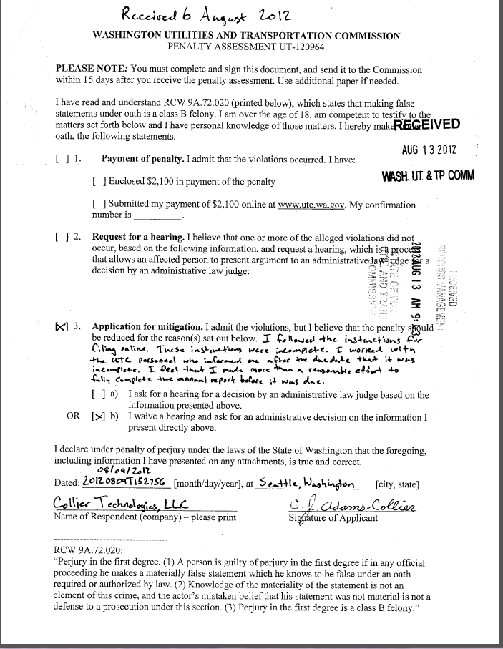

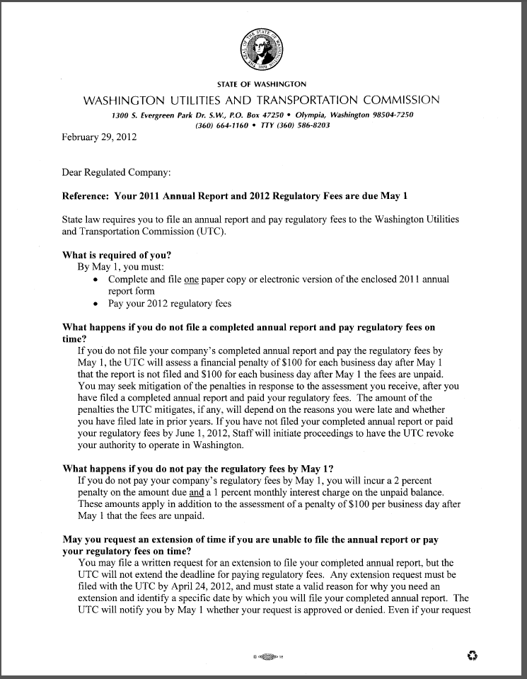**Attachment B**

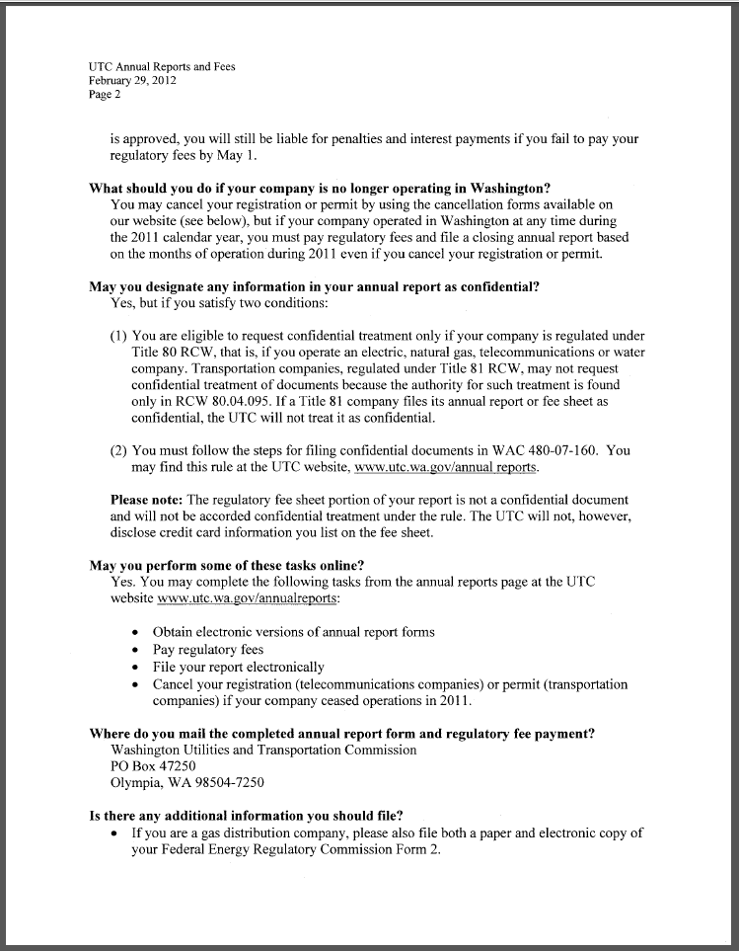

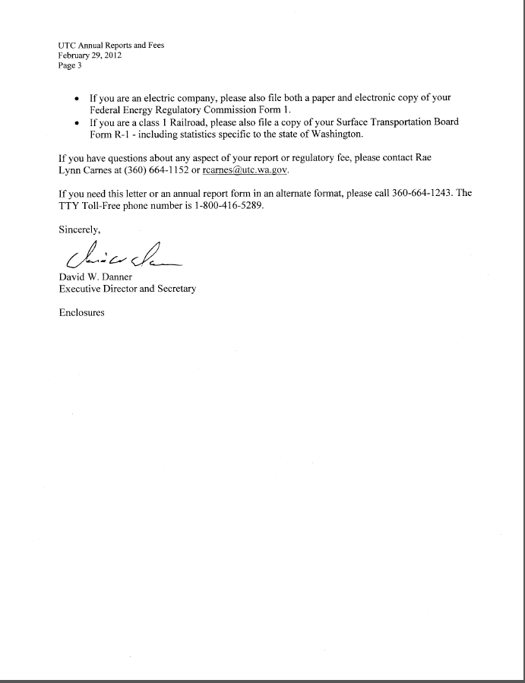

**Attachment C**

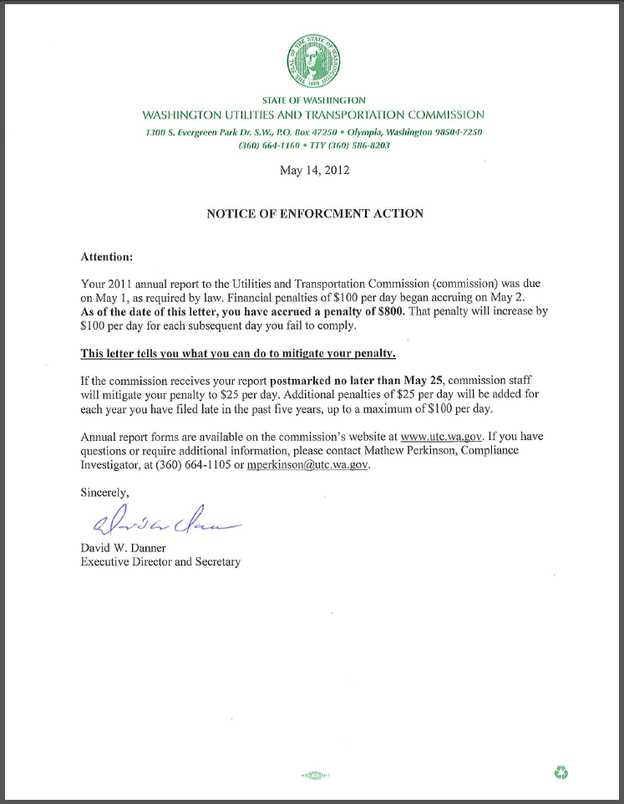

1. See attachment A for a copy of Collier Technologies, LLC’s Mitigation Request.
2. See attachment B for a copy of the letter sent to all regulated companies on February 29, 2012.
3. See attachment C for a copy of the enforcement letter sent to the company on May 14, 2012.