

October 29, 2010

Advice No. 3671T

David Danner

Executive Director and Secretary

1300 S. Evergreen Park Dr. S.W.

P.O. Box 47250

Olympia, Washington 98504-7250

Dear Mr. Danner:

Qwest Corporation (Qwest) is forwarding for filing the sheet listed on Attachment A.

This filing decreases Puyallup, Washington’s Occupational Tax Rate and the Effective Tax Rate for billing from 6.0% to 2.2%. Qwest requests an effective date of November 1, 2010. The actual effective date of the tax change, as indicated on the notice from Puyallup, was April 1, 2010. Although Qwest’s vendor received the tax rate change notice from Puyallup, miscommunications between Qwest’s vendor and the Qwest tax and billing groups resulted in the lapse between the tax rate change effective date and the filing date. Qwest is working with its vendor to determine the cause of the miscommunications and to implement process changes to ensure the problem is corrected. Finally, Qwest will work with Puyallup to ensure that the tax overcharge during the affected billing cycles is resolved.

If you have questions concerning this filing please contact me.

Sincerely,

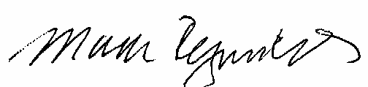

Mark Reynolds

Attachments

Attachment A

Advice No. 3671T

**EXCHANGE AND NETWORK SERVICES**

**WN U-40**

|  |  |  |
| --- | --- | --- |
| **SECTION** | **SHEET** | **REVISION** |
| 2 | 72 | 8 |
|  |  |  |