**REQUESTED BY:** Dave Pratt

**UTC STAFF DATA REQUEST NO. 1:**

Please provide Staff with copies of your response(s), when available, to Speedishuttle’s Second Set of Data Requests (propounded 1/20/17) and to any future Speedishuttle data requests related to the topics of unauthorized commissions or rescue service/independent contractors.

RESPONSE:

Copies will be provided as requested.

Responding Person: Wesley Marks

Date of Response: February 3, 2017

Witness: Wesley Marks

**UTC STAFF DATA REQUEST NO. 2:**

For the period of time beginning January 16, 2014, and ending September 29, 2016:

1. Identify each occurrence in which Shuttle Express used an independent contractor to provide **any** transportation service, including shared ride, rescue, luxury upgrade, or any other term used by Shuttle Express to describe the provision of transportation services.
2. For each occurrence, provide the date of service, the independent contractor’s name, the trip’s origin(s) and destination(s), the customer’s name(s), the type of transportation provided (shared ride, rescue, luxury upgrade, or any other term used by Shuttle Express to describe the provision of transportation services), the number of stops, and the amount of revenue generated (including total cost to the customer and a breakdown of how much went to the independent contractor and how much Shuttle Express retained).

This information may be provided as a spreadsheet or table.

RESPONSE:

1. Shuttle Express understands that the scope of this is clarified or modified to exclude charter service and services that are clearly outside the scope of the Commission’s jurisdiction, such as limousine service that was never accepted from or booked as auto transportation service. The request is intended to cover all services provided to passengers that initially booked auto transportation service and subsequently switched to another mode of service, including limousine. Within the modified scope, Shuttle Express will provide a complete response via an electronic Excel spreadsheet file named “SE to Staff DR 2 Resp.” Producing the file in paper would be needlessly burdensome, as it would comprise over 10,000 pages of documents.

This response should not be construed as an admission that any of the trips were auto transportation service or within the scope of the Commission’s jurisdiction.

1. Shuttle Express understands that the scope of this is clarified or modified to exclude individual contractor and passenger names, to protect privacy and commercially and competitively valuable proprietary information. With that limitation, see the Excel file provided in response to 2.a. (SE to Staff DR 2 Resp), which shows, for each trip, the date, reservation ID, number of stops, Trip ID, pick up/drop off location (by zip, airport, or cruise terminal), base fare, and independent contractor’s share of the fare. The Excel file shows all 40,727 passengers or parties during the period requested who originally booked auto transportation service and who subsequently switched to a service provided by an independent contractor. All the trips identified involved a single person or party and a single stop. The 40,727 trips reflect approximately 5.6 percent of all the auto transportation reservations for the same time period.

Responding Person: Paul Kajanoff

Date of Response: February 3, 2017

Witness: Paul Kajanoff

**UTC STAFF DATA REQUEST NO. 3:**

Staff assumes that when Shuttle Express refers a job to an independent, some form of written or electronic communication describing the job is generated. For each occurrence in which Shuttle Express used an independent contractor to provide transportation from January 16, 2014, to September 29, 2016, please provide a copy of all associated referral documentation.

RESPONSE:

Staff’s assumption is generally correct. The communication is provided electronically only, via a tablet device. The communication per se is transitory and not recoverable or reproducible. The underlying data is stored in a database format. Most of the information that is preserved in that way has been produced in response to UTC Staff Data Request No. 2 (Excel spreadsheet “SE to Staff DR 2 Resp”). The Excel spreadsheet shows each occurrence requested, subject to the limitations noted in response to Date Request No. 2. In addition, attached to this response is a screenshot of the opening display on the tablet, to show the general character of the electronic manifest that the contractors use.

Responding Person: Wesley Marks

Date of Response: February 3, 2017

Witness: Wesley Marks

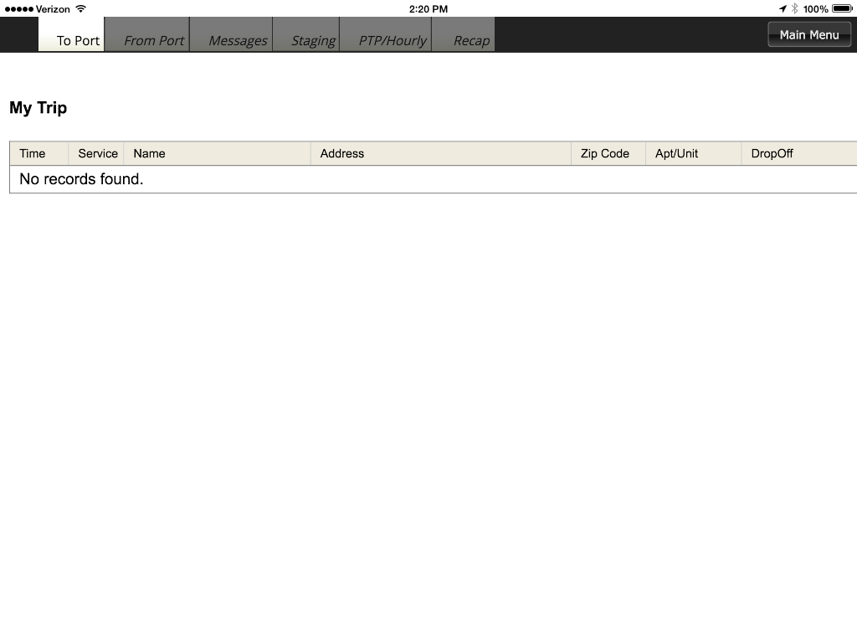

**REQUESTED BY:** Danny Kermode

**UTC STAFF DATA REQUEST NO. 4:**

Is Shuttle Express, or any affiliate of Shuttle Express, currently paying, rewarding or in any way compensating concierges, bellhops, travel agents or other hotel or facility personnel (regardless of job title) to refer or direct passengers to Shuttle Express?

RESPONSE:

Shuttle Express does compensate a few hotel concierges for referring (but not selling tickets) passengers to Shuttle Express. Shuttle Express also compensates travel agents and wholesale or group travel arrangers who actually sell tickets for Shuttle Express. All such arrangements are pursuant to agreements filed with the Commission.

Responding Person: Wesley Marks

Date of Response: February 3, 2017

Witness: Wesley Marks

**UTC STAFF DATA REQUEST NO. 5:**

For the period of time beginning January 16, 2014, and ending December 31, 2016, has Shuttle Express, or any affiliate of Shuttle Express, paid, rewarded, or in any way compensated any concierges, bellhops, travel agents or any other hotel or facility personnel (regardless of job title) to refer or direct passengers to Shuttle Express?

RESPONSE:

During the time period requested, Shuttle Express compensated a few hotel concierges for referring (but not selling tickets) passengers to Shuttle Express. Shuttle Express also compensated travel agents and wholesale or group travel arrangers who actually sold tickets for Shuttle Express during the time period requested. All such arrangements were pursuant to agreements filed with the Commission.

Responding Person: Wesley Marks

Date of Response: February 3, 2017

Witness: Wesley Marks

**UTC STAFF DATA REQUEST NO. 6:**

Please provide the number of IRS forms 1099 Miscellaneous Income, Shuttle Express issued in 2015, if any.

RESPONSE:

Shuttle Express issued a total of 116 IRS 1099-MISC forms for the 2015 tax year. Those forms are generally categorized as follows:

* Suppliers operating on behalf of Shuttle Express – 56
* Suppliers providing direct service to Shuttle Express – 49
* Referral associated services for Hotels and Concierge – 6
* Medical Services – 4
* Rents – 1

Responding Person: Wesley Marks

Date of Response: February 3, 2017

Witness: Wesley Marks

**UTC STAFF DATA REQUEST NO. 7:**

During 2016, did Shuttle Express, or any of its affiliates, pay, reward, or in any way compensate Ted Milanio, concierge for the Westin in Seattle, Washington, to refer or direct passengers to Shuttle Express? If applicable, please provide the following:

a. If payment(s) were made (e.g., cash, check or any other form of disbursement), please provide the related disbursement journal for the day prior to, of and after such payment.

b. Please provide the company name and general ledger account number/name used to expense the payment.

c. Please provide the vendor ledger for Mr. Milanio reflecting the history of payments.

d. If some form of compensation or reward was provided other than cash, describe the form of the compensation and explain how it was computed or derived.

RESPONSE:

Similar to other hotel concierges, during 2016 Shuttle Express compensated Mr. Milanio for referring passengers to Shuttle Express. Mr. Milanio and the other concierges did not sell Shuttle Express tickets, did not charge for or receive compensation for the transportation from the passengers, and did not pay or remit any sums to Shuttle Express. Shuttle Express sold the tickets directly to the passengers and the passengers paid the tariffed (if the service was a rate-regulated service) fares directly to Shuttle Express.

1. See response to c. below.
2. Company Name: Shuttle Express, Inc.;

General Ledger Account Name: Commissions, Hotel & Travel

1. Please see the attached Exhibit for specific detail of payments to Mr. Milanio in 2016. The “net” shown is simply the sum of all the compensation earned and paid to Mr. Milanio in a given check or transaction. It does not reflect that there were any withholdings or offsets owed to Shuttle Express. Also, note that not all of this compensation was for regulated or tariffed services. It also includes compensation for charter and limousine referrals.
2. No other form of compensation or reward was provided to Shuttle Express’ knowledge other than described above and in the attached exhibit.

Responding Person: Wesley Marks

Date of Response: February 3, 2017

Witness: Wesley Marks

