

December 1, 2010

Advice No. 3672T

David Danner

Executive Director and Secretary

1300 S. Evergreen Park Dr. S.W.

P.O. Box 47250

Olympia, Washington 98504-7250

Dear Mr. Danner:

Qwest Corporation (Qwest) is forwarding for filing the sheet listed on Attachment A.

This filing increases the Town of Yarrow Point, Washington’s Occupational Tax Rate and the Effective Tax Rate for billing from 5.0% to 6.0%.

The Effective Date will be January 2, 2011.

If you have questions concerning this filing please contact me.

Yours very truly,

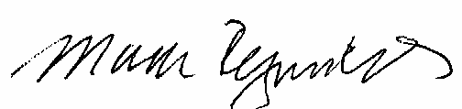

Mark Reynolds

Attachments

Attachment A

Advice No. 3672T

**EXCHANGE AND NETWORK SERVICES**

**WN U-40**

|  |  |  |
| --- | --- | --- |
| **SECTION** | **SHEET** | **REVISION** |
| 2 | 73 | 11 |
|  |  |  |