**Exhibit No. JLB-5T**

**Dockets UE-160228/UG-160229**

**Witness: Jason L. Ball**

**BEFORE THE WASHINGTON**

**UTILITIES AND TRANSPORTATION COMMISSION**

|  |  |
| --- | --- |
| **WASHINGTON UTILITIES AND TRANSPORTATION COMMISSION,**  **Complainant,**  **v.**  **AVISTA CORPORATION d/b/a**  **AVISTA UTILITIES,**  **Respondent.** | **DOCKETS UE-160228 and**  **UG-160229 (*Consolidated*)** |

**CROSS ANSWERING TESTIMONY OF**

**JASON L. BALL**

**STAFF OF**

**WASHINGTON UTILITIES AND**

**TRANSPORTATION COMMISSION**

***Demand Response Program and Schedule 91 Rate Design***

**September 19, 2016**

**TABLE OF CONTENTS**

I. INTRODUCTION 1

II. DEMAND RESPONSE 1

III. SCHEDULE 91 4

# INTRODUCTION

Q. Are you the same Jason Ball who testified previously in this case?

##### A. Yes.

Q. What topics will you be discussing in your cross-answering testimony?

##### A. I am responding to certain rate design proposals presented by ICNU witness Robert Stephens. Specifically, I address the proposed demand response program and the proposed changes to Schedule 91 rate design.

Q. Overall, what are your recommendations regarding the proposed demand response program and Schedule 91?

##### A. I recommend the Commission not require Avista to implement a demand response program in the present docket but rather allow Avista’s Advisory Group to evaluate such a proposal. Lastly, I recommend the Commission reject the proposed changes to Schedule 91 rate design.

# DEMAND RESPONSE

Q. Please describe ICNU witness Robert Stephens’ Demand Response Proposal.

A. Mr. Stephens proposes a new Schedule 78 – Large Customer Demand Response Pilot Program. His proposed schedule is designed for customers that have at least 25 MW of demand response capability and are served under Schedule 25. Load reduction events are limited to no more than 100 hours per year for each customer, with certain restrictions on the timing between load reduction events based on the type of event.[1]

Q. Has Avista evaluated the potential for demand response?

A. Yes. In the 2015 IRP, Avista contracted with Applied Energy Group (AEG) to study the potential for industrial demand response programs. The AEG report found specifically that a “firm curtailment option has the highest savings potential. . . .”[2] This finding was based on a 22.3 percent participation rate from eligible customers with an average demand above 100 kW. Currently, all twenty-one customers in Schedule 25 have average demand in excess of 100 kW.

Q. How many customers currently served under Schedule 25 would be eligible for the service proposed by Mr. Stephens?

A. One.[3]

Q. In general, is Staff supportive of well-designed demand response programs?

A. Yes. Demand response programs are an increasingly important component of any utility’s resource portfolio. Demand response is a resource clearly included in RCW 19.280.030 that must be considered when choosing the resource mix with the lowest reasonable cost.[4] In addition to the requirement from the integrated resource planning standard, Commission rules also identify demand response as one of the resources included in a request for proposals.[5]

Q. Is this docket the appropriate forum to develop and implement the demand response program as proposed by INCU?

A. No. Because ICNU’s proposal is narrowly tailored to target a specific individual customer, it should not be a tariffed service. If ICNU wishes to implement a demand response program for a single customer, then that proposal should be discussed with the Energy Efficiency or IRP Advisory Groups. This would allow stakeholders and interest groups with the appropriate expertise to evaluate and comment on the proposal. Alternatively, ICNU or the customer in question could negotiate with Avista and bring to the Commission a special contract to implement a demand response program. The resulting contract could then be evaluated by the Commission independently.

Q. How could a general demand response program be implemented?

A. A pilot program could evaluate potential interest and costs of demand response. The first step would be to issue a Request for Proposals (RFP) from third-party demand response program marketers. This is consistent with the AEG report, which found:

Typically [sic] Firm Curtailment programs in the industry are delivered through third parties who are responsible for all aspects of program implementation including program marketing and outreach, customer recruitment, technology installation, and incentive payments to participants.[6]

An RFP, similar to those by PSE in Dockets UE-160808 and UE‑160809, would allow Avista to evaluate demand response programs that target multiple customers. The second step would be for Avista to propose a demand response pilot program through a tariff filing based on the RFPs.

# SCHEDULE 91

Q. Please describe ICNU’s witness Robert Stephens’ proposed changes to Schedule 91.

A. Mr. Stephens presents three proposals for changing Schedule 91, but recommends that the Commission only implement the second and third. The second proposal implements a self-direct option for Schedule 25 customers. Under this option, the current DSM contributions from Schedule 25 customers would be reduced and redirected into individual “reserve” accounts that Schedule 25 customers would use for energy efficiency or demand response programs. The third proposal simply reduces the current level of DSM funding provided from Schedule 25 customers.[7]

Q. Regarding the second proposal, is this proceeding the appropriate forum to discuss a self-direct option?

A. No. Avista has an Energy Efficiency Advisory Group that specifically discusses and makes recommendations regarding this type of program. Importantly, the Advisory Group has various stakeholders and interest groups with various expertise that evaluate and comment on these types of proposals. It also allows Avista and interested stakeholders to evaluate the cost-effectiveness of such a program. Further, Mr. Stephens’ argument supporting the need for this option is fundamentally flawed.

Q. Regarding the third proposal, please summarize your review of the contributions made by Schedule 25 to the overall DSM program.

A. As discussed below, a reduction in Schedule 25 DSM rates is entirely unwarranted. Schedule 25 customers are already receiving a much higher level of benefits from DSM programs than they are paying into Schedule 91. I believe Mr. Stephens’ argument obscures this fact with incomplete and misleading analysis.

Q. What is Mr. Stephens’ rationale for both of these proposals?

A. Mr. Stephens presents these proposals to address the “clear disparity among the rate classes in the relationship of benefits to costs associated with the Schedule 91 collection.”[8]

Q. Do you agree with this rationale?

##### A. No. The analysis provided by Mr. Stephens is fundamentally flawed and should be disregarded. Mr. Stephens’ analysis fails to include the indirect benefits of DSM measures. A quantification of those benefits was provided to ICNU in Avista’s response to ICNU Data Request 37. Specifically, Mr. Stephens’ analysis ignores the indirect benefits of avoided capacity and reduced market purchases, and instead only calculates the ratio of direct incentives to contributions. The Company correctly pointed out the flaw in this logic, stating:

Although systematic benefits would be difficult to quantify whether customers benefit in the exact same way at all times, the Company believes that the actual benefits that accrue to all customers is much greater than just the direct incentives provided to customers for efficiency projects, so judging the equity of DSM by purely comparing direct incentives to the portion of funds collected through schedule 91 for specific customer classes is an incomplete analysis.[9]

##### Analysis that ignores pertinent but inconvenient evidence obfuscates the issues important to this proceeding and is detrimental to the record.

Q. Have you prepared a complete version of Mr. Stephens’ analysis?

A. Yes. The chart below shows the total DSM Schedule 25 direct benefits and adds the appropriate indirect benefits that Mr. Stephens fails to include. This comparative analysis shows that the direct and indirect benefits from DSM far exceed the DSM contributions (marked as the Break Even Point) by Schedule 25 customers no matter which allocator is used.

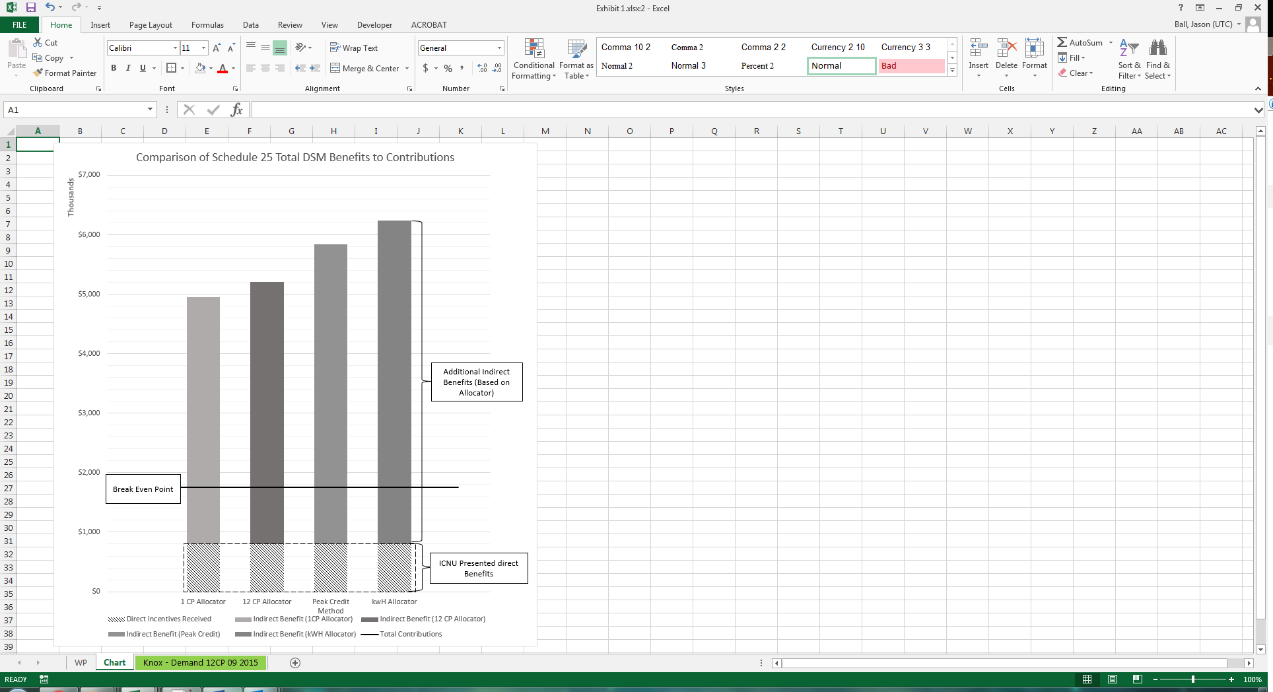

The benefits of this program clearly exceed the costs being recovered from Schedule 25 customers. Consideration of both direct and indirect benefits is consistent with the Total Resource Cost test benefit-to-cost ratio that the Commission uses to evaluate the cost effectiveness of energy efficiency measures.

Q. Does this conclude your testimony?

A. Yes.

1. Stephens, Exh. No. RRS-10.
2. Docket UE‑143214, Avista 2015 Integrated Resource Plan, Appendix C, 29 (Aug. 31, 2015).
3. ICNU Response to UTC Staff Data Request No. 57C.
4. RCW 19.280.030(1)(b).
5. *See* WAC 480-107-007(2).
6. Docket UE‑143214, Avista 2015 Integrated Resource Plan, Appendix C at 19 (Aug. 31, 2015).
7. Stephens, Exh. No. RRS-1TC 41:7 - 42:15.
8. *Id.* at 40:4-5.
9. ICNU Response to UTC Staff Data Request No. 41.