GAS ANALYSIS

More than 790,000 customers in Washington state depend on PSE for safe, reliable and affordable natural gas services. The IRP analysis in this chapter enables PSE to develop valuable foresight about how resource decisions to serve our natural gas customers may unfold over the next 20 years in conditions that depict a wide range of futures.

Contents

***7-2. GAS SALES RESOURCE NEED   
 & KEY ISSUE***

* *Gas Sales Need*
* *Gas Sales Key Issue*

***7-4. GAS SALES ANALYTIC   
 METHODOLOGY***

* *Optimization Analysis Tools*
* *Deterministic Optimization Analysis*

***7-6. GAS SALES EXISTING SUPPLY-  
 SIDE RESOURCES***

* *Existing Pipeline Capacity*
* *Transportation Types*
* *Existing Storage Resources*
* *Existing Peaking Supply   
   and Capacity Resources*
* *Existing Gas Supplies*
* *Existing Demand-side Resources*

***7-19. GAS SALES RESOURCE   
 ALTERNATIVES***

* *Combinations Considered*
* *Baseload Capacity Alternatives*
* *Storage and Peaking Capacity   
   Alternatives*
* *Gas Supply Alternatives*
* *Demand-side Resource Alternatives*

***7-31. GAS SALES ANALYSIS RESULTS***

* *Key Findings*
* *Gas Sales Portfolio Resource   
   Additions Forecast*
* *Complete Picture: Gas Sales Base   
   Scenario*
* *Average Annual Portfolio Cost   
   Comparisons*
* *Sensitivity Analyses*

GAS SALES RESOURCE NEED AND KEY ISSUE

Gas Sales Need

Figure 7-1 illustrates gas sales peak resource need over the 20-year planning horizon for the three demand scenarios modeled in this IRP. The lines rising toward the right indicate peak day customer demand before demand-side resources (DSR)[1] and the bars represent existing gas supply resources such as storage facilities, peaking supply resources and contracts for transportation of gas to customers from receipt points at various gas supply locations such as gas supply hubs and storage facilities. The gap between the demand and the existing resources represents the resource need.

Figure 7-1: Gas Sales Peak Resource Need before DSR

Existing Resources Compared to Peak Day Demand

(Meeting need on the coldest day of the year)

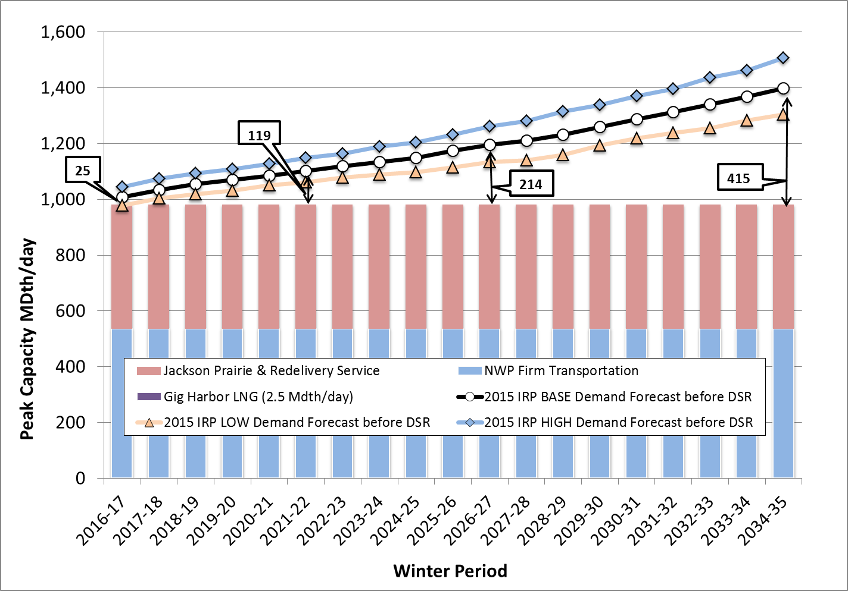

PSE’s gas sales need is driven by two factors: peak day demand per customer and the number of customers. Our gas sales planning standard is based on peak day demand, which occurs in the winter[2] when temperatures are lowest and heating needs are highest. The heating season and number of lowest-temperature days in the year remain fairly constant and the use per customer is not growing much, if at all, so the growth in customer count is the biggest factor in determining load growth.

The IRP analysis tested three customer demand forecasts over the 20-year planning horizon: the 2015 IRP Base Demand Forecast, the 2015 IRP High Demand Forecast, and the 2015 IRP Low Demand Forecast.[3] In the high case, we have a current need for additional firm resources to meet peak day need; in the base demand case, we have sufficient firm resources to meet peak day need until the winter of 2016-17; and in the low demand case, we have sufficient firm resources to meet peak day need until the winter of 2017-18.

Gas Sales Key Issue

**Market Reliance on Sumas.** Sumas is essentially an interconnection between Westcoast Pipeline (Westcoast) and Northwest Pipeline (NWP). Unlike other market hubs, there is no gas production and no convergence of several pipelines. For years, Westcoast has had surplus capacity, meaning that even on very cold days, there was sufficient infrastructure to bring gas from production areas in Northern British Columbia (B.C.) south to Sumas; PSE did not have to pay in advance for that pipeline capacity. But, as the demand for natural gas to serve gas customer growth and electric generation fuel needs has increased in the Pacific Northwest, less non-firm pipeline capacity is available. Throughput on Westcoast is beginning to hit that pipeline’s design planning limit. That means PSE cannot rely on spot market supplies at Sumas to meet our peak loads, but must acquire upstream pipeline capacity on Westcoast to ensure reliable gas supplies will be available to meet our customers’ needs. Therefore, in this IRP, we are not considering pipeline capacity on NWP to Sumas alone as a resource; rather, NWP capacity must be coupled with pipeline capacity on Westcoast to be deemed a reliable resource for meeting gas customer peaking needs.

**GAS SALES ANALYTIC METHODOLOGY**

In general, analysis of the gas supply portfolio begins with an estimate of resource need that is derived by comparing 20-year demand forecasts with existing resources. Once need has been identified, a variety of planning tools, optimization analyses and input assumptions help PSE identify the lowest-reasonable-cost portfolio of gas resources in a variety of scenarios.

Optimization Analysis Tools

PSE uses a gas portfolio model (GPM) to model gas resources for long-term planning and long-term gas resource acquisition activities. The current GPM is SENDOUT Version 14.2.0 from ABB Ventyx, a widely-used model that employs a linear programming algorithm to help identify the long-term, least-cost combination of integrated supply- and demand-side resources that will meet stated loads. While the deterministic linear programming approach used in this analysis is a helpful analytical tool, it is important to acknowledge this technique provides the model with "perfect foresight" – meaning that its theoretical results may not be achievable. For example, the model knows the exact load and price for every day throughout a winter period, and can therefore minimize cost in a way that is not possible in the real world. Numerous critical factors about the future will always be uncertain; therefore we rely on linear programming analysis to help *inform* decisions, not to *make* them. See Appendix O, Gas Analysis, for a more complete description of the SENDOUT gas portfolio model.

Deterministic Optimization Analysis

As described in Chapter 4, Key Analytical Assumptions, PSE developed 10 scenarios for this IRP. Scenario analysis allows the company to understand how different resources perform across a variety of economic and regulatory conditions that may occur in the future. Scenario analysis also clarifies the robustness of a particular resource strategy. In other words, it helps determine if a particular strategy is reasonable under a wide range of possible circumstances.

PSE also tested two sensitivities in the gas sales analysis; these are described below. Sensitivity analysis allows us to isolate the effect a single resource has on the portfolio.

1. How does the timing of pipeline expansions affect resource choices? This sensitivity allows pipeline expansions in every year, versus a baseline of every four years.
2. How does the discount rate affect the amount of cost-effective DSR? This sensitivity applies an alternate discount rate that is lower than PSE’s approved weighted average cost of capital (WACC).

Gas portfolio analysis is discussed in more detail in Appendix O, Gas Analysis.

**GAS SALES EXISTING SUPPLY-SIDE RESOURCES**

Existing gas sales resources consist of pipeline capacity, storage capacity, peaking capacity, gas supplies and demand-side resources.

Existing Pipeline Capacity

There are two types of pipeline capacity. “Direct-connect” pipelines deliver supplies directly to PSE’s local distribution system from production areas, storage facilities or interconnections with other pipelines. “Upstream” pipelines deliver gas to the direct pipeline from remote production areas, market centers and storage facilities.

**Direct-connect Pipeline Capacity.** All gas delivered to our gas distribution system is handled last by PSE’s only direct-connect pipeline, Northwest Pipeline (NWP). We hold nearly one million dekatherms (Dth) of capacity with NWP.

* 532,872 Dth per day of year-round TF-1 (firm) transportation capacity
* 447,057 Dth per day of NWP-Jackson Prairie storage redelivery service

Receipt points on the NWP transportation contracts access supplies from four production regions: British Columbia, Canada (B.C.); Alberta, Canada; the Rocky Mountain Basin and the San Juan Basin. This provides valuable flexibility, including the ability to source gas from different regions on a day-to-day basis in some contracts.

**Upstream Pipeline Capacity.** To transport gas supply from production basins or trading hubs to the direct-connect NWP system, PSE holds capacity on several upstream pipelines.

A schematic of the gas pipelines for the Pacific Northwest region is provided in Figure 7-2 below. In addition, please see Figure 7-3 for details of PSE’s gas sales pipeline capacity.

*Figure 7-2: Pacific Northwest Regional Gas Pipeline Map*

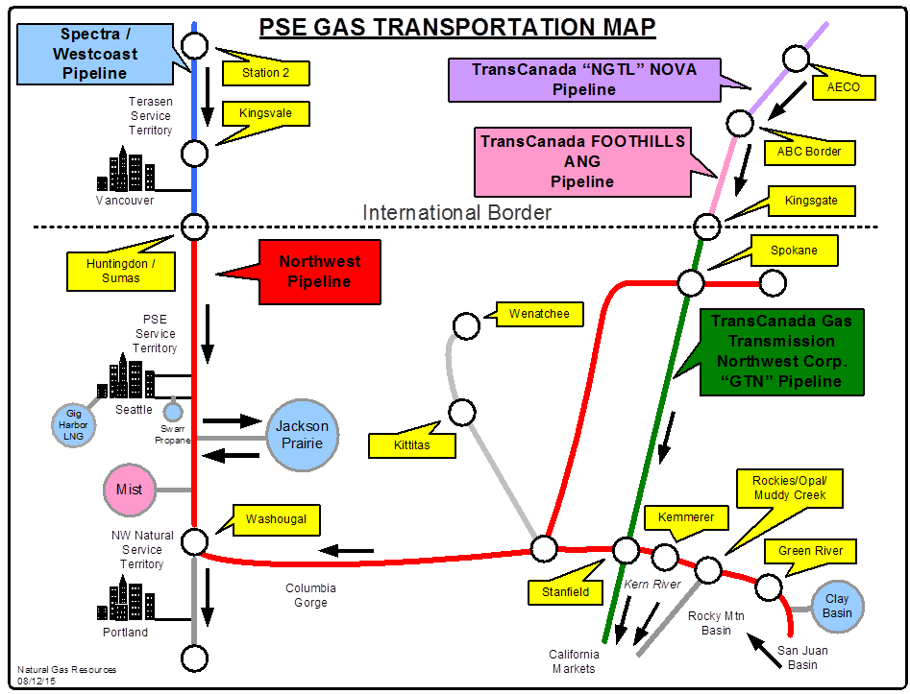

Figure 7-3: Gas Sales Pipeline Capacity (Dth/day)

|  |  |  |  |  |  |  |  |  |  |  |  |  |  |  |  |  |  |
| --- | --- | --- | --- | --- | --- | --- | --- | --- | --- | --- | --- | --- | --- | --- | --- | --- | --- |
| **Pipeline/Receipt Point** | **Note** | | | **Total** | | | | | **Year of Expiration** | | | | | | | | |
| **2016** | | | **2017-20** | | | **2021-35** | | |
| ***Direct-connect*** | |  | |  | | | | |  | | |  | | |  | | |
| NWP/Westcoast Interconnect (Sumas) | | 1 | | 269,181 | | | | | 8,386 | | | 254,645 | | | 6,150 | | |
|
| NWP/TC-GTN Interconnect (Spokane) | | 1 | | 75,936 | | | | | - | | | 75,936 | | | - | | |
| NWP/various Rockies | | 1 | | 187,755 | | | | | - | | | 187,755 | | | - | | |
|
| **Total TF-1** | |  | | **532,872** | | | | | **8,386** | | | **518,336** | | | **6,150** | | |
| NWP/Jackson Prairie Storage Redelivery Service | | 1,2 | | 447,057 | | | | | - | | | - | | | 447,057 | | |
|
| **Total Storage Redelivery Service** | | | |  | **447,057** | | | | | **-** | | | **-** | | | **447,057** | |
| **Total Capacity to City Gate** | |  | | **979,929** | | | | | **8,386** | | | **518,336** | | | **453,207** | | |
|  |  | |  | | |  |  |  | | |  | | |  | | |  | |
| **Pipeline/Receipt Point** | **Note** | | | **Total** | | | | | **Year of Expiration** | | | | | | | | |
| **2016** | | | **2017-20** | | | **2021-35** | | |
| ***Upstream Capacity*** | |  | |  | | | | |  | | |  | | |  | | |
| NOVA / from AECO to Alberta-BC Border (A-BC Border) | | 3 | | 79,744 | | | | | - | | | 79,744 | | | - | | |
| Foothills / from Alberta-BC Border to TC-GTN Interconnect (Kingsgate) | | 4 | | 78,631 | | | | | 70,604 | | | - | | | 8,027 | | |
| GTN / from Kingsgate to NWP Interconnect (Spokane) | | 5 | | 65,392 | | | | | - | | | - | | | 65,392 | | |
| TC-GTN / from TC-BC Interconnect (A-BC Border) to NWP Interconnect (Stanfield) | | 5,6 | | 11,622 | | | | | - | | | - | | | 11,622 | | |
| Westcoast / from Station 2 to NWP Interconnect (Sumas) | | 4,7 | | 129,855 | | | | | - | | | 129,855 | | | - | | |
| **Total Upstream Capacity** | | **8** | | **365,245** | | | | | **70,604** | | | **209,600** | | | **85,041** | | |

*NOTES*

*1 NWP contracts have automatic annual renewal provisions, but can be canceled upon one year’s notice.*

*2 Storage redelivery service is intended only for delivery of storage volumes during the winter heating season, November through March; these annual costs are significantly lower than year-round TF-1 service.*

*3 Converted to approximate Dth per day from contract stated in gigajoules per day.*

*4 Converted to approximate Dth per day from contract stated in cubic meters per day.*

*5 TCPL-GTN contracts have automatic renewal provisions, but can be canceled by PSE upon one year’s notice.*

*6 Capacity can alternatively be used to deliver additional volumes to Spokane.*

*7 The Westcoast contracts contain a right of first refusal upon expiration.*

*8 Upstream capacity is not necessary for a supply acquired at interconnects in the Rockies and for supplies purchased at Sumas.*

Transportation Types

**TF-1.** TF-1 transportation contracts are “firm” contracts, available every day of the year. PSE pays a fixed demand charge for the right, but not the obligation, to transport gas every day.

**Storage Redelivery Service.** PSE holds TF-2 and winter-only discounted TF-1 capacity under various contracts to provide for firm delivery of Jackson Prairie storage withdrawals. These services are restricted to the winter months of November through March and provide for firm receipt only at Jackson Prairie; therefore, the rates on these contracts are substantially lower than regular TF-1 transportation contracts.

**Firm versus Non-firm Transportation Capacity.** Firm transportation capacity carries the right, but generally not the obligation (subject to operational flow orders from a pipeline), to transport up to a maximum daily quantity of gas on the pipeline from a specified receipt point to a specified delivery point. Firm transportation requires a fixed payment, whether or not the capacity is used, plus variable costs when physical gas is transported.

Non-firm service is subordinate to the rights of shippers who hold and use firm transportation capacity, hence it is “interruptible.” The rate for interruptible capacity is negotiable, and is typically billed as a variable charge.

Non-firm capacity on a fully contracted pipeline results from a firm shipper not fully utilizing its firm rights on a given day. This unused (aka: interruptible) capacity, if requested (nominated) by a shipper and confirmed by the pipeline, becomes firm capacity for that day. The rights of this type of non-firm capacity are subordinate to the rights of firm pipeline contract owners who request to transport gas outside of their firm transportation path.

PSE may release capacity when it has a surplus of firm capacity and when market conditions make such transactions favorable for customers. The company also uses the capacity release market to access additional firm capacity when it is available. Interruptible service plays a limited role in PSE’s resource portfolio because it cannot be relied on to meet peak demand.

Existing Storage Resources

PSE’s natural gas storage capacity is a significant component of the company’s gas sales resource portfolio. Storage capacity improves system flexibility and creates significant cost savings for both the system and customers. Benefits include the following.

* Ready access to an immediate and controllable source of firm gas supply or storage space enables PSE to handle many imbalances created at the interstate pipeline level without incurring balancing or scheduling penalties.
* Access to storage makes it possible for the company to purchase and store additional gas during the lower-demand summer season, generally at lower prices.
* Combining storage capacity with storage redelivery service transportation allows us to contract for less year-round pipeline capacity to meet winter-only demand.
* PSE also uses storage to balance city gate gas receipts with the actual loads of our gas transportation customers.

We have contractual access to two underground storage projects. Each serves a different purpose. Jackson Prairie storage, in Lewis County, Wash. is an aquifer-driven storage field designed to deliver large quantities of gas over a relatively short period of time. Clay Basin, in northeastern Utah, provides supply-area storage and a winter gas supply. Figure 7-4 presents details about storage capacity.

Figure 7-4: Gas Sales Storage Resources1

|  |  |  |  |  |
| --- | --- | --- | --- | --- |
| **Facility** | **Storage Capacity (Dth)** | **Injection Capacity (Dth/Day)** | **Withdrawal Capacity (Dth/Day)** | **Expiration Date** |
|  |  |  |  |  |
| Jackson Prairie – Owned | 8,528,000 | 156,000 | 398,667 | N/A |
| Jackson Prairie – NWP |  |  |  |  |
| SGS-2F3 | 1,359,481 | 21,313 | 54,467 | 2016 |
| Subtotal Jackson Prairie –Available | 9,887,481 | 177,313 | 453,134 |  |
| Jackson Prairie – Owned2 | (500,000) | (25,000) | (50,000) | 2016 |
| Jackson Prairie – NWP |  |  |  |  |
| SGS-2F4 | (178,460) | (2,378) | (6,077) | 2020 |
| Net Jackson Prairie | 9,209,021 | 149,935 | 397,057 | *Note 7* |
| Clay Basin5 | 12,882,750 | 53,678 | 107,356 | 2018/20 |
| Clay Basin6 | (4,000,000) | (37,011) | (74,023) | 2018 |
| Net Clay Basin | 8,882,750 | 16,667 | 33,333 |  |
| **Total Gas Sales Storage Resources** | **18,091,771** |  | **430,390** |  |

*NOTES*

*1 Storage, injection, and withdrawal capacity quantities reflect PSE's capacity rights rather than the facility's total capacity.*

*2 Storage capacity made available to PSE’s power portfolio (at market-based prices) from PSE gas sales portfolio. Renewal may be possible, depending on gas sales portfolio needs.*

*3 NWP contracts have automatic annual renewal provisions, but can be canceled upon one year’s notice.*

*4 Released to Cascade Natural Gas through 4/1/2020, subject to recall.*

*5 PSE expects to renew the Clay Basin storage agreements.*

*6 Assigned to third parties through 4/1/2018.*

*7 Total withdrawal capacity is 447,057 Dth/day if the 50,000 Dth/day is retained.*

**Jackson Prairie Storage**. PSE, NWP and Avista Utilities each own an undivided one-third interest in the Jackson Prairie Gas Storage Project (Jackson Prairie), which is operated by PSE under FERC authorization. As shown in Figure 7-3, PSE has 447,057 Dth per day of storage redelivery service transportation capacity from Jackson Prairie. In addition to firm daily deliverability and firm seasonal capacity, PSE has access to deliverability and seasonal capacity through contracts for SGS-2F storage service from NWP. The NWP contracts are automatically renewed each year, but PSE has the unilateral right to terminate the agreement with one year’s notice.

PSE uses Jackson Prairie and the associated NWP storage redelivery service transportation capacity primarily to meet the intermediate peaking requirements of core gas customers – that is, to meet seasonal load requirements, balance daily load and minimize the need to contract for year-round pipeline capacity to meet winter-only demand.

**Clay Basin Storage.** Questar Pipeline owns and operates the Clay Basin storage facility in Daggett County, Utah. This reservoir stores gas during the summer for withdrawal in the winter. PSE has two contracts to store up to 12,882,750 Dth and withdraw up to 107,356 Dth per day under a FERC-regulated service. As shown in Figure 7-4, 4,000,000 Dth of this storage capacity has been assigned to third parties through March 2018.

PSE uses Clay Basin for certain levels of baseload supply, and for backup supply in the case of well freeze-offs or other supply disruptions in the Rocky Mountains during the winter. It provides a reliable source of supply throughout the winter, including peak days; it also provides a partial hedge to price spikes in this region. Gas from Clay Basin is delivered to PSE’s system (and other markets) using firm NWP TF-1 transportation.

**Treatment of Storage Cost.** Similar to firm pipeline capacity, firm storage arrangements require a fixed charge whether or not the storage service is used. PSE also pays a variable charge for gas injected into and withdrawn from Clay Basin. Charges for Clay Basin service (and the non-PSE-owned portion of Jackson Prairie service) are billed to PSE pursuant to FERC-approved tariffs, and recovered from customers through a purchased gas adjustment (PGA) regulatory mechanism, while costs associated with the PSE-owned portion of Jackson Prairie are recovered from customers through base distribution rates.

Existing Peaking Supply and Capacity Resources

Firm access to other resources provides supplies and capacity for peaking requirements or short-term operational needs. The Gig Harbor liquefied natural gas (LNG) satellite storage and the Swarr vaporized propane-air (LP-Air) facility provide firm gas supplies on short notice for relatively short periods of time. Generally a last resort due to their relatively higher variable costs, these resources typically help to meet extreme peak demand during the coldest hours or days. These resources do not offer the flexibility of other supply sources.

Figure 7-5: Gas Sales Peaking Resources

|  |  |  |  |  |
| --- | --- | --- | --- | --- |
| **Facility** | **Storage Capacity (Dth)** | **Injection Capacity (Dth/Day)** | **Withdrawal Capacity (Dth/Day)** | **Transport Tariff** |
|  | | | | |
| Gig Harbor LNG | 10,500 | 2,500 | 2,500 | On-system |
| Swarr LP-Air2 | 128,4402 | 16,6801,2 | 02 | On-system |
| **Total** | **138,940** | **19,180** | **2,500** |  |

NOTES

1 Swarr holds 1.24 million gallons. At a refill rate of 111 gallons per minute, it takes 7.7 days to refill, or 16,680 Dth per day.

2 Swarr upgrade is anticipated to be complete for winter 2016-2017 operations.

**Gig Harbor LNG.** Located in the Gig Harbor area of Washington state, this satellite LNG facility ensures sufficient supply during peak weather events for a remote but growing region of PSE’s distribution system. The Gig Harbor plant receives, stores and vaporizes LNG that has been liquefied at other LNG facilities. It represents an incremental supply source and its 2.5 MDth per day capacity is therefore included in the peak day resource stack. Although the facility directly benefits only areas adjacent to the Gig Harbor plant, its operation indirectly benefits other areas in PSE’s service territory since it allows gas supply from pipeline interconnects or other storage to be diverted elsewhere.

**Swarr LP-AIR.** The Swarr LP-Air facility has a net storage capacity of 128,440 Dth natural gas equivalents and can produce the equivalent of approximately 10,000 Dth per day. Swarr is a propane-air injection facility on PSE’s gas distribution system that operates as a needle-peaking facility. Propane and air are combined in a prescribed ratio to ensure the mixture injected into the distribution system maintains the same heat content as natural gas. Preliminary work necessary to upgrade the facility’s environmental safety and reliability systems and increase production capacity to 30,000 Dth per day is under way. The upgrade is evaluated as a resource alternative for this IRP (see Combination #7 – Swarr), and is assumed to be available for the 2016-2017 winter, beginning November 2016. Since Swarr connects to PSE’s distribution system, it requires no upstream pipeline capacity.

Existing Gas Supplies

Advances in shale drilling have expanded the economically feasible natural gas resource base and changed the picture with regard to gas supplies. Not only has development of shale beds in British Columbia, Canada directly increased the availability of supplies in the West, but the east coast no longer relies so heavily on western supplies now that shale deposits in Pennsylvania and West Virginia are in production.

Within the limits of its transportation and storage network, PSE maintains a policy of sourcing gas supplies from a variety of supply basins. Avoiding concentration in one market helps to increase reliability. We can also mitigate price volatility to a certain extent; the company’s capacity rights on NWP provide some flexibility to buy from the lowest-cost basin, with certain limitations based on the primary capacity rights from each basin. While PSE is heavily dependent on supplies from northern British Columbia, it also maintains pipeline capacity access to producing regions in the Rockies, the San Juan basin and Alberta.

Price and delivery terms tend to be very similar across supply basins, though shorter-term prices at individual supply hubs may “separate” due to pipeline capacity shortages. This separation cycle can last several years, but should be alleviated when additional pipeline infrastructure is constructed. PSE expects generally comparable pricing across regional supply basins over the 20-year planning horizon, with differentials primarily driven by differences in the cost of transportation and forecast demand increase.

PSE has always purchased our supply at market hubs. In the Rockies and San Juan basin, there are various transportation receipt points, including Opal and Clay Basin; but alternate points, such as gathering system and upstream pipeline interconnects with NWP, allow some purchases directly from producers as well as marketers. In fact, PSE has a number of supply arrangements with major producers in the Rockies to purchase supply near the point of production. Adding upstream pipeline transportation capacity on Westcoast, TransCanada’s TC-AB Nova pipeline and TransCanada’s TC-BC Foothills pipeline to the company’s portfolio has increased PSE’s ability to access supply nearer producing areas in Canada as well.

Gas supply contracts tend to have a shorter duration than pipeline transportation contracts, with terms to ensure supplier performance. PSE meets average loads with a mix of long-term (more than two years) and short-term (two years or less) gas supply contracts. Long-term contracts typically supply baseload needs and are delivered at a constant daily rate over the contract period. PSE also contracts for seasonal baseload firm supply, typically for the winter months November through March. Near-term transactions supplement baseload transactions, particularly for the winter months; PSE estimates average load requirements for upcoming months and enter into month-long transactions to balance load. PSE balances daily positions using storage from Jackson Prairie and Clay Basin, day-ahead purchases and off-system sales transactions, and balances intra-day positions using Jackson Prairie. PSE continuously monitors gas markets to identify trends and opportunities to fine-tune our contracting strategies.

PSE’s customer demand is highly weather dependent and therefore seasonal in nature. PSE’s general policy is to maintain longer-term firm supply commitments equal to approximately 50 percent of expected seasonal demand, including assumed storage injections in summer and net of assumed storage withdrawals in winter; that percentage grows as we move closer to the delivery month and day.

Existing Demand-side Resources

PSE has provided demand-side resources since 1993.[4] These energy efficiency programs operate in accordance with requirements established as part of the stipulated settlement of PSE’s 2001 General Rate Case.[5] Through 1998, the programs primarily served residential and low-income customers; in 1999 the company expanded them to include commercial and industrial customer facilities. Figure 7-8 shows that energy efficiency measures installed through 2014 have saved a cumulative total of nearly 4.9 million Dth – more than half of which has been achieved since 2007.

PSE spent almost $12 million for natural gas conservation programs in 2014 compared to $3.2 million in 2005. Spending over that period increased more than 25 percent annually and more recently there has been a shift downwards as gas prices have come down and fewer measures qualify as cost-effective savings. This shift, however, is not sustainable. PSE is engaged in collaborative regional efforts to find creative ways to make delivery and marketing of gas efficiency programs more cost-effective and to find ways to reduce barriers for promising measures that have not yet gained significant market share.

PSE’s energy efficiency programs serve residential, low-income, commercial and industrial customers. Energy savings targets and the programs to achieve those targets are established every two years. The 2012-2013 biennial program period concluded at the end of 2013; current programs operate January 1, 2014 through December 31, 2015. The majority of gas energy efficiency programs are funded using gas “rider” funds collected from all customers.

For the 2014-2015 period, PSE has a two-year target of approximately 694,060 Dth in energy savings. This goal was based on extensive analysis of savings potentials and developed in collaboration with key external stakeholders represented by the Conservation Resource Advisory Group and Integrated Resource Plan Advisory Group.

  
Figure 7-6: Gas Sales Energy Efficiency Program Summary, 2012 – 2015  
 Total Savings and Costs

Figure 7-7: Natural Gas Program Costs and Savings Trends

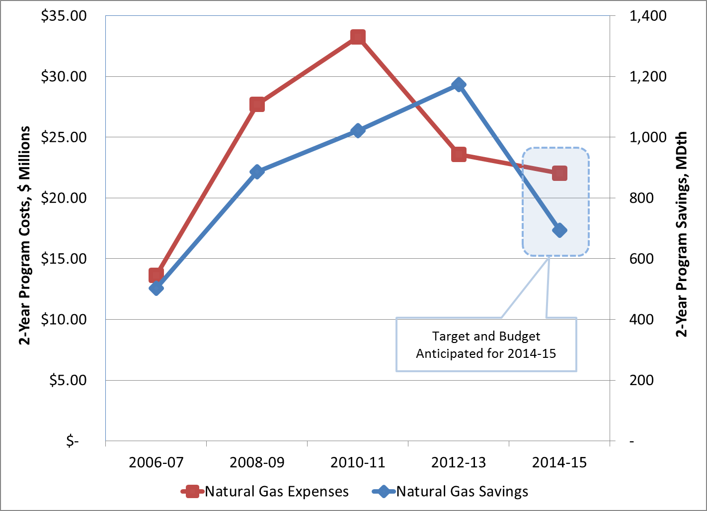

Figure 7-8: Cumulative Gas Sales Energy Savings from DSR, 1997 – 2014

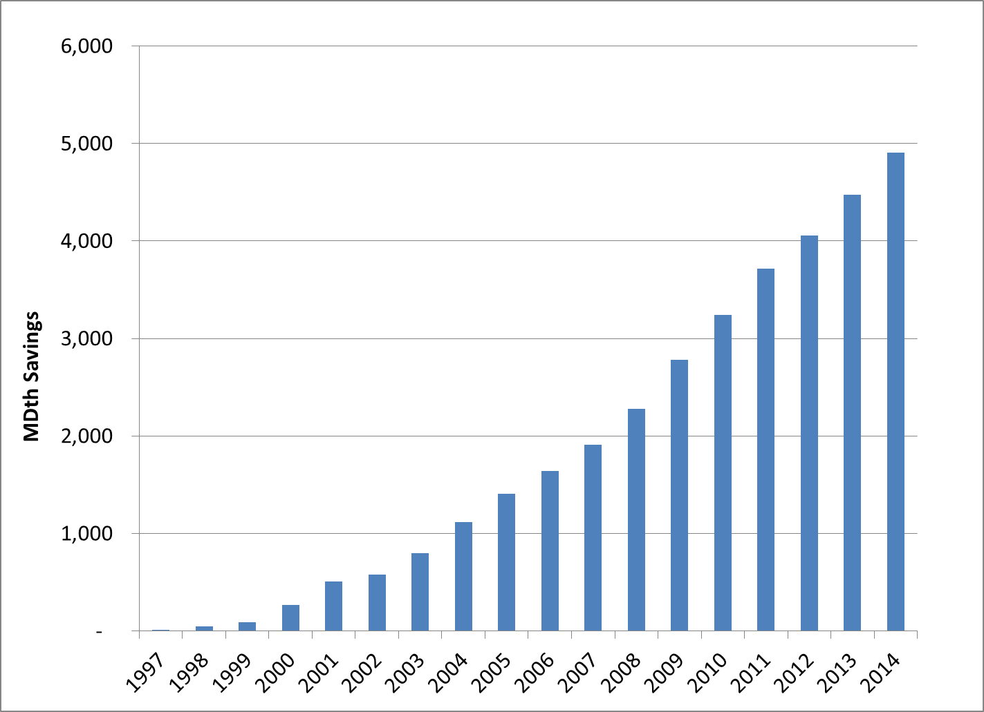

**GAS SALES RESOURCE ALTERNATIVES**

The gas sales resource alternatives considered in this IRP address long-term capacity challenges rather than the shorter-term optimization and portfolio management strategies PSE uses in the daily conduct of business to minimize costs.

Combinations Considered

Transporting gas from production areas or market hubs to PSE’s service area generally entails assembling a number of specific pipeline segments and gas storage alternatives. Purchases from specific market hubs are joined with various upstream and direct-connect pipeline alternatives and storage options to create combinations that have different costs and benefits. Within PSE’s service territory, demand-side resources are a significant resource.

In this IRP, the alternatives have been gathered into seven broad combinations for analyses. These combinations are discussed below and illustrated in Figure 7-9. Note that DSR is a separate alternative discussed later in this chapter.

**Combination #1 & 1a – NWP Additions + Westcoast**

This option expands access to northern British Columbia gas at the Station 2 hub beginning October 2018, with expanded transport capacity on Westcoast pipeline to Sumas and then on expanded NWP to PSE’s service area. Gas supplies are also presumed available at the Sumas market hub. In order to ensure reliable access to supply and achieve diversity of pricing, PSE seeks to hold Westcoast capacity equivalent to 100 percent of NWP firm take-away capacity at Sumas. This upstream capacity strategy has increased from 50 percent in the 2013 IRP due to the regional decline of available non-firm pipeline capacity.

**Combination #1a – NWP-TF-1**

This is a short-term pipeline alternative that represents excess capacity on the existing NWP system from Sumas to PSE that could be contracted to meet PSE needs from October 2016 through September 2018 only. Beyond September 2018, other long-term resources would be added to serve demand.

**Combination #2 – FortisBC/Westcoast (KORP)**

This combination includes the Kingsvale-Oliver Reinforcement Project (KORP) pipeline proposal, which is in the development stages and sponsored by FortisBC and Spectra with an estimate that it is available beginning October 2018. Essentially, the KORP project expands and adds flexibility to the existing Southern Crossing pipeline. This option would allow delivery of AECO gas to PSE via existing or expanded capacity on the TC-AB and TC-BC pipelines, the KORP pipeline across southern British Columbia to Sumas, and then on expanded NWP capacity to PSE.

**Combination #3 – Cross-Cascades - AECO**

This option provides for deliveries to PSE via the prospective Cross Cascades pipeline. The increased gas supply would come from Alberta (AECO hub) via existing or new upstream pipeline capacity on the TC-AB (NOVA), TC-BC (Foothills) and TC-GTN pipelines to Stanfield. Final delivery from Stanfield to PSE would be via the proposed Cross Cascades pipeline.

**Combination # 4 – Cross-Cascades - Malin**

This option provides for deliveries to PSE via the prospective Cross Cascades pipeline. The increased gas supply would come directly from Malin or from the Rockies hub on the Ruby pipeline to Malin, with backhaul on the TC-GTN pipeline to Stanfield. Final delivery from Stanfield to PSE would be via the proposed Cross Cascades pipeline.

**Combination #5 – PSE LNG Project**

This combination entails construction of an LNG peak-shaving facility to serve the needs of core gas customers as well as regional LNG fuel consumers. By serving new LNG fuel markets (primarily large marine consumers) the project achieves economies of scale that reduce costs for core gas customers. This project would be located at the Port of Tacoma and connect to PSE’s existing distribution system. The analysis assumes the project is put into service for the 2018-19 heating season, providing 69 MDth per day of capacity. The full 85 MDth per day capacity will be available with additional upgrades to the gas distribution system, which are estimated to be in service for the 2020-21 heating season.

**Combination #6 – Mist**

This option provides for PSE to lease storage capacity from NW Natural after an expansion of the Mist storage facility. Delivery of gas would require expansion of pipeline capacity from Mist to PSE’s service territory for Mist storage redelivery service. The expansion of pipeline capacity from Mist to PSE will be dependent on an expansion on NWP from Sumas to Portland.

**Combination #7 – Swarr**

This is an upgrade to the existing Swarr LP-air facility as discussed above. This upgrade would increase the peak day planning capability from 10 MDth per day to 30 MDth per day. This plant is located within PSE’s distribution network.

A schematic of the gas sales resource alternatives is depicted in Figure 7-9 below.

Figure 7-9: PSE Gas Transportation Map Showing Supply Alternatives

Baseload Capacity Alternatives

**Direct-connect Pipeline Capacity Alternatives.** The direct-connect pipeline alternatives considered in this IRP are summarized in Figure 7-10 below.

Figure 7-10: Direct-connect Pipeline Alternatives Analyzed

|  |  |
| --- | --- |
| **Direct-connect**  **Pipeline Alternatives** | **Description** |
|  | |
| NWP - Sumas to PSE city gate  *(from Combinations 1 & 2)* | Expansions considered either independently (from 2016 to 2018), or in conjunction with upstream pipeline/supply expansion alternatives (KORP or additional Westcoast capacity) assumed available October 2018. |
| Cross Cascades – Stanfield/TC-GTN to PSE city gate  *(from Combinations 3 & 4)* | Representative of costs and capacity of the proposed Cross Cascades pipeline with delivery on NWP to PSE city gate. Assumed to be available by 2018. |

**Upstream Pipeline Capacity Alternatives.** In some cases, a tradeoff exists between buying gas at one point and buying capacity to enable purchase at an upstream point closer to the supply basin. PSE has faced this tradeoff with supply purchases at the Canadian import points of Sumas and Kingsgate. For example, previous analyses led the company to acquire capacity on Westcoast Energy’s BC Pipeline (Westcoast), which allows PSE to purchase gas at Station 2 rather than Sumas and take advantage of greater supply availability at Station 2. Similarly, acquisition of additional upstream pipeline capacity on TransCanada’s Canadian and U.S. pipelines would enable PSE to purchase gas directly from suppliers at the very liquid AECO trading hub and transport it to interconnect with the proposed Cross Cascades pipeline on a firm basis. FortisBC and Spectra have proposed the KORP, which in conjunction with additional capacity on TransCanada’s Canadian pipelines, would also increase access to AECO supplies.

Figure 7-11: Upstream Pipeline Alternatives Analyzed

|  |  |
| --- | --- |
| **Upstream**  **Pipeline Alternatives** | **Description** |
|  | |
| Increase Westcoast Capacity  (Station 2 to PSE)  *(from Combination 1)* | Acquisition of currently uncontracted Westcoast capacity is considered to increase access to gas supply at Station 2 for delivery to PSE on expanded NWP capacity from Sumas. |
| Increase TransCanada Pipeline Capacity  (AECO to Stanfield)  *(from Combinations 2 & 3)* | Acquisition of currently uncontracted capacity of TransCanada pipeline capacity in Canada (TC-AB & TC-BC) and on TC-GTN in the U.S., to increase deliveries of AECO gas to Stanfield for delivery to PSE city gate via the proposed Cross Cascades pipeline. |
| Kingsvale-Oliver Reinforcement Project (KORP)  *(from Combination 2)* | Expansion of the existing FortisBC Southern Crossing pipeline across southern B.C., enhanced delivery capacity on Westcoast from Kingsvale to Huntingdon/Sumas. This alternative would include a commensurate acquisition of uncontracted capacity on the TC-AB and TC-BC pipelines. |
| GTN Backhaul from Malin to Stanfield  (Malin to Stanfield)  *(from Combination 4)* | Acquisition of GTN Backhaul capacity from Malin to Stanfield to provide access to Malin hub and connect over proposed Cross Cascades pipeline to PSE. |

The KORP alternative includes PSE participation in an expansion of the existing FortisBC pipeline across southern British Columbia which includes a cooperative arrangement with Westcoast for deliveries from Kingsvale to Huntingdon/Sumas. Acquisition of this capacity, as well as additional capacity on the TC-AB and TC-BC lines, would improve access to the AECO trading hub. While not inexpensive, such an alternative would increase geographic diversity and reduce reliance on British Columbia-sourced supply connected to upstream portions of Westcoast.

Storage and Peaking Capacity Alternatives

As described in the existing resources section, PSE is a one-third owner and operator of the Jackson Prairie storage facility, and PSE also contracts for capacity at the Clay Basin storage facility located in northeastern Utah. Additional pipeline capacity from Clay Basin is not available and storage expansion is not under consideration. Expanding storage capacity at Jackson Prairie is not analyzed in this IRP although it may prove feasible in the long run. For this IRP, the company considered the following storage alternatives.

**PSE LNG Project.** PSE is developing a small-scale LNG liquefaction and storage facility within its service territory to serve the peaking needs of PSE’s core gas customers and the growing demand for LNG as a marine and vehicle transportation fuel. The economies of scale afforded by a combined-use facility may make this a cost-effective resource for gas customers.

The peaking component of the PSE LNG Project would utilize gas purchased by the PSE gas sales portfolio throughout the year, transported over NWP and PSE distribution system to the plant, where it would be liquefied and stored. Under peak demand conditions, up to 66,000 Dth per day of PSE’s 538,039 Dth share of stored LNG would be vaporized and injected back into the PSE gas distribution system to meet customer demand. In addition, under peak demand conditions, up to 19,000 Dth per day of natural gas flowing on NWP to serve the daily liquefaction requirements of LNG transportation fuel customers could be diverted to other PSE gas distribution system interconnects to serve PSE customers. The diverted gas volumes would be replaced with PSE-owned LNG already in storage to keep the LNG transportation fuel customers whole. As configured, the PSE LNG Project would provide a peaking resource of up to 85,000 Dth per day to PSE gas sales customers for the equivalent of approximately 6 days per year. For analysis purposes, the facility is assumed to enter service for the 2018-19 heating season, with 69,000 Dth per day peaking service (providing an 8-day supply), and the full 85,000 Dth per day peaking capacity (providing a 6-day supply) is assumed available at the start of the 2020-21 winter season.

**Mist Expansion.** NW Natural Gas Company, the owner and operator of the Mist underground storage facility near Portland, Ore., is investigating a potential expansion project to be completed in 2016-2017. PSE is assessing the cost-effectiveness of leasing storage capacity beginning November 2018, once Mist is built. This would also require expansion of NWP’s interstate system to PSE’s city gate. PSE may be able to acquire discounted winter only capacity from Mist to PSE's city gate if NWP expands from Sumas to Portland for other shippers, however, that has not been modeled due to the unknown timeline for that potential project.

**Swarr.** The Swarr LP-Air facility is discussed above under “Existing Peaking Supply and Capacity Resources.” This resource alternative is being evaluated as PSE is in the preliminary stages of upgrading Swarr’s environmental safety and reliability systems and increasing production capacity to 30,000 Dth per day. The facility is assumed to be available for the 2016-2017 heating season.

Figure 7-12: Storage Alternatives Analyzed

|  |  |
| --- | --- |
| **Storage Alternatives** | **Description** |
|  | |
| PSE LNG Project  *(Combination 5)* | These analyses assume an 8-day supply at full deliverability of 69 MDth/day beginning the 2018-19 heating season (50 MDth/day out of the LNG plant and 19 MDth/day of diverted gas deliverable to points across the PSE system). Beginning the 2020-21 heating season, additional upgrades to the PSE distribution system will allow the LNG plant to inject 66 Dth/day, increasing the total project capacity to 85 MDth/day, which is a net 6.3-day supply. |
| Expansion of Mist Storage Facility  *(Combination 6)* | Based on estimated cost and operational characteristics of expanded Mist storage. Assumes a 20-day supply at full deliverability. |
| Swarr LP-Air Facility Upgrade  *(Combination 7)* | This upgrade would increase the peak day planning capability from 10 MDth/day to 30 MDth/day. |

Gas Supply Alternatives

As described earlier, gas supply and production are expected to continue to expand in both northern British Columbia and the Rockies production areas as shale and tight gas formations are developed using horizontal drilling and fracturing methods. With the expansion of supplies from shale gas and other unconventional sources at existing market hubs, PSE anticipates that adequate gas supplies will be available to support pipeline expansion from northern British Columbia or from the Rockies basin.

Additional cost and capacity data for all of the supply-side resource alternatives is presented in Appendix O, Gas Analysis.

Demand-side Resource Alternatives

To develop demand-side alternatives for use in the portfolio analysis, PSE first conducts a conservation potential assessment. This study reviews existing and projected building stock and end-use technology saturations to estimate the savings possible through installation of more efficient commercially available technologies. The broadest measure of savings from making these installations (or replacing old technology) is called the technical potential; this represents the total unconstrained savings that could be achieved without considering economic (cost-effectiveness) or market constraints.

The next level of savings is called *achievable* technical potential. This step reduces the unconstrained savings to levels considered achievable when accounting for market barriers. The achievability factors developed in previous IRPs have not changed: 75 percent are considered achievable. The measures are then organized into a conservation supply curve, from lowest to highest levelized cost.

Next, individual measures on the supply curve are grouped into cost segments called “bundles.” For example, all measures that have a levelized cost of between $2.2 per Dth and $3.0 per Dth may be grouped into a bundle and labeled “Bundle A1.” The Code and Standards bundle has zero cost associated with it because savings from this bundle accrue due to new codes or standards that have been passed but that take effect at a future date. This bundle is always selected in the portfolio, where it effectively represents a reduction in the load forecast.

Figure 7-13 shows the two price bundles that were developed for this IRP. One uses the weighted average cost of capital (WACC) assigned to PSE and the other uses the alternate discount rate developed for the discount rate sensitivity analysis.

PSE currently seeks to acquire as much cost-effective gas demand-side resources as quickly as possible. The acquisition or “ramp rate” of gas sales DSR can be altered by changing the speed with which discretionary DSR measures are acquired. In these bundles, the discretionary measures are assumed to be acquired in the first 10 years; this is called a 10-year ramp rate. Acquiring these measures sooner rather than later has been tested in prior IRPs and has consistently been found to reduce portfolio costs. Ten years is chosen because it aligns with the amount of savings that can practically be acquired at the program implementation level.

Figure 7-13: DSR Cost Bundles and Savings Volumes for 10-Year Ramp Rate

|  |  |  |  |  |  |
| --- | --- | --- | --- | --- | --- |
|  |  | **Using WACC** | | **Using Alternate Discount Rate** | |
| **Bundle** | **Price Cut-Offs for Bundles** | **2025 MDth  10-Yr** | **2035 MDth  20-Yr** | **2025  MDth  10-Yr** | **2035  MDth  20-Yr** |
| **Codes & Standards** | **$0** | **2,016** | **2,797** | **2,016** | **2,797** |
| A | < $2.20/Dth | 1,235 | 1,677 | 1,778 | 2,781 |
| A1 | $2.2 to $3.0 | 1,761 | 2,737 | 1,889 | 2,966 |
| A2 | $3.0 to $4.5 | 1,886 | 2,950 | 2,047 | 3,411 |
| B | $4.5 to $5.5 | 2,011 | 3,337 | 2,267 | 3,800 |
| B1 | $5.5 to $7.0 | 2,236 | 3,729 | 2,534 | 4,208 |
| C | $7.0 to $8.5 | 2,422 | 4,050 | 2,891 | 4,743 |
| C1 | $8.5 to $9.5 | 2,667 | 4,432 | 3,612 | 6,269 |
| D | $9.5 to $12.0 | 3,218 | 5,316 | 5,374 | 8,319 |
| E | $12.0 to $15.0 | 3,872 | 6,734 | 6,018 | 9,365 |
| F | $15.0 to $20.0 | 6,022 | 9,390 | 7,972 | 13,186 |
| G | >= $20 | 14,001 | 21,476 | 14,001 | 21,476 |

More detail on the measures, assumptions and methodology used to develop DSR potentials can be found in Appendix J, Demand-side Resources.

In the final step, the gas portfolio model (GPM) was used to test the optimal level of demand-side resources in each scenario. To format the inputs for the GPM analysis, the cost bundles were further subdivided by market sector and weather/non-weather sensitive measures. Increasingly expensive bundles were added to each scenario until the GPM rejected bundles as not cost effective. The bundle that reduced the portfolio cost the most was deemed the appropriate level of demand-side resources for that scenario. Figure 7-14 illustrates the methodology described above.

Figure 7-14: General Methodology for Assessing Demand-side Resource Potential

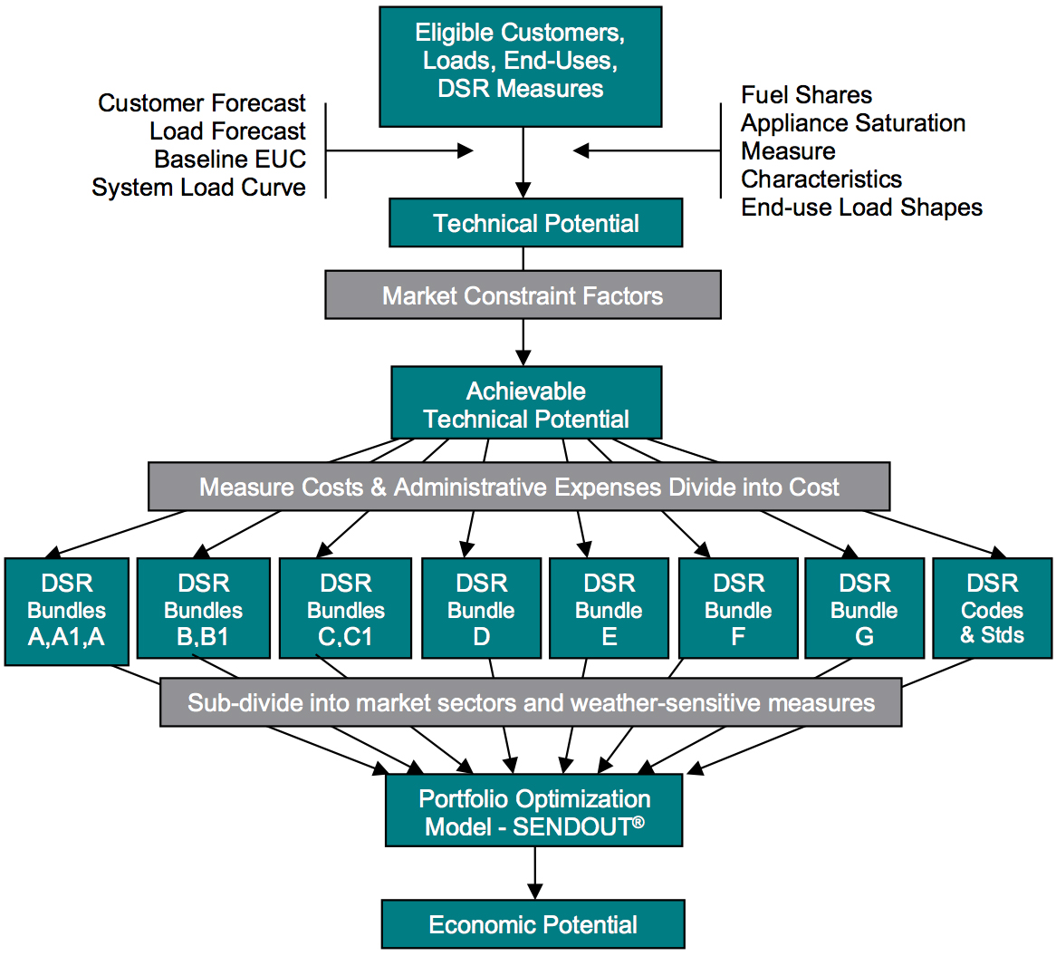

Figure 7-15 shows the range of achievable technical potential among the eleven cost bundles used in the GPM. It selects an optimal combination of each bundle in every customer class to determine the overall optimal level of demand-side gas resource for a particular scenario.

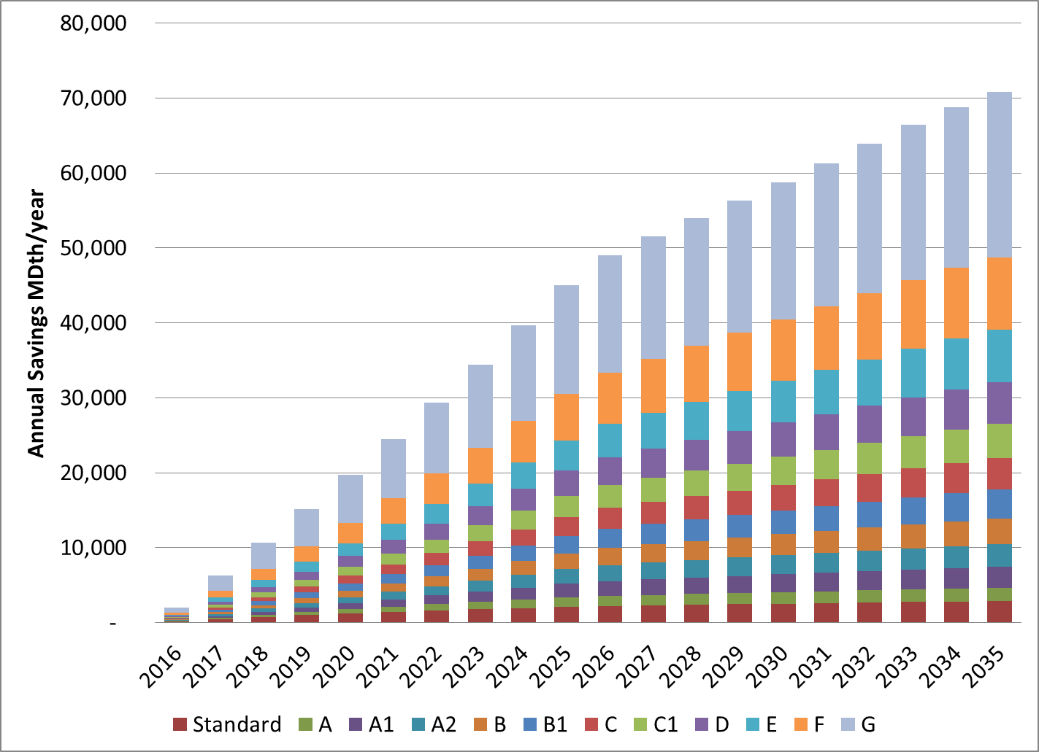Figure 7-15: Demand-side Resources – Achievable Technical Potential Bundles

Figure 7-16 shows a sample input format subdivided by customer class for Bundle A (<$2.20 per Dth) used in the GPM for all the IRP scenarios.

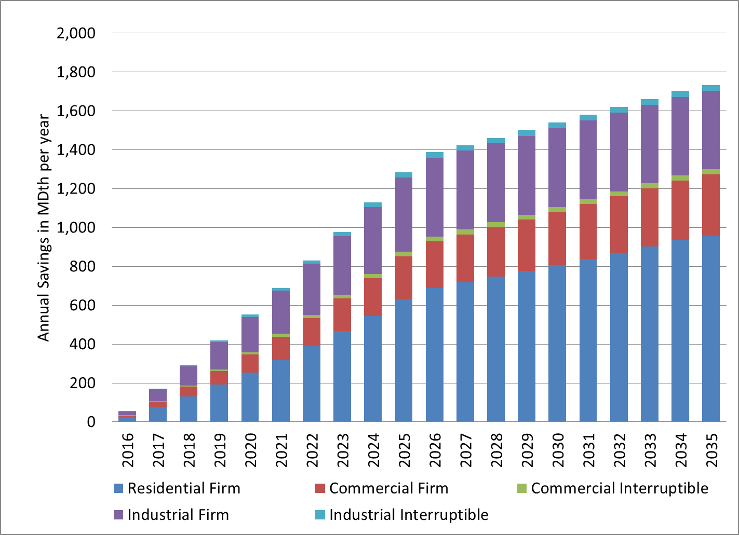Figure 7-16: Savings Formatted for Portfolio Model Input  
by Customer Class – Bundle A (< *$2.20/Dth)*

**GAS SALES ANALYSIS RESULTS**

Key Findings

The key findings from this analytical and statistical evaluation will provide guidance for development of PSE’s long-term resource strategy, and also provide background information for resource development activities over the next two years.

1. **In the Base Scenario, the gas sales portfolio is short resources in the winter of 2016-17.** The High Demand Scenario shows a current resource shortfall in the gas sales portfolio, while the Low Demand Scenario is short in the winter of 2017-18.
2. **Immediate short-term need will be met with combination of three resources in all scenarios:** demand-side resources, a 2016-2018 short-term contract for excess pipeline capacity from Sumas to PSE and the Swarr upgrade project.
3. **Cost-effective DSR is lower in the 2015 IRP** due to past program achievements, updated end-use energy consumption model assumptions, and new standards and codes that resulted in some DSR being shifted out of utility-program DSR bundles and into the standards and codes bundle**.**
4. **The PSE LNG Project is cost-effective in all scenarios.** As currently envisioned, this project would have a total peaking capacity of 69 MDth per day available for service for the 2018-19 heating season. After additional distribution upgrades, it would reach its full peaking capacity of 85,000 Dth per day starting the winter of 2021-22. The timing of the capacity increase can be adjusted to meet customer needs.
5. **The Swarr upgrade project is cost-effective in all scenarios** and is expected to provide 30 MDth per day of peaking capacity effective November of 2016-17.
6. **The Mist storage expansion is selected in most scenarios starting in 2026-27.** While this resource is selected in most scenarios, its feasibility is dependent on expansion of NWP from Sumas to Portland.
7. **Increased Westcoast capacity to Station 2 is the favored pipeline alternative in most scenarios.** The pipeline alternative to purchase gas at Malin and deliver it to PSE’s city gate via the TC-GTN pipeline across the proposed Cross Cascades pipeline is chosen in most scenarios by winter 2030-31. While this is true, the GPM indicates acquisition of additional pipeline capacity on Westcoast to access gas from Station 2 is more cost effective as early as 2018-19 in some scenarios and by 2022-23 in most scenarios.

Gas Sales Portfolio Resource Additions Forecast

Differences in resource additions were driven primarily by three key variables modeled in the scenarios: load growth, gas prices and CO2 price assumptions. Demand-side resources are influenced directly by gas and CO2 price assumptions because they avoid commodity and emissions costs by their nature; however, the absolute level of efficiency programs is also affected by load growth assumptions. Also, the timing of pipeline additions was limited to four-year increments, because of the size that these projects require to achieve economies of scale.

The optimal portfolio resource additions in each of the ten scenarios[6] are illustrated in Figure 7-17 for winter periods 2018-19, 2022-23 and 2030-31. Combination #2, FortisBC/Westcoast (KORP), was chosen in only one of the scenarios – in 2030-31 in the Base + High Gas scenario.

Figure 7-17: Gas Resource Additions in 2018-19,   
2022-23, 2026-27 and 2030-31 (Peak Capacity – MDth/day)

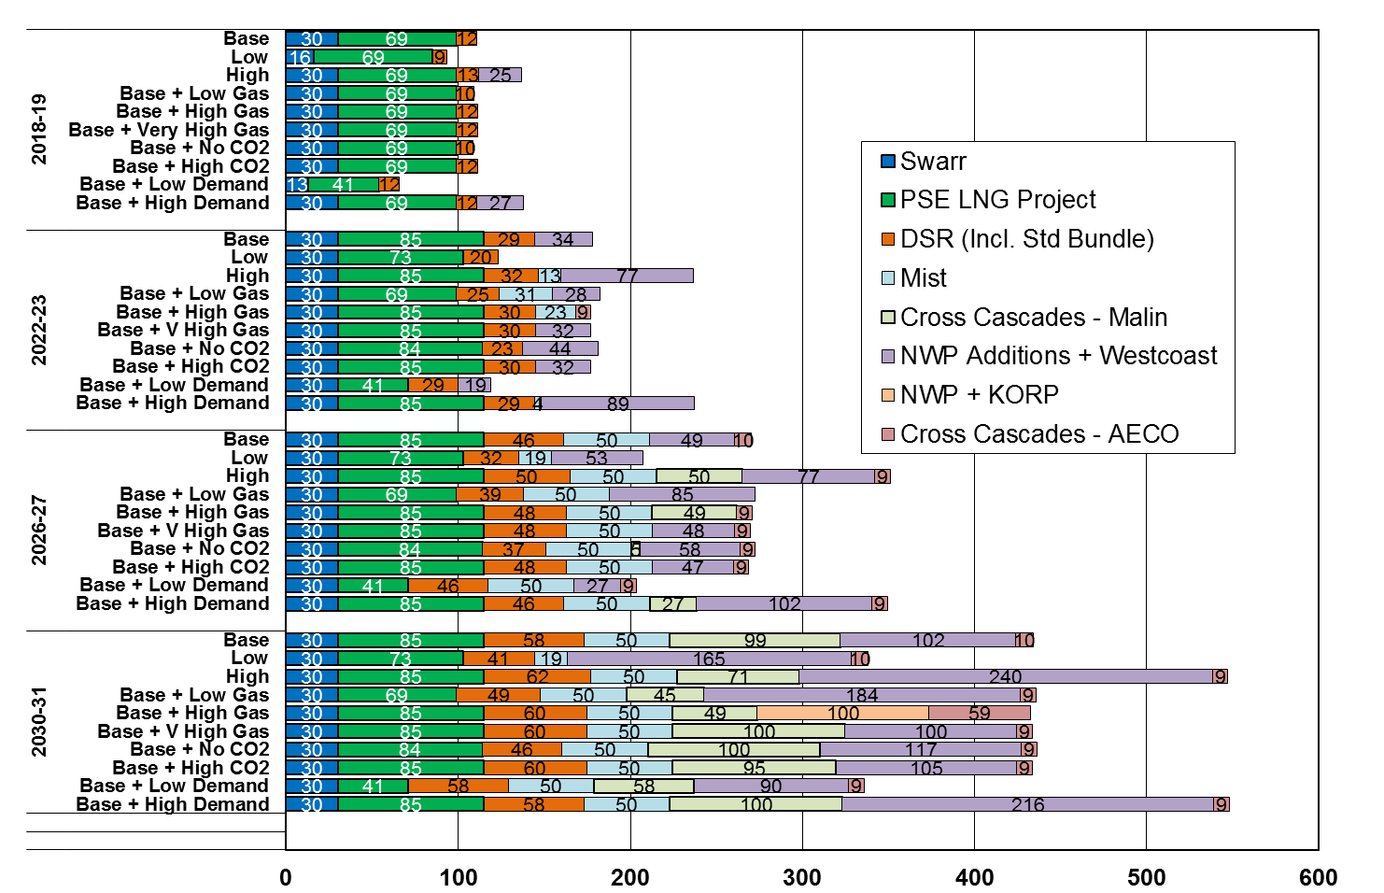

**Demand-side Resource Additions.** Two categories of demand-side resources are input in to the GPM: codes and standards and program measures. Codes and standards is a no-cost bundle that becomes a must-take resource; it essentially functions as a decrement to gas demand. Program measures are input as separate cost bundles along the demand-side resource supply curve. The bundles are tested from lowest to highest cost along the supply curve until the system cost is minimized. The incremental bundle that raises the portfolio cost is considered the inflexion point, and the prior cost bundle is determined to be the cost-effective level of demand-side resources.

Carbon costs do impact the amount of cost-effective DSR. For example, the above Figure 7-18 illustrates that in the Base Scenario, which includes a CO2 price, cost-effective DSR is 12 MDth per day by 2018/19, whereas in the Base Scenario without CO2 price, the DSR level falls to 10 MDth per day. In terms of gas supply planning, 2 MDth per day is not a significant volume; however, it does highlight that including a CO2 price in the 2015 IRP Base Scenario increases conservation by approximately 20 percent in 2018-19.

Figure 7-18: Cost-effective Gas Energy Efficiency Savings by Scenario



DSR remains relatively sensitive to avoided costs in the gas analysis. The amount of achievable energy efficiency resources selected by the portfolio analysis in this plan ranged from roughly 3,800 MDth in 2035 for the Low Scenario to nearly 50 percent higher at 5,700 MDth in 2035 in the High Scenario.

Peak savings by scenario are shown in Figure 7-19.

*Figure 7-19: Cost-Effective Gas Efficiency, Peak Day Savings by Scenario*

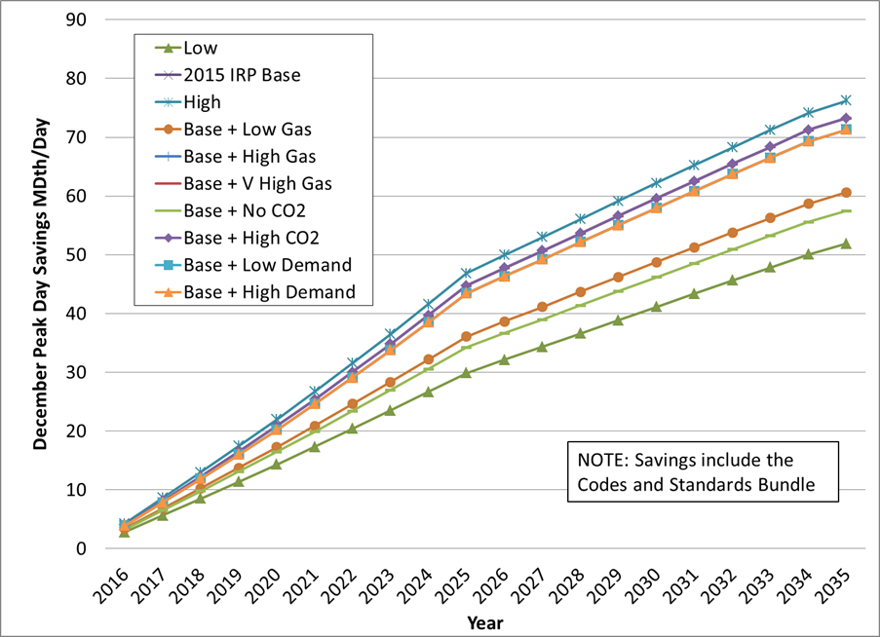

The optimal levels of demand-side resources selected by customer class in the portfolio analysis are shown in Figures 7-20 and 7-21, below. More detail on this analysis is presented in Appendix J, Demand-side Resources Analysis.

Figure 7-20: Gas Sales Cost-effective DSR Bundles by Class and Scenario

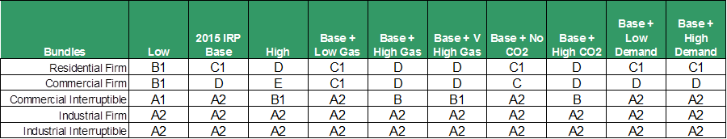

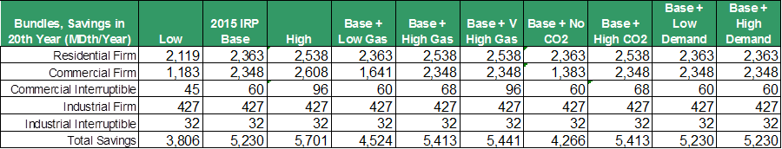Figure 7-21: Gas Sales Cost-effective Annual Savings by Class and Scenario

Overall, the economic potential of DSR in this IRP is lower than in the 2013 gas sales Base Scenario, even though higher-cost bundles are being selected by the analysis as the most cost-effective level of DSR (see Figure 7-22 below).

The downward shift in the overall savings is due to several factors:

* Past program accomplishments have lowered future achievable potentials.
* New, higher Department of Energy efficiency standards for some gas appliances have moved some potentials from utility program bundles to the standards and codes bundles.
* Building stock data has been updated using the Residential Building Stock Assessment.
* Models to simulate energy use and savings have been updated.

On the other hand, inclusion of CO2 costs in the Base Scenario tended to increase conservation targets, because it made the overall levelized cost of gas in the 2015 IRP Base Scenario higher than the 2013 IRP Base Scenario. For more information on how gas sales DSR differs in the 2015 IRP vs. the 2013 IRP, see Appendix J, Demand-side Resources Analysis.

*Figure 7-22: Cost-effective Gas Energy Efficiency Savings, 2013 IRP vs 2015 IRP*

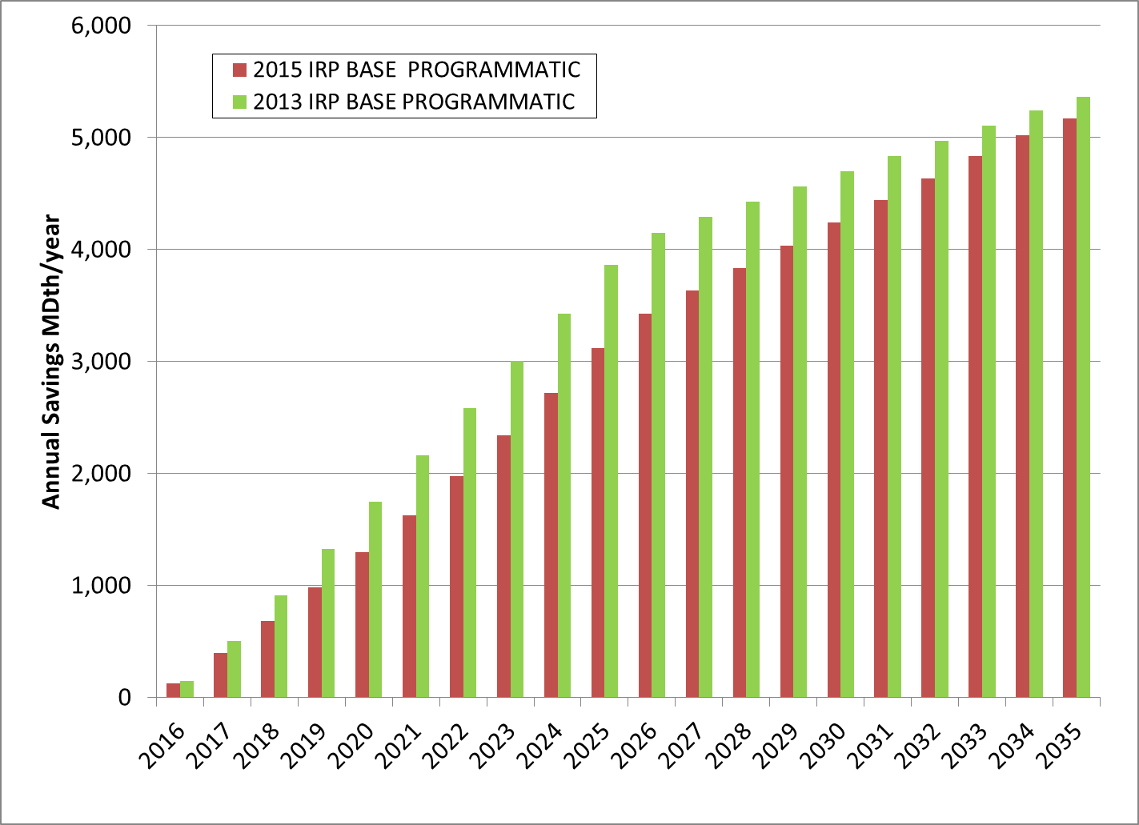

Figure 7-23 below compares PSE’s energy efficiency accomplishments, current targets and the new range of gas efficiency potentials as determined by the analysis. In the short term, the 2015 IRP indicates an economic potential savings of 397 to 618 MDth for the 2016-2017 period.[7] The 694 MDth target for the current 2014-2015 period is higher than this range. These two-year program accomplishments and projections show a downward trend, for the reasons discussed above.

Figure 7-23: Short-term Comparison of Gas Energy Efficiency in MDth

|  |  |
| --- | --- |
| **Short-term Comparison of Gas Energy Efficiency** | **Dth over 2-year program** |
|  | |
| 2012-2013 Actual Achievement | 1,174 |
| 2014-2015 Target (Updated Jan 2015) | 694 |
| 2016-2017 Range of Economic Potential | 397 – 618 |

Figure 7-24 below shows the impact on CO2 emissions from energy efficiency measures selected in the Base Scenario.

Figure 7-24: CO2 Emissions Reduction from Energy Efficiency in Base Scenario

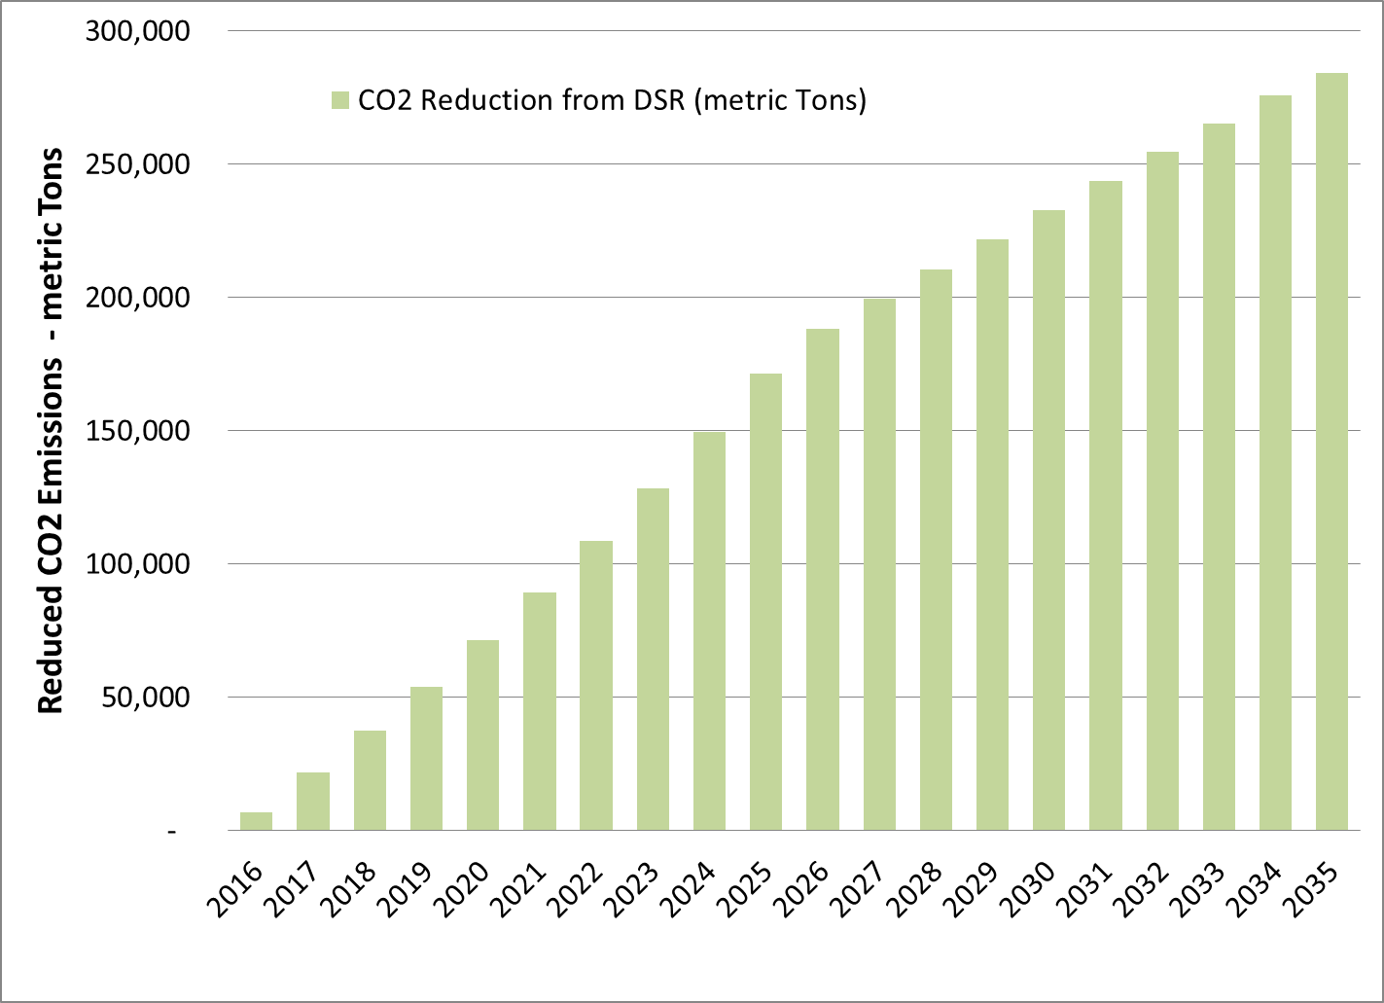

**Pipeline Additions.** Pipeline expansion alternatives were made available as early as the 2018-19 winter-season, the same time that the other non-pipeline alternatives were made available. Though this timeline is too short for any realistic pipeline expansion, it allowed PSE to ensure that the other resources were selected on their own merits as a least-cost resource. A short-term, firm pipeline contract was also included as an alternative. That contract would transport gas from Sumas to PSE as a bridge contract from October 2016 through September 2018.

The Sumas to PSE 2016-2018 short-term contract was selected in most scenarios. Based on lower costs, most scenarios chose some of the NWP expansion and Westcoast pipeline to purchase gas from Station 2 as cost effective in 2022-23, increasing these capacities in subsequent years. The expansion of the Northwest and Westcoast pipelines from Station 2 increases access to northern B.C. gas supplies. Other pipeline additions were not cost effective till 2026-27 in most scenarios, but the Cross Cascades - Malin which sources gas from Malin through Stanfield across the proposed Cross Cascades pipeline was included in most scenarios by 2030-31. The NWP + KORP pipeline alternative was more expensive and chosen only in the Base + High Gas Scenario. Additional upstream pipeline capacity from AECO on the TC-AB, the TC-BC, and GTN pipelines was selected in minor amounts to deliver supplies to the proposed Cross Cascades pipeline.

**Storage Additions.**Based on lower costs, the PSE LNG Project and the Mist storage expansion were selected in all scenarios.

**PSE LNG Project.** PSE is in the early stages of developing a small-scale natural gas liquefaction and LNG storage facility within its service territory to serve the peaking needs of PSE’s core gas customers and the growing demand for LNG as a marine and vehicle transportation fuel. The PSE LNG Project was found to be cost effective in every scenario, as shown in Figure 7-17, above. Figure 7-25 focuses on just the PSE LNG Project additions by scenario. It shows that in most scenarios and sensitivities, all 85 MDth per day of LNG[8] is part of the least cost plan forecast. However, it also illustrates that in four of the scenarios, less than the full 85 MDth per day would be optimal given the modeling constraints of the GPM. The optimization routine in the SENDOUT GPM doesn’t optimize on all or nothing choices; it simply cannot decide whether it is best to either acquire a fixed capacity resource or not – rather, the model is designed to help answer optimal sizing questions.

In these types of all-or-nothing resource decisions, the GPM is a good first screen, but additional analysis is needed when considering resources with fixed capacity. PSE can, however, use the SENDOUT GPM to help analyze the all-or-nothing question by comparing two cases: one where the fixed capacity resource is not an alternative and another where 100 percent of the fixed capacity resource is included. This is the analysis PSE performed for the PSE LNG Project; Figure 7-26 compares the net present value of the portfolio in which the PSE LNG Project is not a choice with a portfolio which includes all 85 MDth per day. Figure 7-26 shows there are portfolio benefits (aka: cost savings) of including the PSE LNG Project as a resource in every scenario. This IRP confirms the PSE LNG Project to be a least-cost resource to serve customer demand.

*Figure 7-25: PSE LNG Project Resource Additions by Scenario*

*(MDth per day)*

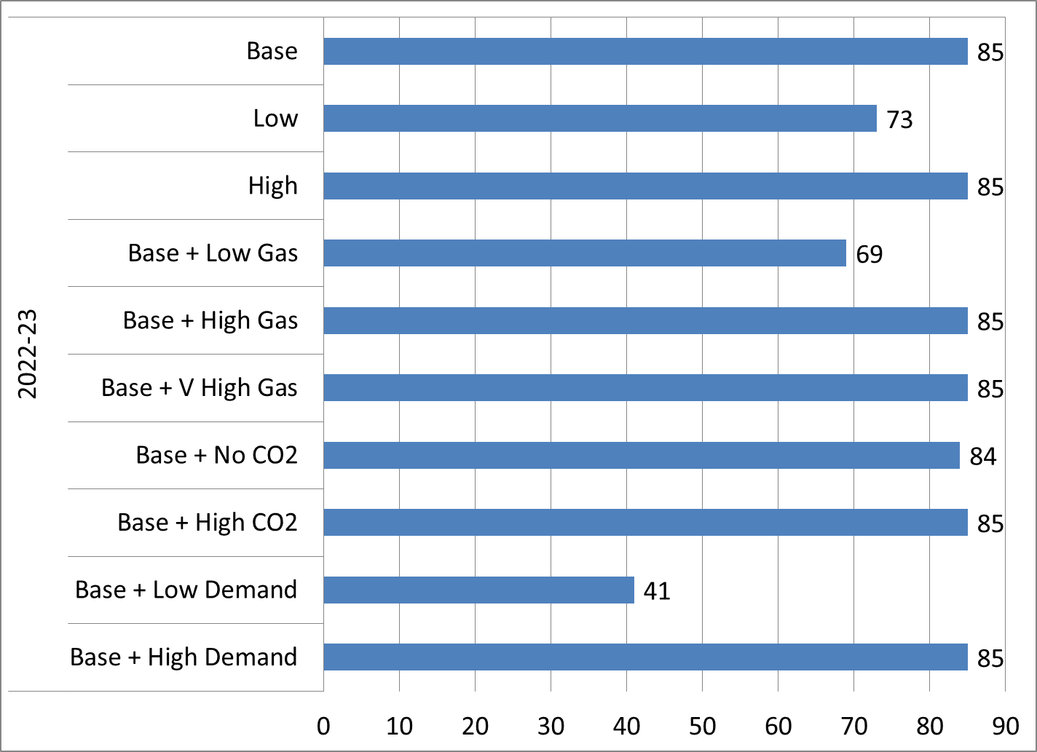

Figure 7-26: Scenario Portfolio Benefit of the PSE LNG Project

|  |  |  |  |
| --- | --- | --- | --- |
|  | **Gas Portfolio Costs Net Present Value ($000s)** | | |
| **SCENARIO** | **FULL LNG** | **NO LNG** | **(Benefit) / Cost of LNG** |
| **BASE** | $ 9,366,925 | $ 9,464,726 | $ (97,801) |
| **LOW** | $ 6,257,998 | $ 6,294,659 | $ (36,661) |
| **HIGH** | $ 12,963,307 | $ 13,052,452 | $ (89,146) |
| **BASE + LOW GAS** | $ 8,212,622 | $ 8,263,903 | $ (51,281) |
| **BASE + HIGH GAS** | $ 10,719,839 | $ 10,823,632 | $ (103,794) |
| **BASE+VERY HIGH GAS** | $ 11,906,047 | $ 11,994,805 | $ (88,758) |
| **BASE+NO CO2** | $ 7,775,728 | $ 7,846,172 | $ (70,444) |
| **BASE+HIGH CO2** | $ 10,465,655 | $ 10,565,404 | $ (99,748) |
| **BASE+LOW DEMAND** | $ 9,031,721 | $ 9,040,101 | $ (8,379) |
| **BASE+HIGH DEMAND** | $ 10,450,532 | $ 10,550,911 | $ (100,379) |

**Mist Storage Expansion.** The Mist storage expansion is selected in most scenarios starting in 2026-27. This result means that PSE will continue to consider pursuing storage capacity at Mist, keeping in mind that Mist expansion is dependent on expansion of NWP from Sumas to the Portland area.

**Supply Additions.**The Swarr LP-Air upgrade project was selected as least-cost in every scenario.

Complete Picture: Gas Sales Base Scenario

A complete picture of the Gas Sales Base Scenario optimal resource portfolio is presented in graphical and table format in Figures 7-27 and 7-28, respectively. Note that Combination #2, FortisBC/Westcoast (KORP), was not chosen in any of the years. Again, additional scenario results are included in Appendix O, Gas Analysis.

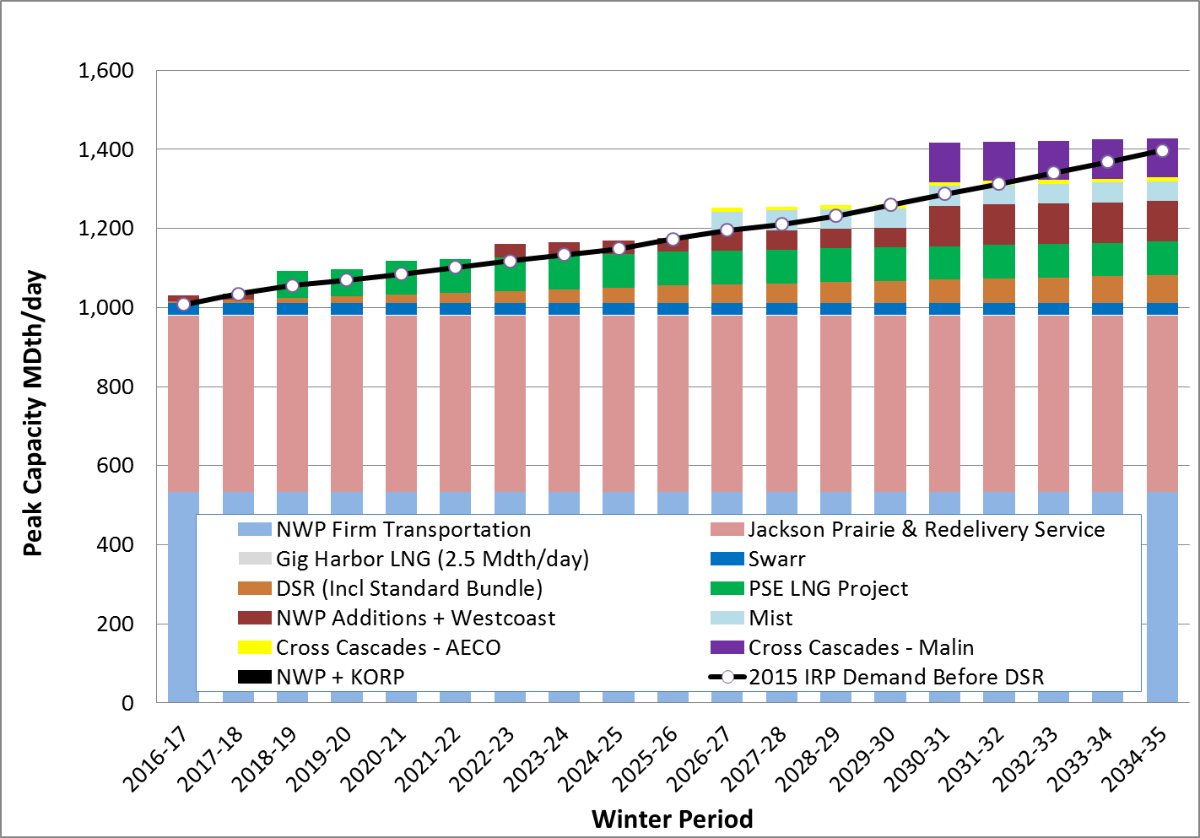*Figure 7-27: Gas Sales Base Scenario Resource Portfolio*

*Figure 7-28: Gas Sales Base Scenario Resource Portfolio (table)*



Average Annual Portfolio Cost Comparisons

Figure 7-29 should be read with the awareness that its value is comparative rather than absolute. It is not a projection of average purchased gas adjustment (PGA) rates; instead, costs are based on a theoretical construct of highly incrementalized resource availability. Also, average portfolio costs include items that are not included in the PGA. These include forecast rate-base costs related to Jackson Prairie storage, the PSE LNG Project and Swarr, as well as costs for energy efficiency programs, which are included on an average levelized basis rather than a projected cash flow basis. Also, note that the perfect foresight of a linear programming model creates theoretical results that cannot be achieved in the real world.

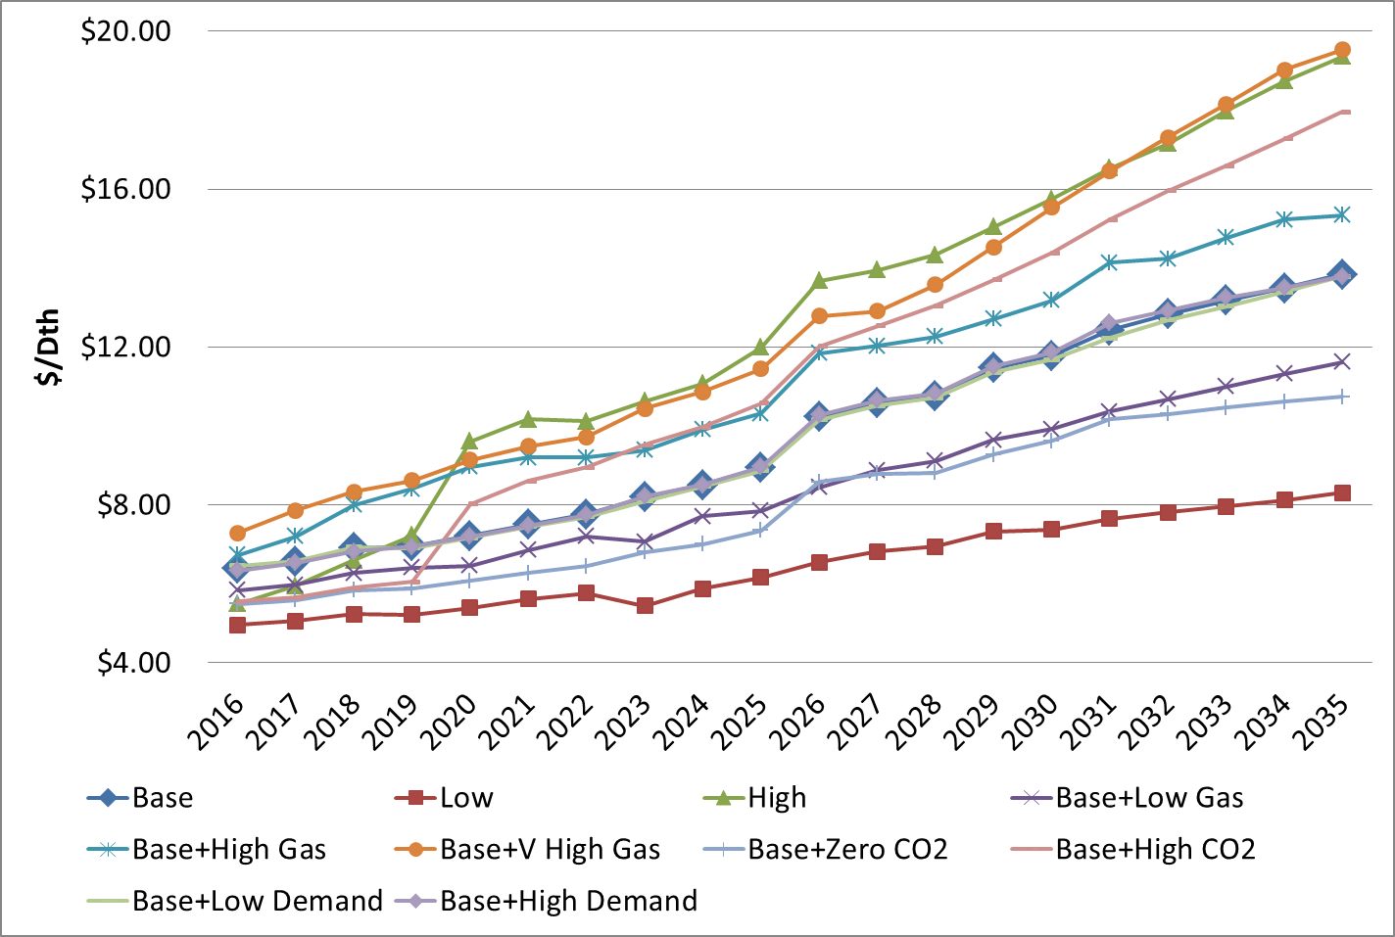Figure 7-29: Average Portfolio Cost of Gas for Gas Sales Scenarios

Figure 7-29 shows that average optimized portfolio costs are heavily impacted by the gas prices and CO2 cost assumptions included in each scenario.

* Changes in customer demand cause only minimal changes in average portfolio costs as shown by the similarity of average portfolio costs in the Base, Base + Low Demand and Base + High Demand Scenarios.
* The Scenarios’ costs range from $4.96 to $7.29 per Dth in 2016 to $8.30 to $19.53 per Dth in 2035.
* The Base Scenario portfolio costs are about $6.39 per Dth in 2016, increasing to about $13.83 per Dth by 2035.
* The highest average system cost was in the Base + Very High Gas Price Scenario, which ranged from $7.29 per Dth in 2016 to $19.53 per Dth in 2035. The High Scenario included high CO2 costs; this helped it track closely to the Base + Very High Gas Price Scenario which included mid CO2 costs.
* The lowest average portfolio cost was in the Low Scenario which ranged from $4.96 per Dth in 2016 to $8.30 per Dth in 2035. This is because this scenario had the lowest gas price assumptions, no CO2 costs and low customer demand.

Sensitivity Analyses

Two sensitivities were modeled in the gas sales analysis for this IRP. Sensitivities start with all of the assumptions in the Base Scenario and change one variable. This allows PSE to evaluate the impact of a single resource change on the portfolio. Two sensitivities were tested in the gas analysis for this IRP:

**1. ALTERNATE DISCOUNT RATE FOR DSR**

**Baseline:** Demand-side resources are evaluated using the weighted average cost of capital (WACC) assigned to PSE.

**Sensitivity:** Demand-side resources are evaluated using an alternate discount rate.

**2. Pipeline expansion timing**

**Baseline:** Pipeline expansions are built in 2022, 2026 and 2030 because they are allowed only every four years in the model.

**Sensitivity:** Pipeline expansion is allowed every year starting in 2022.

**Alternate Discount Rate Sensitivity.** An alternate discount rate was applied in this sensitivity analysis (one that was lower than PSE’s assigned WACC) to find out if it would result in a higher level of cost-effective DSR. The alternate discount rate was first discussed in the April 2014 DSR Technical Advisory Meeting, and later finalized as 1) the weighted average of a long-term 30-year nominal treasury rate for residential customer class, and 2) the WACC discount rate for the commercial and industrial customer classes. The weighting was based on the proportionate share of the savings from these customer classes achieved in the most recent program cycle.

***Weighted Average Alternate Discount Rate*** *= Res * LT CMTave + C&I * WACC*

***ResT*** *= Share of Residential Savings from 2014-15 program cycle (58 percent)*

***LT CMTave*** *= 3 month average of Long Term Constant Maturity Treasury Rate[9](2.87 percent fall 2014)*

***C&IT*** *= Share of Commercial & Industrial Savings from 2014-15 program cycle (42 percent)*

***WACC*** *= Weighted Average Cost of Capital for PSE (7.77 percent)*

The alternate discount rate used was 4.93 percent (0.58 * 0.0287 + 0.42 * 0.0777). This alternate discount rate was used to estimate the DSR achievable potential for the new DSR bundles (see Figure 7-13). These “alternate discount rate” bundles were then input into the gas portfolio model to obtain the cost-effective level of DSR. It should be noted that this lower discount rate was applied uniformly to both demand and supply-side resources.

The bundles chosen with the alternate discount rate were at the same point on the supply curve for the residential class and one bundle lower for the commercial class of customers. The net effect was that

1. savings from residential customers increased nearly 50 percent,
2. the change in the commercial class was unnoticeable, as the lower bundle had almost the same amount of savings, and
3. the industrial class results were the same in both cases

See Figure 7-30 below for the residential customer DSR savings comparison.

There are slightly more measures – in particular in the residential bundles – since the lower discount rate shifted some of the measures on the margin to the lower cost bundles. Thus the overall cost-effective level of DSR increased on average by about 20 percent by the end of the twentieth year (see Figure 7-31). While the choice of the appropriate discount rate by customer class is still a topic of discussion, a lower discount rate increases the amount of cost-effective DSR, as expected. However, in a real program-level evaluation, such an increase in the level of savings will also impact acquisition costs. Higher administrative costs would need to be reflected in the assumptions, and then the bundles would need to be re-optimized.

Figure 7-30: Compare Cost-effective Level of Gas DSR,

Base vs. Alternate Discount Rate by Customer Class – Residential

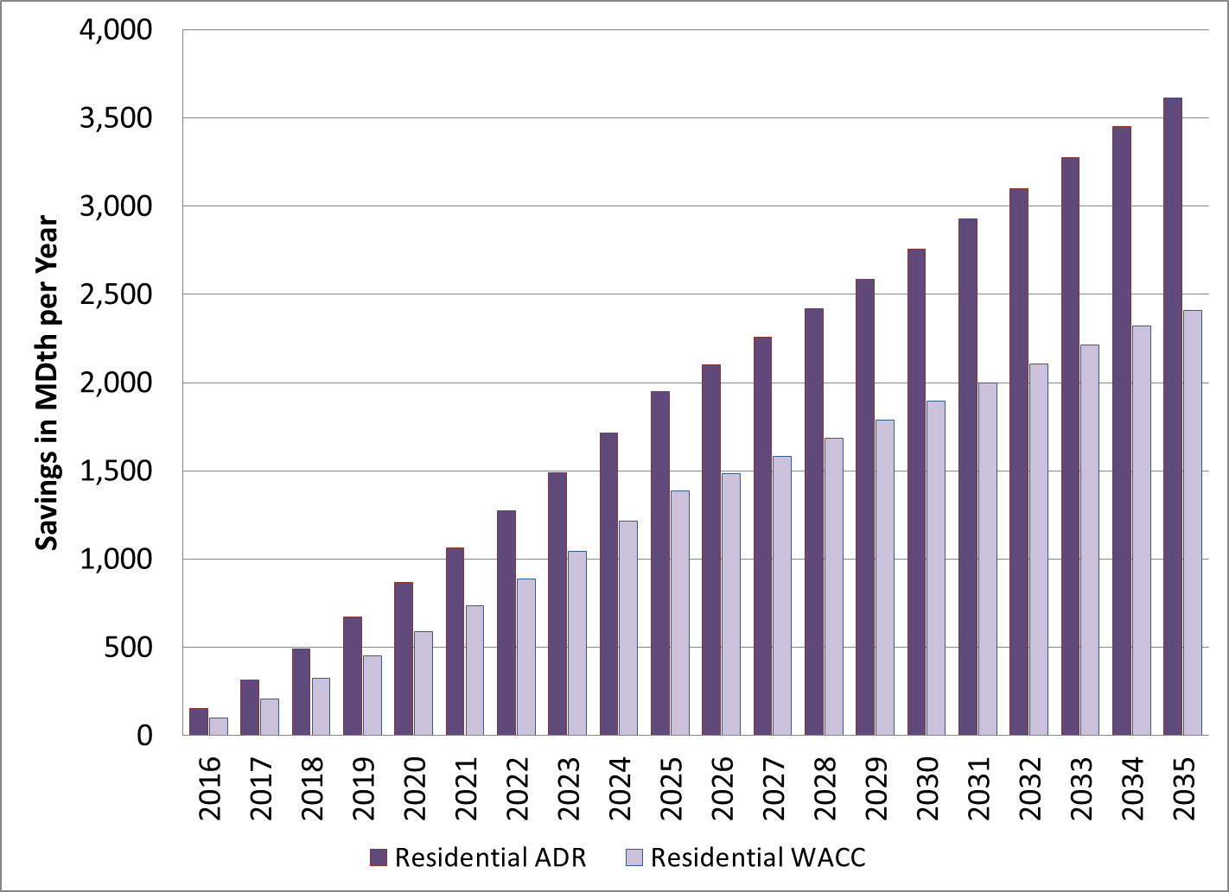

*Figure 7-31: Compare Cost-effective Level of Gas DSR,*

*Base vs. Alternate Discount Rate*

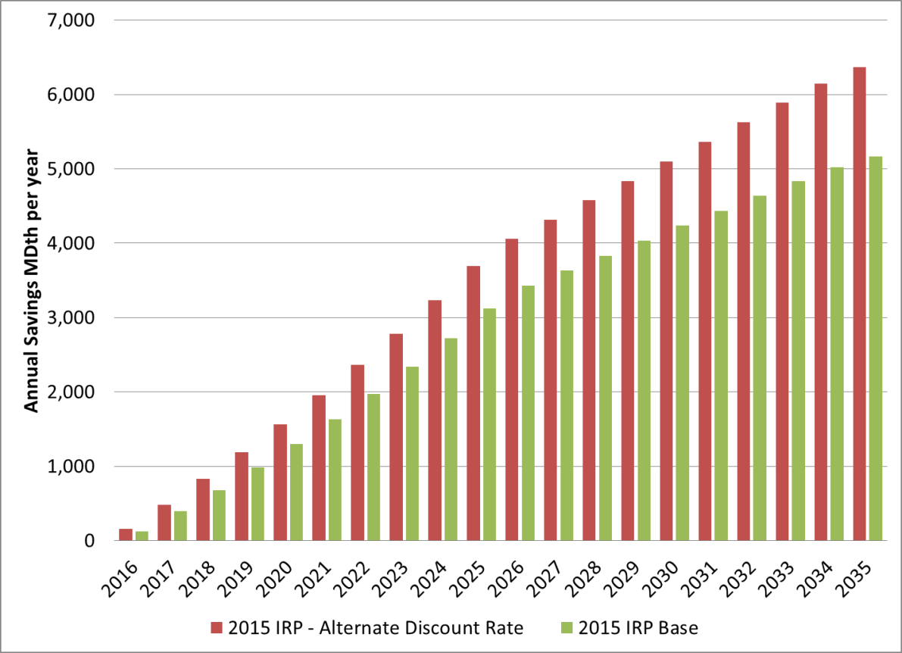

**Pipeline Timing Sensitivity.** In response to the WUTC comments in their letter on the 2013 IRP, PSE ran a “Pipeline Timing” sensitivity to find out how allowing the portfolio model to add pipeline expansions more frequently would impact the resource choices made. The 2015 IRP baseline assumption of expansion every four years is a more realistic simulation of the acquisition process, since pipeline expansions must be constructed in larger capacities to make them financially viable, they require longer lead times to build these larger capacity projects.

The results of most of the scenarios discussed above show that pipeline expansions were not added till 2022. So, in this sensitivity, the model was modified to allow for pipeline expansion in every year, starting in 2022. As shown in Figure 7-32, the result was a smoother load/resource balance starting in 2022 instead of the step or “lumpy” resource additions that were seen in Figure 7-27 above.

*Figure 7-32. Pipeline Timing Sensitivity Gas Resource Portfolio*

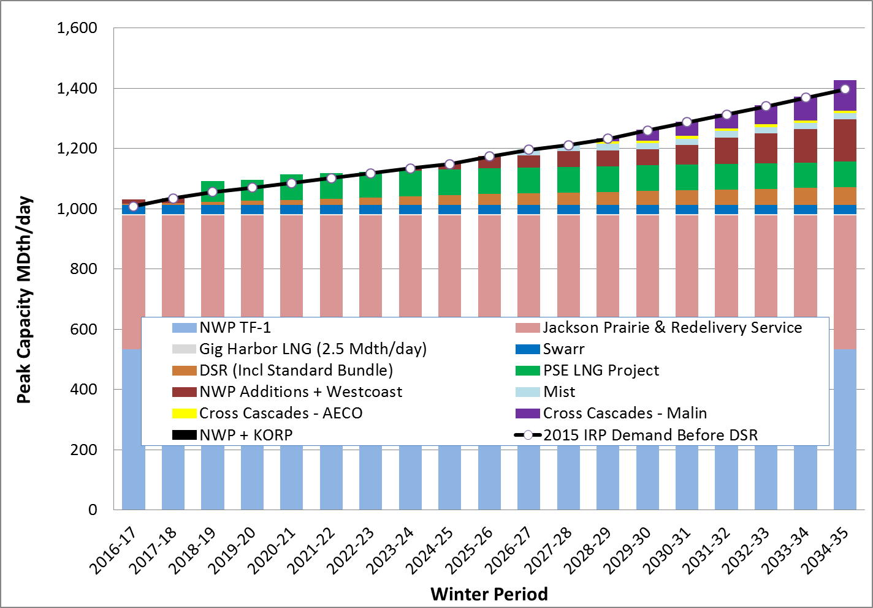

The portfolio builds for the Pipeline Timing sensitivity are shown in comparison with the Base Scenario portfolio in Figure 7-33 below. The chart below shows that the Swarr and PSE LNG Project non-pipeline resource additions are the same in the Base Scenario as in the Pipeline Timing sensitivity. The GPM indicates that gas pipeline capacity is more cost effective than the Mist storage expansion as it chooses less than half of the Mist storage expansion that was selected in the Base Scenario. DSR for the commercial firm customers is also less in the Pipeline Timing sensitivity. All in all, there is no impact to other resource additions prior to 2030, even when pipeline capacity is added every year versus every four years.

*Figure 7-33. Impact on other Resource Builds from Pipeline Timing Sensitivity*

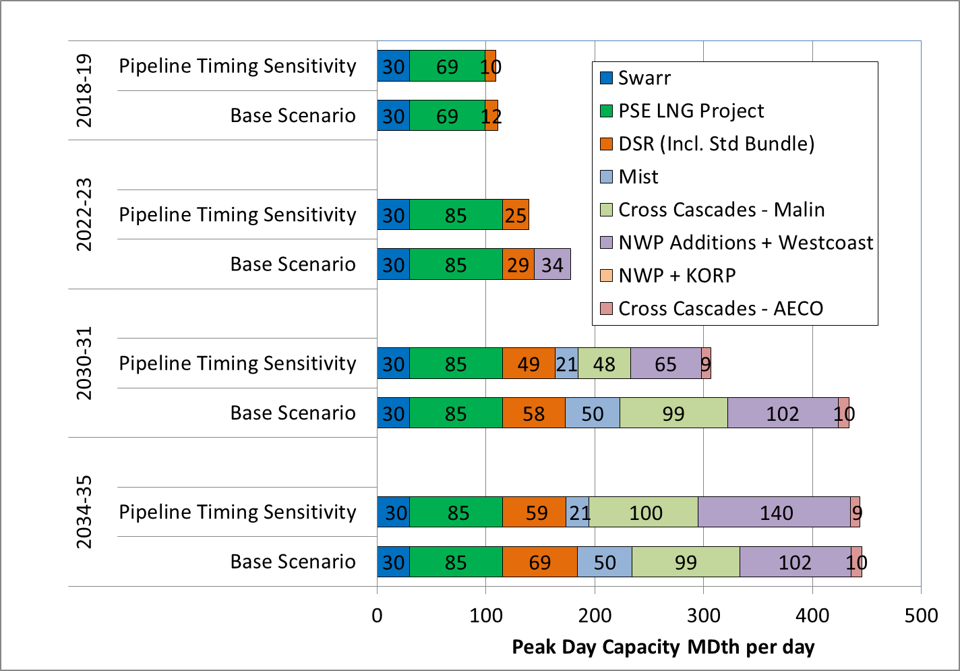

1. / One of the major tasks of the IRP analysis is to identify the most cost-effective amount of conservation to include in the resource plan. To accomplish this, it is necessary to start with demand forecasts that do not already include forward projections of conservation savings. Therefore the IRP Gas Demand Forecasts include only DSR measures implemented **before** the study period begins in 2016. These charts and tables are labeled “before DSR.”
2. / For planning purposes, PSE uses a design peak day demand equivalent to a day with 52 Heating Degree Days (HDDs) or an average temperature of 13° Fahrenheit. HDDs are defined as the number of degrees relative to the base temperature of 65 degrees Fahrenheit. A 52 HDD day is calculated as 65° less the 13° temperature for the day.
3. / The 2015 IRP demand forecasts are discussed in detail in Chapter 5, Demand Forecast.
4. / Demand-side resources are resources that are generated on the customer (demand) side of the meter.
5. / PSE’s 2001 General Rate Case, WUTC Docket Nos. UG-011571 and UE-011570.
6. / Scenarios are explained in detail Chapter 4, Key Analytical Assumptions.
7. */ These savings are based on a no-intra year ramping, which are used to set conservation program targets.*
8. / As noted above, the analyses assume that 69 MDth per day will be available for the 2018-19 heating season and 85 MDth per day will be available for the 2020-21 heating season.
9. / Source: http://www.treasury.gov/resource-center/data-chart-center/interest-rates/Pages/TextView.aspx?data=yieldYear&year=2014