Pacific Northwest Transportation Services, Inc. (C-862)

Dba Capital Aeroporter

P.O. Box 2163

Olympia, Washington 98507

July 1, 2010

Mr. Dave Danner

Executive Director and Secretary

Washington Utilities & Transportation Commission

1300 Evergreen Park Dr. SW

P.O. Box 47250

Olympia, Washington 98504

Re: TC-100471

Mr. Danner:

The company requests Commission withdraw Docket TC-100741.

**John Fricke, COO/Operations Manager**

[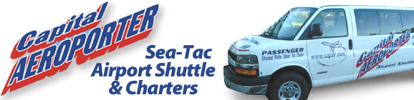](http://www.capair.com/)

**360-754-7113 x105**

**DID  360-292-7685**

**FAX  360-754-7118**

[**johnf@capair.com**](mailto:johnf@capair.com)

[**www.capair.com**](http://www.capair.com)