

|  |  |
| --- | --- |
| **Avista Corp.**  1411 East Mission P.O. Box 3727  Spokane. Washington 99220-0500  Telephone 509-489-0500  Toll Free 800-727-9170 |  |

***VIA – Electronic Mail***

August 31, 2012

David Danner

Executive Director

Washington Utilities & Transportation Commission

1300 S. Evergreen Park Drive S. W.

P.O. Box 47250

Olympia, Washington 98504-7250

RE: Docket No. UE-101475 Avista Utilities Smart Grid Technology Update Report

Dear Mr. Danner:

In compliance with WAC 480-100-505 (Smart Grid Technology Report), Avista Corporation dba Avista Utilities (“Avista or the Company”) submits its progress report on smart grid technologies implemented as provided in the Company’s previously filed report (September 1, 2010) in the above referenced Docket.

1. **A Historical Perspective of Grid Automation at Avista**

It would be easy to assume the modern day grid or “smart grid” is a gigantic leap forward from the present day grid. We’ve probably all heard that Thomas Edison, if he were to return from the dead, could still operate the grid today. While that might be true in the simplest of comparisons, the comparisons do not acknowledge how the grid is really operated today. This information is intended to provide a historical perspective of the transition to the “smart grid.” Avista began the journey to the smart grid in the mid to late 1970’s. At that time the Company began to develop and deploy two very important technology systems that would end up evolving into the foundation for smart grid automation.

SCADA for the Transmission System -

The first of these efforts focused on providing measurement, status and control for the electric transmission system. The system is referred to as SCADA which stands for **S**upervisory **C**ontrol **A**nd **D**ata **A**cquisition. It consists of computers installed at the central office that communicate via telemetry to a remote terminal unit (RTU) installed at an electric substation. The RTU acts as a collector of measurement and status information for devices located within the electrical substation. System operators rely on one-line electrical diagrams that provide a visual representation of the status and measured values from each substation. Circuit breakers, capacitor banks and air switches can be operated remotely in the control center.

SCADA systems are in use at every major utility in the United States. Avista has installed SCADA in approximately 80% of its electrical substations to-date. Over the past 30 years SCADA has become a standard inclusion for new substation installations and is considered for installation during retrofit projects. SCADA is considered the most important operational system in use at Avista and its availability is protected with extensive business continuity plans. The diagram below provides a timeline for Avista technology deployments supporting the smart grid and will be repeated throughout the document.

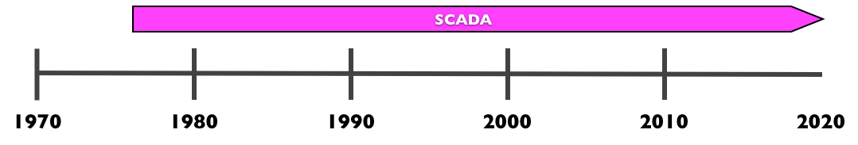

***Technology Implementation Timeline - SCADA***

AMFM for the Distribution System -

The second of the late 1970‘s efforts involved development of a system for **A**utomated **M**apping **F**acility **M**anagement (AMFM) that could provide up-to-date electric distribution system information. The system produced paper maps, focused on primary circuit trunks and laterals, ending at the customer distribution transformers. Technology at that point preceded the personal computer and graphics workstations were rare. Text based consoles, large digitizing boards and ray tracing scopes were used in conjunction with mini-computers equipped with a whopping 4kB of memory. While the system would eventually be replaced, it provided the foundation of knowledge that would allow Avista to make huge strides forward once technology was capable of completing the vision.

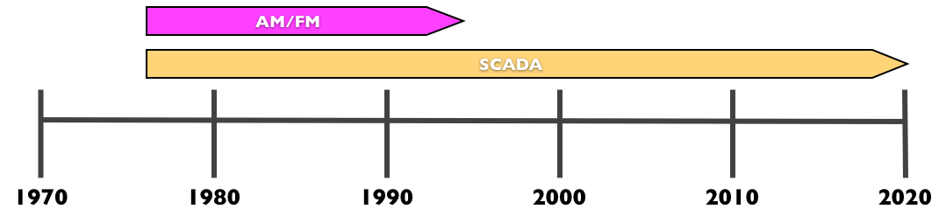

***Technology Implementation Timeline - AM/FM***

**The Transition to GIS -**

In the early 1990’s it became clear the AMFM system needed to be capable of much more than what could be developed by Avista alone. In 1994, Avista implemented the leading commercial **G**eographic **I**nformation **S**ystem (GIS). The system was called Smart Maps and was deployed to manage the Company’s natural gas distribution infrastructure. Meanwhile, the electric AMFM system was scheduled for retirement. The natural gas Smart Maps system would provide the foundational knowledge to later deploy a very advanced electric GIS system.

It was just two years later that a “once in every 100 years” ice storm would challenge Avista in ways not previously experienced. The ice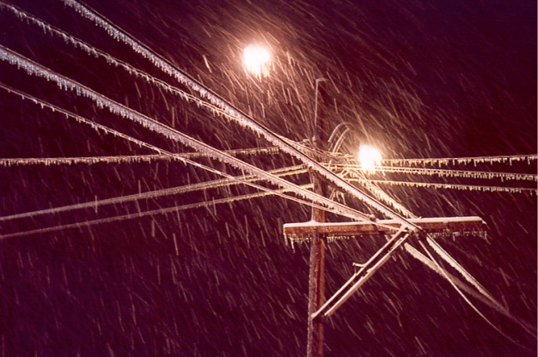 storm struck in the early afternoon of November 19, 1996. At the peak of the storm, approximately 80% of Avista’s customers were experiencing an outage. Over 100,000 customer calls were logged by customer service personnel. Restoration efforts took weeks and required help from neighboring utilities. Outages experienced by individual customers were difficult to identify and required patrolling public streets during evening hours looking for lights within homes. It was clear during the debrief of this gigantic storm that improvements to storm management were warranted. Efforts to improve call and incident management were initiated.

**Help For The Call Center, An IVR Is Installed -**

The call volume experienced during ice storm taxed Avista’s communication system. Circuits were loaded to capacity and human resources were overwhelmed. Clearly there must be a better way to handle customer calls. Avista found a solution in the form of an **I**nteractive **V**oice **R**esponse (IVR) system that would go live in 1997. The system could be scripted to communicate with customers in an automated but intelligent manner pertinent to their interest. Outages could be reported and bill inquiries satisfied with no human intervention. The IVR had a very positive impact on the amount of call volume the call center could handle effectively. Subsequent storm events consistently validated the increase in call volume capacity. Customer satisfaction surveys consistently met expectations.

The Development of AFM -

The outage incident management process during ice storm was totally overwhelmed. Each outage call was printed on a piece of paper and then had to be correlated manually to a circuit on a paper map. It was apparent after just a few hours that the process could not facilitate managing the outage calls as they were received. Identification of an outage location and association of customers experiencing a common outage was needed. A number of inexpensive technology options were explored between 1997 and 1999, but none provided the desired results

In 1999, Avista began the development of an advanced GIS system focused on providing the capability to manage storm restoration efforts. This system called **A**vista **F**acility **M**anagement (AFM) employed a very sophisticated digital model of the electric system, created from an extensive field inventory of the electric distribution system. An application called **O**utage **M**anagement **T**ool (OMT) was developed to manage outage incidents, stage resources understand system status and provide outage statistics. OMT went live in December of 2001 for the Colville Washington office area. By 2005, the system had been rolled out to all office areas and dispatch functions had been centralized in Spokane, Washington.

A testimony to the success of this technology deployment was experienced during a wind storm that took place December 14, 2006. The wind storm impacted the entire northwest region with 65 mph wind gusts. With OMT and the IVR in place, the contrast to ice storm was dramatic. During ice storm, a visit to the dispatch area resembled a visit to a natural disaster area with stress visible on employee faces. Fast forward to 2008, and you see a half dozen people in Central Dispatch handling all the incidents and crew communication. Gone are the stacks of incident printouts, armies of people to assess damage on paper maps and dozens of people staging crews. Only a couple employees in Operations are required to stage crew and physical resources for this windstorm.

Technology allowed restoration efforts to restore 50% of customers in 12 hours and 70% of customers within 24 hours. Nearly one third of Avista’s customers experienced an outage. Overall storm restoration efforts were reduced by 48 hours. The majority of 32,000 customer calls were handled by the IVR during the first two days of the storm.

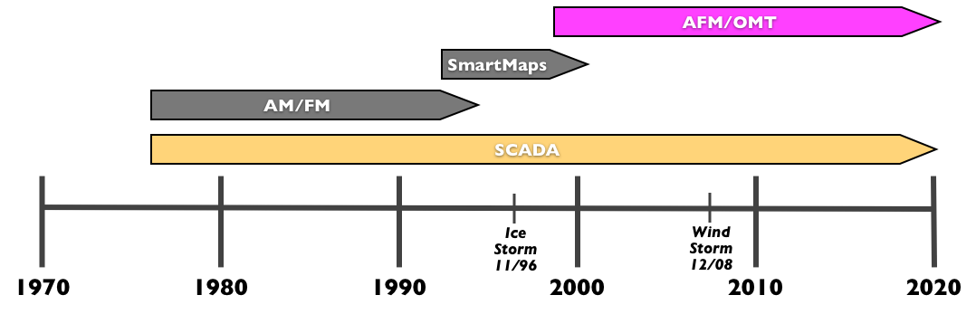

***Technology Implementation Timeline - AFM***

Leveraging Installed Technology for the “Smart Grid” -

The smart grid may be best described as a “system of systems”. The successful deployment of SCADA, IVR, and AFM provided a tremendous foundation from which additional automation could be considered. This information reviews the efforts and programs initiated to take the next logical steps in automating the grid.

Energy efficiency has been a consideration within Avista for years. Many smart grid deployments today consider volt/var management and a concept called conservation voltage reduction (CVR) to be critical for achieving loss and load reduction. Avista first investigated CVR in early 1977. The economics, given the technology of the time, did not warrant deployment. In 2000, distribution engineers conducted a study at the Francis & Cedar substation applying CVR to one feeder and using a second feeder as a reference. The results of this study increased the Company’s interest in CVR. A follow-up study was initiated in 2003 at the same substation. This effort was part of a larger study sponsored by the Bonneville Power Administration (BPA) and the Northwest Energy Efficiency Alliance (NEEA) titled Distribution Efficiency Initiative. The study included 13 utility participants; six of which completed CVR demonstrations and 11 of which completed load research. The results of this study validate the implementation of CVR as providing the largest efficiency/load reduction benefit of all possible distribution remedies by a substantial margin. The NEEA study provides a method for calculation of CVR savings which Avista used to calculate the expected benefits of CVR within the ARRA projects.

In 2006, voter approved Initiative 937 became law. This law placed renewable energy and energy efficiency targets on utilities in the State of Washington. Between 2006 and 2009 a number of projects and programs were initiated and developed to create a vision of the utility of the future. The first of these, the Blueprint Project, was intended to create a vision for the utility 20 years in the future. The Blueprint team was visited by many credentialed speakers and site visits were made to some progressive utility companies and vendors. The future vision was determined taking into account the future of energy supply, customer expectations, T&D efficiency, reliability, operational flexibility, open architectures, climate change, and transportation. Most, if not all of these topics, can be associated with the “smart grid”.

Avista engineers, in late 2007, began leveraging small Research and Development (R&D) efforts to move closer to a smart grid. The mantra for the engineers was “you don’t know what you don’t know.” Questions were repeatedly raised regarding the current efficiency of the system and cause of losses. It was determined that measurements coupled with analytics could provide a base of knowledge from which remedies could be identified. Automation was explored to provide outage notification and validation as well as restoration. The need for a distribution management system (DMS) was determined. The efforts spawned a program called **D**istribution **R**eliability and **E**nergy **E**fficiency or DREE.

An increased effort on asset management began in 2004, with a focus on analysis of equipment life and maintenance costs. Specific equipment classes were prioritized based on need. The efforts of this group provided valuable information for yet another program initiated by the efficiency engineers at Avista in early 2008. It was decided to leverage the DREE and asset management efforts to look at a systemic feeder rebuild program.

The feeder rebuild program focused on three objectives; reducing maintenance expenses, reducing losses, and increasing reliability. The program included the placement of automated capacitor banks, and the replacement of small, high-loss conductor, secondary districts, and high-loss distribution transformers (pre 1981 manufacture date). To test the concept, one feeder in Spokane, Ninth and Central 12F4 (9CE12F4), was equipped with primary measurement devices for pre-rebuild data collection. The feeder was then rebuilt and measures collected to determine effectiveness. Plans were made to facilitate the rebuild of 5 feeders in year one of the program followed by 10 in year two and 15 in years 3 and beyond.

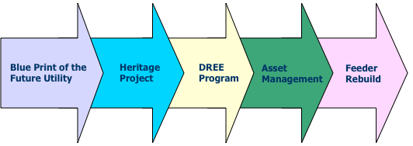

***The road to the Smart Grid since 2006***

The American Reinvestment and Recovery Act of 2009 provided the opportunity to achieve the DREE objectives by quickening the pace of the Feeder Rebuild program. The **S**mart **G**rid **I**nvestment **G**rant (SGIG) project for Spokane includes 58 feeders on the rebuild list to be complete by the end of 2014. In the same timeframe the **S**mart **G**rid **D**emonstration **P**roject (SGDP) in Pullman adds an additional 13 feeders from the list. The two smart grid grant projects, when complete, will result in 71 feeders of the 326 feeders in the Avista system having been rebuilt.

The Next Logical Step -

Avista has been on a path to the smart gird since the mid 1970’s. Each technology solution has positioned the smart grid one step closer. The ARRA projects will realize a vision that is a maturation and meshing of the previous technology deployments, research, and analysis. The risk of failure is minimal because the goal and the solutions are well understood. The smart grid is not some mythical jump over the grand canyon, but is just the “next logical step”.

## **Update on Current Smart Grid Activities**

## **Smart Grid Investment Grant Project -**

At the time of this update, the Smart Grid Investment Grant project is in the final portions of the construction phase of the project. 378 intelligent line devices have been installed throughout Spokane, Washington and 29 miles of primary conductor has been upgraded. 13 of the 15 substations are completely upgraded. Upon completion of the construction, the project will enter a two-year reporting phase where data and performance information from the project will be sent to the Department of Energy (DOE) for benefit analysis.

## **Smart Grid Demonstration Project -**

A current update for the Demonstration Project in Pullman shows that 1.5 miles of reconductor is complete, 225 intelligent line devices are installed and all 3 substations are complete with new or upgrades facilities. There have been approximately 13,000 Electric and 5,000 Gas Smart Utility Meters installed at residents in Pullman. A new web portal has been activated for residents that have the new smart meter to view their energy data.

Avista continues to participate in regional and national forums to discuss, learn, and share current technology trends and best practices. Avista also continues to evaluate equipment and systems that integrate into the distribution system.

## **Beyond the Grants -**

Avista is currently reviewing and analyzing the new technology implemented as part of the grants and determining which technology to incorporate into construction standards. Analysis is also being conducted to determine how to deploy the appropriate technology beyond new construction through feeder upgrade efforts. The intent of this work is to prudently apply the learning from these projects to further reduce system losses and impact of outages on customers.

# **Smart Grid Technologies Investigated Since Previous Report -**

There have been no new Smart Grid specific technologies that are being investigated. Avista continues to modernize its transmission and distribution grid while evaluating equipment and systems that provide increased efficiency and improved reliability.

If you have any questions regarding this update report, please feel free to contact Heather Rosentrater at (509) 495-4430 or myself at (509)-495-4975.

Sincerely,

/S/Linda Gervais

Linda Gervais

Manager, Regulatory Policy

Avista Corporation

509-495-4975

[linda.gervais@avistacorp.com](mailto:linda.gervais@avistacorp.com)