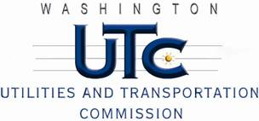

Memorandum
February 3, 2011

To: TR-100690 - File

From: Kathy Hunter, Deputy Assistant Director Transportation Safety

Subject: TR-100690 Cascade and Columbia River Railroad
Grade Crossing Protective Fund (GCPF) Project at the Intersection of
4th Street Northwest and Cascade and Columbia River Railroad’s Tracks in the City of Brewster, Washington

On May 25, 2010, the Washington Utilities and Transportation Commission (Commission) awarded a GCPF grant totaling $7,895 to replace the system batteries and cross-bucks at the 4th Street Northwest crossing in the City of Brewster. The USDOT number assigned to this crossing is 096259P.

On February 3, 2011, the applicant, Cascade and Columbia River Railroad submitted a request for reimbursement pursuant to Commission order. On January 26, 2011, Commission staff conducted a site visit and verified that the project is completed according to the specifications outlined in the order approving the grant.

Please close this docket.

