**Work Plan**

**for the**

**2015 Integrated Resource Plan**

For The

**Washington Utilities and**

**Transportation Commission**

March 31, 2014

**INTRODUCTION**

In compliance with the Washington Utilities and Transportation Commission’s Integrated Resource Planning (IRP) rules (WAC 480-100-238), PacifiCorp submits this work plan for its 2015 integrated resource plan (“2015 IRP”). As required in the rule, PacifiCorp outlines the content of its 2015 IRP, the general method for assessing potential resources, and the anticipated timing and extent of public participation.

This work plan is based on the best information available to PacifiCorp at this time, and may change for the following reasons:

* PacifiCorp received orders from Utah, Washington, Idaho, and Wyoming acknowledging the 2013 IRP. The Public Utility Commission of Oregon has not yet issued an acknowledgement order.
* The 2015 IRP will be developed concurrent with preparation of PacifiCorp’s annual business plan for the 2015-2024 ten-year period (“2015 Business Plan”). Adjustments to the 2015 IRP work plan schedule may be necessary to align key assumptions with those in the 2015 Business Plan.
* During the public process, PacifiCorp will consider stakeholder input and may implement methodology changes, as appropriate, to support the 2015 IRP.
* Market or regulatory developments may prompt the need for additional system modeling or impact assessment.

**CONTENTS OF the 2015 INTEGRATED RESOURCE PLAN**

The contents of the 2015 IRP are expected to be similar to that for the 2013 IRP, which included three volumes: the main document, the appendices, and a third volume containing confidential information as appropriate. The main document, or Volume I, is expected to contain the following chapters:

* “Executive Summary”
* “Introduction”: This chapter summarizes any notable planning process improvements and modeling advancements implemented in the planning cycle, summarizes significant events and accomplishments including an overview of the public process, and lists the report contents.
* “The Planning Environment”: This chapter profiles major external influences that impact the PacifiCorp’s long-term planning (market conditions and developments, legislative and regulatory events, etc.) and summarizes activities supporting resource procurement.
* “Transmission”: This chapter describes the Company’s long-term transmission planning initiatives, focusing on activities associated with the Energy Gateway Transmission projects and other regional planning efforts.
* “Resource Needs Assessment”: This chapter presents PacifiCorp’s findings of resource need. The basis of the chapter is load and resource balances that characterize PacifiCorp’s capacity and energy positions on a system and control area basis for the next 10 years.
* “Resource Options”: This chapter provides background information on the resources considered in the 2015 IRP, detailing cost and performance attributes and current market outlook. Resources covered include utility-scale generation technologies, demand-side management (“DSM”), distributed generation, energy storage technologies, and firm market purchases by market hub.
* “Modeling and Portfolio Evaluation Approach”: This chapter describes the modeling methods and portfolio evaluation techniques used to determine the relative portfolio cost/risk performance attributes and the overall portfolio selection process.
* “Modeling and Portfolio Selection Results”: This chapter summarizes the portfolio development and production cost modeling results, and presents PacifiCorp’s preferred resource portfolio.
* “Action Plan”: This chapter presents PacifiCorp’s action plan and an acquisition path analysis that describes how resource acquisition strategies will be modified in response to changing conditions as informed by the modeling process. Other resource risk management issues are also discussed.

Volume II is expected to contain technical data and supplemental analysis covering: (1) model results; (2) how the 2015 IRP complies with multiple state IRP requirements; (3) load forecasts developed for each state; (4) the public input process; (5) capacity planning reserve margin analysis; (6) wind integration analysis updates; (7) a flexible resources for needs assessment; (8) plant water consumption data; (9) resource adequacy analysis, and (10) other supplemental analysis and data used to support the 2015 IRP planning cycle.

Volume III is expected to contain confidential financial analysis supporting 2015 IRP action items related to coal unit environmental investment decisions.

**GENERAL METHOD FOR ASSESSING POTENTIAL RESOURCES**

The main elements of the 2015 IRP work plan include the following:

1. Revisit strategic assumptions (resource adequacy, market depth, carbon dioxide regulatory scenarios and cost adders, etc.) and update model data appropriately.
2. Implement modeling and methodology enhancements to improve the IRP process and address new analytic requirements from the state commissions or in response to public stakeholder recommendations. For example, the WUTC requested an update on the Company’s energy storage study.
3. Use PacifiCorp’s modeling systems to develop a diverse set of candidate portfolios that considers known and potential costs for environmental requirements and compliance alternatives, and perform risk analysis using a stochastic production cost model. PacifiCorp will use Present Value of Revenue Requirement (“PVRR”) as the main cost-effectiveness measure for comparing portfolios.
4. Apply an initial portfolio screening process that focuses on two key metrics—mean stochastic PVRR and upper-tail PVRR—followed by a final screening process based on measures such as risk-adjusted PVRR, carbon dioxide emissions, supply reliability, customer rate impact, and others.

Figure 1 summarizes the inputs and major modeling steps under the 2013 IRP. The 2015 IRP will follow a similar approach, with the potential for modifications. This plan is based on the use of two computer systems: *System Optimizer*, a linear programming-based optimization program designed for automated development of portfolios, and the *Planning and Risk* (“PaR”)model, a production cost simulation tool integrated with the PROSYM chronological unit commitment/dispatch simulation engine and Monte Carlo modeling capabilities. Both modeling tools are proprietary software products from Ventyx Energy LLC, a subsidiary of ABB.

**Figure 1 – Modeling Process Flow Diagram, 2013 IRP**

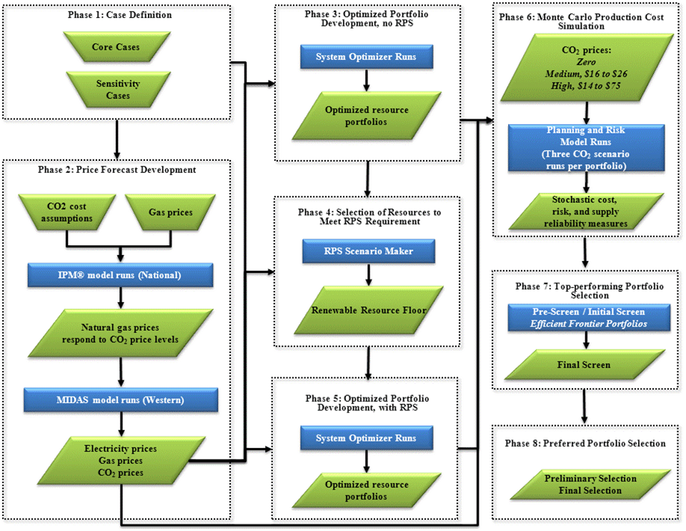

Using existing resources and a representation of the Company’s transmission system as the starting point, PacifiCorp will perform System Optimizer runs with a set of new resource options (supply-side, demand-side, energy storage, and transmission). The resource selections may be based on specific planning strategies to be developed incorporating public input. The key input variables will include, but are not limited to, carbon dioxide (“CO2”) regulatory costs, natural gas/electricity prices and load growth. PacifiCorp will also develop additional CO2 and renewable portfolio standard regulatory compliance scenarios to further analyze regulatory uncertainty. The purpose of the alternative future scenario analysis is to determine how portfolios and their associated resources perform under a variety of input assumptions, serving as an indicator of portfolio robustness. As was done for past IRPs, the Company will evaluate alternative Energy Gateway transmission scenarios.

Once portfolios are developed, the PaR model will be used to implement Monte Carlo sampling of load, electricity price, natural gas price, hydro availability, and thermal unit availability input variables. Portfolio costs are calculated as the mean PVRR of the Monte Carlo iterations. This mean cost, along with bad-outcome (or upper-tail) costs and supply reliability risk measures, constitute the main metrics for determining comparative portfolio risk performance profiles.

PacifiCorp will also evaluate the preferred portfolio and associated resource acquisition strategies in the context of potential changes to planning assumptions and procurement risks, referred to as acquisition path analysis.

**PLANNED MODELING ENHANCEMENTS AND ANALYSIS PROJECTS**

PacifiCorp’s 2015 IRP work plan accounts for the following key modeling and analysis projects that are planned or underway:

* Update the DSM resource supply curves based on a new potentials study to be completed in 2014.
* Conduct a new distributed generation (DG) study. This will incorporate costs and penetration levels for distributed resources, along with sensitivities.
* Conduct a new storage study examining commercially viable storage technologies.
* Provide an update to the 2012 wind integration study.
* Complete an updated loss of load probability study and planning reserve margin analysis.
* Complete a wind and solar capacity contribution study using loss of load probability principals.
* Evaluate the portfolio marginal stochastic costs of alternative planning reserve margin levels.

**ANTICIPATED TIMING AND EXTENT OF PUBLIC PARTICIPATION**

The timeline for 2015 IRP public meetings is shown in Figure 2. The 2015 IRP meeting schedule will consist of a combination of general public meetings and status report conference calls if needed. At least seven public meetings will be held throughout the 2015 IRP development cycle, with additional ones scheduled if required. PacifiCorp is also planning to set up state-specific stakeholder meetings during late June and into July 2014 to discuss topics of regional interest—a practice that was instituted for the 2008, 2011, and 2013 IRP processes. The first general public meeting will be scheduled no later than June 2014 and will kick-off the 2015 IRP process. The kick-off meeting will cover the 2015 IRP schedule, public process, modeling and analysis objectives, lessons learned from the 2013 IRP process, and 2013 Integrated Resource Update report. An email announcement for the kick-off meeting will be sent to IRP stakeholders once meeting dates and locations are identified.

Figure 2 also shows the high-level 2015 IRP development schedule. Filing of the 2015 IRP is scheduled for March 31, 2015, in conformance with the acknowledgement of the 2013 IRP by the Washington Utilities and Transportation Commission in Docket UE-120416. PacifiCorp expects to issue a draft 2015 IRP for a 30-day public comment and review period in February 2015.

**Figure 2 – 2015 IRP Public Meeting and Development Schedule**



**Conclusion**

PacifiCorp’s 2015 IRP work plan represents its current view of the processes and activities needed to file an IRP by March 31, 2015 that meets state IRP standards and guidelines and aligns with the Company’s 2015 business plan and procurement activities. As discussed above, a pending state acknowledgment order and other factors may require adjustment to the schedule and specific contents of the 2015 IRP.

PacifiCorp encourages Washington stakeholders to attend public meetings and actively be involved in this planning process. To join the 2015 IRP participants’ list, send an email request to [IRP@PacifiCorp.com](mailto:IRP@PacifiCorp.com) or call the PacifiCorp IRP phone line at (503) 813-5245.