Rates and Regulatory Affairs

**Facsimile: 503.721.2516**

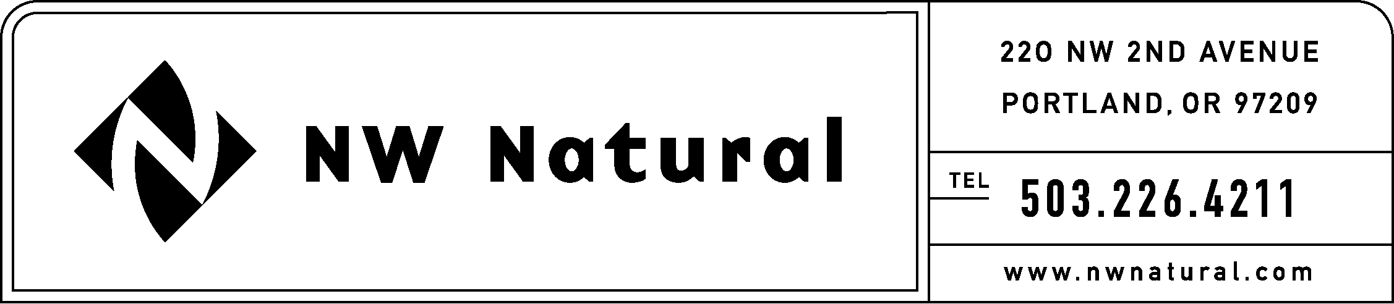

December 6, 2010

***VIA ELECTRONIC FILING***

Dave Danner, Executive Director & Secretary

Washington Utilities and Transportation Commission

1300 S Evergreen Park Drive SW

Post Office Box 47250

Olympia, Washington 98504-7250

**Re: U-100523, Paperless Billing for Gas Customers**

**NW Natural’s Comments**

Dear Mr. Danner:

Northwest Natural Gas Company, dba NW Natural (“NW Natural” or the “Company”), hereby submits comments to the Washington Transportation and Utility Commission’s (“Commission”) draft rules on paperless billing for gas utility customers, issued November 5, 2010.

Attached to this filing are NW Natural’s redlined edits to the Commissions’ draft rules and below is an explanation of each:

**WAC 480-90-153 – Disclosure of private information**

While NW Natural agrees with Staff’s intent behind the new verbiage in WAC 480-90-153, the Company believes the new language could be misinterpreted. The Company is prosing edits that clarify that the new provisions are specific to gaining a customer’s consent to “disclose or sell data private consumer information to an affiliate, subsidiary or any other third party” as established in Section 1 of this rule. The Company also revises the proposed language under Section (4) (b) to make the customer consent to share private customer data specific to a party rather than a service or product as this is more practical to manage.

**WAC 480-90-179– Electronic Information**

Section (2) – Obtaining and documenting customer consent

In previous comments, NW Natural stated that customers appreciate having the opportunity to consent to multiple services at one time rather than filing out separate forms for each offering. NW Natural cited equal pay and automatic billing as two options that customers who choose paperless billing appreciate having simultaneously offered to them. The Company appreciates Staff’s willingness to include these services in the rule but believes its own examples were too narrow. Language is added to allow the consent section to include” separate and individual opportunities” for customers to consent to any utility service offered under the utility’s tariff. J.D. Powers has noted that bundling billing options increases customer satisfaction. Other potential offerings that a customers may choose are bill payment plans like levelized payment or preferred due date. The Company believes customers could be underserved if the rule too narrowly defines the options customers can readily choose in a one-step process. The Company, however, does understand and respect the need for separate, individual consents for each offered service.

NW Natural has also removed the sentence limiting the provision of any other information on the same document, screen or webpage. This language continues to be too broad and would prohibit the use of a company logo, address, or customer call center phone number. NW Natural recommends Staff consider revising the language to disallow the webpage or form from including the specific transaction types it wants prohibited.

Section (7) – Undeliverable electronic documents

NW Natural has revised this section so that it is specific to electronically delivered bills. Section (7)(a) is also revised to allow a utility to either call or email a customer after an emailed bill bounces. A phone call may be more appropriate since returned-email notifications often clarify that the email address is incorrect or that the recipient needs to add the Company’s email to its safe list before one will be received.

NW Natural appreciates the Commission’s consideration of the Company’s comments. Please contact me at (503) 226-4211, extension 3590 if you have questions.

Sincerely,

NW NATURAL

*/s/ Jennifer Gross*

Jennifer Gross

Rates & Regulatory Affairs