July 6, 2012

David Danner

Executive Director and Executive Secretary

Washington Utilities and Transportation Commission

1300 S. Evergreen Park Dr. S.W.

PO Box 47250

Olympia, WA 98504-7250

RE: Docket No. UE-120700 - Pacific Power and Light Company Schedule 191 System Benefits Charge Adjustment

The NW Energy Coalition supports PacifiCorp’s request in this docket for an adjustment to Schedule 191 to better balance revenues and expenses for its Washington conservation programs. According to its May 15, 2012 filing, the Company proposes to increase its system benefits charge (SBC) collection rate by approximately $2.6 million annually for a total of $11.4 million per year.

The SBC level was last approved in Docket UE-091516, effective at the end of October 2009. Since that time, the Company has increased its annual conservation savings acquisition, experienced an under-collection of funds, and faced a commitment to assess its distribution and production efficiency potential. For all of these reasons, we believe the SBC level should be increased as requested by the Company.

We understand that Boise White Paper, LLC has filed a petition to intervene in this Docket. We are hopeful that the DSM Advisory Group can work with the Company and Boise White Paper to develop potential solutions to address Boise’s concerns. As we all know, conservation benefits individual program participants through lowered bills, increased productivity, and improved health and safety, and simultaneously benefits all ratepayers by avoiding more costly resource acquisitions. The Coalition is interested in learning about potential barriers to Boise’s participation in PacifiCorp’s conservation programs, and opportunities to overcome those barriers to ensure that the requirement in RCW 19.285.040(1) is met to pursue all available conservation that is cost-effective, reliable and feasible.

We are optimistic that the parties can work together to propose solutions for the Commission’s consideration at a later date. In the meantime, we respectfully request you approve PacifiCorp’s proposal to increase its SBC to avoid further accrual of under-collections.

Thank you for considering these comments. Unfortunately, I will not be available to attend the Open Meeting on Thursday July 12.

Sincerely,

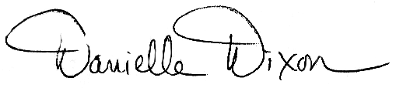

Danielle Dixon

Senior Policy Associate, NW Energy Coalition