BEFORE THE WASHINGTON UTILIES AND TRANSPORTATION COMMISSION

|  |  |
| --- | --- |
| In the Matter of the Penalty Assessment Against INTERNATIONAL DISTRICT PARKING ASSOCIATION D/B/A MERCHANTS PARKING ASSOCIATION/TRANSIA in the amount of $100 | DOCKET NO. TN-100260  DECLARATION OF  BETTY YOUNG |
|  |  |

BETTY YOUNG, under penalty of perjury under the laws of the state of Washington, declares as follows:

1. I am over 18 years of age, a citizen of the United States, a resident of the state of Washington, and competent to be a witness.
2. I am employed by the Washington Utilities and Transportation Commission (Commission) as Compliance Specialist in the Motor Carrier Safety Section. I have been employed at the Commission for 11 years, holding various positions. As a Compliance Specialist, my responsibilities include conducting investigations of regulated transportation companies and providing regulatory and policy analysis for investigations and penalty assessments.
3. On February 24, 2010, International District Parking Association d/b/a Merchants Parking Association/Transia (Merchants Parking or Company), through its Operations Manager, Idris Elhamar, filed with the Commission an application for mitigation (Mitigation Request) in Docket TN-100260. In the Mitigation Request, Merchants Parking waives a hearing and asks for an administrative decision.

The Mitigation Request arises from a Notice of Penalties Incurred and Due for Violations of Laws and Rules issued by the Commission on February 18, 2010, in Docket TN-100260. In that Notice, the Commission issued a penalty of $100 for one violation of WAC 480-30-221, Vehicle and driver safety requirements, which requires passenger charter carriers to comply with Title 49, Code of Federal Regulations (CFR) Part 391, which governs qualification of drivers. Specifically, the Company violated CFR Part 391.45(b)(1), using a driver not medically examined and certified during the preceding 24 months.

As part of my job, I reviewed the compliance file for Merchants Parking, which contains records of the Company’s compliance history with the Commission.

**Specific Issue Addressed by Merchants Parking in its Mitigation Request**

**The Company states that it was under the assumption that only CDL drivers cannot drive with expired medical cards.**

1. Merchants Parking received previous technical assistance from Commission Staff on the requirements for medical cards for non-CDL drivers. In October 2007, former Commission Motor Carrier Investigator Leon Macomber conducted a compliance review of Merchants Parking. During the course of that review, Mr. Macomber found that the Company used a driver not medically examined and certified.[1]
2. Mr. Macomber’s compliance review report included information on this violation under “Part B Violations,” which states, “Driver, Gary Clark, did not have a medical certificate in driver’s qualification file. (Medical certificates required on both CDL and Non-CDL drivers).”[2] In the report under “Part B Requirements and/or Recommendations,” it states, “Make sure all Non-CDL drivers as well as CDL drivers have a current medical certificate.”[3]
3. Mr. Elhamar signed the report, thereby acknowledging receipt and agreeing that the findings of the review had been discussed with him in detail.[4]

**Staff Recommendation**

1. The Commission’s Motor Carrier Safety Section takes any violations related to keeping the public safe from unqualified drivers, such as drivers without medical certification, very seriously. Merchants Parking was given previous technical assistance on how to comply with WAC 480-30-221. Therefore, Staff opposes mitigation and recommends the penalty stand.

Dated March 10, 2010, at Olympia, Washington.

Betty Young

**Attachment A**

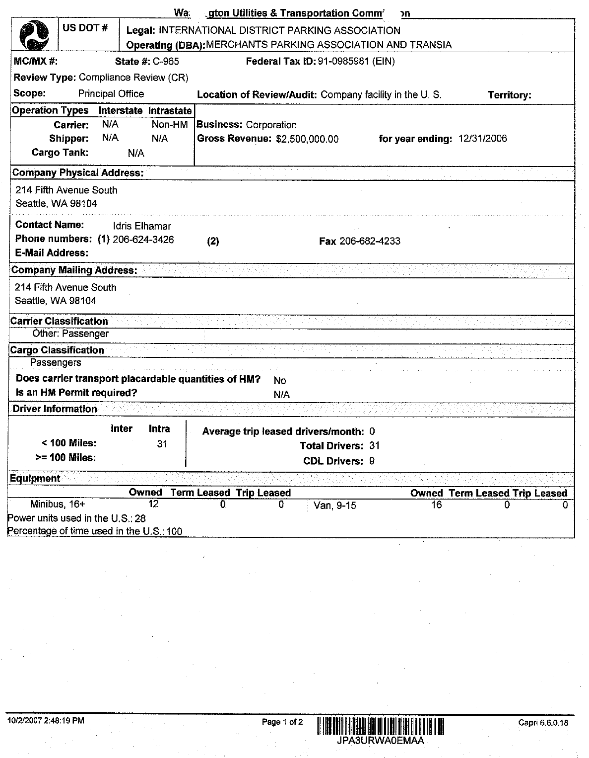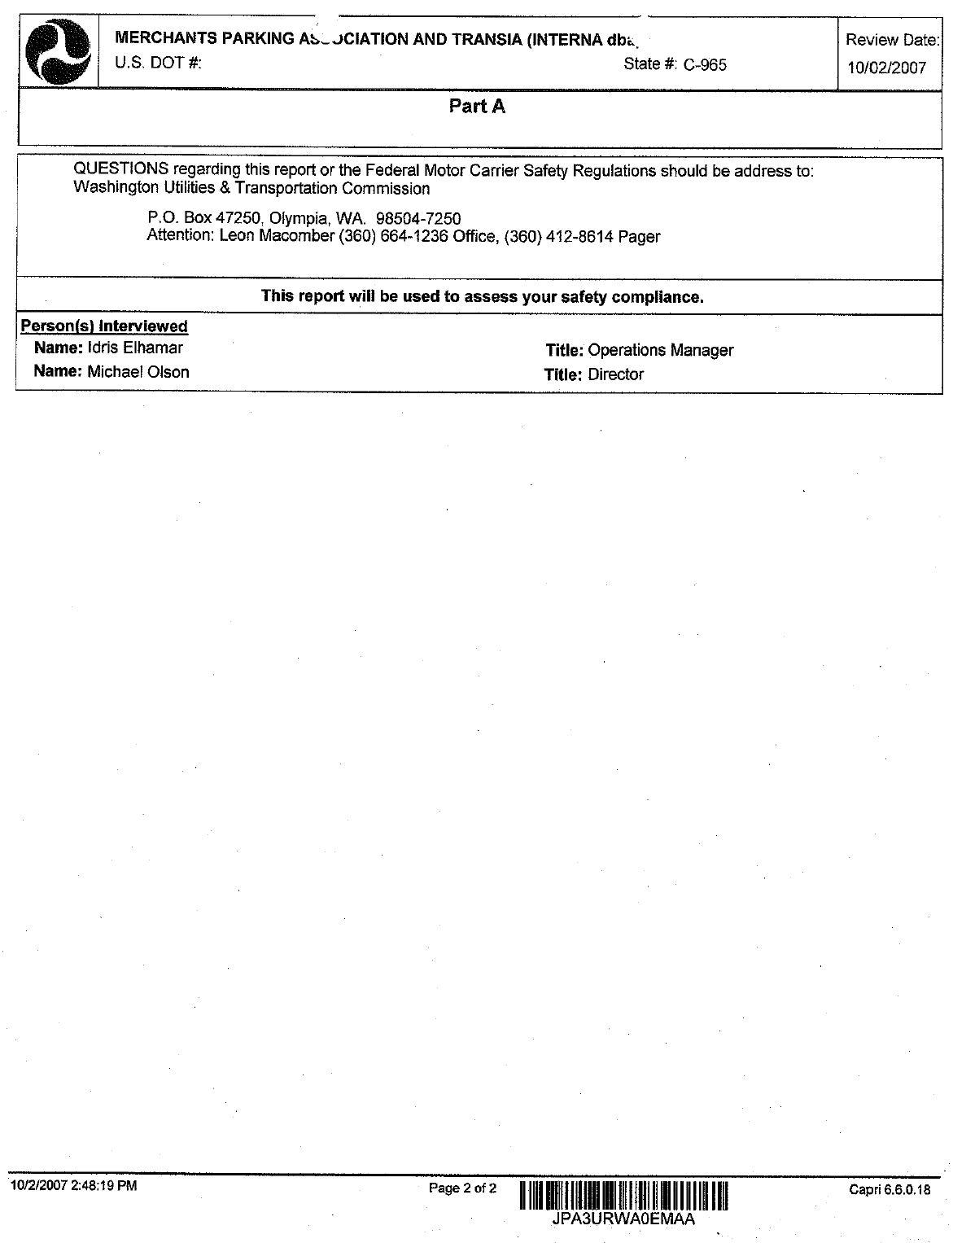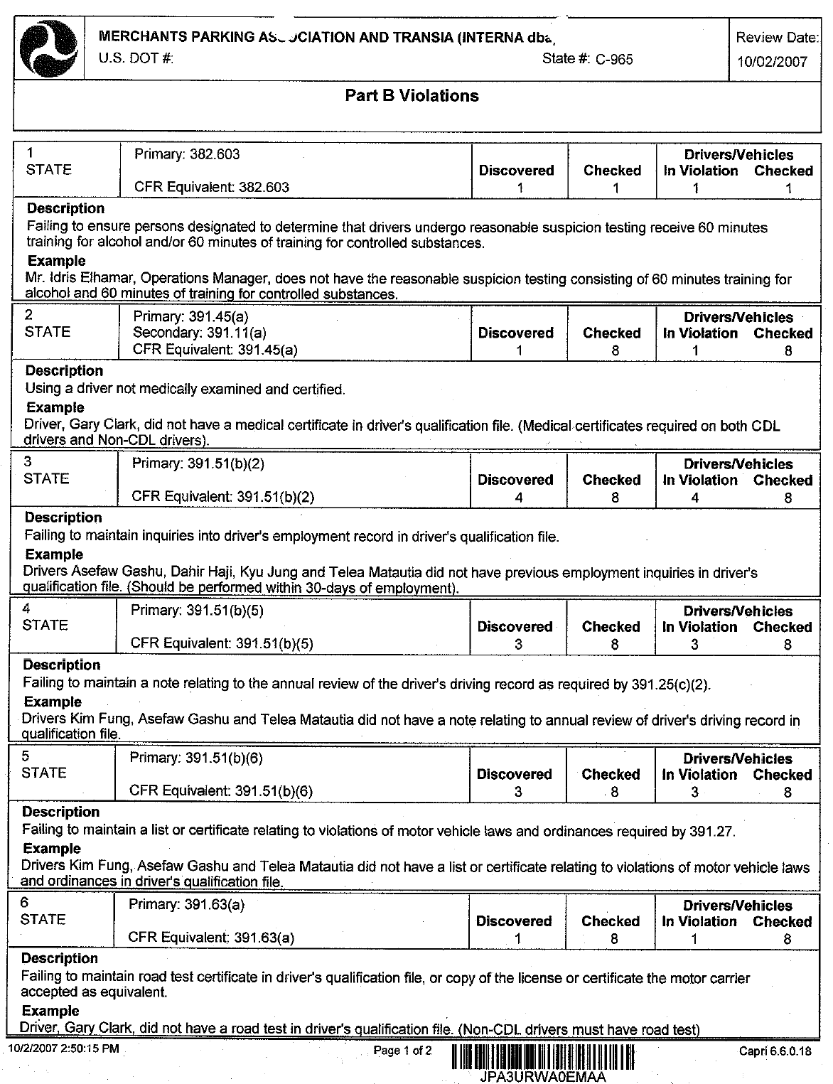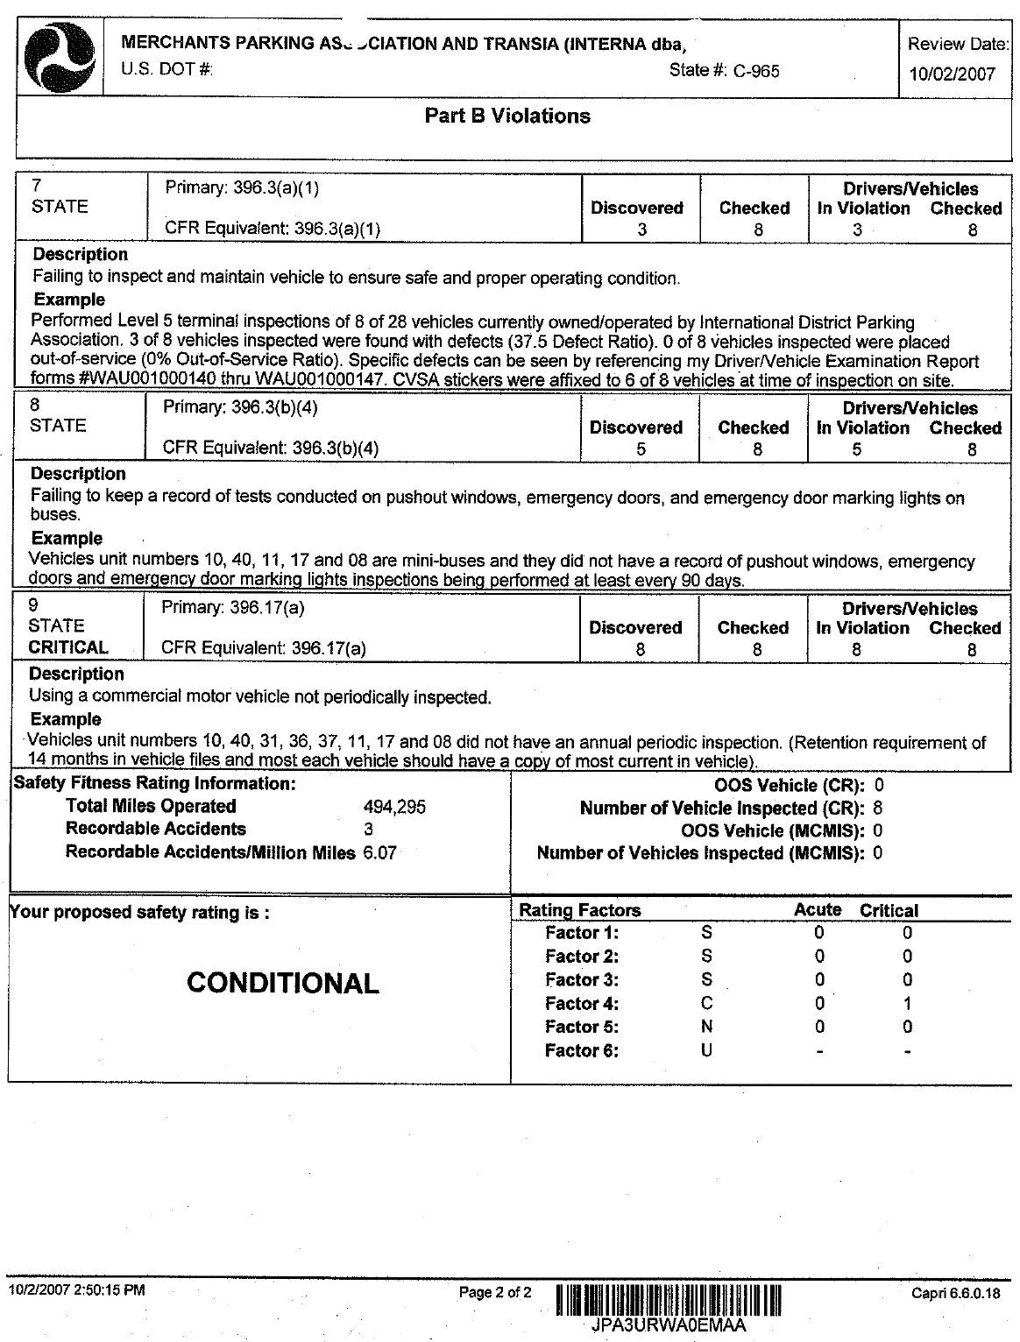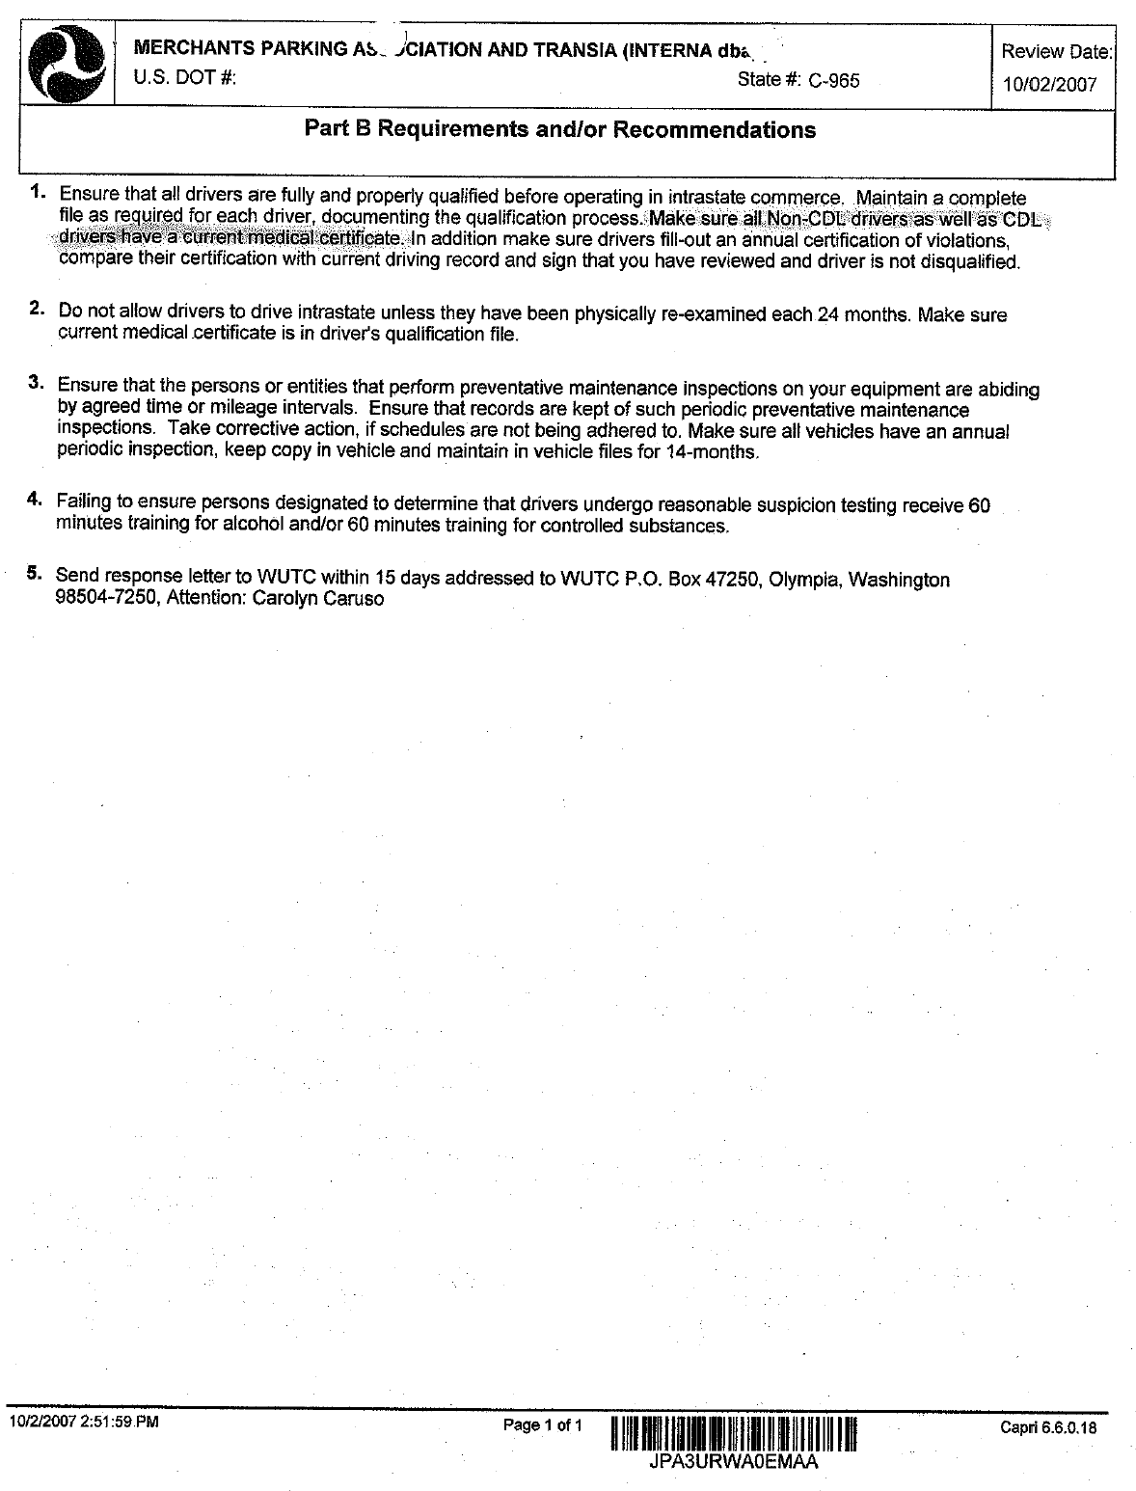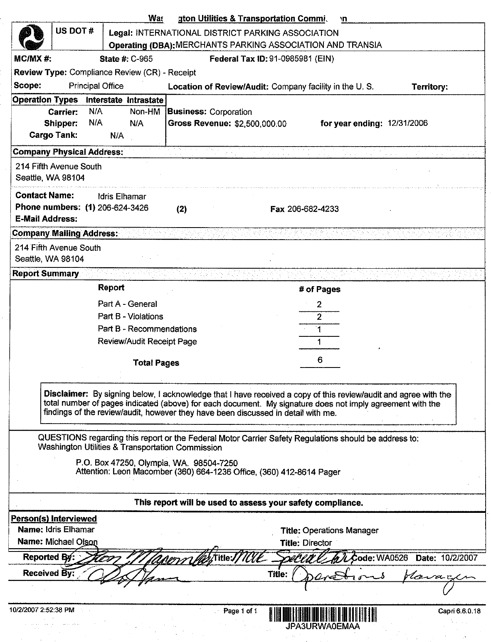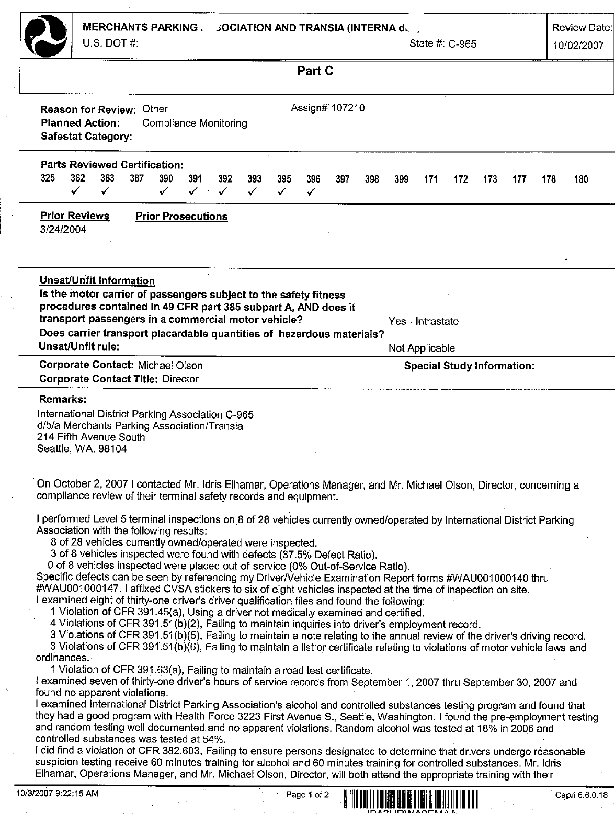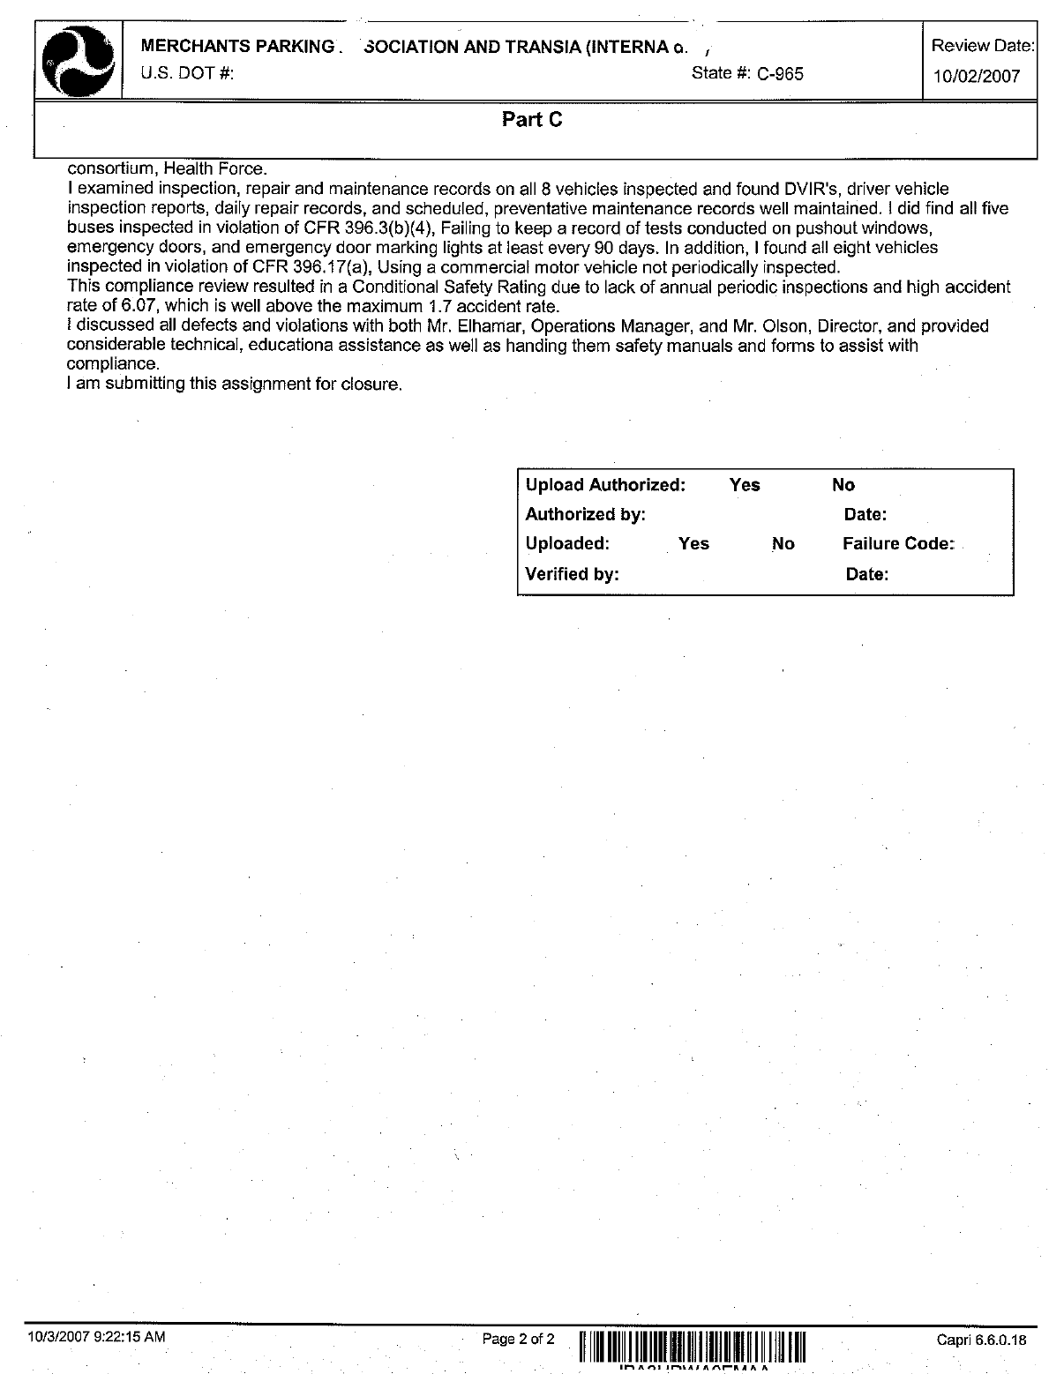

1. A true and accurate copy of the October 2007 Compliance Review report is attached to this declaration as Attachment A.
2. Attachment A at page 5.
3. Attachment A at page 7.
4. Attachment A at page 8.