_1__ Revised Title Page

Tariff No. ____14_______

Cancels

Tariff No. ____13_______

of

**Excess Disposal INC.**

(Name of Solid Waste Collection Company)

**Excess Disposal Service**

(Registered trade name of Solid Waste Collection Company)

Certificate Number G- 107

## NAMING RATES FOR THE COLLECTION, TRANSPORTATION, AND DISPOSAL OF

**SOLID WASTE, AND IF NOTED, RECYCLING AND YARDWASTE**

IN THE FOLLOWING DESCRIBED TERRITORY:

(NOTE: If this tariff applies in only a portion of a company's certificate authority,

a map accurately depicting the area in which the tariff applies must be attached to the tariff)

Territory as described in docket TG - 032143

Official UTC requests for information regarding consumer questions and/or complaints should be referred to the following company representative:

Name: Cindy Low

Title: Secr./owner

Phone: 208 437 4502

E-Mail: low7@verizon.net

Fax: 208 448 2290

Name of person issuing tariff Cindy Low

Mailing address of issuing agent: 2654 E Hwy 2

City, State/Zip Code: Oldtown ID 83822

Telephone number, including area code: 208 437 4502

FAX number, if any: 208 448 2290

E-mail address, if any: low7@verizon.net

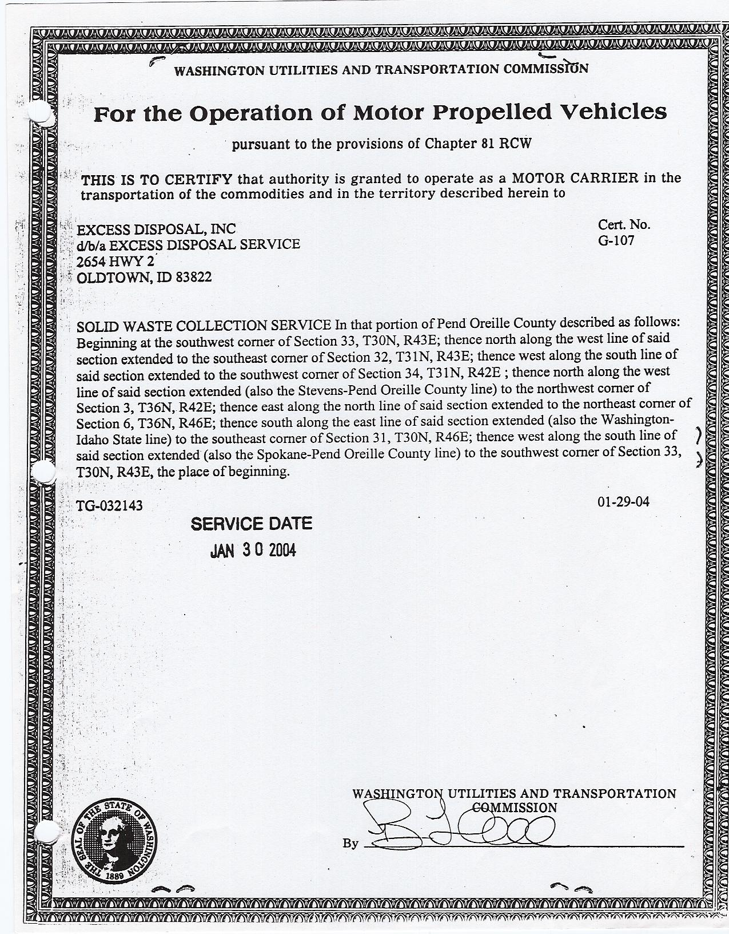

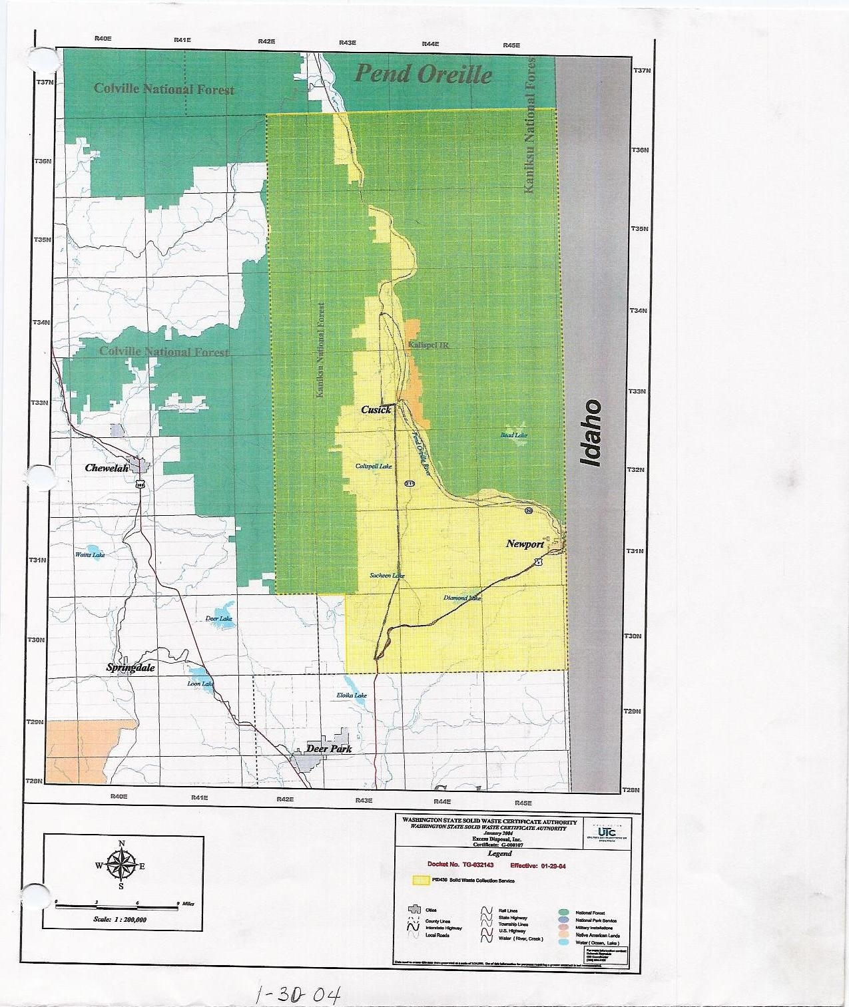

Tariff No. ___14____ ___2__Revised Page No. ___1__

Company Name/Permit Number: Excess Disposal INC G-107

Registered Trade Name: Excess Disposal Service

CHECK SHEET

All pages contained in this tariff are listed below in consecutive order. The pages in the tariff and/or any supplements to the tariff listed on this page have issue dates that are the same as, or are before, the issue date of this page. "O" in the revision column indicates an original page.



# Supplements in Effect

**ALL RATES ON PAGE ARE INCREASED**

Tariff No. __14_____ __1___Revised Page No. __23___

Company Name/Permit Number: Excess Disposal INC G-107

Registered Trade Name: Excess Disposal Service

# Item 100 – Residential Service -- Monthly Rates (continued on next page)

Rates in this item apply:

(1) To solid waste collection, curbside recycling (where noted) and yardwaste collection services (where noted) for residential property. This includes single family dwellings, duplexes, apartments, mobile homes, condominiums, etc., where service is billed directly to the occupant of each residential unit; and/or

(2) When required by a local government service level ordinance solid waste collection, curbside recycling, and yardwaste service must be provided for single-family dwellings, duplexes, mobile homes, condominiums and apartment buildings of less than ____ residential units, where service is billed to the property owner or manager.

Rates below apply in the following service area: As per Appendix A



Frequency of Service Codes: WG=Weekly Garbage; EOWG=Every Other Week Garbage; MG=Monthly Garbage; WR=Weekly

Recycling; EOWR=Every Other Week Recycling; MR=Monthly Recycling

List others used:

Note 1: Description/rules related to recycling program are shown on page ______.

Note 2: Description/rules related to yardwaste program are shown on page ______.

Note: 3: In addition to the recycling rates shown above, a recycling credit/debit of $_______________applies.

Notes for this item are continued on next page.

###### Recycling service rates on this page expire:______________

**ALL RATES ON THIS PAGE ARE INCREASED**

Tariff No. __14_____ __1___Revised Page No. _23A___

Company Name/Permit Number: Excess Disposal INC G-107

Registered Trade Name: Excess Disposal Service

# Item 100 – Residential Service -- Monthly Rates (continued on next page)

Rates in this item apply:

(1) To solid waste collection, curbside recycling (where noted) and yardwaste collection services (where noted) for residential property. This includes single family dwellings, duplexes, apartments, mobile homes, condominiums, etc., where service is billed directly to the occupant of each residential unit; and/or

(2) When required by a local government service level ordinance solid waste collection, curbside recycling, and yardwaste service must be provided for single-family dwellings, duplexes, mobile homes, condominiums and apartment buildings of less than ____ residential units, where service is billed to the property owner or manager.

Rates below apply in the following service area: As per Certificate



Frequency of Service Codes: WG=Weekly Garbage; EOWG=Every Other Week Garbage; MG=Monthly Garbage; WR=Weekly

Recycling; EOWR=Every Other Week Recycling; MR=Monthly Recycling

List others used:

Note 1: Description/rules related to recycling program are shown on page ______.

Note 2: Description/rules related to yardwaste program are shown on page ______.

Note: 3: In addition to the recycling rates shown above, a recycling credit/debit of $_______________applies.

Notes for this item are continued on next page.

###### Recycling service rates on this page expire:______________

**ALL RATES ON THIS PAGE ARE INCREASED**

Tariff No. ___14____ __1___Revised Page No. ___24__

Company Name/Permit Number: Excess Disposal INC G-107

Registered Trade Name: Excess Disposal Service

# Item 100 – Residential Service – Monthly Rates (continued from previous page)

Note 4: Customers will be charged for service requested even if fewer units are picked up on a particular trip. No credit will be given for partially filled cans. No credit will be given if customer fails to set receptacles out for collection.

Note 5: For customers on automated service routes: The company will assess roll-out charges where, due to circumstances outside the control of the driver, the driver is required to move an automated cart or toter more than __N/A____ feet in order to reach the truck. The charge for this roll-out service is: $___N/A_____ per cart or toter, per pickup.

Note 6: The charge for an occasional extra residential bag, can, unit, toter, mini-can, or micro-mini can on a regular pickup is:

|  |  |
| --- | --- |
| Type of receptacle | Rate per receptacle, per pickup |
| 32-gallon can or unit | $ 3.56 |
| Mini-can | $ |
| Micro-mini can | $ |
| 60-gallon toter | $ |
| 90-gallon toter | $ |
| Bag | $ |
| Other: 45 GAL | $ 5.87 |

Note 7: Customers may request no more than one pickup per month, on an "on call" basis, at $__10.47__ per can/unit. Service will be rendered on the normal scheduled pickup day for the area in which the customer resides. Note: If customer requires service be provided on other than normal scheduled pickup day, rates for special pickups will apply.

**ALL RATES ON THIS PAGE ARE INCREASED**

Tariff No. __14_____ __1___Revised Page No. _30___

Company Name/Permit Number: Excess Disposal INC G-107

Registered Trade Name: Excess Disposal Service

# tem 120 – Drums

|  |  |
| --- | --- |
| Type of Service | Rate Per Drum, Per Pickup |
| Regular Route Service | $ |
| Special Pickup | $ |

# Item 130 – Litter Receptacles and Litter Toters

|  |  |  |
| --- | --- | --- |
| Customer-owned Receptacle | | Rate Per Receptacle, Per Pickup |
| Size or Type: | | $ |
| Size or Type: | | $ |
| Company-owned Receptacle | | |
| Size or Type: | $ | |
| Size or Type: | $ | |

# Item 150 – Loose and Bulky Material

Special trips: Time rates in Item 160 apply.

Regular Route:

|  |  |  |  |  |
| --- | --- | --- | --- | --- |
|  | 1 to 4 cubic yards Rate per Yard | Additional cubic yards  Rate per Yard | Minimum Charge  Per Pickup | Carry Charge  Per each 5 feet over 8 feet |
| Bulky materials | $ 20.93 | $ 20.93 | $ 89.43 | $ 20.93 |
| Loose material  (customer load) | $ | $ | $ | $ |
| Loose material  (Company load) | $ 22.70 | $ 22.70 | $ 89.43 | $ 22.70 |

**All RATES ON THIS PAGE ARE INCREASED**

Tariff No. __14_____ __1___Revised Page No. __34___

Company Name/Permit Number: Excess Disposal INC G-107

Registered Trade Name: Excess Disposal Service

# tem 207 – Excess Weight – Rejection of Load, Charges to Transport

The company reserves the right to reject pickup of any container, stationary packer, or drop box which, upon reasonable inspection:

* Appears to be overloaded;
* Would cause applicable vehicle load limitations to be exceeded;
* Would cause the company to violate load limitations or safe vehicle operation; and/or
* Would negatively impact or otherwise damage road surface integrity.

For the purposes of this tariff, the following maximum weights apply:

|  |  |  |  |  |
| --- | --- | --- | --- | --- |
| Type/Size of  Container, Drop Box, Toter, or Cart | Maximum Weight  Allowance  (in pounds) |  | Type/Size of  Container, Drop Box, Toter, or Cart | Maximum Weight Allowance  (in pounds) |
| 40yd drop box | 18,000 |  | 1yd container | 275 |
| 30yd drop box | 18,000 |  | 1.5yd container | 375 |
| 20yd drop box | 18,000 |  | 2yd container | 500 |
| Compactors | 18,000 |  | 4yd container | 900 |
|  |  |  | 6yd container | 1250 |
|  |  |  |  |  |

**Overfilled or overweight, charges if transported.** If the container, drop box, toter, or cart exceeds the limits stated above, is filled beyond the marked fill line, or the top is unable to be closed, but the company transports the materials, the following additional charges will apply:

|  |  |  |  |  |
| --- | --- | --- | --- | --- |
| Type/Size of  Container, Drop Box, Toter, or Cart | Charge |  | Type/Size of  Container, Drop Box, Toter, or Cart | Charge |
| 1yd container | $ 22.46 per yd |  |  | $ per |
| 1.5yd container | $ 22.46 per yd |  |  | $ per |
| 2yd container | $ 22.46 per yd |  |  | $ per |
| 4yd container | $ 22.46 per yd |  |  | $ per |
| 6yd container | $ 22.46 per yd |  |  | $ per |
|  | $ per |  |  | $ per |

**RATES ARE INCREASED**

Tariff No. __14_____ __1___Revised Page No. ___36__

Company Name/Permit Number: Excess Disposal INC G-107

Registered Trade Name: Excess Disposal Service

# Item 230 – Disposal Fees

Charges in this item apply when other items in the tariff specifically refer to this item.

|  |  |  |
| --- | --- | --- |
| Disposal site (name or location) | Type of Material | Fees for disposal |
| A Deer Valley Transfer Station | All | $ 104.00 per Ton |
| Deer Valley Transfer Station | Tires | $ 20.00 per Tire |
| Deer Valley Transfer Station | Freon | $ 20.00 per appliances |
|  |  | $ per |
| North County Transfer Station | General Trash | $ 103.00 per Ton |
|  |  | $ per |
| Graham Road | Special Waste | $ 85.00 per Ton |
|  |  | $ per |
|  |  | $ per |
|  |  | $ per |
|  |  | $ per |
|  |  | $ per |
|  |  | $ per |
|  |  | $ per |
|  |  | $ per |
|  |  | $ per |
|  |  | $ per |
|  |  | $ per |
|  |  | $ per |
|  |  | $ per |

State whether fees are per yard, per ton, etc. Include charges assessed for special commodities (tires, appliances, asbestos, etc.) or special conditions at each specific disposal site. Attach additional sheets as necessary.

**ALL RATES ON THIS PAGE ARE INCREASED**

Tariff No. ___14____ __1___Revised Page No. __37___

Company Name/Permit Number: Excess Disposal INC G-107

Registered Trade Name: Excess Disposal Service

# tem 240 – Container Service – Dumped in Company's Vehicle

Non-Compacted Material (Company-owned container)

Rates stated per container, per pickup

Service Area: As per certificate

|  |  |  |  |  |  |  |
| --- | --- | --- | --- | --- | --- | --- |
| Permanent Service | Size or Type of Container | | | | | |
| _1___ Yard | _1.5_ Yard | _2__Yard | __4__Yard | __6__Yard | _____Yard |
| Monthly Rent, if applicable | $ | $ | $ | $ | $ | $ |
| First Pickup | $ 20.98 | $ 27.63 | $ 32.34 | $ 60.00 | $ 79.13 | $ |
| Each Additional Pickup | $ 14.98 | $ 21.13 | $ 24.81 | $ 46.80 | $ 63.63 | $ |
| Special Pickups | $ 14.98 | $ 21.13 | $ 24.81 | $ 46.80 | $ 63.63 | $ |
|  | | | | | | |
| Temporary Service |  | | | | | |
| Initial Delivery | $ 61.82 | $ 61.82 | $ 61.82 | $ 61.82 | $ 61.82 | $ |
| Pickup Rate | $ 38.67 | $ 53.98 | $ 59.40 | $ 86.77 | $ 130.23 | $ |
| Rent Per Calendar Day | $ | $ | $ | $ | $ | $ |
| Rent Per Month | $ | $ | $ | $ | $ | $ |

Note 1: Permanent Service: Service is defined as no less than scheduled, every other week pickup, unless local government requires more frequent service or unless putrescibles are involved. Customer will be charged for service requested, even if fewer containers are serviced on a particular trip. No credit will be given for partially filled containers.

Note 2: Permanent Service: If rent is shown, the rate for the first pickup and each additional pickup must be the same. If rent is not shown, it is to be included in the rate for the first pickup.

Note 3: Permanent & Temporary Service: Due to distance & terrain a delivery charge of $61.82 will be charged on all containers.

Accessorial charges assessed (lids, tarping, unlocking, unlatching, etc.):

Note 4: A gate or obstruction charge of $10.00 will be assessed for opening, unlocking, closing gates, or

moving obstructions in order to pick up solid waste. **ALL RATES ON THIS PAGE AE INCREASED**

Tariff No. ____14___ __1___Revised Page No. __38___

Company Name/Permit Number: Excess Disposal INC G-107

Registered Trade Name: Excess Disposal Service

# Item 245 – Container Service – Dumped in Company's Vehicle

Non-Compacted Material (Customer-owned container)

Includes Commercial Can Service

Rates stated per container, per pickup

Service Area: As per Certificate

|  |  |  |  |  |  |  |  |  |  |  |
| --- | --- | --- | --- | --- | --- | --- | --- | --- | --- | --- |
| Permanent Service | Size or Type of Container | | | | | | | | | |
| 32-gallon can or unit | 45_Gal. Toter | | ____Yard | | ____Yard | | ____Yard | | ____Yard |
| Each Scheduled Pickup | $ 2.54 | $ 5.87 | | $ | | $ | | $ | | $ |
| Special Pickups | $ 3.71 | $ 6.88 | | $ | | $ | | $ | | $ |
|  | | | | | | | | | | |
| Temporary Service |  | | | | | | | | | |
| Pickup Rate | $ 5.51 | $ 8.67 | $ | | $ | | $ | | $ | |

Note 1: Permanent Service: Service is defined as no less than scheduled, every other week pickup, unless local government requires more frequent service or unless putrescibles are involved. Customer will be charged for service requested, even if fewer containers are serviced on a particular trip. No credit will be given for partially filled containers.

Note 2: Minimum monthly charge: 32 gal can $16.48 45 gal can $ 24.91.

Accessorial charges assessed (lids, tarping, unlocking, unlatching, etc.):

**ALL RATES ON THIS PAGE ARE INCREASED**

Tariff No. __14____ __1___Revised Page No. __39___

Company Name/Permit Number: Excess Disposal INC G-107

Registered Trade Name: Excess Disposal Service

# Item 250 – Container Service – Dumped in Company's Vehicle

Compacted Material (Company-owned container)

Rates stated per container, per pick up

Service Area: As per Certificate

|  |  |  |  |  |  |  |
| --- | --- | --- | --- | --- | --- | --- |
| Permanent Service | Size or Type of Container | | | | | |
| __1__ Yard | _1.5_ Yard | __2___Yard | __4__Yard | __6__Yard | _____Yard |
| Monthly Rent, if applicable | $ | $ | $ | $ | $ | $ |
| First Pickup | $ 35.38 | $ 47.99 | $ 61.98 | $ 110.88 | $ 149.96 | $ |
| Each Additional Pickup | $ 29.62 | $ 41.85 | $ 56.22 | $ 98.40 | $ 137.43 | $ |
| Special Pickups | $ | $ | $ | $ | $ | $ |
|  | | | | | | |
| Temporary Service |  | | | | | |
| Initial Delivery | $ 60.02 | $ 60.02 | $ 60.02 | $ 60.02 | $ 60.02 | $ |
| Pickup Rate | $ 49.56 | $ 73.62 | $ 82.36 | $ 136.OO | $ 184.75 | $ |
| Rent Per Calendar Day | $ | $ | $ | $ | $ | $ |
| Rent Per Month | $ | $ | $ | $ | $ | $ |

Note 1: Permanent Service: Service is defined as no less than scheduled, every other week pickup, unless local government requires more frequent service or unless putrescibles are involved. Customer will be charged for service requested, even if fewer containers are serviced on a particular trip. No credit will be given for partially filled containers.

Note 2: Permanent Service: If rent is shown, the rate for the first pickup and each additional pickup must be the same. If rent is not shown, it is to be included in the rate for the first pickup.

Note 3: Permanent & Temporary Service: Due to distance & terrain a delivery charge of $60.02 will be charged on all containers.

Accessorial charges assessed (lids, tarping, unlocking, unlatching, etc.)

Note4: A gate or obstruction charge of $10.00 will be assessed for opening, unlocking, closing gates, or

moving obstructions in order to pickup solid waste.**ALL RATES ON THIS PAGE ARE INCREASED**

Tariff No. ___14____ ___1__Revised Page No. __40___

Company Name/Permit Number: Excess Disposal INC G-107

Registered Trade Name: Excess Disposal Service

# Item 255 – Container Service – Dumped in Company's Vehicle

Compacted Material (Customer-owned container)

Rates stated per container, per pick up

Service Area: As per certificate

|  |  |  |  |  |  |  |
| --- | --- | --- | --- | --- | --- | --- |
| Permanent Service | Size or Type of Container | | | | | |
| __1__ Yard | _1.5__Yard | __2__Yard | __4__Yard | __6___Yard | _____Yard |
| Each Scheduled Pickup | $ 29.62 | $ 42.38 | $ 56.86 | $ 99.22 | $ 138.53 | $ |
| Special Pickups | $ 29.62 | $ 42.38 | $ 56.86 | $ 99.22 | $ 138.53 | $ |
|  | | | | | | |
| Temporary Service |  | | | | | |
| Pickup Rate | $ 29.62 | $ 42.38 | $ 56.86 | $ 99.22 | $ 138.53 | $ |

Note 1: Permanent Service: Service is defined as no less than scheduled, every other week pickup, unless local government requires more frequent service or unless putrescibles are involved. Customer will be charged for service requested, even if fewer containers are serviced on a particular trip. No credit will be given for partially filled containers.

Accessorial charges assessed (lids, tarping, unlocking, unlatching, etc.):

