

November 20, 2008

Carole Washburn, Executive Secretary

Washington Utilities and

Transportation Commission

P.O. Box 47250

Olympia, Washington 98504-7250

* **Do Not Re-docket**

RE: Docket UT-081973 (Advice No. 3653T, Replacement No. 2)

ATTENTION: Sharyn Bate

Dear Ms. Washburn:

As a result of customer discussions, Qwest is replacing Sheets 12 and 15 to make two changes in the filing. The unidentified percent interstate usage floor will change from 3% to 5%. Language will be added to clarify the customer’s dispute options in the event the customer believes that the intrastate rate should not be applied to the unidentified traffic in excess of the floor.

If you have any questions concerning this filing, please contact Sue Henson at 206-345-4341.

Sincerely,

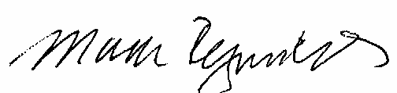

Mark Reynolds

Attachment A

Advice No. 3653T

Replacement No. 1

**ACCESS SERVICE**

**WN U-44**

|  |  |  |
| --- | --- | --- |
| **SECTION** | **SHEET** | **REVISION** |
| 2 | 12 | 3 |
| 2 | 15 | 2 |