Report to the Washington Utilities and Transportation Commission

## Electric Service Reliability - Major Event Report

# Event Date: February 15, 2016

Date Submitted: August 3, 2016

Primary Affected Locations: Sunnyside

Primary Cause: Loss of Substation

Exclude from Reporting Status: Yes

Report Prepared by: April Brewer

Report Approved by: Heide Caswell / Kevin Putnam / David O’Neil / Steve Henderson

**Event Description**

On February 2, 2016, Sunnyside, Washington, experienced a system average interruption frequency index-driven (SAIFI)-based major event when a lightning arrestor failed. The outage affected 3,800[1] customers with all customer restorations completed within 2 hours 13 minutes. Sustained interruptions were experienced by approximately 16% of the Sunnyside operating area’s customers.

|  |  |
| --- | --- |
| **Event Outage Summary** | |
| **# Interruptions (sustained)** | 3 |
| **Total Customer Interrupted (sustained)** | 3,800 |
| **Total Customer Minutes Lost** | 460,282 |
| **Event SAIDI** | 3.45 Minutes |
| **CAIDI** | 121 |
| **Major Event Start** | 2/15/16 12:00 AM |
| **Major Event End** | 2/15/16 11:59 PM |

**Restoration Summary**

On the evening of February 15, 2016, the Toppenish substation experienced a loss of supply event when a blown “A” phase arrestor caused the station transformer to trip open. The outage de-energized feeds to three circuits affecting 3,800 customers. Dispatch quickly notified the substation operation manager, who along with a serviceman responded to the incident. Upon inspection the manager discovered the failed arrestor, and notified dispatch. Dispatch began preparing a switching plan to restore feeds to customers. When the substation technician arrived he performed the restoration switching. Stage restorations were performed to avoid cold load pick-up issues. Once all customers were restored the failed transformer was isolated and replacement to the lightning arrestors was performed. Upon completion of the repairs system configuration was returned to normal.

The first restoration occurred just short of two hours, with the final circuit restored in 2 hours 13 minutes. Restoration activities utilized 5 operations personnel.

There were no company or commission customer complaints made regarding the major event.

**Restoration Intervals**

|  |  |  |  |
| --- | --- | --- | --- |
| **Total Customers Sustained** | **< 3 Hrs.** | **3 - 24 Hrs.** | **24+ Hrs.** |
| **3,800** | 3,800 | 0 | 0 |

**Restoration Resources**

|  |  |
| --- | --- |
| **Resources** | |
| **Journeymen** | 5 |

|  |  |
| --- | --- |
| **Materials** | |
| **12kV arrestors** | 3 |

**State Estimated Major Event Costs**

|  |  |  |  |
| --- | --- | --- | --- |
| **Estimate $** | **Labor** | **Materials** | **Total** |
| **Capital** | $0 | $0 | $0 |
| **Expense** | $4,645 | $2,212 | $6,857 |
| **Total** | **$4,645** | **$2,212** | **$6,857** |

**Major Event Declaration**

Pacific Power is requesting designation of this event and its consequences to be classified as a “Major Event” for exclusion from underlying network performance reporting. This major event exceeded the company’s current Washington system average interruption frequency index-driven (SAIFI) threshold of 10% total operating area customers served sustained interruptions (3,800 customers interrupted out of 24,317 Sunnyside operating area customers, or 16% of the operating area customers) simultaneously in a 24-hour period.

**Event Detail**

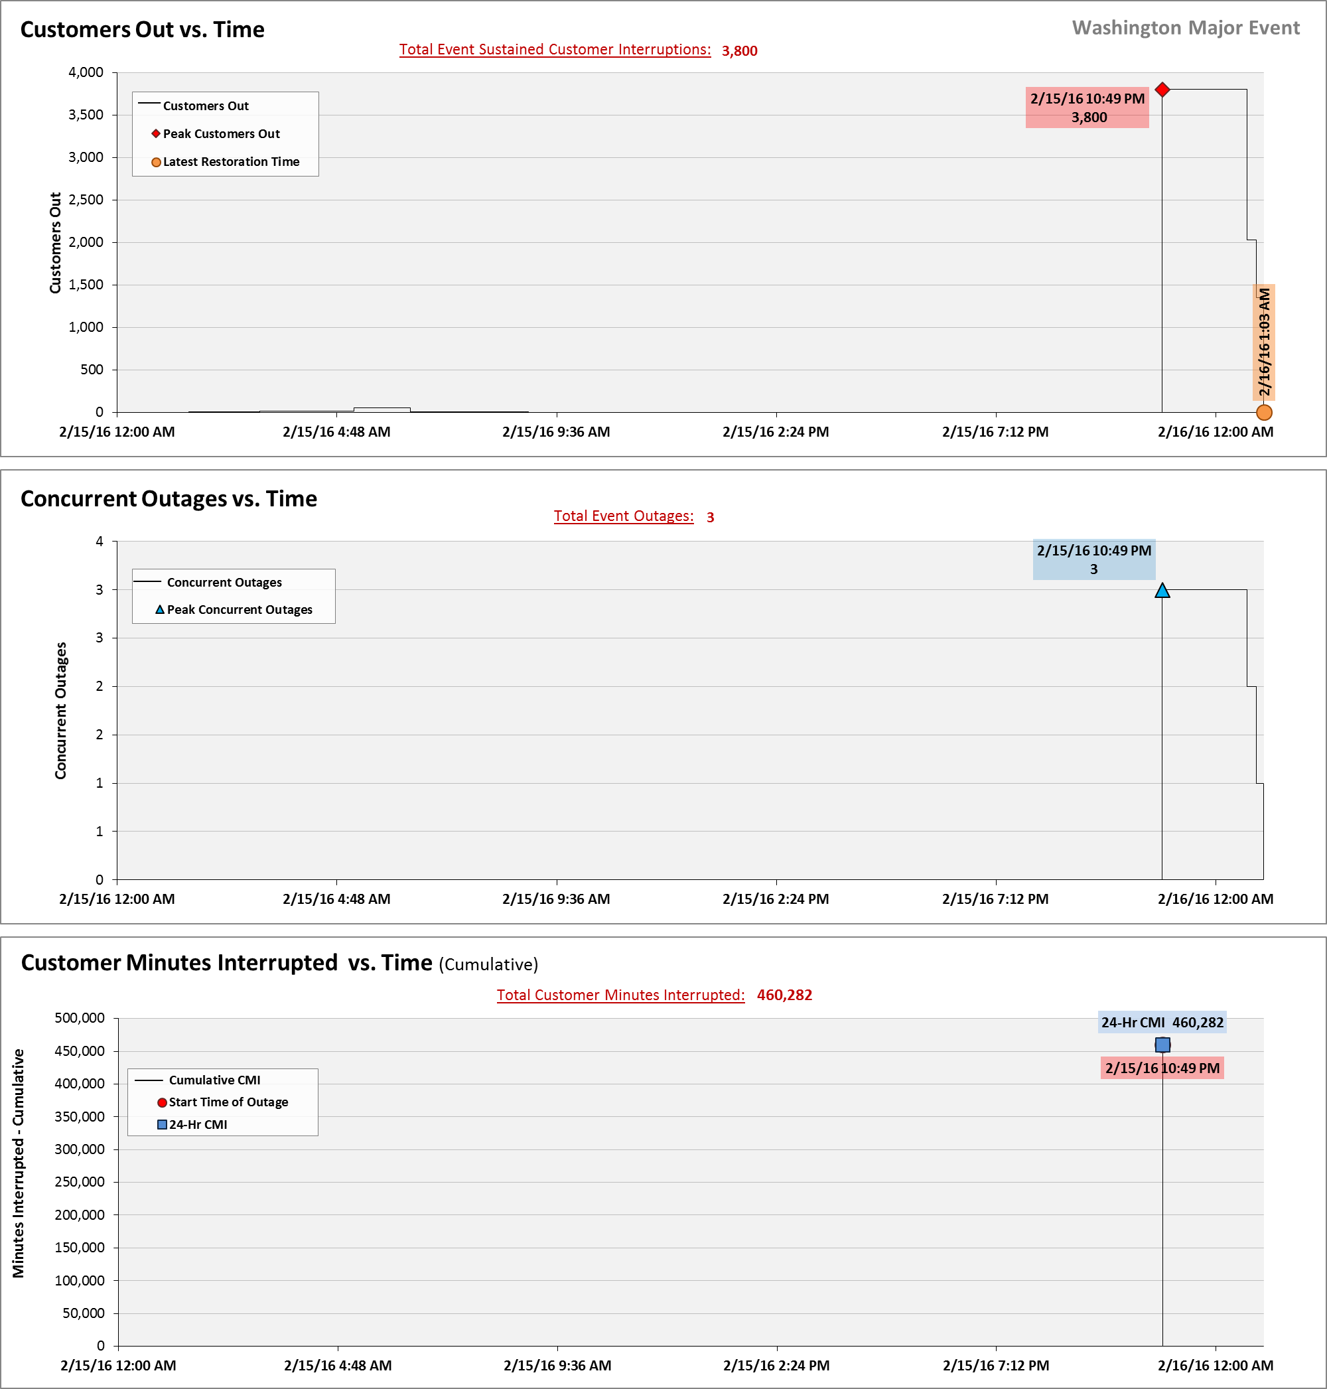

**SAIDI, SAIFI, CAIDI by Reliability Reporting Region**

Please see the attached system-generated reports.

1. A SAIFI-based major event threshold (as identified in PacifiCorp’s reporting plan, pursuant to Washington Administrative Code (WAC) 480-100-393 & 398 Electric Reliability Annual Monitoring and Reporting Plan) is defined as an event in which more than 10% of an operating area’s customers are simultaneously without service as a result of a sustained interruption. Sunnyside operating area’s Calendar 2016 Frozen Customer Count is 24,317 customers.