Rates and Regulatory Affairs

**Facsimile: 503.721.2516**

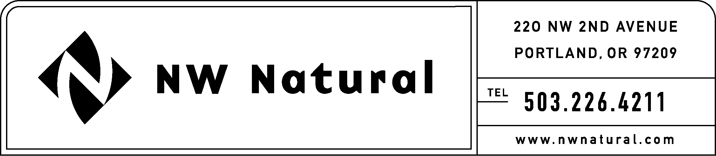

December 16, 2010

***VIA ELECTRONIC FILING***

Dave Danner, Executive Director & Secretary

Washington Utilities and Transportation Commission

1300 S Evergreen Park Drive SW

Post Office Box 47250

Olympia, Washington 98504-7250

**Re: U-100523, Paperless Billing for Gas Customers**

**NW Natural’s Comments**

Dear Mr. Danner:

Northwest Natural Gas Company, dba NW Natural (“NW Natural” or the “Company”), supports the draft rules on paperless billing for gas utility customers, issued by the Washington Transportation and Utility Commission (“Commission”) on December 13, 2010.

NW Natural appreciates the Commission’s continued consideration of the Company’s and other parties’ concerns in this docket. The draft rules, issued on December 13, 2010, represent a good compromise on positions.

Please contact me at (503) 226-4211, extension 3590 if you have questions.

Sincerely,

NW NATURAL

*/s/ Jennifer Gross*

Jennifer Gross

Rates & Regulatory Affairs