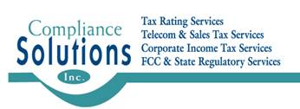

June 30, 2016

Steven V. King

Executive Director and Secretary

Washington Utilities and Transportation Commission

P.O. Box 47250

Olympia, Washington 98504-7250

**RE: Docket No. 110321 -Lifeline Certification on FCC Form 481 – Carrier Annual Reporting Data Collection Form filed on behalf of Telrite Corporation d/b/a Life Wireless**

Dear Staff,

Pursuant to FCC requirements under 47 C.F.R. § 54.422, enclosed please find for filing a copy of Telrite Corporation d/b/a Life Wireless’ FCC Form 481 – Carrier Annual Reporting Data Collection Form.

If you have any questions regarding this filing, please contact me at (407) 260-1011 or regulatory@csilongwood.com.

Respectfully submitted,

Mark Lammert

Attorney-in-Fact

Telrite Corporation d/b/a Life Wireless