December 22, 2015

Roger Hahn, Regulatory Analyst
Washington Utilites and Transportion Commission
1300 South Evergreen Park Drive SW
Olympia, WA 98504-7250

RE: Docket No. UT-152364

Dear Mr Hahn,

Regarding the filing made on December 18, 2015 whereby Ellensburg Telephone Company d/b/a FairPoint Communications filed a tariff revision to introduce a Business Customer Save Offer promotion, we would like to respectfully withdraw the tariff sheets filed in the above referenced docket.

Thank you for your attention to this matter. If you have any questions, please feel free to contact me at 207.535.4249 or bwestman@fairpoint.com

Sincerely,
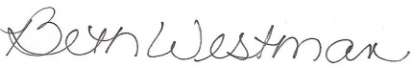

Beth Westman,
State Government Affairs Manager
FairPoint Communications

