February 26, 2013

Seinergy, LLC

Bob Gunn

840 3rd Street

Langley, WA 98260

**RE: Energy Independence Act (EIA) Advisory Opinion Application**

Market-Induced Non-Programmatic Savings; Residential HVAC & Shell

Mr. Gunn:

We reviewed your advisory opinion application regarding methods for documenting energy savings for conservation measures and programs. It is our opinion that your request lies outside of the scope of the legislation—[SSB 6414 Electric Generation Project or Conservation Resource: Review Process](http://apps.leg.wa.gov/documents/billdocs/2011-12/Pdf/Bills/Session%20Laws/Senate/6414-S.SL.pdf)—since your product is not a “conservation resource”, but rather, a process for verification of installed conservation measures.

The Energy Independence Act and Commerce rules already authorize the counting of non-programmatic resources and, pursuant to that authority, utilities have already credited savings from building code changes, appliance efficiency standards, and regional market transformation programs run by the Northwest Energy Efficiency Alliance (NEEA) and BPA toward their Energy Independence Act conservation targets.

For further detail, please refer to the relevant sections of the Commerce rules: [WAC 194-37-060](http://apps.leg.wa.gov/wac/default.aspx?cite=194-37&full=true#194-37-060) and [WAC 194-37-080](http://apps.leg.wa.gov/wac/default.aspx?cite=194-37&full=true#194-37-080). Your services may be of value in helping utilities calculate and document their energy savings from these resources, but verification services are not the conservation resources themselves, and it is the eligibility of conservation resources that the advisory opinion process addresses.

We are fully refunding your application fee. Please let us know if you have further questions. We wish you the best with this effort.

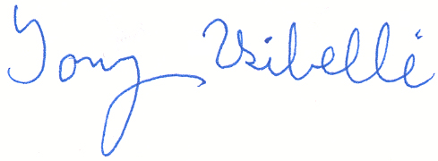Sincerely,

Tony Usibelli

Director, State Energy Office – Washington State Department of Commerce