

April 01, 2010

Advice No. 3666T

David Danner

Executive Director and Secretary

1300 S. Evergreen Park Dr. S.W.

P.O. Box 47250

Olympia, Washington 98504-7250

Dear Mr. Danner:

Qwest Corporation (Qwest) is forwarding for filing the sheet listed on Attachment A.

This filing introduces the City of Carbonado, Washington’s occupational tax rate of 6%. The effective tax rate for billing will be 6.382%. Qwest requests an effective date of

May 1, 2010.

If you have questions concerning this filing please contact me.

Yours very truly,

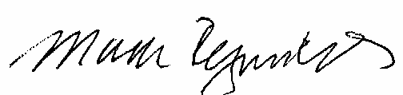

Mark Reynolds

Attachments

Attachment A

Advice No. XXXXT

**EXCHANGE AND NETWORK SERVICES**

**WN U-40**

|  |  |  |
| --- | --- | --- |
| **SECTION** | **SHEET** | **REVISION** |
| 2 | 68 | 8 |
|  |  |  |