

November 24, 2010

Advice No. 3672T

David Danner

Executive Director and Secretary

1300 S. Evergreen Park Dr. S.W.

P.O. Box 47250

Olympia, Washington 98504-7250

Dear Mr. Danner:

Qwest Corporation (Qwest) is forwarding for filing the sheet listed on Attachment A.

This filing establishes the City of Liberty Lake, Washington’s Occupational Tax Rate. The Tax Rate will be 6.0% and the Bill Rate will be 6.382% to be effective on December 26, 2010.

If you have questions concerning this filing please contact me.

Yours very truly,

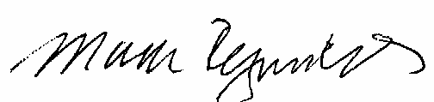

Mark Reynolds

Attachments

Attachment A

Advice No. 3672T

**EXCHANGE AND NETWORK SERVICES**

**WN U-40**

|  |  |  |
| --- | --- | --- |
| **SECTION** | **SHEET** | **REVISION** |
| 2 | 70 | 7 |
|  |  |  |