**EXHIBIT NO. ___(GJZ-1T)   
DOCKETS UE-17___/UG-17___  
2017 PSE GENERAL RATE CASE  
WITNESS:  GREG ZELLER**

**BEFORE THE**

**WASHINGTON UTILITIES AND TRANSPORTATION COMMISSION**

|  |  |
| --- | --- |
| **WASHINGTON UTILITIES AND TRANSPORTATION COMMISSION,**  **Complainant,**  **v.**  **PUGET SOUND ENERGY,**  **Respondent.** | **Docket UE-17____ Docket UG-17____** |

**PREFILED DIRECT TESTIMONY (NONCONFIDENTIAL) OF**

**GREG J. ZELLER**

**ON BEHALF OF PUGET SOUND ENERGY**

**JANUARY 13, 2017**

**PUGET SOUND ENERGY**

**PREFILED DIRECT TESTIMONY** **(NONCONFIDENTIAL**) **OF  
GREG J. ZELLER**

**CONTENTS**

I. INTRODUCTION 1

II. PSE’S SERVICE QUALITY PROGRAM 2

III. CUSTOMER CARE CENTER SERVICE QUALITY INDICES 6

IV. EVOLVING CHANNELS OF COMMUNICATIONS 11

V. PROPOSED CHANGE TO SQI NO. 5 16

VI. PSE’s OUTAGE MANAGEMENT AND CUSTOMER INFORMATION SYSTEMS 18

VII. CUSTOMERS’ EVOLVING EXPECTATIONS 20

VIII. CONCLUSION 22

**PUGET SOUND ENERGY**

**PREFILED DIRECT TESTIMONY** **(NONCONFIDENTIAL**) **OF  
GREG J. ZELLER**

# I. INTRODUCTION

Q. Please state your name, business address, and position with Puget Sound Energy.

A. My name is Greg Zeller. My business address is 10885 N.E. Fourth Street, Bellevue, WA 98004. I am the Director Customer Care for Puget Sound Energy (“PSE”).

Q. Have you prepared an exhibit describing your professional qualifications?

A. Yes, I have. It is Exhibit No. ___(GJZ-2).

Q. What are your duties as Director Customer Care for PSE?

A. I am responsible for the strategy and overall operations of customer services including the call center, customer experience (customer self-service channels), applications support for call center technologies, billing services, credit and collection services, customer related field and metering services, meter maintenance and support, and business reporting and analytics. I direct efforts to meet certain service quality indices as mandated by the Washington Utilities and Transportation Commission (“Commission”) and key business performance indicators, tariff requirements, WAC and RCW rules, and customer privacy security regulations and policies.

Q. What is the nature of your testimony in this proceeding?

A. My testimony provides an overview of PSE’s Service Quality Index (“SQI”) Program and PSE’s recommendation to modify SQI No. 5 – Customer Access Center Answering Performance metric PSE is proposing to include the Integrated Voice Response (“IVR”) self-service transactions in the calculation in order to better reflect today’s customer service expectations. The SQI No. 5 measurement has not changed since 1997 when it was originally established and measures only one currently declining customer contact channel. Customer’s expectations for greater self-service choice and better service have changed significantly since 1997. There is a growing segment of the PSE customers who expect more sophisticated self-serve options, and with recent technology upgrades PSE has begun to enable more self-serve communication channels. Customers are responding enthusiastically to the new self-serve channels and PSE is experiencing increased customer utilization.

# II. PSE’S SERVICE QUALITY PROGRAM

Q. Please describe PSE’s Service Quality Program.

A. PSE first implemented its Service Quality Program ("SQ Program") in 1997 pursuant to Dockets UE-951270 and UE-960195, the dockets approving the merger of Washington Natural Gas Company and Puget Sound Power & Light Company ("Merger"). The purpose of the SQ Program is to “provide a specific mechanism to assure customers that they will not experience deterioration in quality of service”[1] and to “protect customers of PSE from poorly-targeted cost cutting”[2] as a result of that Merger.

The SQ Program includes three components:

1. Customer Service Guarantee: The Customer Service Guarantee provides for a $50 missed appointment credit for both natural gas and electric service. This guarantee became effective in 1997.
2. Restoration Service Guarantee: The Restoration Service Guarantee provides for a $50 electric outage restoration credit to a qualified PSE electric customer. This guarantee was established in 2008.
3. Service Quality Indices: PSE currently reports semiannually and annually to the UTC on nine SQIs. The table below shows the indices, their associated benchmark, and PSE’s 2015 SQI performance.

| **Table 1 - SQ Program Components** | | | |
| --- | --- | --- | --- |
| **SQI No.** | **Service Quality Index** | **Annual Benchmark** | **2015 SQI Performance** |
| 2 | UTC Complaint Ratio | 0.40 complaints per 1000 customers, including all complaints filed with UTC | 0.23 |
| 3 | SAIDI (System Average Interruption Duration Index) | 320 minutes per customer per year | 272[3] |
| 4 | SAIFI (System Average Interruption Frequency Index) | 1.30 interruptions per year per customer | 1.11 |
| 5 | Customer Access Center Answering Performance | 75 percent of calls answered by a live representative within 30 seconds of request to speak with live operator | 70 percent |
| 6 | Customer Access Center Transactions Customer Satisfaction | 90 percent satisfied (rating of 5 or higher on a 7-point scale) | 94 percent |
| 7 | Gas Safety Response Time | Average of 55 minutes from customer call to arrival of field technician | 29 |
| 8 | Field Service Operations Transactions Customer Satisfaction | 90 percent satisfied (rating of 5 or higher on a 7-point scale) | 96 percent |
| 10 | Kept Appointments | 92 percent of appointments kept | 100 percent |
| 11 | Electric Safety Response Time | Average of 55 minutes from customer call to arrival of field technician | 54 |

Q. Please describe the evolution of PSE’s Service Quality Program.

A. The SQ Program began in 1997 and was to be in effect for five years. The SQ Program mechanics outlined the benchmarks, the potential penalty calculations, and the reporting requirements.

The SQ Program was extended for a minimum of five years as part of the settlement in PSE’s 2001 general rate case, UE-011570 and UG-011571 (consolidated).[4]

In 2007, Puget Holdings, LLC and PSE filed an application seeking approval of the acquisition of Puget Energy by Puget Holdings LLC, an investor consortium. The first commitment made by the Joint Applicants in that docket was that PSE would continue its SQ Program. As part of a multi-party settlement stipulation, PSE and Puget Holdings ultimately committed “to continue the Service Quality measures currently in place for PSE or as may be modified in any future proceeding.” [5] The Commission approved the merger and the commitments made by PSE.

The choices customers have to interact with PSE are evolving and the customer behavior has changed significantly since 1997 when the metrics were established. The number of customers using the self-serve channels is increasing, which is addressed later in the testimony. In order to respond to customer expectations, PSE is focused on expansion support and management of the new self-serve channels. The changing customer expectations and PSE’s improved technology capabilities support this evolution.

# III. CUSTOMER CARE CENTER SERVICE QUALITY INDICES

Q. What are the current service quality indices pertaining to PSE’s Customer Care Center performance?

A. There are three indices that measure PSE’s Customer Care Center performance:

* SQI No. 2 –UTC Complaint Ratio,
* SQI No. 5 – Customer Access Center Answering Performance, and
* SQI No. 6 – Customer Access Center Transactions Customer Satisfaction.

Q. How does PSE calculate SQI No. 2 – UTC Complaint Ratio performance?

A. The UTC complaint ratio is calculated by dividing the sum of all gas and electric complaints reported to the UTC by the average monthly number of PSE customers. The quotient is then multiplied by 1,000. The formula follows:

|  |  |  |
| --- | --- | --- |
| **UTC complaint ratio =** | **electric and gas complaints recorded by UTC** | **X 1,000** |
| **average monthly number of electric and gas customers** |

The average monthly customer count is the average of the total number of PSE customers, per month, during the reporting period. The SQI No. 2 benchmark is no more than 0.40 complaints per 1,000 customers, including all complaints filed with the Commission.

Q. Please describe PSE’s performance on SQI No. 2.

A. PSE has met the benchmark every year since the SQ Program started in 1997.

Figure 1 - UTC Complaint Ratio Performance

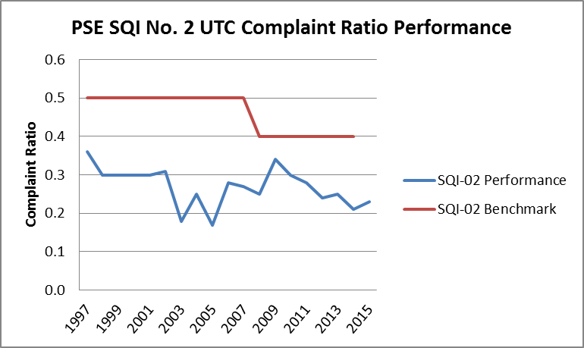

Q. How does PSE calculate its SQI No. 5 (Customer Access Center Answering Performance)?

A. SQI No. 5 measures the amount of time from when a customer initiates a request to speak with alive Customer Care Center representative until a representative arrives on the line.

The annual performance is determined by the average of the 12 monthly call answering performance percentages. The calculation of the monthly answering performance is demonstrated through the following formula:

|  |  |
| --- | --- |
| *Monthly call answering performance =* | *aggregate number of calls answered by a company rep within 30 seconds* |
| *aggregate number of calls received* |

PSE is currently required to achieve a benchmark of 75 percent of calls answered within 30 seconds.

Q. Please describe PSE’s performance on SQI No. 5.

A. The graph below illustrates PSE’s performance on SQI No. 5 since the inception of the SQI program.

Figure 2 - 1997-2015 SQI No. 5

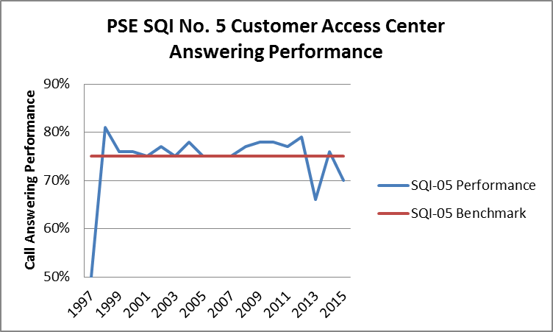

Since 1997, PSE has been meeting the SQI No. 5 benchmark of 75 percent for most of the reporting years except 1997, 2013, and 2015. In 2015, PSE’s Customer Care Center representatives answered 70 percent of calls within 30 seconds of customer requests, which is below the 75 percent benchmark. There were three contributing factors to this: 1) a change in bill collection and disconnect procedure, 2) unseasonal outage and storm activity, and 3) unexpected staff turnover including impacts of new-hire training.

The primary cause for missing the 2013 benchmark by 9 percent was due to the major technology improvements; however PSE was granted approval of its petition for penalty mitigation.[6]

**Q. How does PSE calculate SQI No. 6 (Customer Access Center Transactions Customer Satisfaction performance)?**

A. On a weekly basis, EMC Research Inc., an independent research company, conducts phone surveys to customers who have made calls to PSE following the survey procedures established in consolidated Dockets UE-011570 and UG-011571.[7] The survey question pertaining SQI No. 6 is as follows:

Overall, how would you rate your satisfaction with this call to Puget Sound Energy? Would you say 7 – completely satisfied, 1- not at all satisfied or some number in between?

Customers are considered to be satisfied if they responded 5, 6 or 7. The annual performance is determined by the monthly weighted average percent of satisfied customers. The formula for the monthly percentage follows:

|  |  |
| --- | --- |
| *Monthly percentage of satisfied customers =* | *aggregate number of survey responses of 5, 6 or 7* |
| *aggregate number of survey responses of*  *1, 2, 3, 4, 5, 6 or 7* |

PSE must meet a customer satisfaction percentage of at least 90 percent.

Q. Please describe PSE’s performance on SQI No. 6.

A. The graph below illustrates PSE’s performance on SQI No. 6 since the inception of the SQI program.

Figure 3 - 1997-2015 SQI No. 6

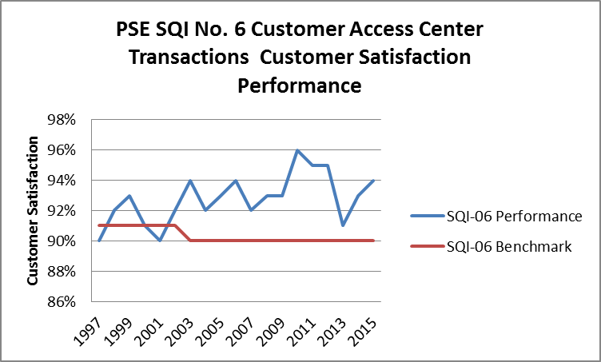

As demonstrated above, PSE has consistently met the SQI No. 6 benchmark since 2002.

Q. How did PSE’s performance on SQI No. 6 compare to its performance on SQI No. 5 in 2013 and 2015?

A. Figure 4, below, illustrates PSE’s performance on SQI No. 5 and SQI No. 6 since the inception of the SQI program.

Figure 4 - 1997 to 2015 SQI No. 5 and No. 6 Performance

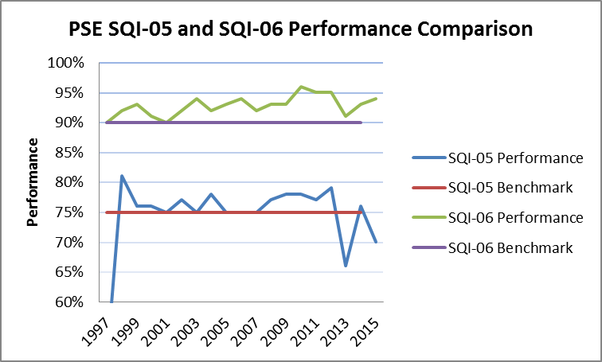

SQI No. 6 was met or exceeded during 2013 and 2015 when PSE did not meet the benchmark for SQI No. 5. In 2013, SQI No. 6 performance was 91 percent and in 2015, it was 94 percent, demonstrating that customer satisfaction remained high even in the years when less than 75 percent of calls were answered within 30 seconds.

# IV. EVOLVING CHANNELS OF COMMUNICATIONS

Q. How have customer calls changed over the years?

A. The availability of customer self-serve channels of communication has influenced PSE’s incoming calls. A significant segment of PSE customers utilize Integrated Voice Response (“IVR”) to complete self-serve transactions for outage, account balance, credit card payments and setup of installment plans.

There is a growing customer segment that prefers the web, mobile applications, and social media channels to relay and receive information from PSE. These self-serve alternatives to phone calls were virtually unheard of when SQI No. 5 was established in 1997.

Q. What is an automated self-service communication channel?

A. The automated self-serve channels include IVR, web, mobile device, electronic mail and social media; essentially any mode of communication between a customer and PSE that does not involve speaking directly to a PSE Customer Care Center agent or a communication method that enables customers to complete their request by themselves at their convenience.

Q. How has PSE responded to increased customer preference for automated self-serve channels?

A. The customer information system (“CIS”) project completed by PSE in 2013 set the foundation necessary to begin to offer automated self-serve channels to customers. In 2014, PSE made technology upgrades to its IVR capabilities and launched its web/mobile outage map and application. In 2015, customers completed approximately fourteen milliontransactions via self-serve channels. Figure 5 reflects growth in the various self-serve channels since the 2013 technology upgrades through September 30, 2016.

Figure 5 - 2013 - 9/30/2016 Customer Self-Serve Transactions

*The IVR channel –* The IVR Self Service channel provides capabilities for the customer to complete an outage report, inquire about account balance, make a payment and establish an installment plan from a phone call without any wait time. In 2014, improvements were made to the IVR resulting in improved IVR utilization for these transactions. In the November 2014 JD Power Summary of Changes customer survey[8] results, customers reported a 28 percent improvement in ease of IVR menu prompts over the 2013 survey results. Figure 6 reflects the customer phone calls handled by the IVR and Customer Care Center representatives. There is a significant increase in the IVR-handled phone calls starting in October 2014 when the IVR improvements were introduced. The 2016 IVR transactions through September 30, 2016 continues to exceed the number of agent handled calls indicating higher utilization of the IVR self-serve channel.

Figure 6 - Total Successful IVR and Agent Handled Phone Calls  
(Jan. 1, 3013-Sept. 30, 2016)



*The web transactions -* The web capabilities on PSE.com and my.PSE.com have evolved significantly. PSE has developed web self-serve transactions including energy usage analysis, payment, bill history, and start/stop service. Figure 7 reflects the percentage of web self-serve transactions excluding outages reflecting a high utilization by customers specifically for billing and payment.

Figure 7 - Web Self-Serve Transactions 2013- 9/30/2016

*Web and Mobile for Outage Status-* PSE upgraded its technology in 2014 to enhance customers’ web and mobile capabilities for outage reporting and outage status inquiry. In 2015 there were approximately 1.6 million self-serve outage transactions for the outage map on the PSE website and approximately half a million mobile outage customer transactions. This represents customers either reporting an outage or inquiring about an outage status. Customers are using this self-service channel to obtain periodic updates during a storm or other outage event.

*E-mail and Text Messaging -* PSE currently utilizes email and to a lesser extent text messaging to communicate with its customers. Use of texting will increase as PSE begins to enable pro-active notifications and communicate via customer preference.

*Social Media* - PSE is engaged with customers on social media channels Facebook and Twitter. PSE maintains an inter-company social media communication protocol for all Customer Care Center inquiries that are received through this channel. The inquiry is forwarded to the Customer Care Center supervisor for direct customer resolution. As of December 31, 2015, PSE had approximately 53,000 active followers on Facebook and Twitter. The social media channels are heavily used during storms. Customers use Flicker, a web-based image application, to post pictures of storm damage and restoration progress. PSE anticipates that more customers will begin to use this channel because it enables PSE to proactively communicate with customers via their mobile devices.

Q. How do customers access automated self-service channels?

A. In order to access the IVR self-serve channel, a customer will make a phone call to the Customer Care Center. In order to access the web, mobile device applications, electronic mail and social media self-serve channels, a customer uses a computer, smart phone, or other hand held electronic device.

# V. PROPOSED CHANGE TO SQI NO. 5

Q. How should the Customer Care Center performance be assessed if the current SQI No. 5 does not measure how customers interact with PSE today?

A. The SQI-No. 5 measure should be modified to include IVR transactions as well as transactions handled by a live agent because both types of transactions are originated by a phone call to PSE. The current SQI-No. 5 calculation is no longer a representative measure of customer satisfaction because of the number of customers successfully transacting through the IVR. Customers are increasing their use of self-serve channels, and PSE is experiencing declining live agent-customer contact. The current SQI No. 5 measures a contact channel that is being transformed progressively by self-serve channels. Such self-serve channels did not exist in 1997, when SQI No. 5 was established. In fact, the self-serve channels that have been expanded through the 2013 technology upgrade have set the foundation for the continued growth of self-serve capabilities.

**Q. What about the customers who do not have access to the internet or a smart phone?**

A. For those customers, PSE’s Customer Care Center is always able to help them via a phone call. They will not experience any deterioration in service quality when they call PSE.

Q. **What does PSE propose for the measurement of customer contact with PSE’s Customer Care Center?**

A. The SQI No. 5 measure should be modified to include both live calls as well as calls that do not require a live agent, as measured through the IVR transactions. As discussed earlier, customers access the IVR channel by initiating a phone call, and many transactions can be completed by the customer without ever requiring an interaction with a live agent. The IVR transactions should be treated equally to those involving a live agent and, therefore, the number of IVR transactions should be included in both the numerator and the denominator of the measure. As indicated in PSE’s August 2015 customer communication preference survey (as shown in Figures 8 and 9) and the decreasing trend in the number of calls requesting to speak with a Customer Care Center representative, the current SQI No. 5 calculation is no longer a good measure of PSE’s customer contact performance. To better meet customer’s changing expectation and need, it is appropriate to include the transactions completed through the IVR self-service channel with the Customer Care Center performance. The benefit to customers of the IVR is that it allows them to complete certain simple transactions, on their own, on their schedule rather than only during the 7 a.m. to 7 p.m. Customer Care Center business hours.

# VI. PSE’s OUTAGE MANAGEMENT AND CUSTOMER INFORMATION SYSTEMS

Q. Do PSE’S new outage management system (“OMS”) and CIS effect Customer Care Center operations?

A. Yes.

Q. How so?

A. The 2013 implementation of OMS and CIS has enabled integration among different systems, which has enhanced operational performance reporting and enabled integrated web and mobile self-serve transactions, as shown in Figure 5.

Q. What technology, process and training improvements have occurred in the last three years at PSE’s Customer Care Center?

A. The following is a chronology of the changes that have occurred since 2013:

2013 – New CIS and OMS were implemented in April, 2013.

2014 – PSE was focused on stabilizing the current CIS and OMS environments and enabling new technology capabilities to provide more self-serve choices for customers.

The web and mobile outage capabilities have enabled an increase in self-service customer transactions and have resulted in decreased phone calls during storms. Customers are accessing this self-service channel during storms for outage reporting and periodic updates. As PSE builds the capability for proactive outage communications to customers through mobile channels, PSE fully expects more customers will use the mobile channel, ultimately reducing calls to the Customer Care Center.

PSE anticipates that, over time, the ability for a customer to report an outage through a mobile device or the web will reduce the number of calls to the Customer Care Center.

The IVR upgrade in the fourth quarter of 2014 included a Cisco[9] phone system upgrade and enhanced authentication integration with the CIS. In addition, there were IVR menu prompt changes, which improved the outage reporting, and status update, enhanced menu path for Spanish speaking customers, and increased payment arrangement transactions. This resulted in increased IVR utilization in 2015 and through September 2016.

2015 – PSE made business transaction enhancements to enable OMS technology capabilities. The Customer Care Center continued operational integration with call skill management technique training. PSE implemented more proactive collection practices, which had a latent effect on the Customer Care Center call volume. PSE also revised its customer bill format, which was last updated in 1998.

2016 – PSE deployed billing and payment improvements to the bill payment presentment, account status on the web, streamlined the IVR and web customer experience, outage text communication, and made improvements to the self-service start/stop/transfer transaction web tool.

# VII. CUSTOMERS’ EVOLVING EXPECTATIONS

Q. What other trends are you observing that are likely to affect Customer Care Center answering performance?

A. PSE customers’ increasingly prefer interacting with PSE through multiple self-serve communication channels, including online and mobile phone applications. Many of PSE’s customers are accustomed to interacting with retail and service providers through smart devices, and they expect similar self-service experiences to be offered by PSE. They want the ability to handle their business at all hours of the day or night, with no agent interaction.

Q. Have you completed customer communication preference surveys and, if so, what were the results?

A. Yes. A customer communication preferences survey was conducted on PSE’s residential research panel in August 2015. The residential research panel is comprised of about 2,000 residential customers from across the PSE service territory. It was originally recruited in 2013 by mail invitation. Panelists were told to expect 1-2 surveys per month, with topics ranging from energy efficiency, program ideas, and other utility- or energy-related issues. The panel has been used to field surveys about customer communication preferences, testing outage map design, the redesigned bill, and various program ideas. These online surveys are processed via email.

Out of the 2,000 customers surveyed approximately thirteen hundred customers responded to the communication preference survey. Eighty percent of the customers who responded indicated that they prefer to communicate with PSE using a self-serve channel like the IVR, website, and/or a mobile phone application. In addition, they indicated that they prefer to receive pro-active notifications from PSE through email and text messaging.

Figure 8 shows a strong customer preference for non-agent transactions through the web/mobile, IVR, and email/chat/social. Figure 9 reflects a strong notification preference for email and text messaging. Proactive text messaging reflects an increased preference during outage events.

Figure 8 - 2015 Customer Communication Preference Survey Results

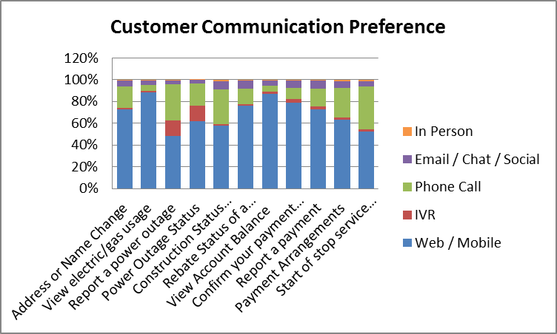

Figure 9 - 2015 Customer Preference Pro-active Notification Survey Results

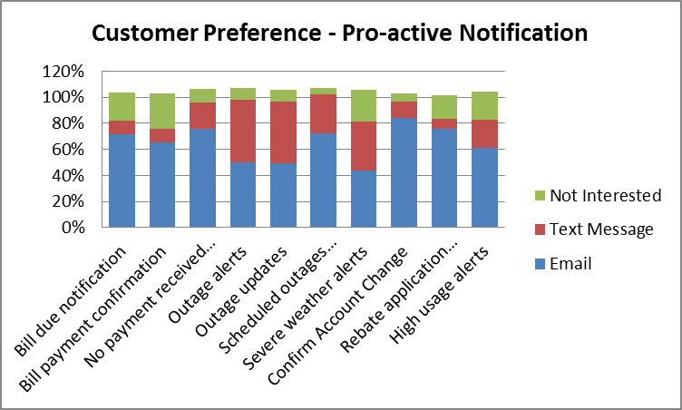

# VIII. CONCLUSION

Q. Does that conclude your testimony?

A. Yes, it does.

1. Docket Nos. UE-951270 and UG-960195, Fourteenth Supplemental Order Accepting Stipulation (Feb. 5, 1997) (Stipulation at 11:11-15).
2. *Id.,* Fourteenth Supplemental Order at 32.
3. Taking effect in SQI reporting year 2016, the target for PSE SQI SAIDI is set to 155 outage minutes per customer.  The target and PSE’s performance will be reported in PSE’s Service Quality Report Card, and any failure to meet the target for consecutive years will also be noted in the Service Quality Report Card.  However, the current SQI penalty for any failure by PSE to meet its SQI SAIDI benchmark is removed for reporting years 2016 and after.
4. Updated Appendix 2 to Exhibit J in the Twelfth Supplemental Order in Docket Nos. UE-011570 and UG-011570 (consolidated) as in the January 18, 2015 compliance filing of the appendix per Order No. 25 of Docket Nos. UE-072300 and UG-072301 (consolidated)–,

   <http://www.utc.wa.gov/_layouts/CasesPublicWebsite/GetDocument.ashx?docID=2104&year=2007&docketNumber=072300>
5. *In re Joint Application of Puget Holdings LLC and Puget Sound Energy, Inc., For an Order Authorizing Proposed Transaction*, Docket U-072375, Order 08 Approving and Adopting Settlement Stipulation; Authorizing Transaction Subject to Conditions, Appendix A to Attachment A at 1.
6. Dockets UE-072300 and UG-072301, Order 24 Final Order Granting Petition for Mitigation (April 29, 2014).
7. PSE’s compliance filing pursuant to the paragraph 13 of Order 21 of Dockets UE-072300 and UG-072301 (consolidated), Granting in Part, and Denying in Part, Puget Sound Energy, Inc's Petition for Waiver and Suspension of Service Quality Index Nos. 6 and 8 (June 21, 2013).
8. JD Power November 2014, Current JD Power Scorecard Metrics - Summary of Changes.
9. PSE’s phone system provider, Cisco Systems, Inc., is an American multinational technology company headquartered in San Jose, California, that designs, manufactures and sells networking equipment.