**Via email and U.S.P.S.**

Washington Utilities and Transportation Commission

1300 S Evergreen Park Dr SW

Olympia, WA 98504-7250

Re: City of Woodinville v. Eastside Community Rail/Ballard Terminal Railroad Company

TR-143902 and TR-143903

Dear Commission,

Attached, please find the original and three copies of ECYR’s response, including attachments.

Also, the Declaration of Service is enclosed.

Respectfully,

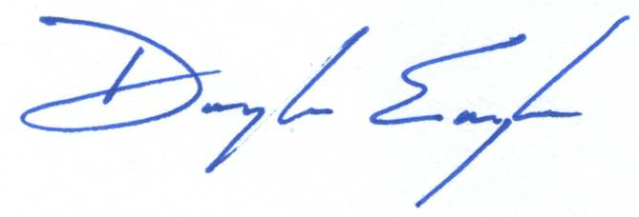

Douglas Engle

Managing Director

Eastside Community Rail, LLC