June 1, 2015

VIA U.S. MAIL AND EMAIL

Steven King – Executive Director/Secretary

Washington Utilities and Transportation Commission

1300 S. Evergreen Park Drive S.W.

P.O. Box 47250

Olympia, WA 98504-7250

**RE: YAKAMA NATION’S POST-HEARING BRIEF FOR TR-140382 and TR-14083**

Dear Director King:

Enclosed please find originals and three copies of the following documents for each above-referenced docket/matter number:

* POST-HEARING BRIEF OF INTERVENOR YAKAMA NATION

The documents, including this cover letter, have also been submitted electronically, and copies have been sent to all interested parties via electronic mail and U.S. Mail, and to the presiding administrative law judge via electronic mail.

Sincerely yours,

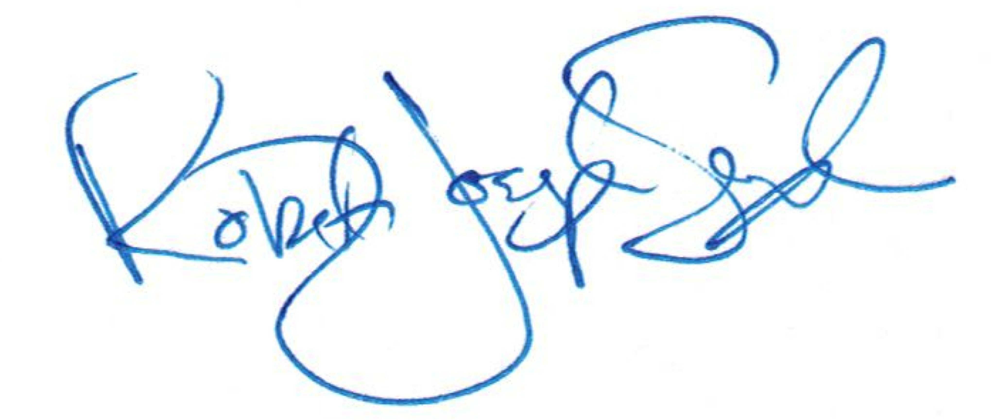

R. Joseph Sexton

Attorney at Law

[joe@galandabroadman.com](mailto:joe@galandabroadman.com)

Enclosures: Original Post-Hearing Brief w/ Copies

cc: Yakama Nation Office of Legal Counsel