

August 12, 2010

Advice No. 3668T

David Danner

Executive Director and Secretary

1300 S. Evergreen Park Dr. S.W.

P.O. Box 47250

Olympia, Washington 98504-7250

Dear Mr. Danner:

Qwest Corporation (Qwest) is forwarding for filing the sheet listed on Attachment A.

This filing increases the City of Maple Valley, Washington’s Occupational Tax Rate and the Effective Tax Rate for billing from 2.25% to 3.0%. Qwest respectfully requests less than statutory consideration of this filing, allowing for an effective date of August 23, 2010. Qwest apologizes for the short timeline.

If you have questions concerning this filing please contact me.

Yours very truly,

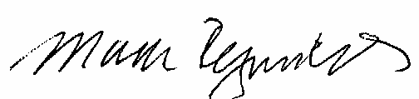

Mark Reynolds

Attachments

Attachment A

Advice No. 3668T

**EXCHANGE AND NETWORK SERVICES**

**WN U-40**

|  |  |  |
| --- | --- | --- |
| **SECTION** | **SHEET** | **REVISION** |
| 2 | 70.1 | 2 |
|  |  |  |