EXHIBIT NO. ___(LEA-1T)
DOCKET NO. UG-15____
WITNESS: LARRY E. ANDERSON

BEFORE THE
WASHINGTON UTILITIES AND TRANSPORTATION COMMISSION

In the Matter of the Petition of  PUGET SOUND ENERGY, INC.  for (i) Approval of a Special Contract for Liquefied Natural Gas Fuel Service with Totem Ocean Trailer Express, Inc. and (ii) a Declaratory Order Approving the Methodology for Allocating Costs Between Regulated and Non-regulated Liquefied Natural Gas Services | DOCKET NO. UG-15____

PREFILED DIRECT TESTIMONY (NONCONFIDENTIAL) OF
LARRY E. ANDERSON
ON BEHALF OF PUGET SOUND ENERGY, INC.

AUGUST 11, 2015

PUGET SOUND ENERGY, INC.
PREFILED DIRECT TESTIMONY (NONCONFIDENTIAL) OF
LARRY E. ANDERSON
CONTENTS
I. INTRODUCTION 1
II. DESCRIPTION OF THE GAS DISTRIBUTION SYSTEM UPGRADES 2
A. Four Miles of New Piping to Connect the Tacoma LNG Facility to the PSE Natural Gas Distribution System 3
B. Installation of Piping Around the Golden Given Limit Station and the New Limit Station 4
C. Frederickson Gate Station Upgrades 5
D. System Adjustments Needed to Facilitate Injection Into the PSE Natural Gas Distribution System 6
E. Projected Costs of the Gas Distribution System Upgrades 7
III. GAS SYSTEM PLANNING FOR THE TACOMA LNG PROJECT 7
A. Gas System Planning Overview 7
B. Prior 10-year Plans 8
C. Analysis of New Loads 10
D. History of the Tacoma LNG Project Analysis 11
IV. CONCLUSION 12

PUGET SOUND ENERGY INC.
PREFILED DIRECT TESTIMONY (NONCONFIDENTIAL) OF
LARRY E. ANDERSON

I. INTRODUCTION
Q. Please state your name, business address, and occupation.
A. My name is Larry E. Anderson. My business address is 10885 NE 4th Street, P.O. Box 97034, Bellevue WA 98009-9734. I am Supervisor Engineering for Gas System Integrity, System Planning, at Puget Sound Energy, Inc. (“PSE”).
Q. Have you prepared an exhibit describing your education, relevant employment experience, and other professional qualifications?
A. Yes, I have. It is Exhibit No. ___(LEA-2).
Q. What are some of your duties as Supervisor Engineering, Gas System Planning?
A. I supervise the Gas System Integrity-Gas Planning group that analyzes the capacity of PSE’s natural gas system. When new customers request service, the group investigates to determine if the new load would reduce the system performance below acceptable levels and, if so, develops acceptable system reinforcements to allow the additional load. The group develops the long range plan of system reinforcements to handle the predicted general load growth and go through the budgeting process to prioritize their funding. The group develops a Cold Weather Action plan each year to direct curtailments of customers on interruptible rate schedules and manual interventions to keep firm customers on line during cold weather events. The group also provides support to Gas Operations during planned maintenance and emergency operations.
Currently, I am working as the Project Engineer for the distribution improvement projects to serve the proposed Tacoma Liquefied Natural Gas Facility (the “Tacoma LNG Facility”). The Tacoma LNG Facility and the distribution improvement projects to serve the Tacoma LNG Facility are referred to collectively as the “Tacoma LNG Project” in PSE’s testimony and supporting exhibits.
Q. Please summarize the purpose of your prefiled direct testimony.
A. My testimony describes the distribution system upgrades necessary to connect the Tacoma LNG Facility to the PSE gas distribution system for both use as a peak day resource and a source of LNG for LNG Fuel Supply service. My testimony also provides cost projections and a general description of how system improvement planning is conducted and how multiple options are analyzed.

II. DESCRIPTION OF THE GAS DISTRIBUTION
SYSTEM UPGRADES
Q. Please describe the upgrades to connect the Tacoma LNG Facility to the PSE gas distribution system.
A. There are three primary area upgrades to connect the Tacoma LNG Project to the PSE gas distribution system:
1) four miles of new piping will connect the Tacoma LNG Facility to the PSE natural gas distribution system;
2) one mile of piping along the Golden Given Rd E and the installation of the new Golden Given Limit Station; and
3) upgrades to the Frederickson Gate Station.
Please see Figure 1 below for a map of the gas distribution system upgrades.
Figure 1. Map of Natural Gas Distribution System Upgrades
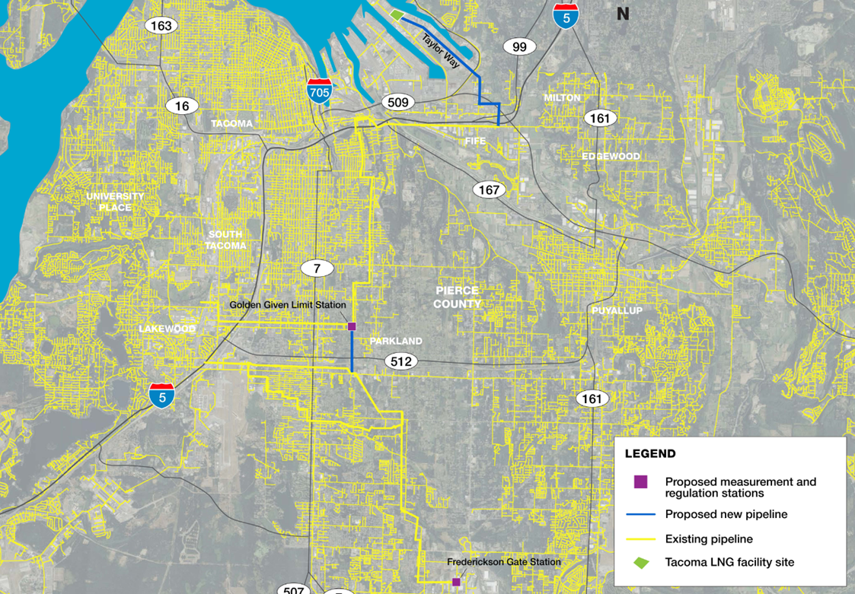

A. Four Miles of New Piping to Connect the Tacoma LNG Facility to the PSE Natural Gas Distribution System
Q. Please describe the four miles of new piping to connect the Tacoma LNG Facility to the PSE natural gas distribution system.
A. PSE will install a new 16-inch line from the existing North Tacoma high pressure line beginning near the intersection of 20th Street East and 62nd Avenue East in Fife, Washington, and extending the new line to the Tacoma LNG Facility at Taylor Way and East 11th Street at the Port of Tacoma. The route will generally follow 62nd Avenue East, East 12th Street, 54th Avenue East and Taylor Way in Fife and Tacoma.
Q. Why is it necessary to install four miles of new 16-inch piping to connect the Tacoma LNG Facility to the PSE natural gas distribution system?
A. The new 16-inch line will be used to (i) supply natural gas to the Tacoma LNG Facility for liquefaction and (ii) transport vaporized natural gas from the Tacoma LNG Facility to the distribution system when required to provide a peak day resource to the system. The same pipe will be used for both functions.

B. Installation of Piping Around the Golden Given Limit Station and the New Limit Station
Q. Please describe the one-mile of piping along Golden Given Rd E and the installation of the new Golden Given Limit Station.
A. PSE will install one mile of 12-inch high pressure pipe north along Golden Given Road East from the existing 12-inch high pressure line at the intersection of Golden Given Road East and 112th Street South in Tacoma to the existing 8-inch high pressure line just north of 96th Street South in Tacoma. PSE will also install a Golden Given Limit Station on PSE property near the intersection of 99th Street East and 10th Avenue East in Tacoma. The purpose of the new limit station is to reduce the natural gas pressure from an inlet maximum allowable operating pressure (“MAOP”) of 490 pounds per square inch gage (“psig”) to an outlet MAOP of 250 psig.
Q. Why is it necessary to install one-mile of piping around the Golden Given Limit Station and the new limit station?
A. Currently, the Tacoma natural gas distribution system is served from the North Tacoma high pressure line and the South Tacoma high pressure line. These two lines operate independently, both serving limit stations feeding the remainder of the natural gas distribution system. The addition of the Tacoma LNG Facility natural gas load will exceed the capacity of the North Tacoma high pressure line unless reinforcement actions are taken to increase system capacity. Installation of the one-mile of piping around the Golden Given Limit Station and the installation of the new limit station connect the North Tacoma high pressure line and the South Tacoma high pressure line, thereby allowing the South Tacoma high pressure line to take up more of the load and increase overall system capacity.

C. Frederickson Gate Station Upgrades
Q. Please describe the upgrades to the Frederickson Gate Station.
A. The current Fredrickson Gate Station has a delivery capacity of 2.356 million cubic feet per hour (“MMcf/h”). The current peak design day is 92% of this capacity, and the addition of the volumes for the Tacoma LNG Facility would exceed the capacity of the Fredrickson Gate Station. PSE will therefore rebuild the Fredrickson Gate Station to serve 6 MMcf/h, which will meet anticipated loads, including the Tacoma LNG Facility, for the next 20 years.

D. System Adjustments Needed to Facilitate Injection Into the PSE Natural Gas Distribution System
Q. Please describe adjustments to the PSE Natural Gas Distribution System needed to facilitate the injection into the system for peak day resourcing.
A. In order to inject into the system, the system pressure must be less than the injection pressure. Only small adjustments and monitoring will be required for injection requirements up to a volume of approximately 69 million cubic feet per day (“MMCFD”) (19 MMCFD supply diversion and 50 MMCFD injection). When the injection requirements exceed this level, up to the planned 85 MMCFD in about 2021, the pressure out of the North Tacoma Gate Station will need to be reduced by approximately 20 psig. This gate station also is the feed to the Bonney Lake lateral that is already at capacity at the current operating pressure. In order to accommodate the lowering of the North Tacoma Gate Station outlet pressure, PSE will need to install approximately 2.1 miles of 12" high pressure line in order to increase capacity.

E. Projected Costs of the Gas Distribution System Upgrades
Q. What is PSE’s calculation of the projected total cost of the gas distribution system upgrades?
A. The projected total cost of the gas distribution system upgrades described in this testimony is over $53.5 million. Please see Exhibit No. ___(LEA-3C) for the calculation of the projected total cost of the gas distribution system upgrades, including the Bonney Lake improvements.

III. GAS SYSTEM PLANNING FOR
THE TACOMA LNG PROJECT

A. Gas System Planning Overview
Q. Please describe how the Gas System Integrity-Gas Planning group evaluates the capacity of the natural gas distribution system.
A. The Gas System Integrity-Gas Planning group evaluates the capacity of PSE’s natural gas system to reliably deliver natural gas to PSE’s customers. The group analyzes the gas system and infrastructure using the most recent infrastructure load information. PSE obtains this load data for each customer from either current billing data or continuous telemetry sources. PSE then adjusts this data for peak hour load conditions, as needed.
To build future system models, PSE adds anticipated growth, as necessary, to account for anticipated growth trends. PSE uses only firm loads for this analysis because all interruptible loads are assumed to be interrupted on peak days.
Q. Can you further describe this long-range planning?
A. The growth numbers used are based on multiple sources that include: (i) the overall corporate forecast; (ii) past ZIP code growth of actual gas customers by year; (iii) local planner knowledge; and (iv) specific build-out and load approval knowledge. PSE then applies this growth data to the system model in the specific area where PSE expects the growth to occur.
PSE adds this system growth one year at a time and then evaluates the system to determine what possible reinforcements may be necessary to ensure reliable delivery during peak day conditions. PSE completes this analysis for a ten-year period to create a long-range plan (and budget) of anticipated projects. PSE bases the timing of the projects on the assumption that PSE would not use other measures, such as Cold Weather Actions, to maintain service.

B. Prior 10-year Plans
Q. Please describe the identified system improvements identified by PSE that predate the proposed Tacoma LNG Facility.
A. Prior to PSE considering the development of the Tacoma LNG Facility, the Gas System Integrity-Gas System Planning group had identified system improvements that would be necessary to serve anticipated future growth in the South Tacoma area where the natural gas distribution upgrades described in this testimony are located. PSE documented these in its ten-year plans, which PSE typically revises annually, using the latest models with the most current system information and growth estimates. For example, PSE’s 2010 10-Year Plan documents the 10-year plan completed in 2010, and PSE’s 2011 10-Year Plan documents the 10-year plan completed in 2011.
Q. Please list the improvement projects that PSE had previously identified as necessary to reinforce the Tacoma high pressure system.
A. The following lists provide the projects from the respective 10-Year Plans that PSE identified as necessary for reinforcing the South Tacoma region, based strictly on growth estimates (and not the proposed Tacoma LNG Facility):
2010 10-Year Plan:
2011 Salishan High Pressure Uprate
2015 S Tacoma Phase I
2011 10-Year Plan:
2012 Salishan High Pressure Uprate
2015 S Tacoma Lateral Phase I
2018 S Tacoma High Pressure Connector
2019 S Tacoma Lateral Phase II
2012 10-Year Plan:
2019 S Tacoma High Pressure Pressure Increase and Limit Station
2020 S Tacoma High Pressure Connector and Limit Station
2013 10-Year Plan:
2017 S Tacoma High Pressure Pressure Increase and Limit Station
2018 S Tacoma High Pressure Connector and Limit Station
Q. Did PSE consider the projects from the respective 10-Year Plans that PSE identified as necessary for reinforcing the South Tacoma region in developing the gas distribution upgrades described in this testimony?
A. Yes. PSE considered the projects from the respective 10-Year Plans that PSE identified as necessary for reinforcing the South Tacoma region in developing the gas distribution upgrades described in this testimony. The development of the Tacoma LNG Facility accelerates each of the following projects to reinforce the South Tacoma region by at least one year: (i) the increase in South Tacoma high pressure line and (ii) the installation of the new limit station near I-5, which was part of the pressure increase scope.

C. Analysis of New Loads
Q. Please describe how PSE analyzes proposed new large gas loads for firm customers.
A. When analyzing new large gas loads for firm customers, PSE places the proposed load into the latest system model to determine the potential effect on the system. If the system is not adequate to serve the customer on a peak day based on PSE’s design requirements for the system, PSE must design and install system reinforcements as part of the customer’s conditions of service. A Feasibility Investment Analysis completed by PSE determines the portion of the cost of system reinforcements that is the customer’s responsibility.

D. History of the Tacoma LNG Project Analysis
Q. What type of system configuration options did the Gas System Integrity–Gas System Planning group consider?
A. The Gas System Integrity–Gas System Planning group considered several options for serving the natural gas load at the Tacoma LNG Facility. As previously discussed, four miles of pipe from the existing North Tacoma high pressure system south of Interstate-5 are required to provide natural gas from PSE’s distribution system to the Tacoma LNG Facility and vice versa. There are additional reinforcements of the existing system required. The Gas System Integrity–Gas System Planning group considered increasing capacity from the existing North Tacoma high pressure system and from the existing South Tacoma high pressure system. The Gas System Integrity–Gas System Planning group determined that the more cost-effective and efficient approach was to reinforce the system from the south.
Q. Please describe other benefits of reinforcing the system from the south.
A. Without the additional reinforcements, the flow from the North Tacoma system would not be adequate to serve both the Tacoma LNG Facility and other customers in the Tacoma area. Without the one-mile of piping around the Golden Given Limit Station connecting the North Tacoma system and the South Tacoma system, gas could not move between these two systems. After the one-mile reinforcement, these two systems will be interconnected allowing gas to flow from the south system to the north system as needed.

IV. CONCLUSION
Q. Please summarize your prefiled direct testimony.
A. The natural gas distribution system upgrades associated with the Tacoma LNG Project are necessary to (i) supply natural gas to the Tacoma LNG Facility for liquefaction and (ii) transport vaporized natural gas from the Tacoma LNG Facility to the distribution system when required to provide a peak day resource to the system. Additionally, the Tacoma LNG Project modestly accelerates (by a little over one year) the need for natural gas distribution system upgrades that PSE had already identified as necessary in its planning processes. Benefits of the Tacoma LNG Project include the connection of the South Tacoma and North Tacoma systems and the increase in the capacity of natural gas coming out of the Frederickson Gate Station.
Q. Does this conclude your prefiled direct testimony?
A. Yes.

Confidential per
WAC 480-07-160

The projected total cost of the gas distribution system upgrades of $53.5 million is exclusive of the Bonney Lake improvements, which PSE projects will occur in the 2020-2021 period.
Cold Weather Actions are actions taken by staff during cold weather to maintain gas delivery pressure to firm customers, such as injection and bypass actions. When appropriate, PSE uses Cold Weather Actions to delay projects for one or more years while maintaining system reliability.

