BEFORE THE WASHINGTON UTILITIES AND TRANSPORTATION COMMISSION

DOCKET NO. UE-10_______

DOCKET NO. UG-10_______

DIRECT TESTIMONY OF

SCOTT L. MORRIS

REPRESENTING AVISTA CORPORATION

##### I. INTRODUCTION

**Q. Please state your name, employer and business address.**

A. My name is Scott L. Morris and I am employed as the Chairman of the Board, President and Chief Executive Officer of Avista Corporation (Company or Avista), at 1411 East Mission Avenue, Spokane, Washington.

**Q. Would you please briefly describe your educational background and professional experience?**

A. Yes. I am a graduate of Gonzaga University with a Bachelors degree and a Masters degree in organizational leadership. I have also attended the Kidder Peabody School of Financial Management.

I joined the Company in 1981 and have served in a number of roles including customer service manager. In 1991, I was appointed general manager for Avista Utilities’ Oregon and California natural gas utility business. I was appointed President and General Manager of Avista Utilities, an operating division of Avista Corporation, in August 2000. In February 2003, I was appointed Senior Vice-President of Avista Corporation, and in May 2006, I was appointed as President and Chief Operating Officer. Effective January 1, 2008, I assumed the position of Chairman of the Board, President, and Chief Executive Officer.

I am a member of the Western Energy Institute board of directors, a member of the Gonzaga University board of trustees, a member of Edison Electric Institute board of directors, a member of the American Gas Association board of directors, a member of ReliOn board of directors, and board director of the Washington Roundtable. I also serve on the board of trustees of Greater Spokane Incorporated.

**Q. What is the scope of your testimony in this proceeding?**

A. I will provide an overview of Avista Corporation. I will also summarize the Company’s rate requests in this filing, the primary factors driving the Company’s need for general rate relief, and provide some background on why utility costs are continuing to increase. In addition to major increases in power supply costs, the Company continues to experience increasing costs from additional compliance requirements, and the need to replace aging infrastructure. It is simply not possible to cut other costs enough to offset these cost increases.

My testimony will provide an overview of some of the measures we have taken to cut costs, as well as initiatives to increase operating efficiencies in an effort to mitigate a portion of the cost increases. I will briefly explain the Company's customer support programs in place to assist our customers, as well as our communications initiatives to help customers better understand the changes in costs that are causing our rates to go up.

Finally, I will introduce each of the other witnesses providing testimony on the Company’s behalf.

A table of contents for my testimony is as follows:

Description Page

I. Introduction 1

II. Overview of Avista 3

III. Summary of Rate Requests 6

IV. Background for Proposed Rate Changes 9

V. Cost Management and Efficiencies 31

VI. Communications with Customers 34

VII. Customer Support Programs 36

VIII. Other Company Witnesses 39

**Q. Are you sponsoring any exhibits in this proceeding?**

A. Yes. I am sponsoring Exhibit No.___(SLM-2), pages 1 and 2. Page 1 is a diagram of Avista’s corporate structure; and page 2 includes a map showing Avista’s electric and natural gas service areas. This exhibit was prepared under my direction.

**II. OVERVIEW OF AVISTA**

**Q. Please describe Avista’s current business focus for the utility and subsidiary operations.**

A. Our strategy continues to focus on our energy and utility-related businesses, with our primary emphasis on the electric and natural gas utility business. There are four distinct components to our business focus for the utility, which we have referred to as the four legs of a stool, with each leg representing customers, employees, the communities we serve, and our financial investors. For the stool to be level, each of these legs must be in balance by having the proper emphasis. This means we must maintain a strong utility business by delivering efficient, reliable and high quality service at a reasonable price to our customers and the communities we serve, and provide the opportunity for sustained employment for our employees, while providing an attractive return to our investors.

**Q. Please briefly describe Avista’s subsidiary businesses.**

A. Avista Corp.’s primary subsidiary is the information and technology business, Advantage IQ, described below, which is headquartered in Spokane, Washington. In 2007, Avista completed the sale of the operations of Avista Energy to Coral Energy Holding, L.P. Avista currently holds a 6.8% share in Avista Labs’ successor company, ReliOn, which is held under Avista Capital. A diagram of Avista’s corporate structure is provided on page 1 of Exhibit No. ___(SLM-2).

**Q. Please provide an overview of Advantage IQ.**

A. Advantage IQ, formerly known as Avista Advantage, commenced operations in 1998 and is a provider of utility bill processing, payment and information services to multi-site customers. Advantage IQ analyzes and presents consolidated bills on-line, and pays utility and other facility-related expenses for multi-site customers throughout North America. Customers include, CSK Auto, Jack in the Box, Staples, and Big Lots, to name a few. Information gathered from invoices, providers and other customer-specific data allows Advantage IQ to provide its customers with in-depth analytical support, real-time reporting and consulting services with regard to facility-related energy, waste, repair and maintenance, and telecom expenses. In 2007, 2008 and 2009, Advantage IQ was awarded the ENERGY STAR® Sustained Excellence Award and in 2010, received the Energy Management Award in recognition of its continued leadership in protecting our environment through energy efficiency.

**Q. Please briefly describe Avista Utilities.**

A. Avista Utilities provides electric and natural gas service within a 26,000 square mile area of eastern Washington and northern Idaho. Of the Company’s 356,620 electric and 316,350 natural gas customers (as of December 31, 2009), 234,243 and 146,743, respectively, were Washington customers. The Company, headquartered in Spokane, also provides natural gas distribution service in southwestern and northeastern Oregon. A map showing Avista’s electric and natural gas service areas is provided on page 2 of Exhibit No. ___(SLM-2).

As of December 31, 2009, Avista Utilities had total assets (electric and natural gas) of approximately $3.6 billion (on a system basis), with electric retail revenues of $705 million (system) and natural gas retail revenues of $397 million (system). As of December 2009, the Utility had 1,538 full-time employees.

Avista has a long history of innovation and environmental stewardship. At the turn of the 20th century, the Company built its first renewable hydro generation plant on the banks of the Spokane River. In the 1980’s, Avista developed an award-winning biomass plant (Kettle Falls) that generates energy from wood-waste.

To the future, Avista as well as other utilities are facing new state and federal mandates for renewable energy and carbon control standards. For example, Washington’s Senate Bill 6001 and Initiative 937 require certain public and private utilities to produce 15 percent of their power from new renewable resources by 2020, not including legacy hydro production, and eliminate the option of coal-fired generation because of carbon emission limitations. Recognizing these changes, the Company did not model any coal fired generation in its 2009 electric IRP, instead relying on natural gas, renewables, and energy efficiency. Today, Avista has one of the smallest carbon footprints in the U.S.

**III. SUMMARY OF RATE REQUESTS**

**Q. Please provide an overview of Avista’s electric rate request in this filing.**

A. Avista is proposing an increase in electric billed retail rates of $55.3 million or 13.4%. The Company’s request is based on a proposed rate of return of 8.33% with a common equity ratio of 48.39% and a 10.9% return on equity.

Mr. Ehrbar will provide details related to rate spread and rate design. The proposed rate spread for the increase to each electric customer class is shown in the illustration below.

**Illustration No. 1:**

Proposed

Service Schedule Increase

Residential Service Schedule 1 14.6%

General Service Schedules 11 & 12 11.9%

Large General Service Schedules 21 & 22 12.7%

Extra Large General Service Schedule 25 12.0%

Pumping Service Schedules 31 & 32 14.1%

Street & Area Lighting Schedules 41-48 13.1%

**Overall Increase** **13.4%**

**Q. What is Avista’s natural gas rate request in this filing?**

A. With regard to natural gas, the Company is requesting an increase of $8.5 million or 6.0% of billed rates. As with the electric increase, the Company’s request is based on a proposed rate of return of 8.33% with a common equity ratio of 48.39% and a 10.9% return on equity. The proposed rate spread for each natural gas customer class is shown in the illustration below.

**Illustration No. 2:**

Proposed

Service Schedule Increase

General Service Schedule 101 6.8%

Large General Service Schedule 111 3.8%

Extra Large General Service Schedule 121 3.8%

Interruptible Sales Service Schedule 131 3.3%

Transportation Service Schedule 146

(excluding natural gas costs) 11.4%

**Overall Increase 6.0%**

**Q. What are the primary factors causing the Company’s request for an electric rate increase in this filing?**

A. The Company’s electric general rate case test period is based on 12-months ending December 31, 2009, and a January 1, 2011 through December 31, 2011 pro forma period. As shown in Illustration No. 3, the Company’s electric request is driven primarily by an increase in production and transmission expenses, due to the addition of the Lancaster plant Power Purchase Agreement (PPA), the termination of some low cost power purchases, reduced hydro generation, and increased fuel costs and higher retail loads. These costs equate to approximately 61% of the Company’s overall request. In addition, 27% of the request is due to the increased net plant investment in the Company’s hydro and thermal generation projects, and transmission and distribution upgrades.

**Illustration No. 3:**



Later witnesses provide details explaining these changes in costs.

**Q. What are the primary factors driving the Company’s request for a natural gas rate increase?**

A. The Company’s natural gas request is primarily driven by the inclusion in this case of the increased plant investment and inventory associated with the transfer of the Jackson Prairie Storage facility from Avista Energy to Avista Utilities effective May 1, 2011. Company witness Mr. Christie discusses the details of this project. Other changes are due to various operating cost components, mainly administrative and general expenditures.

**Q. Is the Company proposing any changes to the cost of natural gas for its retail natural gas customers in this case?**

A. No. Avista is not proposing changes in this filing related to the cost of natural gas included in current rates for natural gas customers. Changes in natural gas costs are addressed in the annual purchased gas adjustment (PGA) filings.

**IV. BACKGROUND FOR PROPOSED RATE CHANGES**

**Q. Would you please provide some background on the changes in costs the Company is experiencing, which are leading to the need for increased rates?**

A. Yes. Although we would like to avoid any rate increase request under the current economic circumstances, as I will explain later in my testimony we have no other choice. Some of our customers have made the comment that we should “tighten our belt” and cut costs – and we have done that. The fact is we are experiencing major cost impacts such that it is not possible to cut other costs enough to offset them, and still be able to meet mandatory compliance requirements and provide safe, reliable service to our customers.

I am going to get into a little more detail in my testimony than I have historically, because as we listen to our customers it is evident that it is even more important now, given the current state of the economy, that we clearly explain to all of our stakeholders the cost changes and circumstances that we are experiencing. And because technology today allows all of our stakeholders ready-access to this testimony and the other documents of our filing, we are hopeful that the additional detail and explanation will promote a better understanding by all stakeholders of why it is necessary for us to request a rate increase at this time.

**Q. Why is it necessary to file a rate increase request?**

A.The Company is experiencing major increases in power supply costs, as well as increased costs from additional compliance requirements, and the need to continually replace aging infrastructure. The current ratemaking process employed by the Commission is to establish new retail rates for only the one upcoming year that the new rates will be in effect. The process does not allow recovery of costs beyond that first year. In addition, processing a rate request in Washington generally takes eleven months, which means the only way to recover increasing costs to serve customers is to file a new rate request every year.

**Q. Do other states have ratemaking processes that set rates for multiple years, so that an annual rate filing is not necessary?**

A. Yes. Some states use formula-based or multi-year rate making mechanisms to avoid rate filings every year. For example, in the state of California, the CPUC in 2008 approved multi-year settlements in Southern California Gas Company’s general rate case (Application 06-12-010), which provided a $59 million rate increase in 2008, $52 million in 2009, $51 million in 2010, and $53 million in 2011. The CPUC order directed SCG to file in 2010, two years later, to address cost recovery beginning in 2012.

The use of formula-based or multi-year ratemaking would reduce the administrative burden for regulators and the Company associated with filing cases every year. It would also reduce frustration for customers who see not only news of annual rate filings, but also multiple news stories within the same year for the same rate case related to the Company’s rate proposals. There is media coverage on Commission Staff and intervener proposals, proposals on rebuttal, and finally another news story following the rate decision by the Commission.[1] The multi-year mechanisms can include protections for both customers and the Company to ensure that there is not a material over-recovery or under-recovery of costs during the multi-year period.

Although we have not proposed a multi-year mechanism in the current filing, I am hopeful that we can work together collaboratively in the future toward some solution to avoid these types of filings year after year.

**Q. What is the nature of the cost changes that have caused the Company to file this rate request?**

A. Let me give you a couple of examples. As Mr. Storro explains in his testimony, we currently have 100 aMW of purchased power agreements that began in 2004 and end on December 31, 2010. Our average retail load is approximately 1,100 aMW, so the 100 aMW supplies a meaningful portion (9%) of our customers’ load. The cost of these agreements is approximately 3 cents per kWh, which is well below the cost to replace this power. The expiration of these contracts alone will increase our power supply costs by approximately $16 million on a system basis, which equates to a rate increase to customers of approximately 2.7%. These contracts have provided substantial benefits to our customers since 2004, but will expire at the end of this year.

A second example is the addition of the Lancaster Project generation to our system. While Lancaster is a very low cost resource compared to other resource alternatives available to us, its cost is higher than our existing low-cost resource base, which results in increased costs to serve our customers. The net additional cost associated with Lancaster is approximately $19 million per year, which equates to a rate increase to customers of approximately 3%.

I want to emphasize the impacts that resource changes can have on our total resource costs, because we are a low-cost utility. For example, if a utility with a resource portfolio having an embedded cost of power of 7 cents per kWh, adds a new resource with a cost of 7 cents per kWh, it would result in essentially no rate increase to customers, because the cost of the new resource is the same as the cost already built into base rates. However, Avista’s embedded cost of resources to serve customers is approximately 4.3 cents/kWh. Therefore, the addition of a new long-term firm resource at 7 cents/kWh would result in an increase in costs, and rates, to our customers.

Although our low-cost resource base is a substantial benefit to our customers, when these low-cost resources expire or we need to add new resources, it results in rate increases for our customers. These same resource changes may have little impact on other utilities because they already have higher rates.

These two issues alone (expiration of the low-cost contracts, and the addition of the Lancaster Project) represent a rate increase of approximately $22 million (Washington share) or 5.6%, which is approximately 40% of the Company’s overall request. It is simply not possible to cut other costs enough to offset these kinds of increases.

**Q. What else has caused the need to request a rate increase?**

A. As a regulated company, we operate under what has been referred to as a “regulatory compact.” As part of that compact, although we are provided with an opportunity to make a fair profit, that profit is limited by the regulators. And under that same compact we have an obligation to serve all customers with safe, reliable service. When a new customer wants service, we must hook them up, even if the cost to serve that customer results in increased costs to all other customers. Likewise, if the facilities serving an existing customer are deteriorating and need repair, we must repair or replace them so that the customer continues to receive safe, reliable service.

As I mentioned earlier, we occasionally receive comments from some of our customers to the effect that Avista should cut its costs, and “tighten its belt,” like other businesses are having to do in these difficult economic circumstances, and keep retail rates the same. We hear those comments and take them to heart, but we are not like other businesses. Without the obligation to serve, we could consider refusing to hook up some new customers, because it could avoid a further increase in costs to our existing customers. Without an obligation to serve, we could consider no longer serving some of the more remote, more costly areas to provide service, which would allow us to avoid further investment, and reduce labor and other costs. Unregulated businesses have the opportunity to shut down under-producing retail outlets, eliminate product lines, and cut back on investment, maintenance, and other costs.

Please don’t misunderstand my point -- we do have opportunities to cut back on investment and operating costs, and we have. I will address that later in my testimony. But those opportunities are limited by our obligation to safely and reliably serve all customers, and our obligation to comply with numerous mandatory state and federal requirements.

In recent years there has been a significant increase in costly, mandatory requirements on utilities related to, among others things, reliability, environmental compliance, safety, and security. These mandates, together with litigation and other claims related to the ownership and operation of hydroelectric resources, have added, and continue to add, significant costs to run the utility. The penalties associated with non-compliance with some of these requirements can be as much as $1 million per day per violation.

We simply don’t have the choice to say no to new customers, no to maintaining a safe, reliable system, and no to mandatory requirements. Although we have taken extensive measures to ensure that the costs that we incur represent the most cost-effective and reliable way to continue to serve our customers, we continue to experience significant increases in costs.

**Q. Can you provide some examples of the state and federal mandates and other costs recently imposed on the utility?**

A. Yes. Most of the larger cost impacts are on the electric side of the utility. Just for context, our electric retail revenues in 2009 (on a system basis) were approximately $700 million and our average electric rate base for 2009 was approximately $1.6 billion (system).

Under federal law we must have a license to operate our hydro-electric projects to serve customers. In recent years we negotiated new licenses for the projects on both the Clark Fork and Spokane rivers. The cost to gain new licenses was over $40 million up front and approximately $600 million over the life of the new licenses (45 to 50 years). These costs reflect aggressive bargaining on the part of the Company to keep the costs as low as possible. The requirements in the new long-term licenses address environmental and cultural protection while preserving our low-cost hydroelectric resources for the benefit of our customers, but they also represent significant increases in costs associated with owning and operating our hydro-electric system.

In addition, the recent settlement with the Coeur d’Alene Tribe related to the US Supreme Court decision granting the Tribe ownership of the lower one-third of Lake Coeur d’Alene cost $39 million up front and over $175 million over a 50 year term.

Recent claims in Montana related to Avista’s use of the bed and banks of the Clark Fork River for hydro-electric generation resulted in costs of over $47 million for the first 10-year period beginning in 2007, after which the annual amount will be renegotiated. In addition, there are new mercury emission limitation requirements in Montana effective in 2010 related to our ownership interest in the Colstrip Generating Projects that required capital investment up front and annual costs of $1.5 million per year (Avista share).

With regard to reliability requirements, the Energy Policy Act of 2005 changed the national reliability standards for utilities, enforced by the North American Electric Reliability Corporation (NERC), from voluntary to mandatory beginning June 2007. Non-compliance with any of the requirements may result in monetary penalties up to $1 million per day per violation. The reliability standards are focused primarily on system operation, transmission planning and equipment maintenance.

The planning standards require utilities to perform planning studies at least 10 years in the future to ensure sufficient facilities are in place to avoid real time loss of customers or impact to neighboring utilities for the loss of transmission facilities. The transmission system must be designed and operated so that the simultaneous loss of up to two facilities will not impact the interconnected transmission system. If a potential violation is observed in the future analysis, then Avista must develop a project plan to ensure that the violation is fixed prior to it becoming a reality. Avista budgets for future projects and ensures that the design and construction of the required projects are completed prior to the time they are needed. The NERC standards require Avista to continually invest in its transmission system to maintain system reliability based on load growth, the addition of new generation, and system configuration changes. These requirements have been, and will continue to be, very costly.

Avista has incurred significant O&M costs since 2007 to adhere to the mandatory reliability standards. Several new positions have been added as a result of the NERC reliability standards becoming mandatory. A Compliance Manager and Analyst have been hired to coordinate the Company’s compliance program. The Company has also added an additional System Operator to allow adequate time for operator training, a Training Coordinator to train, track and manage all the extensive training needs and continuing education hours required for System Operators to maintain certification, and two additional engineers to support the new Critical Infrastructure Protection standards. Avista was required to construct a redundant Backup Control Center at a cost of approximately $6 million to meet one of the emergency operating standards. Avista also has approximately 25 subject matter experts that spend anywhere from 10-30% of their time working on compliance initiatives and documentation.

I could go on, but I believe the point has been made related to the significant costs associated with the recent mandates and other costs imposed on the Company. And this is prior to talking about new requirements and costs related to mandatory renewable portfolio standards, new and higher energy efficiency requirements, and the potential future costs associated with climate change.

**Q. During the 1990s Avista filed for very few changes in base retail rates. What were the circumstances that allowed Avista to not change rates during that period?**

A. Avista and other regional utilities had surplus energy during the 1990s, and the wholesale cost of power generally was in the range of 1.5 to 2.0 cents/kWh. As retail loads grew, the incremental cost of power to serve customers was equal to or less than the amount embedded in retail rates, and therefore growing loads did not create retail price pressure. As is evident from the discussion above, we have many more mandates and compliance requirements now than in the 1990s. In addition, our utility infrastructure in the 1990s was generally newer and in better condition, and required less capital investment. The combination of an aging infrastructure and more stringent reliability requirements has resulted in the necessity to invest in generation, transmission and delivery infrastructure to ensure reliability and compliance with new mandates. Finally, among other things, the higher cost of materials for utility equipment today, versus the 1990s, has had a significant impact on the cost to own and operate the utility today.

**Q. Has there been a dramatic change in the cost of materials in recent years?**

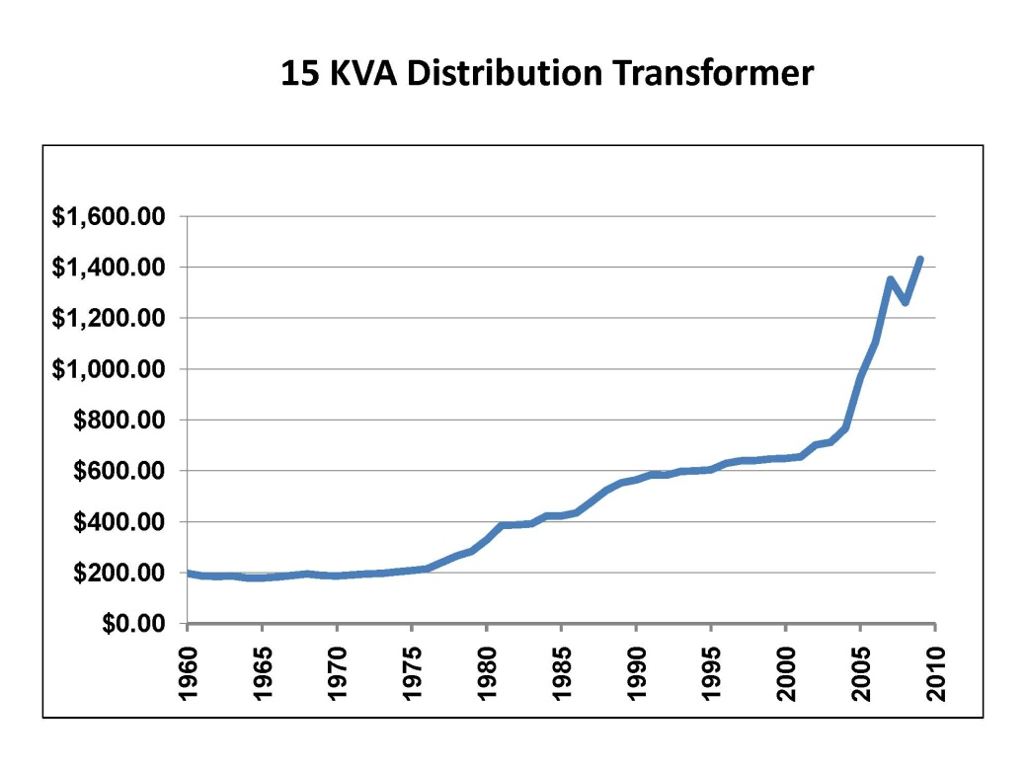A. Yes. One example is the cost of a 15 kVA distribution transformer, which is what is commonly used to step-down the voltage for our residential electric customers. The chart below shows the change in the cost of these transformers for the past 50 years. What is noteworthy is the rapid escalation that has occurred in the more recent years, i.e., the cost has essentially doubled in the last six years.

The dramatic escalation in the cost of materials has not been limited to just transformers. Mr. DeFelice provides additional details related to the significant increase in the cost of utility materials and equipment in recent years.

In the next five years, our relatively small Company will need to spend approximately $1.2 billion of capital on utility facilities and other requirements. And this is not including the costs associated with any climate-change requirements. This $1.2 billion represents 57% of the current rate base of approximately $2.1 billion serving customers today.

Utility equipment and facilities are big and expensive, and the required investment in new facilities is one of the major reasons that we need an increase in retail rates.

**Q. In what areas is it necessary for the Company to make new investment?**

A. We are in the middle of a roughly 10-year schedule to refurbish our Cabinet Gorge and Noxon hydro-electric generating units. We are also performing necessary upgrades to some of our Spokane River projects. These incremental upgrades at our hydroelectric facilities count as new renewable energy, another requirement under Washington’s renewable portfolio standard law.

The photo below shows Avista crews removing one of our Noxon turbine runners:

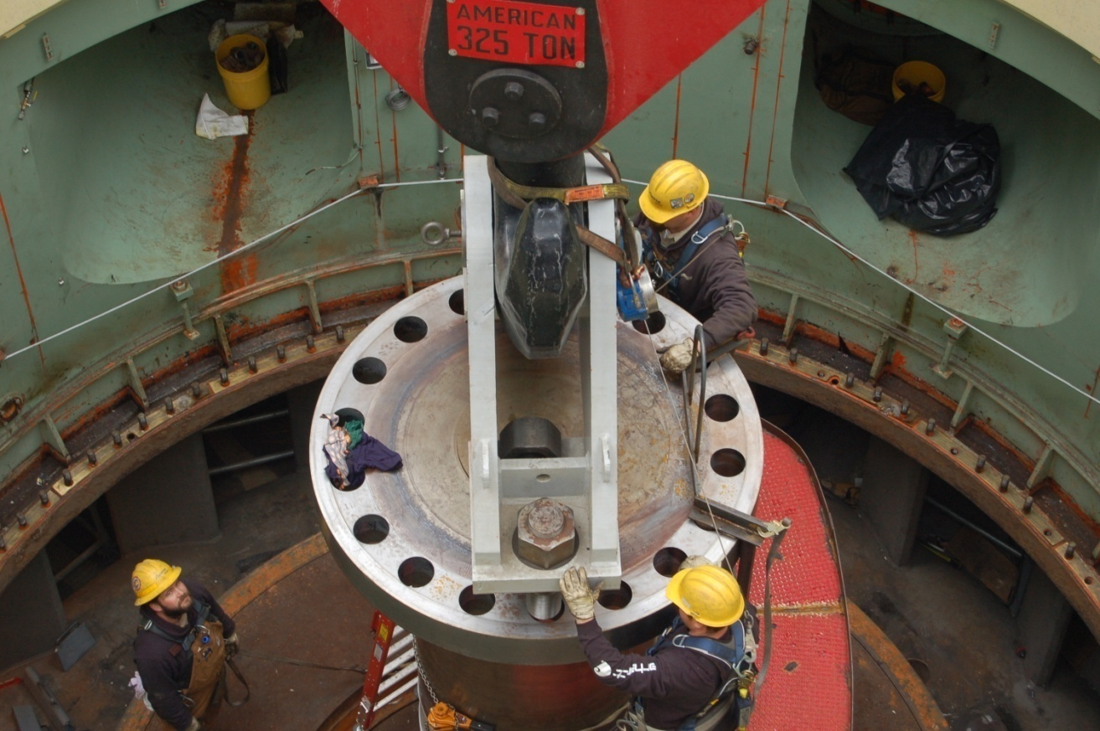

This turbine has been in place since 1959, and recently has operated at less than full capability, because of its 50 years of use. In 2006, we began the process of replacing/rebuilding the turbines and generating units at Noxon, one unit per year, and plan to continue until all the 50+ year-old units are refurbished. The engineering, materials and labor must be scheduled well in advance, i.e., it is a multi-year process to refurbish each of these units, and it is important that we not lose our place in the “queue” for materials and labor. It is also imperative that we take care of these low-cost hydro-electric projects to preserve this safe, reliable energy for our customers and meet new renewable energy mandates.

**Q. What is the nature of the investment necessary in the electric distribution system?**

A. Among other electric distribution investment needs, it is necessary for us to replace some of our aging distribution infrastructure. We have over 240,000 distribution poles and 34,500 transmission poles in our electric system. As an example, the distribution pole and transformer shown below are pre-1964, and the pole has deteriorated to the point where it needs to be replaced.

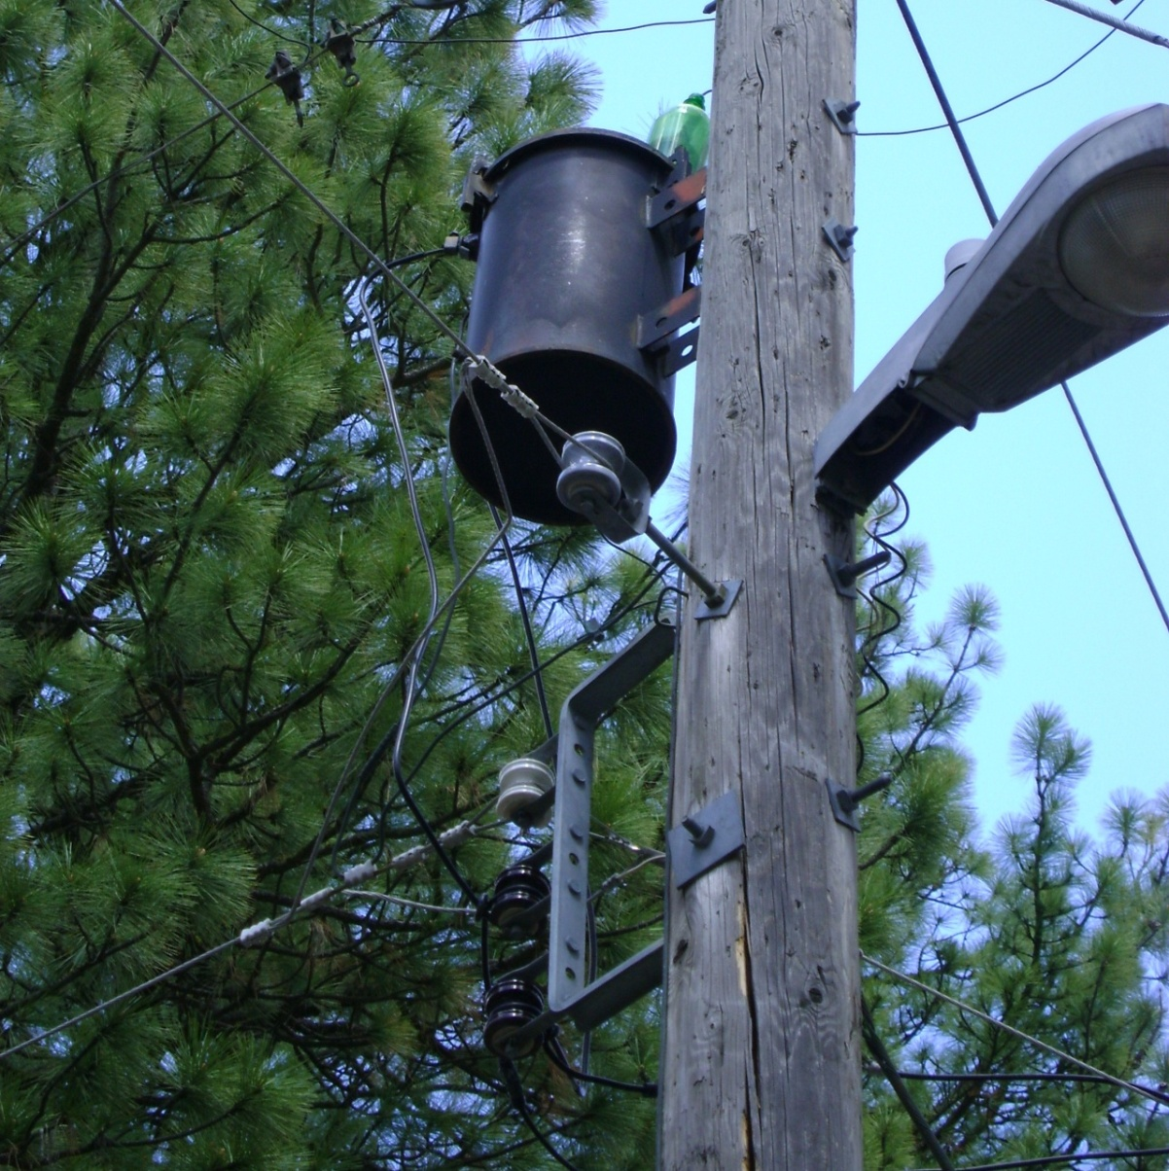

Each year our existing system gets older and a portion of it must be replaced. And the complexity of our electric system requires us to hire, train and retain highly-skilled and experienced employees to safely and reliably build and maintain our system.

In addition to the investment necessary to hook up new customers, and the investment necessary to comply with the reliability requirements I touched on earlier, we must continue to systematically replace our distribution facilities – some of which are 60 to 70 years old.

**Q. Does the level of depreciation each year cover the cost to replace these facilities?**

A. No. Some of our customers suggest to us that we set aside dollars every year to replace these facilities over time – and we do. That is what depreciation is for. The level of annual depreciation dollars built into retail rates is available to the Company to replace aging facilities over time. However, under the “regulatory compact” our retail rates are “cost-based,” meaning the annual depreciation is based on the actual historical costs of our electric system. And as I explained earlier, because the cost of our utility facilities decades ago was orders of magnitude less than what it costs to build facilities today, the annual depreciation falls dramatically short of providing the funds necessary to replace facilities today. Therefore, retail rate increases are necessary to cover the higher costs to replace facilities.

**Q. Are other utilities facing similar circumstances?**

A. Yes. Other retail electric utilities, and their facilities, have been around for a long time and are also experiencing significant increases in costs associated with aging infrastructure.

In a February 26, 2010 article in the Spokane area Journal of Business, it was reported that a neighboring public utility, Inland Power & Light (IP&L), will increase rates April 1st by 8.5% related to increased power costs and increased infrastructure costs:

Inland Power plans to raise its rates 8.5 percent on April 1, mostly because of the need to pass along a 7 percent increase in the wholesale price the co-op pays the Bonneville Power Administration for power, with the rest targeted at system infrastructure upgrades. (emphasis added)

Kris Mikkelsen, the Chief Executive Officer of IP&L, was quoted in the article as stating:

’We don’t have a choice’ but to raise rates, Mikkelsen says. ‘There’s no way to absorb that. The hope is that the economy will start to get a little better, and it will be easier for people to deal with.’

A number of other regional utilities have also recently announced rate increases, due in part to the higher cost of owning and operating their utility systems. In the March 1, 2010 issue of Clearing Up, an article on page 5 stated as follows regarding Seattle City Light:

Cost pressures aren’t limited to IOUs. Seattle City Light is a good example. The muni’s rates increased by 13.8 percent in January because it needs to replace aging infrastructure and cover a drop in revenues from wholesale energy sales. (emphasis added)

PacifiCorp recently, on March 2, 2010 filed two electric rate increase requests in the State of Oregon totaling 20% to cover increased investments in infrastructure and higher power supply costs.

And this Commission is familiar with the regular rate increases filed by Puget Sound Energy and PacifiCorp in Washington, due in part to higher power supply costs and the need to replace aging infrastructure.

**Q. You mentioned earlier that Avista is a low-cost utility, as compared to other utilities. How do Avista’s retail rates compare to other utilities in the Northwest and across the country?**

A. Edison Electric Institute periodically prepares a comparison of residential electric bills for investor-owned utilities across the country. The chart below provides a comparison of an Avista customers’ monthly bill[2] in Washington and Idaho, with utility bills in other states. The chart shows that Avista’s residential customers’ rates are the lowest, or are among the lowest, in the country.

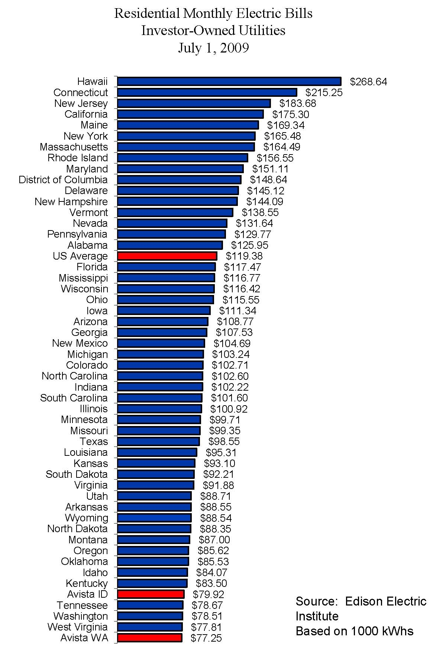

Our low retail rates are due in large part to a history of our Company aggressively pursuing the acquisition and preservation of a diversified portfolio of low cost resources for the benefit of our customers, and controlling costs. This portfolio includes hydroelectric, wood-waste fired, gas-fired baseload, gas-fired peakers, and coal-fired generation, together with long-term purchases of power and an aggressive energy efficiency program.

In spite of our best efforts to manage our costs, the expiration of low-cost power contracts, the required addition of higher-cost resources to serve increasing loads, the required investment to replace aging infrastructure, and the costs to comply with ever-increasing mandates makes it absolutely necessary to request an increase in our rates.

**Q. How do Avista’s rates for residential customers today compare to what they were a year ago?**

A. Avista’s billed rates for both electric and natural gas residential customers today are actually less than they were a year ago. The following chart shows a comparison of a monthly bill for both a Washington residential electric and natural gas customer in March 2010 versus March 2009.[3] The chart shows that the current electric bill is 7.1% below last year, and the current natural gas bill is 31.1% below last year.

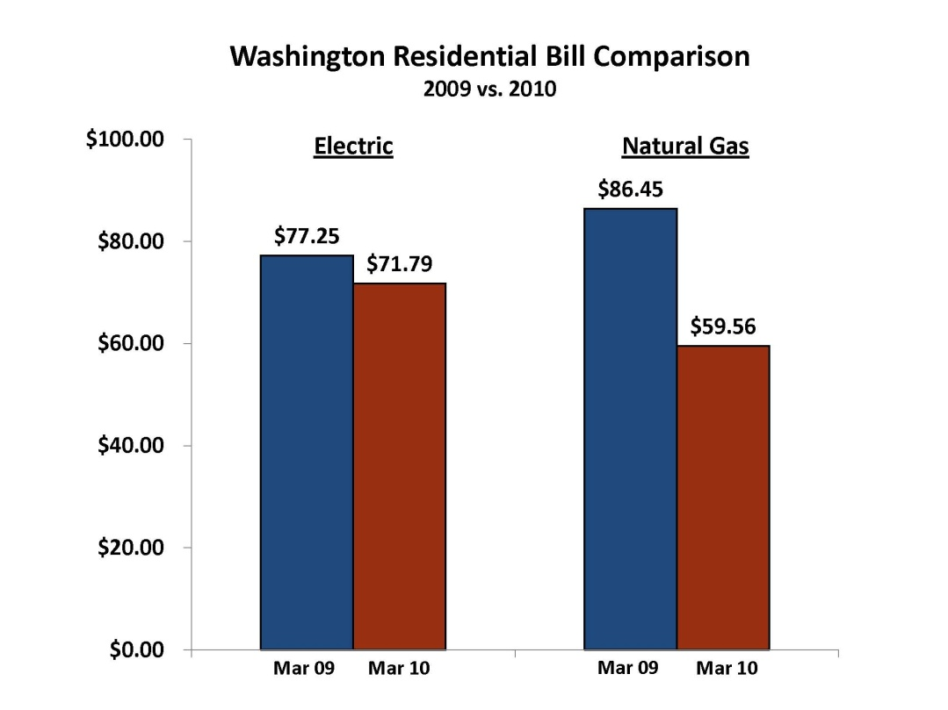

Although we are pleased that rates have decreased for customers in the last year, it is very important that rates be adjusted now to allow the Company the opportunity to recover the increased costs that we are experiencing.

**Q. Is the Company currently recovering its costs to provide service to its customers?**

A. No. We are currently not recovering our costs to serve customers, and we are not earning the return on investment that this Commission has determined to be fair and reasonable. Although we recently reported improved earnings in 2009 as compared to 2008, the utility return on equity in 2009 was 9.2% which is below our authorized return of 10.2% in Washington.

Furthermore, with regard to cost recovery in 2010, even though new retail rates were implemented January 1, 2010, the Commission’s decision in that case did not provide recovery of capital investment beyond June 2009, nor recovery of increased costs in 2010 related to items such as labor, vegetation management and information systems. Therefore, we will certainly not recover our costs in 2010, and if we do not receive meaningful rate relief though this filing, it will compound our under-recovery of costs going forward.

The current earnings guidance for Avista Utilities for 2010 is the range of $1.45 to $1.60 per common share. At December 31, 2009 Avista had approximately 55.0 million common shares outstanding, and an equity investment in the utility of $970 million, per our 2009 10-K filed with the Securities and Exchange Commission. For illustrative purposes only, if we were to assume that Avista’s earnings were in the middle of the earnings guidance, at $1.53/share, it would result in a return on investment for equity holders of 8.7 %. Even if the Company were to achieve the upper end of the range at $1.60/share, the ROE would be 9.1%, which is still well below the 10.2% authorized by the Commission.

In the comments that we receive from our customers, it appears that some of them believe that the utility earnings (profits) that we report are excessive, or are dollars over and above what is needed to run the utility. But this is obviously not the case. The facilities we use to serve customers are financed with both debt, from bondholders and banks, as well as equity investment from shareholders. Both sources of funds are essential to running the utility. Just as debt-holders expect to be paid interest for the use of their funds, shareholders expect a return on their investment in the utility, i.e., the profit or return on equity.

Not only is it important that we earn a profit, but as Mr. Thies and Mr. Avera explain in more detail, the profit must be sufficient to attract the equity investor to Avista. Investors have many choices on where to invest their dollars, and we are competing with not only other utilities for equity dollars, but also with businesses in other sectors of the economy.

Therefore, it is very important that the rate increase granted in this case provide recovery of our costs to serve customers and the opportunity to earn a fair return for shareholders, so that we can attract equity investment under reasonable terms.

**Q. The Avista Board of Directors recently raised the quarterly dividend to shareholders from $0.21 per share to $0.25 per share. Is this dividend change another element of attracting equity investment to Avista?**

A. Yes. Dividends paid to shareholders is one of the important factors that an investor considers in deciding where to invest his or her money, especially in the utility industry. The current payout ratio (dividends paid as a percentage of earnings) for the utility industry is generally in the range of 60% to 70%. Avista’s payout ratio has been below this range, and the Board has indicated its intention to raise the dividend payout over time to be within this range. Even with the recent dividend increase, Avista’s dividend payout ratio is on the lower end of the 60% to 70% range. Again, we are competing with other companies for shareholder investment, and the recent change in the dividend moved us closer to what other utilities are paying out to investors.

**Q. Do you have any comments on the Company’s access to debt capital?**

A. Yes. I am concerned that Avista’s credit ratings continue to be on the lowest rung of the investment-grade scale: a BBB- on Standard & Poor’s scale. If we were to experience adverse conditions that would cause our credit rating to drop one notch, we would be below investment-grade. A drop below investment-grade would make it much more difficult to access capital under reasonable terms. Costs to our customers would be higher due to the payment of higher interest rates. Some counterparties would not sell wholesale electricity or natural gas to us because of our credit standing, and those that would sell to us would require cash up front or some form of collateral. A drop in our credit rating would also affect our access to equity capital. Some institutions are precluded from owning stock in companies that have a credit rating below investment grade, which would put downward pressure on our stock price and access to equity capital.

As Mr. Thies explains in his testimony, it is important that we improve our credit metrics so that we can move up a notch from BBB- to BBB. This would give the Company and its customers further protection in the event of an unforeseen, adverse event that may result in a downgrade. When Avista lost its credit rating in 2001, it took approximately six years to get it back. Because it could be very costly for the Company and our customers if we were to drop below investment grade, it is very important that we gain one notch to provide that protection.

In order to gain and preserve a BBB credit rating, it is critically important that the Commission’s order in this case provide timely recovery of our increased costs to serve customers, so that our credit metrics will be sufficient to support the higher rating.

**V. COST MANAGEMENT AND EFFICIENCIES**

**Q. What is Avista doing to manage its costs and mitigate the impact of increased costs on its customers?**

A. Although the current economic conditions are at the forefront of everyone’s minds, Avista has focused on managing its costs to mitigate rate pressure over a much longer period of time. Following the energy crisis of 2000/2001, Avista cut its operating expenses and reduced capital spending. Since that time we have continued to pay particular attention to limiting the growth in these costs, and Avista continues to run its operations with attention to minimizing expenses, while meeting its reliability and environmental compliance requirements, and preserving a high level of customer satisfaction. We worked very hard for many years to gain upgrades to our corporate credit ratings to investment grade by Moodys Investors Service in December 2007 and Standard & Poors in February 2008. Part of what made that possible was tight controls on operating expenses and capital investment in recent years.

One of the more recent decisions to reduce near-term costs was to delay the construction of the Reardan Wind Project. While there were reasons to build it now, we concluded that the near-term cost impacts to our customers did not outweigh the uncertain long-term benefits of building it now. If we were to build it prior to the end of 2012 we could take advantage of a 30% investment tax credit under the Federal Stimulus Package, and also benefit from a Washington state sales tax credit of 7.7% for the Project.

On the other hand, as the law stands now, we do not need additional renewable energy credits until 2016, and do not need new energy resources until 2019. And even with the tax credits, the cost of power from the project would be 9 to 10 cents per kWh, which would have resulted in a rate increase for our customers. The cost of the Project would be over $200 million, which is sizable in relation to our current electric rate base of over $1.6 billion. So even though the Project is “on sale” now because of the available tax credits, we concluded that the Company and our customers simply cannot afford it at this time.

**Q. What other measures has the Company taken to mitigate increased costs?**

A. Avista is constantly looking for improvements in the way it provides services to its customers, as well as ways to reduce the costs of those services. Ideas are generated through periodic evaluation of our operating practices, and communications with other utilities and other industry participants across the country on best practices.

Some of the measures we have taken to control costs and improve efficiency are as follows:

**Hiring Restriction**

The Company continues to operate under a hiring restriction which requires approval by the Chairman/President/CEO, the CFO, and the Sr. VP for Human Resources for all replacement or new hire positions.

**Limitations on Capital Spending**

For both 2009 and 2010 Avista approved a lower capital budget than was requested by the Company’s Engineering and Operations personnel. The Capital Prioritization Committee reduced the list of projects to be completed by approximately $60 million in 2009, and we have limited our near-term capital budget to approximately $210 million annually (excluding Stimulus Projects[4]).

**Long Term Debt Issuance**

As explained further by Mr. Thies, in 2008 the Company opted to defer its plan to issue $250 million of long-term secured debt until 2009. Avista instead established a second bank line of credit to ensure continued adequate liquidity. The Company’s decision to delay the debt issuance, and rely on short-term debt for a longer period of time, resulted in a reduction of interest costs to customers by approximately $80 million over a ten year period (approximately $8 million annually). This benefit to customers is reflected in our filing.

**Cancelled Office Building Addition**

Avista’s main office building was constructed in 1958, and expanded in 1978. Even though Avista’s ratio of the number of customers served per employee continues to increase, we have needed additional office space for some time. In 2008, in order to reduce costs, we cancelled plans to build additional office space adjacent to the main office, and instead chose to remodel existing space formerly used by Horizon Credit Union nine miles from the main office.

**Outsourced Billing and Disaster Recovery**

Avista’s bill printing and mail services were outsourced to Regulus, the second largest first class mailer in the United States. The project objectives were to move bill printing, inserting and mailing offsite and to leverage core competencies of the provider. It will also serve to meet disasterrecovery requirements, ensure daily print volume flexibility and scalability, reduce costsfor bill print, inserting and mailing, and serve to maximize technology.

**Sale of Renewable Energy to California**

Our existing hydroelectric generation does not qualify as renewable energy under the Washington State Energy Independence Act (I-937). However, Avista took the initiative to qualify some of its Spokane River hydroelectric projects as certified renewable resources under California guidelines. Avista is now selling the “green tags” from these projects to California utilities at a premium, and flowing 100% of these benefits through to our retail customers. The additional value included in this rate case for customers from these sales is $5.4 million on a system basis.

We recognized that our proposed rate increases will result in energy bills that will be more difficult for some of our customers to pay. I can assure you that we are not just sitting on the sidelines as our costs go up, as evidenced by these measures and others explained by Mr. Kopczynski.

**VI. COMMUNICATIONS WITH CUSTOMERS**

**Q. Is Avista communicating with its customers to explain what is driving increased costs for the Company?**

A. Yes. The Company proactively communicates with its customers in a number of ways: electronic customer communications, one-on-one customer interactions through field personnel and account representatives, media contacts, and through our employees’ involvement in community, business and civic organizations, to name a few. We believe our communications are helping our customers, and the communities that we serve, better understand the issues faced by the Company, such as increased environmental mitigation, infrastructure investment, and generation constraints, all of which have led to higher costs for our customers.

The economic recession, rising prices for necessities, including energy, extreme cold and record snow, coupled with a variety of public policy issues, created an increased response from our customers in early 2009 related to energy prices. We learned that customers don’t always understand the complexities of the energy business and want information and conversations with Avista employees to better understand the choices they have to manage how they use energy. We began intensifying our communication efforts last year and are continuing to engage every employee in the Company in our efforts to more directly communicate with customers.

**Q. How has the Company stepped-up its communications with its customers?**

A. One of the important principles in our intensified outreach is to meet customers where they gather. The “new conversation” uses traditional and non-traditional communication channels including print, radio, website, face-to-face listening posts, newsletters, videos, social media, emails, and one-on-one and group presentations.

One important customer segment that we targeted are those customers who gather online. Last year we implemented our social media program with the Avista blog as our foundation. We also communicate on Twitter and in online discussion forums. For those customers who want a more private online conversation, we offer customers a conversation email account to make sure they were comfortable having this new conversation with us.

Our employees provide excellent customer service, and this focus on communicating with our customers includes providing them simplified messaging and new tools to make is easier to have conversations about Avista with friends, family and customers. We are finding that once a customer talks with one of our employees and has the opportunity to voice their concerns and receive answers to their questions, their satisfaction level increases significantly. We’re listening to our customers’ point-of-view and sharing ours about energy issues that directly affect us all.

We’ll continue focusing on informing our customers of the many programs we offer to provide assistance in managing their energy bills, and ensuring that our employees are equipped to engage in these conversations. We will also work to build understanding on how decisions today, specifically in areas such as energy efficiency, sustainability, reliability and renewable energy will affect our energy future.

**VII. CUSTOMER SUPPORT PROGRAMS**

**Q. What is Avista doing to assist customers with their energy bills?**

A. We have a history of making it a priority within our Company to maintain meaningful programs to assist our customers that are least able to pay their energy bills. We also have programs to assist our entire customer base, i.e., not just our low-income customers. Some of the key programs that we offer or support are as follows:

1. **Low-Income Rate Assistance Program (LIRAP).** Avista’s Low Income Rate Assistance Program in Washington collects approximately $4.1 million per year through electric and natural gas tariff surcharges. The Company, with the assistance of community action agencies, directs these funds to customers least able to pay for electric and natural gas service. The purpose of the LIRAP program is to reduce the energy cost burden among those customers least able to pay energy bills. In the 2008/2009 heating period for example, the LIRAP funds supplied close to 4,600 grants to our customers.

2. **Increased DSM Programs and Funding.** In January 2009 Avista proposed, and the WUTC approved, modifications to the Company’s energy efficiency program offerings. The modifications further broadened the technical and financial support Avista provides to its customers, and provides customers with increased opportunity to manage their energy bills. In 2008 Avista also launched the award-winning “Every Little Bit” energy efficiency promotional campaign which integrates all of the Company’s energy efficiency programs into one location.

3. **Project Share.** Project Share is a voluntary program allowing customers to donate funds that are distributed through community action agencies to customers in need. In addition to the customer and employee contributions in 2009 of $302,300 in Washington, the Company contributed $288,200, Washington’s share, to the program in 2009.

4. **Comfort Level Billing.** The Company offers the option for all customers to pay the same bill amount each month of the year by averaging their annual usage. Under this program, customers can avoid unpredictable winter heating bills.

5. **CARES Program.** Customer Assistance Referral and Evaluation Services provides assistance to special-needs customers through access to specially trained (CARES) representatives who provide referrals to area agencies and churches for help with housing, utilities, medical assistance, etc.

Again, Mr. Kopczynski provides additional detail in his testimony concerning these and other programs designed to assist customers.

**Q. Are there other programs in the State of Washington that are available to provide assistance to customers that need help with their energy bill?**

A. Yes. On September 30, 2008, President Bush signed legislation that provided $5.1 billion for the Low Income Home Energy Assistance Program (LIHEAP) for the 2008/2009 heating season. This increased funding was to serve an additional 2 million households and raise the average grant from $355 to $550 and also allow states to carryover any funds remaining to the next years heating season. Washington’s share of the LIHEAP funding was increased from $40,450,000 to $74,603,000.

On December 16, 2009**, President Obama signed an omnibus appropriations bill that continued to provide $5.1 billion in funding for the Low Income Home Energy Assistance program for the current fiscal year. The LIHEAP funding includes $4.5 billion in formula funds and $590 million in contingency funding.** Washington’s share of the LIHEAP funding was increased from $74,603,000 to $78,593,534. This bill also provides increased funding for weatherization assistance programs. These programs and the partnerships we have formed have been invaluable to customers who often have nowhere else to go for help.

**Q. Has the Company conducted any research to assess the effect of the level of support provided by the low income assistance programs offered by Avista?**

A. Yes. In 2009, Avista commissioned a study by the Institute for Public Policy and Economic Analysis through Eastern Washington University. The purpose of the study was “Assessing Heating Assistance Programs in Spokane County.”[5] As noted in that report, the study examined “the recent experience of the two largest heating assistance programs in Spokane County: the federal Low Income Home Energy Assistance Program (LIHEAP) and the Avista Utilities-funded Low Income Rate Assistance Program (LIRAP). The study’s central goal was to assess the reach of these programs among the eligible population.”[6]

A couple of the key findings in the study were as follows:

1. The study found that the assistance provided to limited income customers by Spokane Neighborhood Action Programs (SNAP), primarily through LIHEAP and LIRAP funds, reduces the “energy burden” for those customers to a level comparable to the average household in Spokane County.
2. The report shows that, in 2009, 30% of eligible limited income households were assisted by SNAP, which is much higher than the national average of 16%.

Mr. Kopczynski will address the results of this study in more detail in his direct testimony.

**Q. Would you please comment on the employees’ dedication to achieve customer satisfaction?**

A. Yes. I am pleased with the dedication of Avista Utilities’ employees and their commitment to provide quality service to our customers. While we continue to maintain tight controls on capital and O&M budgets, our customer service surveys indicate that customer satisfaction remains high. Our recent fourth quarter 2009 customer survey results show an overall customer satisfaction rating of 94% in our Washington, Idaho, and Oregon operating divisions. This rating reflects a positive experience for the majority of customers who have contacted Avista related to the customer service they received. These results can be achieved only with very committed and competent employees.

VIII. OTHER COMPANY WITNESSES

**Q. Would you please provide a brief summary of the testimony of the other witnesses representing Avista in this proceeding?**

A. Yes. The following additional witnesses are presenting direct testimony on behalf of Avista:

Mr. Mark Thies, Senior Vice President and Chief Financial Officer will describe, among other things, the overall financial condition of the Company, its current credit ratings, the Company’s plan for improving its financial health, its near term capital requirements, the proposed capital structure, and the overall rate of return proposed by the Company. Mr. Thies explains that:

* Avista’s plans call for significant capital expenditure requirements for the utility over the next two years to assure reliability in serving our customers and meeting customer growth. Capital expenditures of approximately $420 million (excluding Stimulus Projects) are planned for 2010-2011 for customer growth, investment in generation upgrades, transmission and distribution facilities for the electric utility business as well as necessary maintenance and replacements of our natural gas utility systems. Capital expenditures of approximately $1.2 billion are planned for the five year period ending December 31, 2014. Avista needs adequate cash flow from operations to fund these requirements, together with access to capital from external sources under reasonable terms.
* Avista’s corporate credit rating from Standard & Poor’s (S&P) is currently BBB- and Baa3 from Moody’s Investors Service (Moody’s). Avista Utilities must operate at a level that will support a strong investment grade corporate credit rating, meaning “BBB” or “BBB+”, in order to access capital markets at reasonable rates, which will decrease long-term borrowing costs to customers. Avista has been placed on “positive” outlook by both S&P and Moody’s, which may result in an upgrade as early as August 2010. The regulatory environment will be taken into consideration by the rating agencies when reviewing Avista for a possible upgrade. Maintaining solid credit metrics and credit ratings will also help support a stock price necessary to issue equity to fund capital requirements.
* The Company has proposed an overall rate of return of 8.33%, including a 48.39% equity ratio and a 10.9% return on equity. Our cost of debt is 5.93%. We believe the 10.9% proposed ROE provides a reasonable balance of the competing objectives of continuing to improve our financial health, and the impacts that increased rates have on our customers.

Dr. William E. Avera, as a President of Financial Concepts and Applications (FINCAP), Inc., has been retained to present testimony with respect to the Company’s cost of common equity. He concludes that:

* In order to reflect the risks and prospects associated with Avista’s jurisdictional utility operations, his analyses focused on a proxy group of seventeen other utilities with comparable investment risks. Consistent with the fact that utilities must compete for capital with firms outside their own industry, he also references a proxy group of comparable risk companies in the non-utility sector of the economy;
* Based on his evaluation of the strength of the various methods, Dr. Avera concluded that the cost of equity for the proxy groups of utilities and non-utility companies is in the **10.9 percent to 12.5 percent** range, or **11.1 percent to 12.7 percent** after incorporating an adjustment to account for the impact of common equity flotation costs;
* Because Avista’s requested ROE of 10.9 percent falls at the very bottom of his “bare bones” cost of equity range, it represents a conservative estimate of investors’ required rate of return.

Mr. Richard Storro, Vice President of Energy Resources, will provide an overview of Avista’s resource planning and power supply operations. This includes summaries of the Company’s generation resources, the current and future load and resource position, future resource plans, and an update on the Company’s plans regarding the acquisition of new renewable resources. He will also address hydroelectric and thermal project upgrades, followed by an update on recent developments regarding hydro licensing.

Mr. Clint Kalich, Manager of Resource Planning & Power Supply Analyses, will describe the Company’s AURORAXMP model (Dispatch Model) inputs, assumptions, and results related to the economic dispatch of Avista’s resources to serve load requirements, and market forecast of electricity prices. He explains:

* The key assumptions driving the Dispatch Model’s market forecast of electricity prices. This discussion includes the variables of natural gas, Western Interconnect loads and resources, and hydroelectric conditions.
* Why Hydro Biasing as suggested by Commission Staff and ICNU in the past is both unfair to the Company and is unnecessary because of modification to the Energy Recovery Mechanism (ERM).
* How the Model dispatches Avista’s resources and contracts in a manner that maximizes benefits to customers.
* The output results from the Model, including thermal generation and short-term wholesale sales and purchases, were provided to Mr. Johnson to incorporate into the power supply pro forma adjustments.

Mr. William Johnson, Wholesale Marketing Manager, will identify and explain the proposed normalizing and pro forma adjustments to the test period power supply revenues and expenses. He will also explain the new base level of power supply costs for Energy Recovery Mechanism (ERM) calculation purposes using the pro forma costs proposed by the Company in this filing. Mr. Johnson describes:

* The proposed normalizing and pro forma adjustments to the January 2009 through December 2009 test period power supply revenues and expenses
* The proposed level of authorized expense and retail revenue credit for Energy Recovery Mechanism (ERM) purposes, using the pro forma costs proposed by the Company in this filing.

Mr. Robert Lafferty, Director of Power Supply, discusses the Lancaster Power Purchase Agreement, the prudence of the acquisition and the request for determination of the emissions performance standard under RCW Chapter 80.80 for the Lancaster PPA.

Mr. Don Kopczynski, Vice President of Transmission and Distribution Operations, will describe Avista’s electric and natural gas energy delivery facilities and operations, and recent efforts to increase efficiency and improve customer service. Mr. Kopczynski describes:

* Avista’s customer service programs such as the Low-Income Rate Assistance Program (LIRAP), energy efficiency, Project Share, CARES program, Senior Outreach Program, and payment plans. Some of these programs will serve to mitigate the impact on customers of the proposed rate increase.
* The Company’s multi-faceted effort to increase customer service automation, including replacement and upgrade of the new Enterprise Voice Portal (EVP) system.

Mr. Scott Kinney, Director, Transmission Operations, will discuss the electric transmission and distribution capital investments included in this case, and presents the Company’s pro forma period transmission revenues and expenses. In addition, he describes the Company’s Asset Management Program (including the additional vegetation management expenses included in the Company’s case).

Mr. Dave DeFelice, Senior Business Analyst, will describe the Company’s proposed pro forma adjustments for capital investments in utility plant for the 2010 test period. Mr. DeFelice explains:

* The rising cost of essential materials specific to the utility industry is causing significant increases in capital project funding requirements.
* These costs must be pro formed into the test-year in order to allow necessary recovery of our costs to serve customers.

Mr. Jim Kensok, Vice-President, Chief Information Officer, will describe Avista’s information technology cost recovery needs and incremental costs. These incremental costs include increases in expenses for supporting applications utilized by the Company, additional required security and compliance requirements, and additional dollars required for hosting fees, application fees, software maintenance and license fees.

Ms. Karen Feltes, Senior Vice-President, Human Resources and Corporate Secretary will discuss Avista Corporation’s Compensation Programs and employee benefits. In addition, she will describe Avista’s employee incentive plan and why the costs associated with Avista’s employee incentive plan, as part of the total compensation for employees, are appropriate to include in utility customer rates.

Mr. Kevin Christie, Director of Gas Supply, will describe the additional Jackson Prairie (JP) natural gas storage that the utility will receive to serve customers beginning May 1, 2011. He will also describe the allocation of this additional storage and the associated costs to the three jurisdictions that the Company serves.

Ms. Elizabeth Andrews, Manager of Revenue Requirements, will discuss the Company’s overall revenue requirement proposals. In addition, her testimony generally provides accounting and financial data in support of the Company's need for the proposed increase in rates. She sponsors:

* Electric and natural gas revenue requirement calculations.
* Electric and natural gas results of operations.
* Pro forma operating results including expense and rate base adjustments.
* System and jurisdictional allocations.

Ms. Tara Knox, Senior Regulatory Analyst, sponsors the cost of service studies for electric and natural gas service, the revenue normalization adjustments to results of operations, the results from the Company’s demand study, and the proposed retail revenue credit rate. Ms. Knox’s studies indicate:

* Electric residential service, extra large general service, and pumping service schedules are earning less than the overall rate of return under present rates, while general service, large general service and the street and area lighting service schedules are earning more than the overall rate of return under present rates.
* Natural Gas residential and interruptible service schedules are earning less than the overall rate of return at present rates, and small firm, large firm and transportation service schedules are earning more than the overall rate of return.

Mr. Patrick Ehrbar, Manager of Rates and Tariffs, discusses the spread of the proposed annual revenue changes among the Company’s general service schedules. He explains, among other things, that:

* The proposed increase in electric base rates is 13.8%, which consists of an increase in electric base retail rates of $55.3 million.
  + - The monthly bill for a residential customer using an average of 1,000 kWhs per month would increase from $71.79 to $82.41 per month, an increase of $10.62 or 14.8%. This includes the proposed increase in the monthly basic or customer charge from $6.00 to $10.00.
* The proposed natural gas annual revenue increase in base rates is $8.5 million, or 5.4%.
* The monthly bill for a residential customer using 69 therms per month would increase from $58.79 to $62.79 per month, an increase of $4.00 or 6.8 %. This includes the proposed increase in the monthly basic or customer charge from $6.00 to $10.00.

Mr. Bruce Folsom, Senior Manager of Demand Side Management, provides an overview of the Company’s DSM programs and documents Avista’s expenditures for electric and natural gas energy efficiency programs. Mr. Folsom explains that:

* The Company continues to exceed the targets established as part of the IRP process. Electric efficiency savings for 2009 were 141% of the annual target and natural gas therms saved for 2009 were 128% of the annual target.
* Avista’s expenditures for electric and natural gas energy efficiency programs from January 1, 2008 through December 31, 2009 have been prudently incurred.

Q. Does this conclude your pre-filed direct testimony?

1. Yes.

1. Due to this confusion, often some customers believe we have multiple increases in a single year because of these multiple media stories.
2. Based on a residential customer’s usage of 1,000 kWh per month.
3. Using 1,000 kWh per month for electric, and 69 therms per month for natural gas.
4. Avista was awarded matching grants from the U.S. Department of Energy for two “Smart Grid” projects. One project will upgrade portions of the utility’s electric distribution system to smart grid standards in Spokane, Washington and the other project is a demonstration project in Pullman, Washington that involves automation of many parts of the electric distribution system using advanced metering, enhanced utility communication and other elements of smart grid technologies.
5. “Assessing Heating Assistance Programs in Spokane County”, Institute for Public Policy & Economic Analysis (Grant Forsyth, PhD, D. Patrick Jones, PhD, and Mark Wagner). January 2010.
6. id., Page 1