https://www.marinetraffic.com/en/ais/details/ships/shipid:152362/mmsi:218361000/imo:9450399/vessel:PRAGUE_EXPRESS

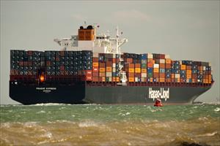

PRAGUE EXPRESS

Voyage Information
UNLOCK VOYAGE INFORMATION
AE DXBDUBAI
CN QDGQINGDAO
ATA: 2020-04-04 12:15 LT (UTC +4)
ETA: 2020-05-16 22:00 LT (UTC +8)
PAST TRACK
ROUTE FORECAST

Reported ETA: 2020-05-16 22:00 LT (UTC +8)
Calculated ETA:
••••••••••
Calculated ETA at:
••••••••••
Predictive ETD:
••••••••••
Reported Destination: CNTAO

Distance Travelled:
••••••••••
Distance to Go:
••••••••••
Total Voyage Distance:
••••••••••
Time to Destination:
••••••••••

Draught (Reported/Max): 9.2 m /
••••••••••
Load Condition:
••••••••••
Speed recorded (Max / Average): 10.5 knots / 8.5 knots

EVENTS TIMELINEPOSITION HISTORY
Reported Destination and ETA Received 2020-05-01 20:28 UTC
Summary
Where is the ship?
Container Ship PRAGUE EXPRESS is currently located at AG - Dubai Area at position 25° 14' 50.928" N, 55° 15' 58.572" E as reported by MarineTraffic Terrestrial Automatic Identification System on 2020-05-01 20:41 UTC (11 minutes ago)
The wind in this area at that time blows from West direction at force 2 Beaufort.

Where is this vessel going to?
The vessel is currently at port DUBAI, AE and her next destination is QINGDAO, CN

What kind of ship is this?
PRAGUE EXPRESS (IMO: 9450399) is a Container Ship that was built in 2010 (10 years ago) and is sailing under the flag of Germany.
It’s carrying capacity is 8600 TEU and her current draught is reported to be 9.2 meters. Her length overall (LOA) is 335.94 meters and her width is 42.94 meters.
Vessel Information
General
IMO: 9450399
Name: PRAGUE EXPRESS
Vessel Type - Generic: Cargo
Vessel Type - Detailed: Container Ship
Status: Active
MMSI: 218361000
Call Sign: DGZR2
Flag: Germany [DE]
Gross Tonnage: 93750
Summer DWT: 104014 t
Length Overall x Breadth Extreme: 335.94 x 42.94 m
Year Built: 2010
Home Port: HAMBURG
Classification Society:
••••••••••
Builder:
••••••••••
Owner:
••••••••••
Manager:
••••••••••
Ownership & Associated Parties
Structure & Machinery
Dimensions
Tonnage, Capacity & Loadline
Ex Names History
UNLOCK VESSEL INFORMATION
Recent Port Calls
No data available at the moment
UNLOCK MORE DATA
Events Timeline
Get access to vessel events for PRAGUE EXPRESS
UNLOCK EVENTS TIMELINE
Service Areas
Trade AreasCountriesPorts
Since 2015Last Year
Trade Area | No Port Calls recorded | Years Observed
•••••••••• | •••••••••• | ••••••••••
•••••••••• | •••••••••• | ••••••••••
•••••••••• | •••••••••• | ••••••••••
•••••••••• | •••••••••• | ••••••••••
•••••••••• | •••••••••• | ••••••••••
UNLOCK SERVICE AREAS
Similar Vessels
See vessels similar to PRAGUE EXPRESS, based on the type, capacity, dimensions.
UNLOCK SIMILAR VESSELS
In the News
No data available at the moment
Latest Position
Position Received: 2020-05-01 20:41 UTC
13 minutes ago
Vessel's Local Time:
2020-05-02 00:41 LT (UTC +4)
Area: AG - Dubai Area
Current Port: DUBAI
Latitude / Longitude: 25.24748° / 55.26627°
Status: Moored
Speed/Course: 0 kn / 107 °
AIS Source: 5348
NEARBY VESSELS
SHOW ON LIVE MAP

Weather
Wind: 6 knots
Wind direction: W (287°)
Air Temperature: 29°C
Vessel Photos

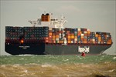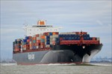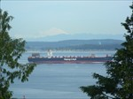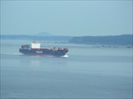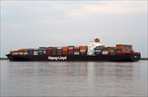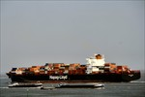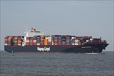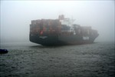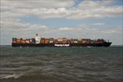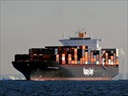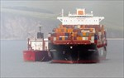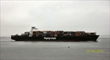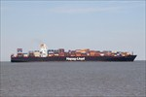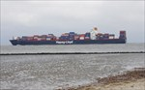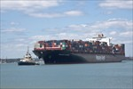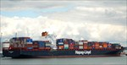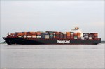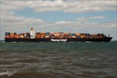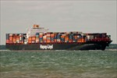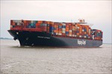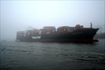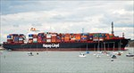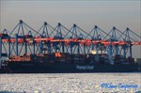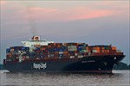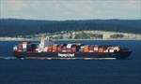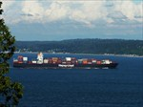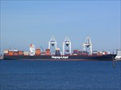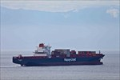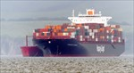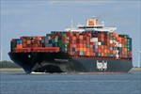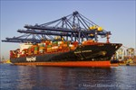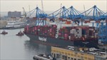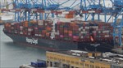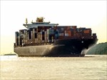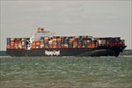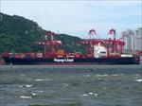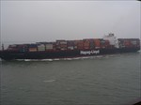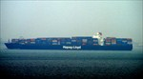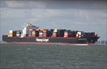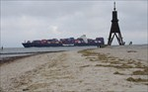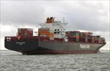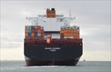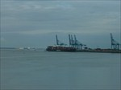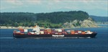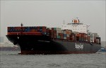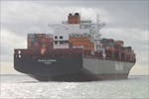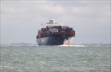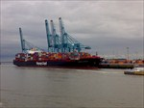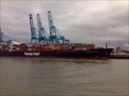
UPLOAD A PHOTOVIEW ALL (83)
Companies
At DestinationNearby

Shipping &amp; Marine services
Port Agents

Baili Petrochemicals (Hainan) Ltd
Oil and Gas

Qingdao Ever Maritime Co., Ltd.
Surveyors

Greenergy A&D Oil and Gas DMCC
Oil and Gas
VIEW FULL LIST
LIST YOUR COMPANY
Vessel Timeline
TimeDraught (m) - Speed (kn)SpeedDraught2. May4. May6. May8. May10. May12. May14. May16. May-20-15-10-505101520
Vessel Utilisation
MovementVoyage related
Last 30 daysLast 12 months
Total Distance Travelled:
••••••••••
Average/Maintained Speed:
••••••••••
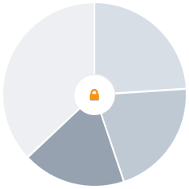
Time Underway
••••••••••
Time Waiting
••••••••••
Time Idle
••••••••••
Time in port
••••••••••
UNLOCK VESSEL UTILISATION
Vessel's Speed vs Wind Profile
Access the speed vs wind profiles for commercial vessels like PRAGUE EXPRESS
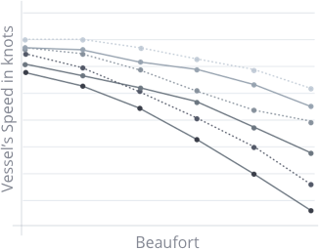
UNLOCK SPEED VS WIND PROFILE
Vessel Coverage
 | Within 24 Hours | Within 1 Month
Positions received | •••••••••• | ••••••••••
Average time interval between consecutive positions when vessel is Underway | •••••••••• | ••••••••••
Average time interval between consecutive positions when vessel is Idle | •••••••••• | ••••••••••
Total time being out of range (periods of more than 3 hours without position) | •••••••••• | ••••••••••
Number of Arrivals & Departures recorded | •••••••••• | ••••••••••
Number of Events Generated | •••••••••• | ••••••••••
Number of AIS static/voyage messages received | •••••••••• | ••••••••••
UNLOCK VESSEL COVERAGE
Quality of AIS-transmitted Information
Overall AIS transmission Quality | ••••••••••
Consistency of Position sequence | ••••••••••
AIS transmissions always ON | ••••••••••
Identification of Reported Destinations | ••••••••••
Matching of reported Destinations to actual Arrivals | ••••••••••
Accuracy of reported ETA | ••••••••••
Valid IMO number | ••••••••••
Valid MMSI number | ••••••••••
Valid Call Sign | ••••••••••
MMSI and Call Sign match | ••••••••••
Unique MMSI | ••••••••••
Valid dimensions | ••••••••••
UNLOCK QUALITY OF AIS-TRANSMITTED INFORMATION
TermsPrivacyUser AgreementAbout
English (EN)MarineTraffic BlogHelp Centre

