2015 PSE IRP EXECUTIVE SUMMARY

Contents:

**1-2. OVERVIEW**

**1-10. ACTION PLANS**

* *Action Plans vs. Resource Plan Forecasts*
* *Electric Action Plan*
* *Gas Sales Action Plan*
* *Gas-Electric Convergence Action Plan*

**1-13. ELECTRIC RESOURCE PLAN   
 FORECAST**

* *Electric Resource Need*
* *Electric Portfolio Resource Additions Forecast*
* *Costs and Carbon Emissions*

**1-23. GAS SALES RESOURCE PLAN   
 FORECAST**

* *Gas Sales Resource Need*
* *Gas Sales Resource Additions Forecast*

**1-26. THE IRP AND THE RESOURCE ACQUISITION PROCESS**

The primary value of the IRP is what we learn from the opportunity to do three things: develop key analytical tools to aid in prudent decision making, create and manage expectations about the near future, and think broadly about the next two decades. The portfolios produced by the analysis are best understood as a forecast of resource additions that appear to be cost effective given what we know today about the future. We know these forecasts will change as the future unfolds and conditions change. PSE’s commitments to action are driven by what we learn through the planning exercise. These commitments are embodied in the Action Plans presented here.

OVERVIEW

In this IRP, we reoriented our capacity planning standard to focus on the value of reliability to our customers; and, for the first time, we explicitly incorporated physical risk in wholesale markets into our needs assessment. This IRP indicates PSE needs to acquire approximately 275 MW of firm, dispatchable generation (most likely natural gas plants) in the next 7 years. This will be required to meet our customers’ capacity needs as the regional capacity surplus – which PSE has relied on as a low cost/low risk resource – dwindles in the next few years.

On the gas side, PSE intends to begin construction of an LNG storage facility at the Port of Tacoma. This facility will serve two purposes. It will provide a cost-effective way to meet the peak needs of our gas customers, while also facilitating conversion of maritime vessels to natural gas fuel, reducing greenhouse gas emissions and reducing particulate emissions in the Puget Sound region.

*Declining regional surpluses require a shift in electric resource strategy.*

The surplus conditions the Pacific Northwest electric markets have experienced for a decade are forecast to change significantly with the scheduled retirement of two coal plants in 2020, Portland General Electric’s 585 MW Boardman plant in Oregon and TransAlta’s 730 MW Centralia Unit 1. According to studies of long-term resource adequacy from the region’s energy organizations, regional market deficits are a possibility unless new resources are added in the region by 2021, and potential outages could affect more people and last longer than under previous conditions.[1]

This shift requires a change in PSE’s electric resource strategy. During the decade of surplus capacity, relying on short-term wholesale market purchases to meet a significant portion of peak customer need has been a low cost/low risk strategy, but now that supplies are tightening, continuing this level of market purchases would expose PSE and its customers to unreasonable levels of physical and financial risk.

In this IRP, we directly incorporated physical wholesale market risk in the resource need analysis, so that risk is now reflected in the capacity planning standard.

*Updating the electric planning standard creates significant net benefits and risk mitigation for customers.*

PSE’s new electric planning standard is the optimal customer planning standard, because it is a product of a benefit/cost analysis that focuses on the cost to customers of potential outages (also known as the value of lost load). The former electric planning standard relied on an industry standard approach that targets a 5 percent loss of load probability (LOLP), which measures the likelihood of potential outage events rather than the magnitude of their impact on customers. Translating the MWh lost into the Customer Value of Lost Load allows us to quantify the value associated with different levels of reliability. Information from Figure 1-1, Comparison of Old and New Electric Capacity Planning Standards, shows that moving to the 2015 Optimal Planning Standard reduces the expected value of lost load to customers by $130 million per year.[2] The cost to achieve that expected savings is $63 million per year,[3] for a net benefit to customers of $67 million per year. Risk[4] reduction to customers is dramatic. That $67 million per year cost reduces the risk to customers by $1.3 billion per year.[5] Additional discussion is included in Chapter 2, Resource Plan Decisions, and Chapter 6, Electric Analysis.

*Figure 1-1: Comparison of Old and New Electric Capacity Planning Standard*

|  |  |  |  |  |  |  |
| --- | --- | --- | --- | --- | --- | --- |
|  |  | **Reliability Metric** | | **2021 Capacity (Surplus)/ Need after DSR (MW)** | **Customer Value of Lost Load** | |
|  |  | LOLP | EUE (MWh) | Expected ($million/yr) | Risk-TailVar90 ($million/yr) |
| 1 | 2013 Planning Standard  with Market Risk | 5% | 50.0 | (117) | 169 | 1,691 |
| 2 | 2015 Optimal Customer Planning Standard  (Includes Market Risk) | 1% | 10.9 | 234 | 39 | 385 |
|  | Change |  |  | 351 | (130) | (1,306) |

*Gas pipelines that serve the region are reaching capacity with consequences for both electric and gas utility customers.*

The region’s natural gas markets are also experiencing a decline in surplus capacity as available pipeline capacity becomes more fully utilized. For decades, the Sumas market has been a reliable, liquid trading hub for PSE, but its supplies depend on the availability of upstream pipeline capacity to move gas from production areas to the market hub. In the past two years, one of the two major pipelines that interconnect at Sumas, the Westcoast Pipeline, has reached its peak design capacity limits.

**Gas utility impacts**

As a direct result of these conditions, PSE’s gas utility has increased firm pipeline capacity commitments to cover 50 percent of the supplies we purchase at Sumas. Also, as pipeline capacity grows scarcer, storage capability may become increasingly important. In the future, PSE may need to take additional actions to ensure firm gas supplies are available at Sumas, even before considering the possibility that new, large gas consumers, such as methanol production or LNG export facilities, could increase demand for natural gas supplies in the region.

**Electric utility impacts**

The reliability of the electric system increasingly depends upon the reliability of the gas supply system, and gas-fired generation in the region will probably increase as coal plants are retired, so the dwindling surplus of pipeline capacity, especially at times of peak need, also has direct and indirect impacts on PSE’s electric resource strategies.

* Electric reliability assessments will need to consider the availability of upstream pipeline capacity as well as direct-connect pipeline capacity, especially on pipelines we know are reaching capacity limits.
* The lack of verifiable firm gas supplies for the 650 MW Grays Harbor combined-cycle gas plant could significantly affect the amount of short-term wholesale power available for purchase by PSE and other regional utilities.

The convergence of natural gas and electric markets will continue to be an important reliability issue for both PSE and the region.

*PSE continues to explore and evaluate emerging resources.*

As part of PSE’s ongoing commitment to the exploration and evaluation of emerging resources, this IRP includes new analyses of rooftop solar generation (distributed solar) and electric energy storage.

**Solar**

Moving beyond the question of whether distributed solar would be cost effective for the utility, we asked: What might we need to do if our customers want PSE to integrate significant amounts of distributed solar? Specifically, we examined the impact that high penetrations of rooftop solar would have on four distribution circuits, each of which serves a different kind of customer base. Also, with the help of the Cadmus Group, we analyzed the maximum amount of rooftop solar PV that could be installed in PSE’s service territory. Finally, in a sensitivity analysis, we studied the impact to portfolio cost and emissions of adding 300 MW of distributed solar across the entire system by 2035.

**Electric Energy Storage**

Electric energy storage has made significant progress in recent years, and in this IRP we studied two storage technologies, batteries and pumped hydro. Batteries demonstrated significantly higher flexibility value than thermal resources when we analyzed them using our sub-hourly flexibility model. However, the relative values were not such that batteries appeared cost effective. To set up the next stage of battery analysis, we included a tipping point analysis in this study to identify what the flexibility value would need to be for batteries to be forecast as part of a least-cost portfolio.

PSE will focus considerable efforts in the 2017 IRP cycle to improving our flexibility analysis and monitoring emerging resource opportunities, as noted in the Action Plans.

*Overall, electric demand growth has slowed, but some areas are growing rapidly.*

At the system level, demand growth has slowed significantly compared with the 2013 IRP Base Demand Forecast, but some areas continue to experience rapid growth – particularly the Eastside area of King County that includes downtown Bellevue.

For the 2015 IRP Electric Base Peak Demand Forecast at the system level, the average annual expected growth rate for the 20-year study period has declined to 1.6 percent from 1.9 percent in the 2013 forecast. Similarly, the average annual growth rate for electric customer counts declined to 1.5 percent from 1.7 percent in the 2013 forecast. These declines are driven by a slower-than-expected recovery from the recession, lower population growth forecasts, and by significant updates to PSE’s load forecasting models. These updates were developed in response to feedback from the WUTC in its acceptance letter for the 2013 IRP. Figure 1-2 shows the 2013 and 2015 IRP Base Peak Electric Demand Forecasts after conservation. Peak capacity need is significantly reduced in the outer years.

Figure 1-2: 2013 IRP Base Peak Electric Demand Forecast Net of 2013 IRP DSR

and 2015 IRP Base Peak Electric Demand Forecast Net of 2015 IRP DSR

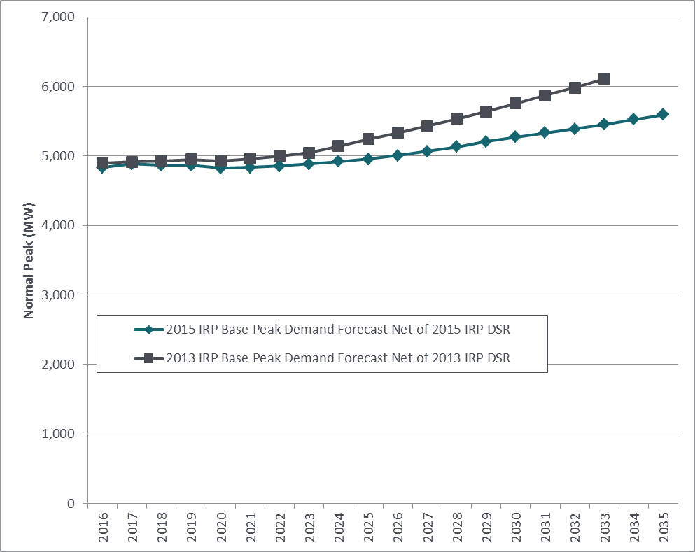

While overall, system-level growth after conservation will be quite low, the map and table in Figure 1-3, illustrate how unevenly population, employment, customers and sales are distributed across PSE’s electric service territory. King County accounts for roughly half of the system’s customer base and electric sales today and 58 percent of employment in the service territory.

*Figure 1-3: Distribution of Population, Employment, Customers and Sales*

*across PSE Electric Service Territory*

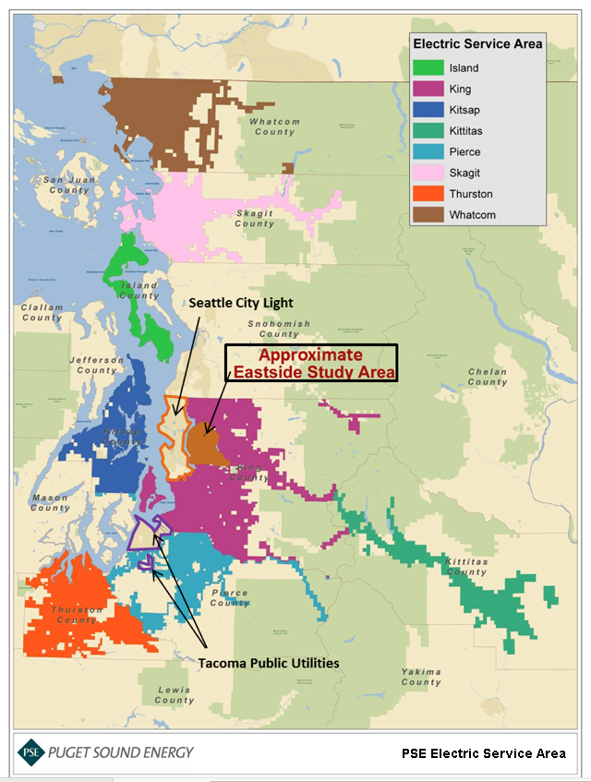

|  |  |  |  |  |
| --- | --- | --- | --- | --- |
| **County** | **Population** | **Employment** | **Customers** | **Sales** |
| King | 48% | 58% | 49% | 52% |
| Thurston | 10% | 9% | 11% | 11% |
| Pierce | 15% | 10% | 10% | 9% |
| Kitsap | 10% | 8% | 11% | 9% |
| Whatcom | 8% | 8% | 9% | 9% |
| Skagit | 5% | 4% | 5% | 7% |
| Island | 3% | 1% | 3% | 2% |
| Kittitas | 2% | 1% | 1% | 1% |
| Eastside Area | 9% | 19% | 10% | 14% |

Growth is concentrated in the Eastside area. The Eastside’s average annual peak demand growth rate of about 2.5 percent from 2014 to 2031 is significantly higher than the 1.6 percent growth rate in the system-level forecast.

The IRP provides inputs to the local infrastructure planning process, including information on conservation and distributed resources; however, the planning process for addressing local distribution and transmission needs focuses on the specific engineering, siting, and permitting details of specific challenges, and is appropriately separate from the IRP’s high-level generic resource and system-wide viewpoint.

**Action PlanS**

Action Plans vs. Resource Plan Forecasts

In recent years, the IRP has attracted more attention from policy makers, the public, and advocacy groups. Many tend to assume the resource plans produced by the IRP analysis are the plan that PSE intends to execute against. This is not the case. The resource plans are more accurately understood as forecasts of resource additions that look like they will be cost effective in the future, given what we know about the future today. What we learn from this forecasting exercise determines the Action Plan, and this is “the plan” that PSE will execute against.

The following discussion presents the Action Plans first, followed by the electric and gas sales resource plan forecasts.

Electric Action Plan

**1. Acquire energy efficiency.**

Develop 2-year targets and implement programs that will put us on a path to achieve an additional 411 MW of energy efficiency by 2021.

**2. Acquire demand-response.**

Develop and implement a demand-response acquisition process and issue a Request for Proposal (RFP). The analysis supports addition of demand-response by 2021, but these programs don’t fit existing energy efficiency or supply-side resource models.

**3. Supply-side resources: Clarify before issuing an all-source RFP.**

Energy efficiency and demand-response additions appear sufficient to meet incremental capacity need until 2021 and additional renewables are not needed until 2023. PSE intends to issue an all-source RFP[6] in 2016, subject to an update to resource needs, most likely in early summer of 2016.[7] This postponement will provide time to incorporate an updated regional adequacy assessment into our resource need, which is scheduled to be completed by the NPCC in the second quarter of 2016.

There are indications from the NPCC that updates to some key assumptions from their draft 7th Power Plan may impact the regional adequacy. Therefore, it makes sense to further refine our resource needs before embarking on this costly and complicated process. The all-source RFP will include a process to aggregate smaller kinds of resources, such as distributed resources, combined heat and power, etc., along-side traditional utility-scale resources.

**4. Improve analytical capabilities.**

With this IRP, PSE made two major improvements to its analytical capabilities. We applied a benefit/cost analysis focused on the cost to customers of potential outages to update the electric planning standard, and we developed a framework for translating regional resource adequacy to its impact on PSE’s electric system and customers. We also analyzed whether backup fuel for our existing peaking units is sufficient to meet reliability needs without firm pipeline capacity.

The next important area of focus will be intrahour flexibility for the electric portfolio. Analysis in this IRP demonstrated that initial estimates of intrahour flexibility values could significantly affect the least-cost mix of resources and possibly add reciprocating engines to the portfolio. Specifically, in the 2017 IRP planning cycle, we will:

* Define specific elements of intrahour flexibility that need to be valued and prioritize them according to their potential to impact future resource decisions.
* Refine existing or develop new analytical frameworks to estimate, from a portfolio perspective, the value that different types of resources can provide for each element of flexibility.
* Ensure that frameworks reasonably address energy storage technologies, including batteries, pumped hydro, kinetic storage and others.

**5. Actively investigate emerging resources.**

For batteries, continue to explore potential applications and demonstration projects; for solar, update market penetration studies and continue study of system planning implications; for electric powered vehicles, continue load research. Continue to explore the possibilities provided by new emerging resources.

**6. Participate in the California Energy Imbalance Market (EIM).**

PSE has committed to joining the California EIM. This market will allow PSE to purchase sub-hourly flexibility at 15- and 5-minute increments from other EIM participants to meet our flexibility needs when market prices are cheaper than using our own resources. This will also allow PSE the opportunity to sell flexibility to other EIM participants when we have surplus flexibility. The benefits of lower costs on the one hand and net revenue from EIM sales on the other will reduce power costs to our customers.

Gas Sales Action Plan

**1. Acquire energy efficiency.**

Develop 2-year targets and implement programs to acquire conservation, using the IRP as a starting point for goal-setting.

**2. Develop the PSE LNG project.**

Continue work to develop an LNG facility for serving both the peak needs of gas customers and the transportation markets at the Port of Tacoma.

**3. Begin upgrades to Swarr.**

Implement plans to ensure that the full upgraded capacity of the Swarr propane-air facility is available by the 2016/17 or 2017/18 heating season.

**4. Improve analysis on basin risk.** Acquiring long-term pipeline capacity to one supply basin entails risk, as the relationship between gas prices in different supply basins is uncertain and changes over time. Resources that do not rely on making a long-term commitment to one supply basin reduce risk. Such resources may include conservation, on-system storage and market-area storage. These resources avoid placing a bet on which basin-plus-transportation cost will be lowest cost in the long run. PSE will refine its analysis of this risk, and work with other gas utilities on ways to improve its ability to analyze this issue, in the 2017 IRP.

Gas-Electric Convergence Action Plan

**1. Non-firm gas supplies for PSE’s portfolio.**

Continue monitoring sufficiency of non-firm gas versus backup fuel as PSE begins operating in the California EIM; as regional natural gas demand grows; and as interstate pipelines become more fully utilized.

**2. Non-firm gas supplies for regional adequacy.**

Work with others in various industry forums on developing resource adequacy criteria for natural gas generating plants that do not have verifiable fuel supply.

ELECTRIC RESOURCE PLAN FORECAST

Electric Resource Need

PSE must meet the physical needs of our customers reliably. For resource planning purposes, those physical needs are simplified and expressed in terms of peak hour capacity and energy. Operating reserves are included in physical needs; these are required by contract with the Northwest Power Pool and by the North American Electric Reliability Corporation (NERC) to ensure total system reliability. In addition to meeting customers’ physical needs, Washington state law (RCW 19.285) also requires utilities to acquire specified amounts of renewable resources or equivalent renewable energy credits (RECs). There are details in the law such that complying with RCW 19.285 may not directly correspond to meeting reliability needs, so this is expressed as a separate category of resource need.

* Figure 1-4 presents electric peak hour capacity need.
* Figure 1-5 presents the electric energy need (the annual energy position for the 2015 Base Scenario).
* Figure 1-6 presents PSE’s renewable energy credit need.

**Electric Peak Hour Capacity Need.** Figure 1-4 compares the existing resources available to meet peak hour capacity[8] with the projected need over the planning horizon. The company’s electric resource outlook in the Base Scenario indicates the initial need for an additional 275 MW of peak hour capacity by 2021.[9] This picture includes the resources required to meet peak hour customer demand events and the planning margin and operating reserves that must be maintained to achieve the 2015 Optimal Planning Standard. It also incorporates an adjustment to the peak capacity contribution of wholesale market purchases.[10] The important role demand-side resources play in moderating the need to add supply-side resources in the future can be seen in the peak load lines in Figure 1-4; the lower line includes the benefit of DSR while the upper line does not.

Figure 1-4: Electric Peak Hour Capacity Resource Need

(Projected peak hour need and effective capacity of existing resources)



**Electric Energy Need.** Peak hour capacity is an important aspect of PSE’s ability to adequately meet the physical needs of our customers. However, our customers require reliable, economic electric service during all hours. Figure 1-5 compares the company’s annual forecast of energy sales to retail electric customers with expected generation for the year by resource type.[11] This “energy position” reflects the most economical dispatch of our electric resource portfolio based on expected market conditions; it is not a physical need. PSE could generate significantly more energy than needed to meet our load on a monthly or annual basis, but will purchase energy in the wholesale market when it is more cost effective than running our thermal resources. Load forecasts in this chart are aggregated to an annual basis.

Figure 1-5: Annual Energy Position for 2015 IRP Resource Plan in the Base Scenario

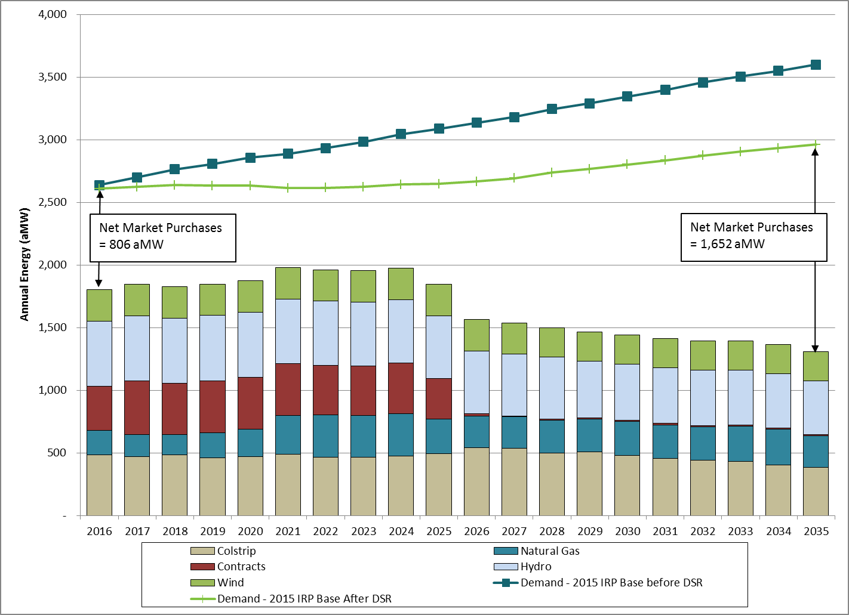

**Renewable Need.** In addition to reliably meeting the physical needs of our customers, RCW 19.285 – the Washington State Energy Independence Act – establishes 3 specific targets for qualifying renewable energy. These are commonly referred to as the state’s renewable portfolio standard. Sufficient “qualifying renewable energy” must equal at least 3 percent of retail sales in 2012, 9 percent in 2016, and 15 percent in 2020. Figure 1-6 compares existing qualifying renewable resources with this annual target, and shows that PSE has acquired enough eligible renewable resources and RECs to meet the requirements of the law through 2022. By 2023, PSE will need just over 100 MW of additional wind resources.

Qualifying renewable energy is expressed in annual qualifying renewable energy credits (RECs) rather than megawatt hours, because the state law incorporates multipliers that apply in some cases. For example, generation from PSE’s Lower Snake River wind project receives a 1.2 REC multiplier, because qualifying apprentice labor was used in construction. Thus the project is expected to generate approximately 900,000 MWh per year of electricity, but would contribute about 1,080,000 equivalent RECs toward meeting the renewable energy target. Note this is a long-term compliance view. PSE has sold surplus RECs to various counterparties in excess of those needed for compliance and will continue to do so as appropriate to minimize costs to customers.

Figure 1-6: Renewable Resource/REC Need

Electric Portfolio Resource Additions Forecast

As explained above, the lowest reasonable cost portfolio produced by the IRP analysis is not an action plan, rather, it is better understood as a forecast of resource additions PSE would find cost effective in the future, given what we know about resource and market trends today. It incorporates significant uncertainty in several dimensions.

Figure 1-7 summarizes the forecast for additions to the electric resource portfolio in terms of peak hour capacity over the next 20 years. This forecast is the “integrated resource planning solution.”[12] It reflects the lowest reasonable cost portfolio of resources that meets the projected capacity, energy and renewable resource needs described above. Generally, this resource strategy is similar to prior IRPs: it accelerates acquisition of energy conservation, acquires renewable resources to meet requirements of RCW 19.285, and forecasts that natural gas plants are cost effective for meeting remaining needs. There is one difference in this IRP: the mix of gas plants. In this IRP, we find a combination of peakers and combined cycle plants are the most reasonable balance of cost and risk.

*Figure 1-7: Electric Resource Plan Forecast,   
Cumulative Nameplate Capacity of Resource Additions*

|  |  |  |  |  |
| --- | --- | --- | --- | --- |
|  | **2021** | **2026** | **2030** | **2035** |
|  |  |  |  |  |
| Conservation (MW) | 411 | 669 | 770 | 906 |
| Demand Response (MW) | 121 | 130 | 138 | 148 |
| Wind (MW) | - | 206 | 337 | 337 |
| Combined Cycle Gas (MW) | - | 577 | 577 | 805 |
| Peaker/CT Dual Fuel (MW) | 277 | 403 | 609 | 609 |

**Demand-Side Resources: Energy Efficiency.** This plan – like prior plans – includes acquiring conservation to levels such that much of what is available will be acquired. That is, significant changes in avoided cost had little impact on how much could be acquired cost effectively. PSE’s analysis indicates that although current market power prices are low, accelerating acquisition of DSR continues to be a least-cost strategy.

**Demand-Side Resources: Demand-response**. In this IRP, we are seeing a significant increase in the amount of demand-response programs. These include direct residential load control programs and voluntary interruptible rate schedule programs for commercial and industrial customers.

**Renewable Resources.** Timing of renewable resource additions is driven by requirements of RCW 19.285. PSE’s analysis shows that while additional wind is not a least-cost resource, we anticipate remaining comfortably below the four percent revenue requirement cap. PSE has acquired enough eligible renewable resources and RECs to meet the requirements of the law through 2022.

**Peakers vs. Combined-cycle Plants: It depends . . .** In all future scenarios, gas-fired plants appear to be the most cost-effective supply-side resource for meeting our customers capacity and energy needs – at least until technology changes. This IRP forecasted that peakers were more cost effective in some scenarios, and combined-cycle combustion turbine (CCCT) plants were more cost effective in others. To a large extent, this depended on whether sufficient backup fuel could be permitted for peakers and how carbon regulations might affect operation of CCCT plants across the WECC. Given this uncertainty, we adopted a strategy that includes both types of plants. This mixed approach reduces expected cost and risk relative to an all-CT portfolio, which appeared to be cost effective in the 2013 IRP.

Costs and Carbon Emissions

**Portfolio Costs.** The long-term outlook for incremental portfolio costs has been dynamic across IRP planning cycles since 2003, driven by changing expectations about natural gas prices and costs associated with carbon regulation. Conservation, gas-fired generation and wind have been the primary resource alternatives since 2005. Figure 1-8 illustrates how incremental portfolio costs have changed over time, along with the context for the range of costs examined in this IRP. Note that in this IRP, carbon costs are included in the IRP Base Scenario assumptions. However, gas prices dropped significantly causing portfolio costs to go down.

*Figure 1-8: Incremental Portfolio Costs Over Time*



**Carbon Emissions Associated with Electric Service.** A number of Washington state laws address carbon emissions. RCW 70.235 adopts a state goal for reducing emissions. RCW 80.80 sets an emissions performance standard (EPS) that prevents utilities from entering into long-term financial commitments for baseload electric generation unless the generation source complies with the greenhouse gas emissions performance standard set by the state, effectively banning purchases from additional coal plants or older gas CCCT plants. In 2011, the legislature amended the EPS to achieve permanent reduction of certain CO2 emissions by retiring the TransAlta coal plant in Centralia, Washington. Utilities are allowed to enter into long-term contracts for “coal transition power” from TransAlta, and TransAlta will shut down one generating unit at the Centralia coal plant by the end of 2020 and the other by the end of 2025. TransAlta also will provide financial assistance for local economic development and clean energy. RCW 19.285, the Energy Independence Act, requires electric utilities to reach certain targets for renewable resources and acquire all cost-effective achievable conservation.  Meanwhile, according to WAC 480-100-238, “Each electric utility regulated by the commission has the responsibility to meet its system demand with a least cost mix of energy supply resources and conservation.”

The combined impact of these laws, rules and policies on PSE’s CO2 emissions from electric operations is shown in Figure 1-9. The initial ramp-up in CO2 emissions followed by a reduction in the Low Scenario is due to PSE’s coal transition power agreement with TransAlta that expires in 2025; ultimately, this contributes to the retirement of the 1,460 MW Centralia coal plant and a permanent reduction of emissions. The Base Scenario emissions remain flat across the 20 year time horizon. Due to the high CO2 price modeled in the Base Scenario, the Centralia coal plant is reduced to a 20 percent capacity factor and most of the contract is being supplied by market. The contract is then replaced by a CCCT plant in 2026, so the emissions of the contract offset the emissions of the CCCT. The High Scenario emissions dropped in 2020 from the impact of the high CO2 price that starts in 2020. The chart also shows a significant reduction in emissions from acquisition of all cost-effective conservation. By 2035, the cumulative CO2 savings over the 20-year time horizon from conservation is approximately 16.11 million tons.

*Figure 1-9: Projected Annual Total PSE Portfolio CO2 Emissions*

*and Savings from Conservation*



The forecast of PSE’s total portfolio emissions may be of interest to policy makers, but PSE’s direct Washington emissions may have a more significant impact on the state. Emissions generated within the state will be impacted by Washington’s implementation plan for the EPA’s Clean Power Plan[13] and also the alternatives developed by policy makers to achieve the state’s emission reduction goals under RCW 70.235. Figure 1-10 shows in-state emissions forecast for PSE’s plants in Washington state, separating emissions from existing plants and new plants from the resource plan. This shows increasing emissions in Washington State associated with adding new, efficient combined cycle plants.

*Figure 1-10: Forecast of PSE’s Washington Direct-Generation CO2 Emissions*



GAS SALES RESOURCE PLAN FORECAST

PSE develops a separate integrated resource plan to address the needs of more than 790,000 retail gas sales customers. This plan is developed in accordance with WAC 480-90-238, the IRP rule for gas utilities. (See Chapter 7 for PSE’s gas sales analysis and Chapter 6 for PSE’s analysis of gas for power need.)

Gas Sales Resource Need

Gas sales resource need is driven by design peak day demand. The current design standard ensures that supply is planned to meet firm loads on a 13-degree design peak day, which corresponds to a 52 Heating Degree Day (HDD). Like electric service, gas service must be reliable every day, but design peak drives the need to acquire resources. Figure 1-11 illustrates the load-resource balance for the gas sales portfolio. The chart demonstrates a need for resources beginning in the winter of 2016/17.

*Figure 1-11: Gas Sales Design Peak Day Resource Need*

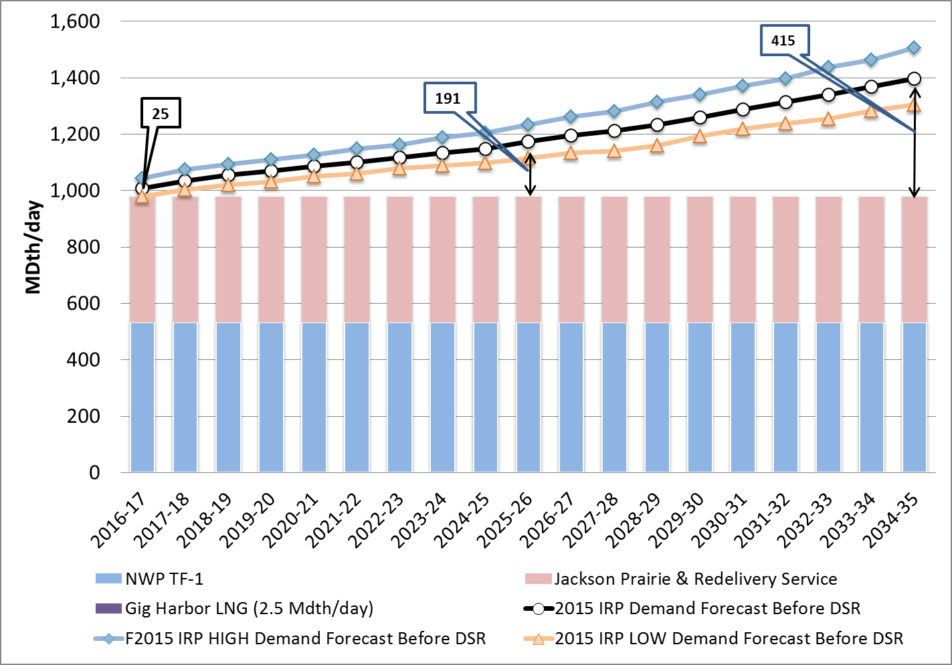

Gas Sales Resource Additions Forecast

Figure 1-12 summarizes the gas resource plan additions PSE forecasts to be cost effective in the future in terms of peak day capacity and in MDth per day. As with the electric resource plan, this is the “integrated resource planning solution.” It combines the amount of demand-side resources that are cost effective with supply-side resources in order to minimize the cost of meeting projected need. Again, this is not PSE’s action plan – it is a forecast of resource additions that look like they will be cost effective in the future, given what we know about resource trends and market trends today.

Figure 1-12: Gas Resource Plan Forecast,

Cumulative Additions in MDth/Day of Capacity



**Demand-side Resources (DSR).** Analysis in this IRP applies a 10-year ramp rate for acquisition of DSR measures. Analysis of 10- and 20-year ramp rates in prior IRPs has consistently found the 10-year rate to be more cost effective. Ten years is chosen because it aligns with the amount of savings that can practically be acquired at the program implementation level.

**PSE LNG Project.** PSE is in the early stages of developing a liquefied natural gas (LNG) project to provide peak day supply to PSE’s gas customers as part of a larger LNG project that would support the needs of emerging transportation markets. Converting local maritime traffic and truck transport to natural gas fuel will significantly improve local air quality and reduce greenhouse gas emissions. If such a multi-purpose project is constructed, this IRP finds the project’s capacity to provide peaking supplies would be cost effective for our gas customers.

**Swarr Upgrade.** This IRP finds that upgrading the Swarr LP-Air facility environmental safety and reliability systems and returning the Swarr production capacity to its original 30 MDth per day capability may be a cost-effective resource. Swarr is a propane-air injection facility on PSE’s gas distribution system that operates as a needle-peaking facility. Propane and air are combined in a prescribed ratio to ensure the mixture injected into the distribution system maintains the same heat content as natural gas. Preliminary work necessary to upgrade Swarr is under way.

**Northwest Pipeline/Westcoast Expansion.** Additional transportation capacity from the producing regions in British Columbia at Station 2 south to PSE’s system on the Westcoast pipeline is also forecast as cost effective beginning in 2022 based on lower projected pipeline costs than the alternatives.

**Mist Storage Expansion.** The Mist storage expansion is selected in most scenarios starting in 2026-27. This result means that PSE will continue to consider pursuing acquiring storage capacity at Mist, keeping in mind that Mist expansion is dependent on expansion of NWP from Sumas to the Portland area.

**Cross Cascades Expansion.** The analysis in this IRP indicated that in the later years of the planning horizon, a Cross Cascades expansion coupled with existing or new upstream pipeline to the liquid AECO or Malin gas hubs could be a cost-effective option for our gas customers. PSE will continue to consider these pipeline expansion options as they become more tangible and analyze their potential benefit for our customers as cost-effective resources.

**The IRP and the Resource Acquisition Process**

The IRP is not a substitute for the resource-specific analysis done to support specific acquisitions, though one of its primary purposes is to inform the acquisition process. The action plans presented here help PSE focus on key decision-points it may face during the next 20 years so that we can be prepared to meet needs in a timely fashion.

Figure 1-13 illustrates the relationship between the IRP and activities related to resource acquisitions. Specifically, the chart shows how the IRP directly informs other acquisition and decision processes. In Washington, the formal RFP processes for demand-side and supply-side resources are just one source of information for making acquisition decisions. Market opportunities outside the RFP and self-build (or PSE demand-side resource programs) must also be considered when making prudent resource acquisition decisions. Figure 1-13 also illustrates that information from the IRP also provides information to the local infrastructure planning process.

Figure 1-13: Relationship of IRP to Resource Decision Processes



1. / The NPCC, PNUCC and BPA regional resource adequacy studies used in the preparation of this IRP analysis are available in Appendix F.
2. / From Figure 1-1. This is calculated by comparing the Expected Customer Value of Lost Load (VOLL) in line 1(2013 Planning Standard with Market Risk) with the Expected VOLL in line 2 (2015 Optimal Planning Standard): $169 million - $39 million = $130 million.
3. / This value is derived by first calculating the difference between the surplus of 117 MW in line 1 (2013 Planning Standard with Market Risk) and the need (deficit) of 234 MW in line 2 (2015 Optimal Planning Standard). This value is then multiplied by the levelized cost of a peaker, estimated from the portfolio model at $0.18 million per MW per year. So: 234 MW – (-117 MW) = 351 MW. Then: 351 MW * $0.18 million per MW per year = $63 million per year.
4. /Risk here is defined as TailVar90, which is the mean of the worst 10 percent of cases. It is a good risk metric, because it measures how bad conditions could be, in the event we find ourselves in extreme conditions. We use TailVar90 as the risk metric in both this planning standard analysis and the portfolio analysis.
5. / */ $1,691 million (line 1) - $385 million (line 2) = $1,306 million.*
6. */ Chapter 3, Planning Environment, describes the resource acquisition process.*
7. 7/ In late August, 2015, the Northwest Power and Conservation Council (NPCC) signaled that draft results in its 7th Power Plan appear to contradict its May 2015 finding that the region needs to add approximately 1,150 MW of generation capacity by 2021 to avoid deficit conditions. Changes in the status of regional resource adequacy as a result of further study in 2016 may cause PSE to adjust the magnitude of its resource need, and we will continue to work with others in the region on this assessment.
8. / Resource capacities illustrated here reflect the contribution to peak, not nameplate capacity, so PSE’s approximate 823 MW of owned and contracted wind appear very small on this chart. Refer to Chapter 6, Electric Analysis, for how peak capacity contributions were assessed.
9. / *The 275 MW in Figure 1-4 shows a small difference from the 234 MW shown above in Figure 1-1. This 41 MW difference is because the analysis to establish the planning standard shown in Figure 1-1 was based on estimated conservation, versus final 2015 IRP conservation savings that came in slightly lower, along with slight differences in applying operating reserves in the deterministic and stochastic analyses, and the transmission availability impact of carrying those reserves at Mid-C.* 
10. / Chapter 6, Electric Analysis, includes a description of electric planning standards.
11. / Wind in this chart shows more prominently than in the capacity need chart, because this reflects the expected annual generation of wind, not just what can be relied upon to meet peak capacity needs.
12. / Chapter 2 includes a detailed explanation of the reasoning that supports each element of the resource plan.
13. / Section 111(d) of the Clean Air Act, often referred to as “111(d).”