Governor Jay Inslee

Via email to: Charles Knutson

Transportation and Land Use, Senior Policy Advisor

October 13, 2015

Dear Governor Inslee,

I am writing to you to support a rapid re-opening of Seattle Ride the Ducks operations.

Since 1997, Brian Tracey and his Ride the Ducks team have worked tirelessly to provide a much-needed service that showcases our great city to the millions of visitors we host. What makes them special is their status as the only company to showcase Seattle by land and sea, with enthusiasm and a trademark sense of humor that leave guests delighted and informed.

As founder and CEO of Clipper Navigation, Inc., a fellow local business in the tourism and hospitality industry, we are proud to have sent thousands of our guests to ride the ducks with full confidence of the high quality experience they would be provided.

The recent Aurora Bridge accident had a tragic and devastating impact on all its victims, their families, and our local residents. Of course after any vehicular accident, it is important to investigate safety. I understand the need to inspect the vehicles, its operation and the route. With that in mind, we ask that you make every effort to conduct this review in a timely manner.

Every day Ride the Ducks is forced to close operations, it is increasing the likelihood that they may never reopen their doors again, due to loss of trained staff and revenue. Ride the Ducks has not only bolstered the tourism economy of Seattle over the past two decades, but there are devoted employees counting on their jobs to support their families. Ride the Ducks has a strong safety record up to this point, and will continue to move forward with safety as the top priority. Alaska Airlines, our “hometown” airline, has suffered accidents in the past, even in spite of an extraordinary culture of safety, but they were allowed to continue operating.

You may remember viewers around the world watching Marshawn Lynch and the Seahawks team riding aboard a Duck with you during the championship parade. The Ducks are iconic and synonymous with Seattle’s playful and innovative spirit, and showcase this region we are proud to call home. Please consider the future of this business and support Ride the Ducks, and Seattle, to recover from this accident.

Sincerely,

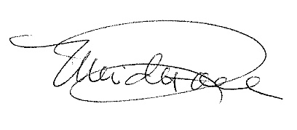

Merideth P. Tall

CEO and Chair

Clipper Navigation, Inc.