

**WASHINGTON**

**SERVICE QUALITY **

**REVIEW**

**January 1 – December 31, 2011**

**Annual Report**

# TABLE OF CONTENTS

TABLE OF CONTENTS 2

EXECUTIVE SUMMARY 3

1 Service Standards Program Summary 3

1.1 PacifiCorp Customer Guarantees 4

1.2 PacifiCorp Performance Standards 5

1.3 Reliability Definitions 6

1.4 Service Territory 8

2 CUSTOMER GUARANTEES SUMMARY 9

3 RELIABILITY PERFORMANCE 10

3.1 10-Year Historical Performance 10

3.2 System Average Interruption Duration Index (SAIDI) 11

3.3 System Average Interruption Frequency Index (SAIFI) 13

3.4 Operating Area Metrics 14

3.5 Cause Code Analysis 15

3.6 Areas of Greatest Concern 18

3.7 Reduce CPI for Worst Performing Circuits by 20% 19

3.8 Restore Service to 80% of Customers within 3 Hours 20

3.9 Telephone Service and Response to Commission Complaints 20

4 CUSTOMER RELIABILITY COMMUNICATIONS 21

4.1 Reliability Complaint Process Overview 21

4.2 Customer Complaint Tracking 22

4.3 Customer Complaints Recorded During the Period 22

5 WASHINGTON RELIABILITY RESULTS DURING 2011 23

5.1 State Reliability 24

5.2 5Y330 Donald Feeder 26

5.3 5Y94 Forney Feeder 29

5.4 5W305 Prescott Feeder 32

5.5 5Y164 Stein Feeder 34

5.6 5Y10 Terrace Hts. Feeder 37

# EXECUTIVE SUMMARY

During January 1 through December 31, 2011, PacifiCorp delivered reliable service to its Washington customers. The level of performance met baselines as well as internal targets. Also, the Customer Guarantee program continued to deliver high quality results (in fact, well above 99%) consistent with the prior year’s performance. As has been noted in the past, the company’s service delivered ranks very high when compared to others across the industry.

The company’s service reliability is impacted by uncontrollable interference events, such as car-hit-pole accidents, and by significant events that exceed the normal underlying level of interruptions but that do not reach the qualifying major event threshold for exclusion from the company’s underlying performance metrics. To provide a perspective on the impact of these events during the reporting period, the significant events experienced during 2011 are listed in Section 3.2. Consideration of the root causes of these significant events is important when evaluating year-on-year performance. When the company develops reliability improvement projects it evaluates these root causes and prepares plans that reflect the certainty of repetition of these events. The outcomes are reflective of the plans outlined in the Areas of Great Concern, shown in Section 3.6.

# Service Standards Program Summary

PacifiCorp has a Service Standards Program comprised of a number of Customer Guarantees and Performance Standards. Regular status reports regarding the program’s performance are provided both internally and externally. These reports detail measures of performance that are reflective of PacifiCorp's reliability in service delivery (of both personnel and the network) to its customers. The company developed these measures after evaluating company and industry standards and practices for delivering, collecting, and reporting performance data. In certain cases, the company chose to adopt a level of performance higher than the industry norm. In other cases, PacifiCorp developed metrics and targets based upon its history of delivery of these measures. The measures are useful in evaluating historical performance and in setting future targets for performance. In its entirety, these measures comply with WAC 480-100-393 and 398 requirements for routine reliability reporting.

In UE-042131, the Washington Utilities and Transportation Commission (the Commission) approved the company’s request to extend the core program through March 31, 2008. During the MidAmerican acquisition of PacifiCorp, in UE-051090, the program was extended again through 2011.

## PacifiCorp Customer Guarantees

|  |  |
| --- | --- |
| Customer Guarantee 1:  Restoring Supply After an Outage | The company will restore supply after an outage within 24 hours of notification from the customer with certain exceptions as described in Rule 25. |
| Customer Guarantee 2:  Appointments | The company will keep mutually agreed upon appointments which will be scheduled within a two-hour time window. |
| Customer Guarantee 3:  Switching on Power | The company will switch on power within 24 hours of the customer or applicant’s request, provided no construction is required, all government inspections are met and communicated to the company and required payments are made. Disconnections for nonpayment, subterfuge or theft/diversion of service are excluded. |
| Customer Guarantee 4:  Estimates For New Supply | The company will provide an estimate for new supply to the applicant or customer within 15 working days after the initial meeting and all necessary information is provided to the company. |
| Customer Guarantee 5:  Respond To Billing Inquiries | The company will respond to most billing inquiries at the time of the initial contact. For those that require further investigation, the company will investigate and respond to the Customer within 10 working days. |
| Customer Guarantee 6:  Resolving Meter Problems | The company will investigate and respond to reported problems with a meter or conduct a meter test and report results to the customer within 10 working days. |
| Customer Guarantee 7:  Notification of Planned Interruptions | The company will provide the customer with at least two days notice prior to turning off power for planned interruptions. |

*Note: See Rules for a complete description of terms and conditions for the Customer Guarantee Program.*

## PacifiCorp Performance Standards

|  |  |
| --- | --- |
| Network Performance Standard 1:  Improve System Average Interruption Duration Index (SAIDI) | The company will maintain SAIDI commitment target during the 3 year-9 month period through December 31, 2011. |
| Network Performance Standard 2:  Improve System Average Interruption Frequency Index (SAIFI) | The company will maintain SAIFI commitment target during the 3 year-9 month period through December 31, 2011. |
| Network Performance Standard 3:  Improve Under Performing Circuits | The company will reduce by 20% the circuit performance indicator (CPI) for a maximum of five under-performing circuits on an annual basis within five years after selection. |
| Network Performance Standard 4:  Supply Restoration | The company will restore power outages due to loss of supply or damage to the distribution system within three hours to 80% of customers on average. |
| Customer Service Performance Standard 5: Telephone Service Level | The company will answer 80% of telephone calls within 30 seconds. The company will monitor customer satisfaction with the company’s Customer Service Associates and quality of response received by customers through the company’s eQuality monitoring system. |
| Customer Service Performance Standard 6:  Commission Complaint Response/Resolution | The company will: a) respond to at least 95% of non-disconnect Commission complaints within three working days, except in Washington, where company will respond to 95% within two working days per state administrative code; b) respond to at least 95% of disconnect Commission complaints within four working hours; and c) resolve 95% of informal Commission complaints within 30 days. |

*Note: Performance Standards 1, 2 & 4 are for underlying performance days, excluding days classified as Major Events.*

## Reliability Definitions

This section defines the various terms[1] used when referring to interruption types, performance metrics and the internal measures developed to meet performance plans. A map of PacifiCorp’s service territory is included.

**Interruption Types**

***Sustained Outage***

A sustained outage is defined as an outage of equal to or greater than 5 minutes in duration.

***Momentary Outage***

A momentary outage is defined as an outage of less than 5 minutes in duration. PacifiCorp has historically captured this data using substation breaker fault counts.

**Reliability Indices**

***SAIDI***

SAIDI (system average interruption duration index) is an industry-defined term that relates to the average duration summed for all sustained outages a customer experiences in a given period. It is calculated by summing all customer minutes lost for sustained outages (those exceeding 5 minutes) and dividing by all customers served within the study area. When not explicitly stated otherwise, this value can be assumed to be for a one-year period.

***Daily SAIDI***

In order to evaluate trends during a year and to establish Major Event Thresholds, a daily SAIDI value is often used as a measure. This concept was introduced in IEEE Standard P1366-2003. This is the day’s total customer minutes out of service divided by the static customer count for the year. It is the total average outage duration customers experienced for that given day. When these daily values are accumulated through the year, it yields the year’s SAIDI results.

***SAIFI***

SAIFI (system average interruption frequency index) is an industry-defined term that attempts to identify the frequency of all sustained outages that the average customer experiences during a given period. It is calculated by summing all customer interruptions for sustained outages (those exceeding 5 minutes in duration) and dividing by all customers served within the study area.

***CAIDI***

CAIDI (customer average interruption duration index) is an industry-defined term that is the result of dividing the duration of the average customer’s sustained outages by the frequency of outages for that average customer. While the company did not originally specify this metric under the umbrella of the Performance Standards Program within the context of the Service Standards Commitments, it has since been determined to be valuable for reporting purposes. It is derived by dividing PS1 (SAIDI) by PS2 (SAIFI).

***CEMI***

CEMI is an acronym for Customers Experiencing Multiple (Sustained and Momentary) Interruptions. This index depicts repetition of outages across the period being reported and can be an indicator of recent portions of the system that have experienced reliability challenges. This metric is used to evaluate customer-specific reliability in Section 4 Customer Reliability Communications.

***CPI99***

CPI99 is an acronym for Circuit Performance Indicator, which uses key reliability metrics of the circuit to identify underperforming circuits. It excludes Major Event and Loss of Supply or Transmission outages. The variables and equation for calculating CPI are:

CPI = Index * ((SAIDI * WF * NF) + (SAIFI * WF * NF) + (MAIFI * WF * NF) + (Lockouts * WF * NF))

Index:  10.645

SAIDI: Weighting Factor 0.30, Normalizing Factor 0.029

SAIFI:  Weighting Factor 0.30, Normalizing Factor 2.439

MAIFI:  Weighting Factor 0.20, Normalizing Factor 0.70

Lockouts:  Weighting Factor 0.20, Normalizing Factor 2.00

Therefore, 10.645 * ((3-year SAIDI * 0.30 * 0.029) + (3-year SAIFI * 0.30 * 2.439) + (3-year MAIFI * 0.20 * 0.70) + (3-year breaker lockouts * 0.20 * 2.00)) = CPI Score

***CPI05***

CPI05 is an acronym for Circuit Performance Indicator, which uses key reliability metrics of the circuit to identify underperforming circuits. Unlike CPI99 it includes Major Event and Loss of Supply or Transmission outages. The calculation of CPI05 uses the same weighting and normalizing factors as CPI99.

**Performance Types & Commitments**

PacifiCorp recognizes two categories of performance: underlying performance and major events. Major events represent the atypical, with extraordinary numbers and durations for outages beyond the usual. Ordinary outages are incorporated within underlying performance. These types of events are further defined below.

***Major Events***

Pursuant WAC 480-100-393 Electric Reliability Annual Monitoring and Reporting Plan modified February 2011, in Docket UE-110634, the company recognizes two types of major events in Washington:

* A SAIDI-based Major Event is defined as a 24-hour period where SAIDI exceeds a statistically derived threshold value, as detailed in IEEE Distribution Reliability Standard 1366-2003[2].
* A SAIFI-Based Major Event is defined as an event in which more than 10% of an operating area’s customers are simultaneously without service as a result of a sustained interruption.

***Underlying Events***

Within the industry, there has been a great need to develop methodologies to evaluate year-on-year performance. This has led to the development of methods for segregating outlier days. Those days which fall below the statistically derived threshold represent “underlying” performance, and are valid (with some minor considerations for changes in reporting practices) for establishing and evaluating meaningful performance trends over time.

***Performance Targets***

During the MidAmerican acquisition of PacifiCorp, in Docket UE-051090 the Service Standards were extended again through 12/31/2011. Because performance delivered by the company in Washington falls within industry second quartile performance levels, the company committed that it will achieve performance by 12/31/2011 that maintains performance targets set in the Merger Commitment Periods.

## Service Territory

**Service Territory Map**

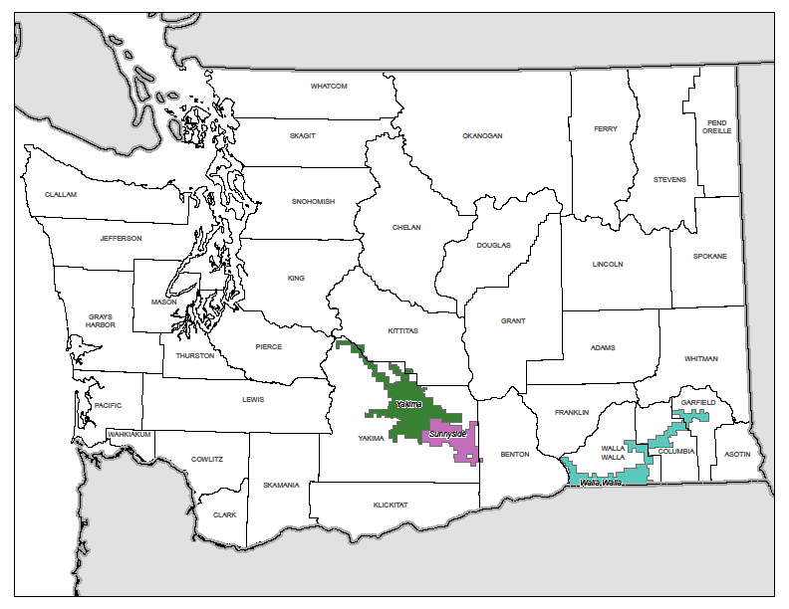

# CUSTOMER GUARANTEES SUMMARY



Overall guarantee performance remains well above 99%, demonstrating PacifiCorp’s continued commitment to customer satisfaction.

Customer Communications: The Customer Guarantee program was highlighted throughout the year in customer communications as follows:

Television advertisements promoting the Guarantees are on routine rotation in our television markets.

Performance reports are included in all billing statements.

Performance reports are highlighted in Voices, the company's newsletter.

The customer-facing website – pacificpower.net -- outlines the details of the program.

(Major Events are excluded from the Customer Guarantees program.)

# RELIABILITY PERFORMANCE

During the reporting period, the company’s reliability compared favorably to its baseline performance level as established in 2003. The year’s “Major Events Excluded As Reported” SAIDI performance of 80 minutes was much better than the approved SAIDI baseline of 150 minutes, while the year’s “Major Events Excluded As Reported” SAIFI performance of 0.550 events was also much better than the approved SAIFI baseline of 0.975 events. Various reliability metrics are shown below providing a historical perspective.

## 10-Year Historical Performance





## System Average Interruption Duration Index (SAIDI)

During the reporting period, the company delivered reliability results better than plan and baseline for both outage duration (SAIDI) and outage frequency (SAIFI); the performance compared to baselines is identified in Section 3.1 above. While outage response (CAIDI) results are not part of the company’s baseline performance metrics, the company reports them annually. During 2011, these results were off plan, most significantly in Yakima area where terrain and access issues contribute to response time. Annual CAIDI statewide in Washington for 2011 was 145 minutes excluding major events and 155 minutes including major events. (The annual CAIDI results for Washington operating areas are exhibited in a table under subsection 3.4 Operating Area Metrics.)

During the year, there was one SAIDI-based major event on February 12 due to an event that involved both wind-related outages and emergency-related outages (these were the result of a mill fire that led to a range fire in Yakima where fire crews required lines to be de-energized). The event excluded 11 minutes from underlying SAIDI. There were no SAIFI-based major events during this reporting period. (As noted in the Definitions section of this report, the company records two major event types and reports reliability metrics reflecting results under both methods.)

In contrast to the prior 2 years, calendar year 2011 reliability results were less impacted by severe weather events and experienced fewer Significant Event[3] days for the year, and so performed better than plan throughout the year. During the period, there were only five dates with a daily underlying SAIDI of 2.5 minutes or more. These five days account for 22 SAIDI minutes, representing 28% of the total underlying SAIDI results for the year.



|  |  |
| --- | --- |
| January 1 through December 31, 2011 | |
| 2011 SAIDI Goal = 110 | SAIDI Actual |
| Total Performance | 91 |
| SAIDI-based Major Events Excluded | 80 |
| SAIFI-based Major Events Excluded | 80 |



## System Average Interruption Frequency Index (SAIFI)

Like outage duration, outage frequency performed better than baseline and plan in 2011.

|  |  |
| --- | --- |
| January 1 through December 31, 2011 | |
| 2011 SAIFI Goal = 1.000 | SAIFI Actual |
| Total Performance | 0.587 |
| SAIDI-based Major Events Excluded | 0.550 |
| SAIFI-based Major Events Excluded | 0.550 |



## Operating Area Metrics

Washington operating area performance for the reporting period is listed in the table below.

|  |  |  |  |  |  |  |  |  |  |
| --- | --- | --- | --- | --- | --- | --- | --- | --- | --- |
| January 1 – December 31, 2011 | Including Major Events | | | Excluding SAIDI-based Major Events | | | Excluding SAIFI-based Major Events | | |
| SAIDI | SAIFI | CAIDI | SAIDI | SAIFI | CAIDI | SAIDI | SAIFI | CAIDI |
| SUNNYSIDE | 46 | 0.38 | 121 | 32 | 0.28 | 114 | 32 | 0.28 | 114 |
| WALLA WALLA | 66 | 0.67 | 97 | 66 | 0.67 | 97 | 66 | 0.67 | 97 |
| YAKIMA | 114 | 0.64 | 179 | 99 | 0.60 | 164 | 99 | 0.60 | 164 |

## Cause Code Analysis

The table and charts below break out the number of incidents, customer hours lost, and sustained interruptions by cause code. Customer Minutes Lost is directly related to SAIDI (average outage duration); Sustained Interruptions is directly related to SAIFI (average outage frequency). Certain types of outages typically result in high duration, but are infrequent, such as Loss of Supply outages. Others tend to be more frequent, but are generally shorter duration. The pie charts depict the breakdown of performance results by percentage of each cause category. Following the pie charts, a cause category table lists the direct causes with definitions and examples.





|  |  |
| --- | --- |
| **Cause Category** | **Description and Examples** |
| **Environment** | Contamination or Airborne Deposit (i.e., salt, trona ash, other chemical dust, sawdust, etc.); corrosive environment; flooding due to rivers, broken water main, etc.; fire/smoke related to forest, brush or building fires (not including fires due to faults or lightning). |
|  |  |
| **Weather** | Wind (excluding windborne material); snow, sleet or blizzard; ice; freezing fog; frost; lightning. |
|  |  |
| **Equipment Failure** | Structural deterioration due to age (incl. pole rot); electrical load above limits; failure for no apparent reason; conditions resulting in a pole/cross arm fire due to reduced insulation qualities; equipment affected by fault on nearby equipment (i.e. broken conductor hits another line). |
|  |  |
| **Interference** | Willful damage, interference or theft; such as gun shots, rock throwing, etc; customer, contractor or other utility dig-in; contact by outside utility, contractor or other third-party individual; vehicle accident, including car, truck, tractor, aircraft, manned balloon; other interfering object such as straw, shoes, string, balloon. |
|  |  |
| **Animals and Birds** | Any problem nest that requires removal, relocation, trimming, etc; any birds, squirrels or other animals, whether or not remains found. |
|  |  |
| **Operational** | Accidental Contact by PacifiCorp or PacifiCorp’s Contractors (including live-line work); switching error; testing or commissioning error; relay setting error, including wrong fuse size, equipment by-passed; incorrect circuit records or identification; faulty installation or construction; operational or safety restriction. |
|  |  |
| **Loss of Supply** | Failure of supply from Generator or Transmission system; failure of distribution substation equipment. |
|  |  |
| **Planned** | Transmission requested, affects distribution sub and distribution circuits; company outage taken to make repairs after storm damage, car hit pole, etc.; construction work, regardless if notice is given; rolling blackouts. |
|  |  |
| **Trees** | Growing or falling trees. |
|  |  |
| **Other** | Cause Unknown. |

## Areas of Greatest Concern

During 2011, reliability enhancement efforts continue to focus on improved system hardening and protection. This includes replacement of hydraulic reclosers, upgrades of substation breakers and/or relays and coordination of circuit protection devices, such as fuses and reclosers. The company has found substantial improvements in performance by focusing on circuits that do not appear to be well coordinated. Additionally, it has continued its circuit hardening efforts by strategic deployment of circuit inspection, pole and/or crossarm replacement and vegetation hot-spotting. Along with circuit hardening and protection efforts, it has reviewed opportunities for localized activities such as feeder ties and cable replacement activities. In this year’s set of areas of greatest concern, the company has identified transmission improvements that will increase distribution system performance by installing an auto sectionalizing scheme and fault indicators on the 69kV local transmission source for this feeder.  This will improve the reliability on this circuit (5W305) as well as the reliability on 5W342, 5W323, 5W306 and 5W324.

The table below lists reliability projects identified and currently underway for Washington’s Areas of Greatest Concern; these circuits will be subsequently reported as Program Year 13 circuits in Section 3.7.

|  |  |  |  |
| --- | --- | --- | --- |
| **Circuit** | **Actions** | **Status** | **Target Date** |
| 5Y94  Forney Feeder | Install recloser on south tap, at or around FP#299800, and fuse coordination | Pending | 12/31/2013 |
| 5Y164  Stein Feeder | Replace relays on 5Y164 at Wiley | Pending | 12/31/2013 |
| 5Y10  Terrace Hts. Feeder | Fuse coordination and add smart links on East tap and possibly West tap; need to determine whether recloser or trip savers are necessary | Pending | 12/31/2013 |
| 5W305  Prescott | Install auto sectionalizing scheme, switch 3W38; need PT and voltage relay; fault indicators; (line affects 5W342, 5W323, 5W305, 5W306 & 5W324) | Pending | 12/31/2013 |
| 5Y330  Donald Feeder | Fuse coordination | Pending | 12/31/2013 |

## Reduce CPI for Worst Performing Circuits by 20%

On a routine basis, the company reviews circuits for performance. One of the measures that it uses is called circuit performance indicator (CPI), which is a blended weighting of key reliability metrics covering a three-year time frame. The higher the number, the poorer the blended performance the circuit is delivering. As part of the company’s Performance Standards Program, it annually selects a set of Worst Performing Circuits for target improvement. The improvements are to be completed within two years of selection. Within five years of selection, the average performance is to be improved by at least 20% (as measured by comparing current performance against baseline performance). Program Years 1-5 and 9-11 have previously met their targets (as filed and approved) so no longer appear in the table below.

| **WASHINGTON WORST PERFORMING CIRCUITS** | **BASELINE** | **Performance 12/31/2011** | |
| --- | --- | --- | --- |
| PROGRAM YEAR 13: | | | |
| DONALD 5Y330 | 90 | |  |
| FORNEY 5Y94 | 207 | |  |
| PRESCOTT 5W305 | 94 | |  |
| STEIN 5Y164 | 156 | |  |
| TERRACE HTS 5Y10 | 114 | |  |
| TARGET SCORE = 106 | 132 | |  |
| PROGRAM YEAR 12: | | | |
| Freeway 5Y356 | 106 | | 114 |
| Pomeroy 5W342 | 97 | | 90 |
| Sheller 5Y314 | 131 | | 133 |
| Park Feeder 5W306 | 128 | | 110 |
| Cambell 5Y184 | 114 | | 127 |
| TARGET SCORE = 92 | 115 | | 115 |
| PROGRAM YEAR 8: | | | |
| Zillah 5Y245 | 114 | 37 | |
| Gurley 5Y358 | 87 | 65 | |
| Stone Creek 5W19 | 135 | 58 | |
| Nile 4Y1 | 760 | 825 | |
| Highland 5Y93 | 247 | 111 | |
| TARGET SCORE = 215 | 269 | 219 | |
| PROGRAM YEAR 7: | | | |
| West 5Y149 | 210 | 135 | |
| Granger 5Y357 | 116 | 165 | |
| Russell Creek 5W121 | 149 | 26 | |
| Tampico 5Y380 | 140 | 214 | |
| Gore 5Y100 | 56 | 61 | |
| TARGET SCORE = 107 | 134 | 120 | |
| PROGRAM YEAR 6: | | | |
| Nile 4Y1 | 383 | 825 | |
| Forney 5Y94 | 246 | 205 | |
| Harrah 5Y202 | 220 | 104 | |
| Windward 4W22 | 233 | 34 | |
| Ferndale 5W106 | 227 | 135 | |
| TARGET SCORE = 210 | 262 | 261 | |

## Restore Service to 80% of Customers within 3 Hours

|  |  |  |  |  |  |
| --- | --- | --- | --- | --- | --- |
| WASHINGTON RESTORATIONS WITHIN 3 HOURS | | | | | |
| 3-Year Program to Date | | | | 84% | |
| January 1 through December 31, 2011 | | | | 77% | |
| January | February | March | April | May | June |
| 78% | 67% | 75% | 71% | 85% | 86% |
| July | August | September | October | November | December |
| 92% | 76% | 80% | 77% | 67% | 83% |

## Telephone Service and Response to Commission Complaints

|  |  |  |
| --- | --- | --- |
| **COMMITMENT** | **GOAL** | **PERFORMANCE** |
| PS5-Answer calls within 30 seconds | 80% | 80% |
| PS6a) Respond to Commission complaints within 3 days | 95% | 100% |
| PS6b) Respond to Commission complaints regarding service disconnects within 4 hours | 95% | 100% |
| PS6c) Resolve Commission complaints within 30 days | 95% | 97% |

# CUSTOMER RELIABILITY COMMUNICATIONS

## Reliability Complaint Process Overview

The company’s process for managing customers’ concerns about reliability are to provide opportunities to hear customer concerns, respond to those concerns, and where necessary, provide customers an opportunity to elevate those concerns.



## Customer Complaint Tracking

Listed below are the various avenues available to a customer to resolve concerns about reliability performance.

* **Customer Reliability Inquiry**

The company records customer inquiries about reliability as Outage Power Quality transactions in its customer service system, referred to as “OPQ” transactions.

* **Customer Complaint**

If a customer’s reliability concerns are not met through the process associated with the OPQ transaction, a customer can register a 1-800 complaint with the company. This is recorded in a complaint repository from which regular reports are prepared and circulated for resolution.

* **Commission Complaint**

If a customer’s reliability concerns are not met through the process associated with a 1-800 complaint, a customer can register a complaint with the Commission. This is recorded by the Commission staff and also by the company in a complaint repository. Regular reports are prepared and circulated for resolution of these items.

## Customer Complaints Recorded During the Period

Listed below, by the recording source, are reliability-related customer complaints received for Washington services during the reporting period.

* **Informal Complaints (800 Customer Assistance Line - CAL)**

There were no Informal Complaints received by the company in the reporting period.

* **Commission Complaints**

There was one Commission Complaint in the reporting period.



# WASHINGTON RELIABILITY RESULTS DURING 2011

To geospatially display reliability results, the company has developed its GREAT tool which blends circuit topology with outage history and uses a variety of industry metrics (differentiated by color) to indicate areas where reliability analysis should be targeted. In the subsequent plots, two important reliability indicators are depicted. First, plots with customers experiencing multiple interruptions (CEMI) are shown. This measure shows how many sustained and momentary outages a given service transformer has experienced. The greater the color intensity, with red as the most severe, the more interruptions the transformer has had. Second sustained interruptions are shown. This measure shows how many sustained outages a service transformer has experienced. Third, service transformer-level SAIDI is shown. While technically SAIDI is a “system-level” metric, the local application of this metric can be revealing in determining service transformers that have had long cumulative durations of outages during the period. As explained previously, the greater the color intensity, the longer the outage duration during the period. (Major events, customer requested and prearranged outages are excluded from underlying results.)

## 

## State Reliability

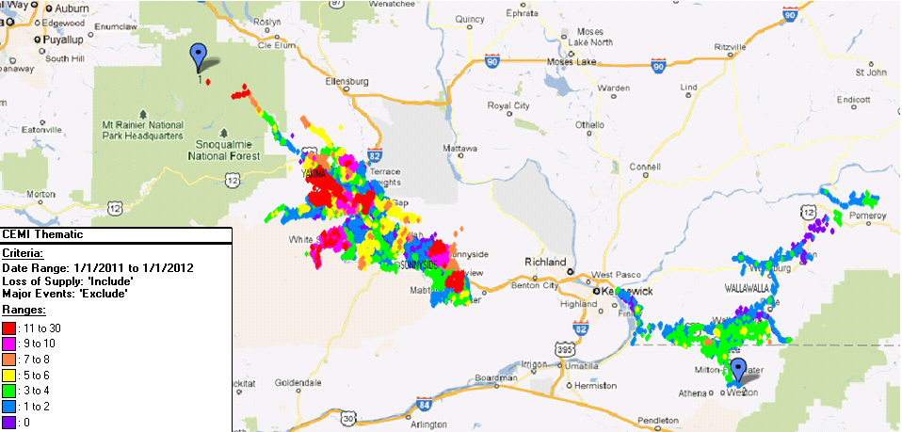

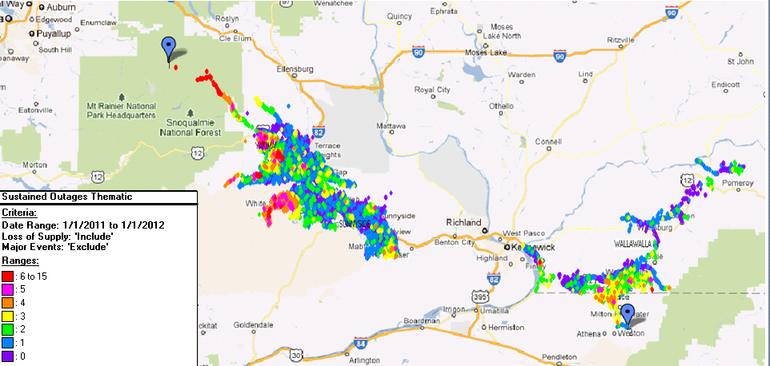

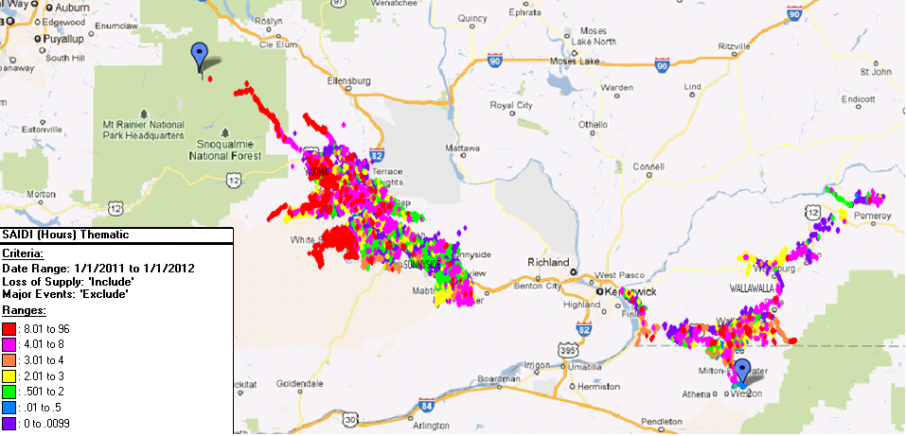

## 5Y330 Donald Feeder

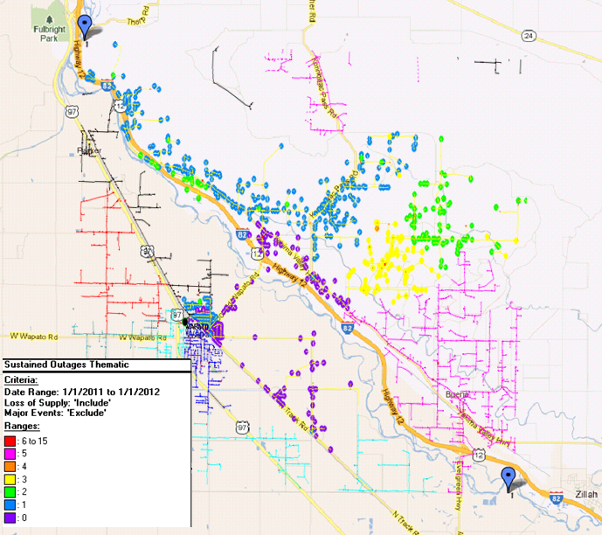

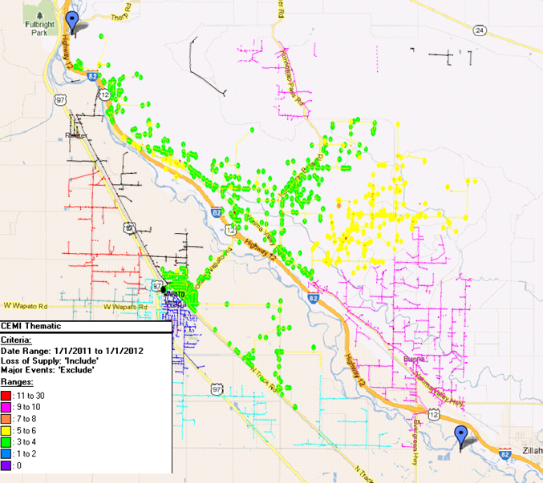

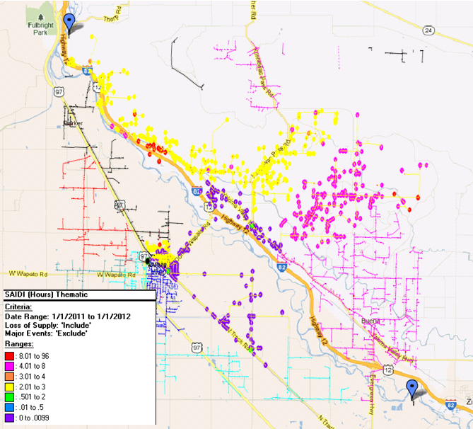

## 5Y94 Forney Feeder

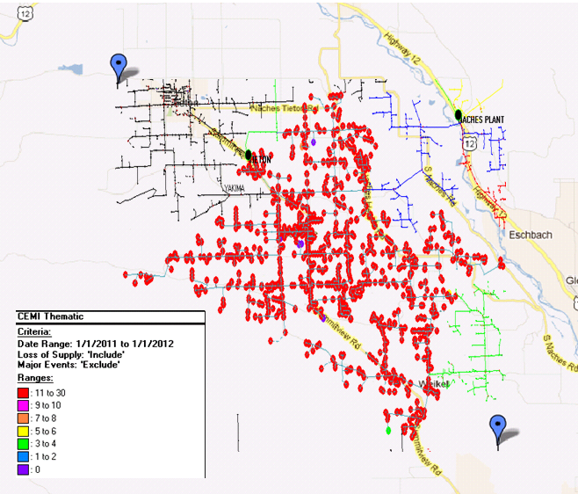

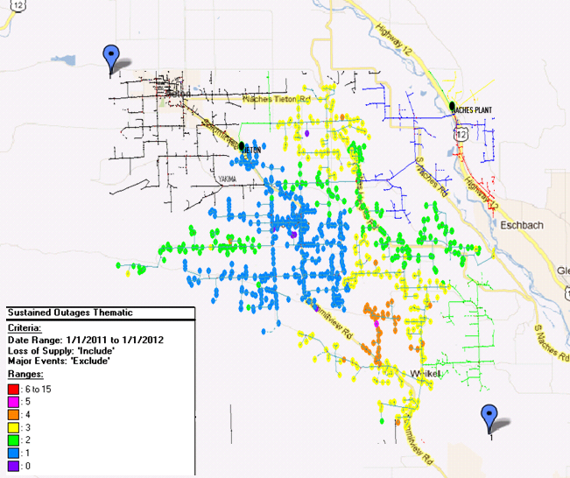

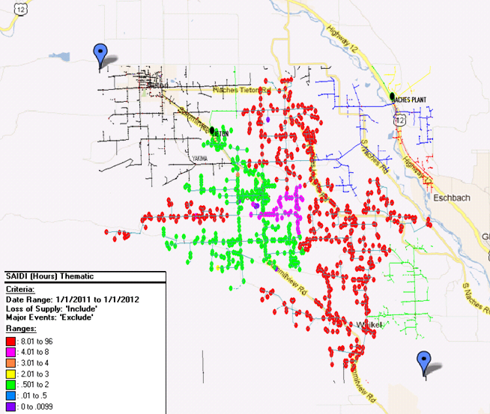

## 5W305 Prescott Feeder

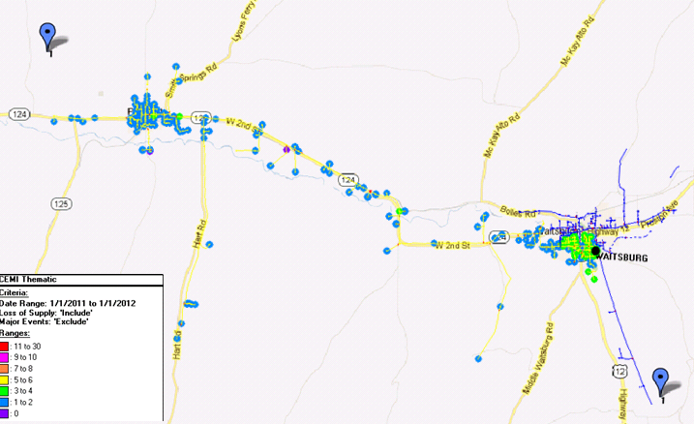

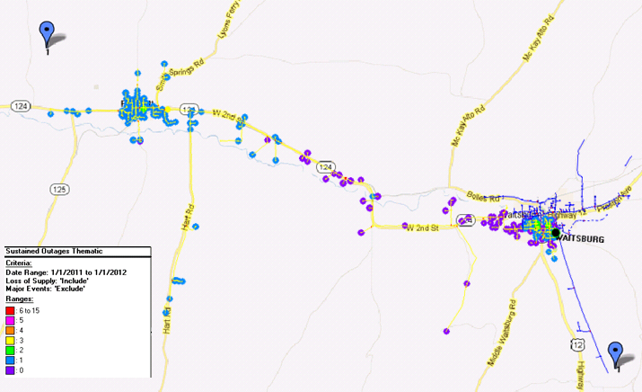

­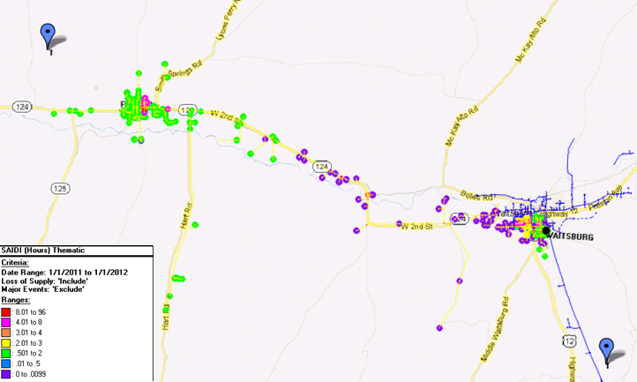

## 5Y164 Stein Feeder

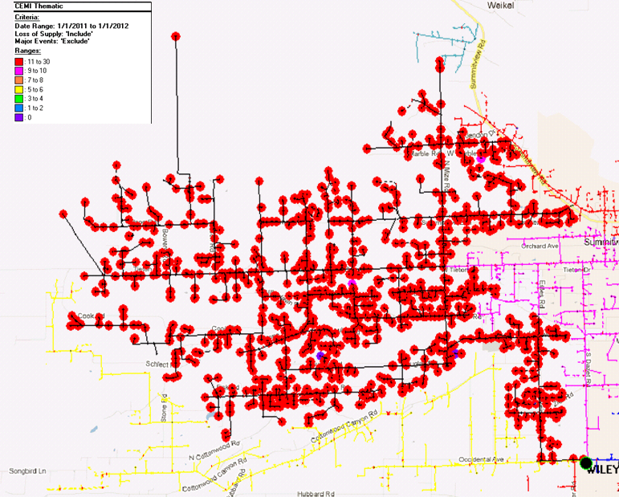

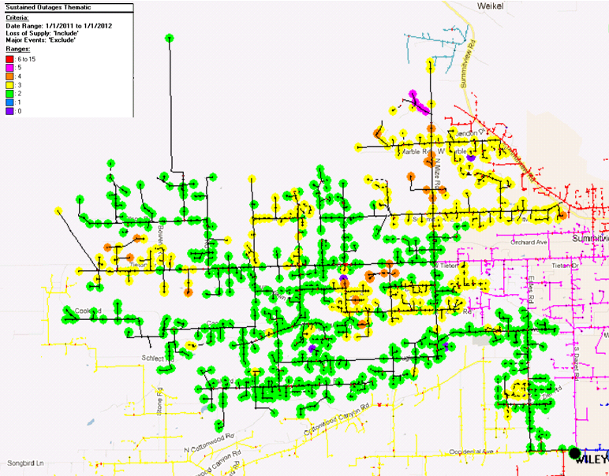

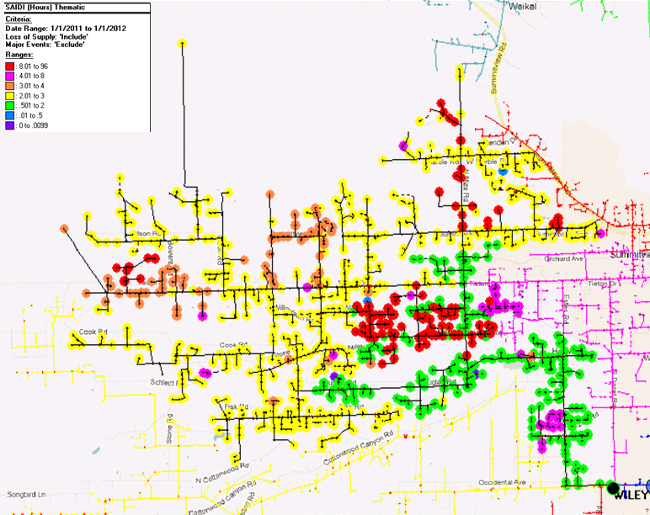

## 5Y10 Terrace Hts. Feeder

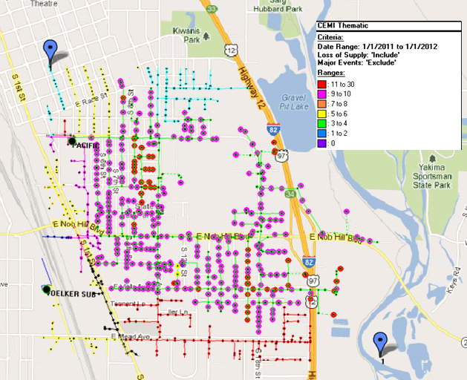

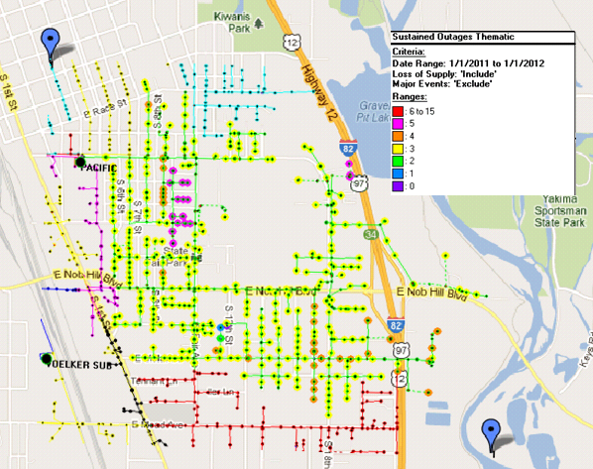

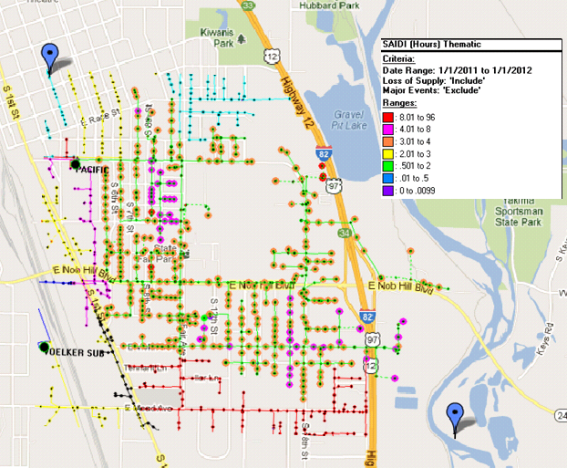

1. IEEE 1366-2003 was adopted by the IEEE Commissioners on December 23, 2003. The definitions and methodology detailed therein are now industry standards.
2. During calendar 2011, the calculated threshold for a major event is 12.33 minutes.
3. A Significant Event Day is 1.75 times the standard deviation of the company’s natural log daily SAIDI results by state.