BEFORE THE WASHINGTON UTILITIES AND TRANSPORTATION COMMISSION

DOCKET NO. UG-11_______

DIRECT TESTIMONY OF

KEVIN J. CHRISTIE

REPRESENTING AVISTA CORPORATION

**Q. Please state your name, business address, and present position with Avista Corp.**

A. My name is Kevin Christie and I am employed as Director of Gas Supply for Avista Utilities (Avista or Company). My business address is at 1411 East Mission Avenue, Spokane, Washington.

**Q. Would you please describe your education and business experience?**

A. Yes. I graduated from Washington State University with a Bachelors Degree in Business Administration with an accounting emphasis. I have also attended the University of Idaho Utility Executive Course.

I joined the Company in 2005 as the Manager of Natural Gas Planning. In 2007, I was appointed the Director of Gas Supply. Prior to joining Avista, I was employed by Gas Transmission Northwest (GTN). I was employed by GTN from 2001 to 2005 and was the Director of Pipeline Marketing and Development from 2003 to 2005 and the Director of Pricing and Business Analysis from 2001 to 2003. From 2000 to 2001, I was employed by PG&E Corporation (PG&E) as the Manager of Finance and Assistant to the SVP, Treasurer and CFO. Before joining PG&E, I was employed by Pacific Gas Transmission Company (PGT) from 1994 to 2000. While at PGT, I held several positions including Manager, Pricing and Business Analysis, Senior Business Analyst, Senior Pricing Planner, Director of Regulatory Affairs, Project Manager – Rates and Regulatory Affairs, Senior Regulatory Analyst, Regulatory Analyst, and Revenue Accountant. From 1990 to 1994, I was employed by Chevron USA as a Lease Revenue Accountant.

**Q. Mr. Christie, what is the purpose of your testimony in this proceeding?**

A. The purpose of my testimony is to describe Avista’s natural gas procurement planning process, provide an overview of the Jackson Prairie natural gas storage facility, and discuss how the Company uses Jackson Prairie for balancing on behalf of our Local Distribution Company (LDC) customers.

**Q. Are you sponsoring exhibits in this proceeding?**

A. Yes. I am sponsoring Exhibit No. ___ (KJC-2), which is a copy of the Company’s 2009 Natural Gas Integrated Resource Plan.

**Procurement Planning**

**Q. Please describe Avista’s natural gas portfolio as it relates to the procurement of natural gas for LDC customers?**

A. Avista purchases natural gas for LDC customers in wholesale markets at multiple supply basins in the western United States and western Canada. Purchased natural gas can be transported through six connected pipelines on which Avista holds contractual transportation rights. Access to this diverse portfolio of natural gas resources allows the Company to make natural gas procurement decisions that benefit our LDC customers. Further, the Company has interstate pipeline transportation capacity to serve approximately 25 percent of natural gas supplies from domestic sources (Rocky Mountains), with the remaining 75 percent from Canadian sources (British Columbia and Alberta). As natural gas prices in the Pacific Northwest can be affected by global energy markets, as well as supply and demand factors in other regions of the United States and Canada, future prices and delivery constraints may cause the source mix to vary. Below is a map showing our service territory, natural gas trading hubs, intrastate pipelines, and natural gas storage facility.

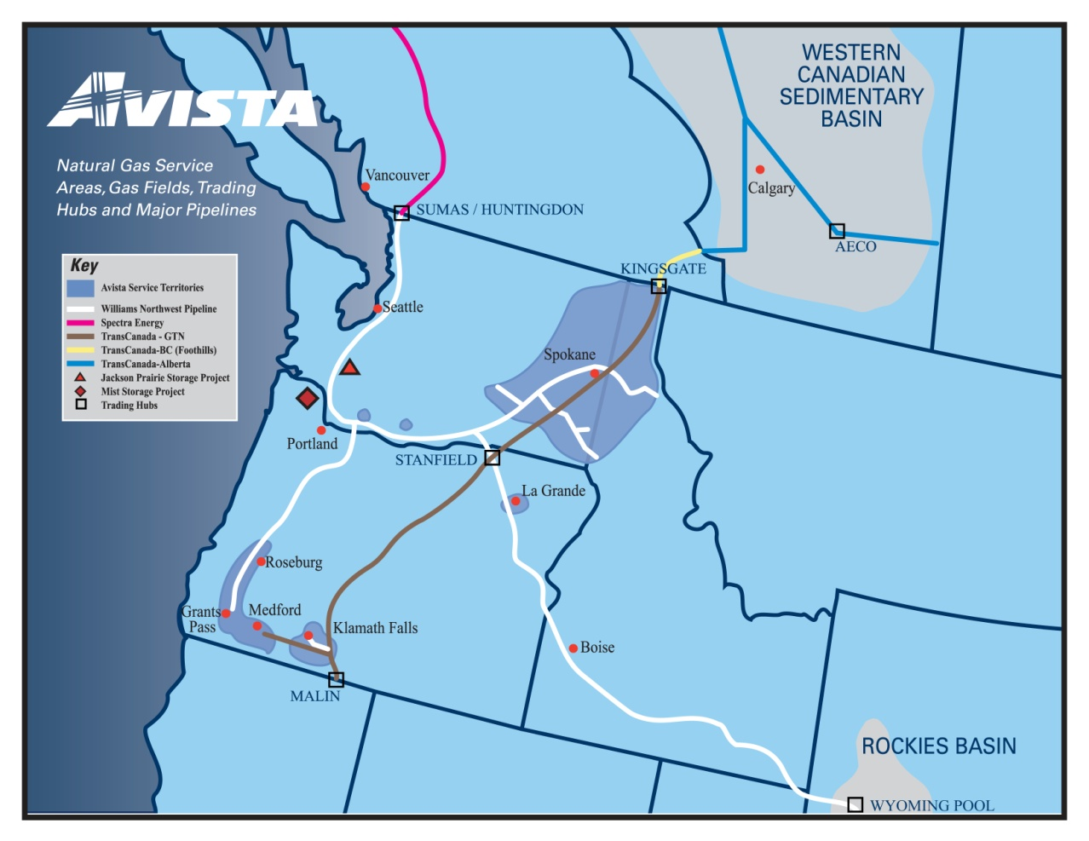

While Avista cannot accurately predict future natural gas prices, market conditions and experience help shape our overall procurement approach. The Company’s goal is to provide reliable supply at competitive prices in volatile commodity markets. To that end, the Company utilizes a Procurement Plan which includes hedging (on both a short term and long term basis), storage utilization, and index purchases. This approach is diversified by time, component, counterparty, and supply basin. The Procurement Plan is disciplined, yet flexible, which layers in fixed price purchases to reduce price volatility to customers. A copy of the Company’s Natural Gas Procurement Plan is included as an exhibit in Avista’s Energy Resources Risk Policy (see Confidential Exhibit No. ___(RJL-4C)).

The Procurement Plan provides a process that fixes prices for a designated portion of the portfolio through the use of hedge windows. The hedge windows are “open” for a predetermined time period and have upper and lower pricing levels which are set by the market at the time the window becomes effective. In a rising market, this reduces exposure to extreme price spikes. In a declining market, it can facilitate locking in lower prices. These windows can be closed if certain pricing levels are met, or upon time expiration. The Company always maintains some level of discretion and may choose not to execute a window given market conditions.

In addition, a portion of the portfolio that is separate from the hedge windows is designated as discretionary. This opportunistic portion of the portfolio allows the Company to hedge additional volumes at potentially favorable pricing levels. In the event those pricing levels are not reached, the unexecuted volumes designated as discretionary hedges will become a part of the index purchases portfolio.

Gas Supply continuously monitors the results of the Procurement Plan, evolving market conditions, variation in demand profiles, new supply opportunities, and regulatory conditions. Although various windows and targets are established in the initial design phase of the portfolio, the plan provides flexibility to exercise judgment to revise and/or adjust the plan in response to changing conditions.

**Q. What delivery period does the natural gas Procurement Plan include?**

A. The natural gas Procurement Plan includes four complete natural gas operating years (November through October) and whole months remaining from now until the next October 31 (the Current natural gas operating year). The four complete upcoming natural gas operating years are designated “Prompt”, “Second”, “Third”, and “Fourth” years.

**Q. Please describe the components of the prompt year natural gas Procurement Plan.**

A. Each year a comprehensive review of the previous year’s plan is performed. The review includes analysis of historical and forecasted market trends, fundamental market analysis, demand forecasting, and transportation and other resource considerations. From this review, decisions are made about how much forecasted demand should be served by various components of the portfolio, including:

1. **Previous Year(s) Hedges –** longer-term fixed-price purchases executed as a part of a previous year’s Procurement Plan.
2. **Prompt Year Hedges** – the portion of the portfolio addressed through the utilization of hedge windows. In each window fixed price purchases are made for various prompt year delivery periods. Prior to the execution of each window, market conditions, fundamental market knowledge, and other information is considered to determine if execution will occur.
3. **Storage Withdrawals** – utilizing the capacity and deliverability from the Jackson Prairie storage facility, Avista is able to inject natural gas during the summer months and withdraw it to serve customers during the higher demand winter months.
4. **Discretionary Prompt Year Hedges** – opportunistic purchases based on a set of price targets that trigger possible execution. At the time the triggers are reached, evaluation of market conditions, fundamental market knowledge, and other information are considered. These hedges will generally be executed when they can be done at or below the established targets.
5. **Index Purchases** – physical index-based natural gas purchases are procured prior to or throughout the delivery month. These purchases are usually associated with daily pricing. The amount of index purchases planned is the difference between the forecasted demand less the sum of the previous year hedges, prompt year hedges, and storage withdrawals.

**Q. Please describe the long term components of the natural gas Procurement Plan.**

A. As part of the development of the prompt year Procurement Plan, future years are also considered (referred to as “Second”, “Third”, and “Fourth” years). For a portion of the forecasted demand of the three years following the prompt year, a discretionary long term hedging program is developed. This program has a series of pricing targets that, when reached, trigger possible execution. At the time the triggers are reached, evaluation of market conditions, fundamental market knowledge, and other information are considered in order to determine if execution will occur.

**Q. Please describe how the Procurement Plan manages volatility.**

A. The Procurement Plan focuses on managing demand and price volatility. Natural gas demand is volatile and will vary day to day. For example, average daily demand for LDC customers in the summer months is approximately 30,000 Dekatherms (Dth) per day, and in a winter month average daily demand can be as high as 185,000 Dth per day. Further, within the month of November, the Company has an average daily demand as high as 150,000 Dth per day and a low of 50,000 Dth per day. Finally, from Avista’s 2009 IRP, peak day demand for 2011-2012 heating season is forecasted to be approximately 344,000 Dth per day. For the winter 2010-2011 heating season the observed peak demand was 272,000 Dth per day. In order to manage these seasonal, monthly and daily swings, Avista shapes the components of the Procurement Plan by month (i.e. more natural gas is hedged for the winter months than for the summer). Below is a chart that shows the demand volatility:



Price volatility can also vary widely by season, month and day. For example, on July 9, 2008 daily natural gas prices at AECO reached $11.82/Dth and on August 29, 2009 hit a low of $1.96/ Dth. By layering in purchases over time (both hedges and index), setting upper and lower pricing levels on the hedge windows, and opportunistically hedging at favorable pricing levels through the discretionary hedge program, Avista is able to meet our goal of providing stable yet competitive prices to our customers. Below is a chart from the Company’s 2009 Integrated Resource Plan demonstrating natural gas price volatility:



**Jackson Prairie Storage Facility & Balancing**

**Q. Could you please describe Avista’s involvement with the Jackson Prairie natural gas storage facility?**

A. Yes. Avista is one of the three original developers and owners of the underground aquifer storage facility at Jackson Prairie, which is located near Chehalis, Washington. Although there have been corporate changes due to mergers, acquisitions and name changes, Avista, Puget Sound Energy (PSE) and Northwest Pipeline each hold a one-third share (equal, undivided interest) of this underground natural gas storage facility through a joint ownership agreement. Development of the facility began in the 1960’s and the project first went into service in the early 1970’s.

**Q. Please describe the present level of storage that Avista owns at Jackson Prairie.**

A. Prior to May 1, 2011, the Company held a total of 5,497,112 Dth of seasonal capacity. This seasonal capacity comes with a withdrawal capability of 294,667 Dth per day (deliverability). As was described in the Company’s previous general rate case UG-100468, on May 1, 2011, the utility received an additional 3,030,887 Dth of seasonal capacity and an additional 104,000 Dth of daily deliverability. This capacity was originally held by Avista Energy and as part of the asset sales agreement this capacity was assigned to Shell Energy through April 30, 2011. As of May 1, 2011, the Company’s total capacity at Jackson Prairie is 8,527,999 Dth and total deliverability is 398,667 Dth per day.

**Q. Please briefly describe what the Commission approved in Docket UG-100468 as it relates to Jackson Prairie assets that were received by the Company on May 1, 2011.**

A. As noted in the Settlement Agreement approved by the Commission[1], the revenue requirement associated with Avista’s rate of return applied on the actual balance of the additional Jackson Prairie working gas inventory applicable to Washington gas operations, and the additional operations and maintenance costs, shall be calculated as a deferred cost beginning on May 1, 2011. Those costs will be recovered in the Company’s future PGA filing starting with Avista’s fall 2011 PGA filing, until recovered in base rates. Company witness Ms. Andrews has included in this case the additional plant[2], inventory and O&M costs associated with the additional Jackson Prairie storage.

**Q. At Paragraph 11, sub-section b of the Settlement Stipulation in Dockets UE-100467 & UG-100468, it states: “The Parties agree that the assignment of underground storage costs by throughput for balancing purposes will be reduced from 20 percent to 13 percent, with the additional Jackson Prairie capacity. The Company agrees to provide further information with respect to this issue in its next general rate case.” What was the basis for the change from 20 percent to 13 percent?**

A. Prior to the settlement in the Dockets noted above, the Company assigned 20% of all underground storage costs for purposes of pipeline balancing. The other 80% of costs were assigned for purposes of meeting the supply and peaking obligations for Avista’s core system natural gas customers. Natural Gas Resources personnel believed that the 20% / 80% split was valid for Jackson Prairie up until May 1, 2011 when the incremental storage assigned to Shell was moved to Avista Utilities. The additional capacity that came to the Company will not increase the balancing benefit (the 20% referenced above). Therefore, an adjustment to the throughput ratio to keep the proportional benefit the same was warranted.

**Q. How is storage used for pipeline balancing?**

A. Storage is utilized to manage daily balancing between purchased natural gas supplies and demand. To the extent that demand is greater than anticipated, or that supply is impacted by pipeline constraints or supplier reductions, storage can provide an incremental supply of natural gas. Conversely, if demand is less than anticipated or pipeline issues arise, storage provides a place for excess natural gas supplies. Managing supply and demand to a tight tolerance greatly reduces the possibility of natural gas pipelines implementing Operational Flow Orders (OFOs) and system wide or customer specific entitlements. During OFOs and declared entitlements, storage is used to comply with the pipeline’s tariff balancing provisions to avoid penalty situations.

**Q. How was the change from 20 percent to 13 percent calculated?**

A. Prior to May 1, 2011, the Company held a total of 5,497,112 Dth of seasonal capacity. Twenty percent of that existing capacity is 1,099,422 Dth. With the May 2011 addition, the total capacity at the facility will be 8,527,999 Dth. Dividing the balancing capacity (prior to May 1, 2011) of 1,099,422 Dth by the total capacity effective May 1, 2011 of 8,527,999 Dth, results in a 13% allocation for balancing.

**Q. Does this conclude your pre-filed, direct testimony?**

A.Yes it does.

1. Order No. 7, Dockets UE-100467 & UG-100468, paragraph 5.
2. Prudence and recovery of the Jackson Prairie plant assets added May 1, 2011 were approved in base rates in Docket UG-100468.