BEFORE THE WASHINGTON UTILITIES AND TRANSPORTATION COMMISSION

DOCKET NO. UG-12_______

DIRECT TESTIMONY OF

KEVIN J. CHRISTIE

REPRESENTING AVISTA CORPORATION

**Q. Please state your name, business address, and position with Avista Corp.**

A. My name is Kevin Christie and I am employed as Director of Gas Supply for Avista Utilities (Avista or Company). My business address is at 1411 East Mission Avenue, Spokane, Washington.

**Q. Would you please describe your education and business experience?**

A. Yes. I graduated from Washington State University with a Bachelors Degree in Business Administration with an accounting emphasis. I have also attended the University of Idaho Utility Executive Course.

I joined the Company in 2005 as the Manager of Natural Gas Planning. In 2007, I was appointed the Director of Gas Supply. Prior to joining Avista, I was employed by Gas Transmission Northwest (GTN). I was employed by GTN from 2001 to 2005 and was the Director of Pipeline Marketing and Development from 2003 to 2005 and the Director of Pricing and Business Analysis from 2001 to 2003. From 2000 to 2001, I was employed by PG&E Corporation (PG&E) as the Manager of Finance and Assistant to the SVP, Treasurer and CFO. Before joining PG&E, I was employed by Pacific Gas Transmission Company (PGT) from 1994 to 2000. While at PGT, I held several positions including Manager, Pricing and Business Analysis.

**Q. Mr. Christie, what is the purpose of your testimony in this proceeding?**

A. The purpose of my testimony is to describe Avista’s natural gas procurement planning process (for the local distribution company), provide an overview of the Company’s 2012 Natural Gas Integrated Resource Plan development, and provide an overview of the Jackson Prairie natural gas storage facility (JP Storage) including a discussion related to the working inventory and O&M costs that will be included in the Company’s 2012 PGA.

**Q. Are you sponsoring exhibits in this proceeding?**

A. Yes. I am sponsoring Exhibit No. ___ (KJC-2), which is a copy of the Company’s 2009 Natural Gas Integrated Resource Plan.

**Q. Is the Company proposing any changes to the cost of natural gas for its retail natural gas customers in this case?**

A. No, Avista is not proposing changes in this filing related to the cost of natural gas included in current rates for natural gas customers as changes in natural gas costs are addressed in the annual PGA filings. My testimony is primarily for informational purposes, related to our natural gas commodity planning and procurement activities, as well as summarizing the recent ratemaking treatment related to the additional JP Storage capacity received by Avista Utilities beginning on May 1, 2011.

**Procurement Planning**

**Q. Please describe Avista’s natural gas portfolio as it relates to the procurement of natural gas for LDC customers?**

A. Avista purchases natural gas for LDC customers in wholesale markets at multiple supply basins in the western United States and western Canada. Purchased natural gas can be transported through six connected pipelines on which Avista holds firm contractual transportation rights. Access to this diverse portfolio of natural gas resources allows the Company to make natural gas procurement decisions that benefit our LDC customers. Further, the Company has interstate pipeline transportation capacity to serve approximately 20 percent of natural gas supplies from domestic sources (Rocky Mountains), with the remaining 80 percent from Canadian sources (British Columbia and Alberta). As natural gas prices in the Pacific Northwest can be affected by global energy markets, as well as supply and demand factors in other regions of the United States and Canada, future prices and delivery constraints may cause the source mix to vary. Below is a map showing our service territory, natural gas trading hubs, intrastate pipelines, and natural gas storage facility.

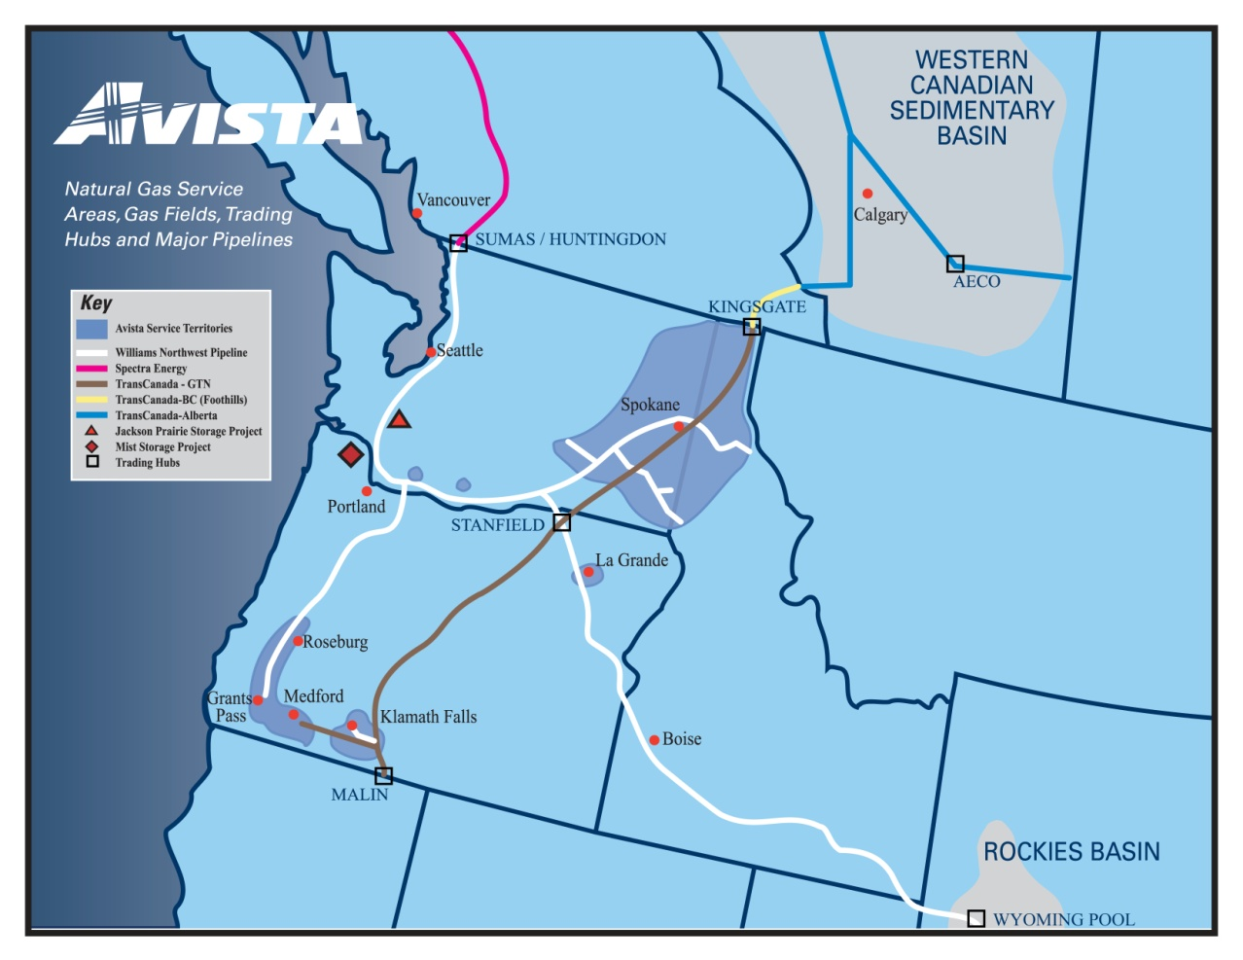

While Avista cannot accurately predict future natural gas prices, market conditions and experience help shape our overall procurement approach. The Company’s goal is to provide reliable supply at competitive prices in volatile commodity markets. To that end, the Company utilizes a Procurement Plan which includes hedging (on both a short term and long term basis), storage utilization, and index purchases. This approach is diversified by time, component, counterparty, and supply basin. The Procurement Plan is disciplined, yet flexible, and layers in fixed-price purchases to reduce price volatility to customers. A copy of the Company’s Natural Gas Procurement Plan is included as an exhibit in Avista’s Energy Resources Risk Policy (see Confidential Exhibit No. ___(RJL-5C)).

The Procurement Plan provides a process that fixes prices for a designated portion of the portfolio through the use of hedge windows. The hedge windows are “open” for a predetermined time period and have upper and lower pricing levels which are set by the market at the time the window becomes effective. In a rising market, this reduces exposure to extreme price spikes. In a declining market, it can facilitate locking in lower prices. These windows can be closed if certain pricing levels are met, or upon time expiration. The Company always maintains some level of discretion and may choose not to execute within a window or to change some aspect of a window given market conditions.

In addition, a portion of the portfolio that is separate from the hedge windows is designated as discretionary. This opportunistic portion of the portfolio allows the Company to hedge additional volumes in gas years beyond the prompt year at potentially favorable pricing levels. In the event those pricing levels are not reached, the unexecuted volumes designated as discretionary hedges will become a part of the prompt year hedging program.

Gas Supply continuously monitors the results of the Procurement Plan, evolving market conditions, variation in demand profiles, new supply opportunities, and regulatory conditions. Although various windows and targets are established in the initial design phase of the portfolio, the plan provides flexibility to exercise judgment to revise and/or adjust the plan in response to changing conditions.

**Q. What delivery period does the natural gas Procurement Plan include?**

A. The natural gas Procurement Plan includes four complete natural gas operating years (November through October) and whole months remaining from now until the next October 31 (the Current natural gas operating year). The four complete upcoming natural gas operating years are designated “Prompt”, “Second”, “Third”, and “Fourth” years.

**Q. Please describe the components of the natural gas Procurement Plan.**

A. Each year a comprehensive review of the previous year’s plan is performed. The review includes analysis of historical and forecasted market trends, fundamental market analysis, demand forecasting, and transportation and other resource considerations. The plan includes the following components:

1. **Previous Year(s) Hedges** – longer-term fixed-price purchases executed as a part of a previous year’s Procurement Plan.
2. **Prompt Year Hedges** – the portion of the portfolio addressed through the utilization of hedge windows. In each window fixed price purchases are made for various prompt year delivery periods. Prior to the execution of each window, market conditions, fundamental market knowledge, and other information is considered to determine if execution will occur.
3. **Storage Withdrawals** – utilizing the capacity and deliverability from the Jackson Prairie storage facility, Avista is able to inject natural gas during the summer months and withdraw it to serve customers during the higher demand winter months.
4. **Discretionary Long-term Hedges** – opportunistic purchases based on a set of price targets that trigger possible execution. At the time the triggers are reached, evaluation of market conditions, fundamental market knowledge, and other information are considered. These hedges will generally be executed when they can be done at or below the established targets.
5. **Index Purchases** – physical index-based natural gas purchases are procured prior to or throughout the delivery month. These purchases are usually associated with daily pricing. The amount of index purchases planned is the difference between the forecasted demand less the sum of the previous year hedges, prompt year hedges, and storage withdrawals.

**Q. Please describe the long term components of the natural gas Procurement Plan.**

A. As part of the development of the prompt year Procurement Plan, future years are also considered (referred to as “Second”, “Third”, and “Fourth” years). For a portion of the forecasted demand of the three years following the prompt year, a discretionary long term hedging program is developed. This program has a series of pricing targets that, when reached, trigger possible execution. At the time the triggers are reached, evaluation of market conditions, fundamental market knowledge, and other information are considered in order to determine if execution will occur.

**Q. Please describe how the Procurement Plan manages volatility.**

A. The Procurement Plan focuses on managing demand and price volatility. Natural gas demand is volatile and will vary day to day. For example, average daily demand for LDC customers in the summer months is approximately 30,000 Dekatherms (Dth) per day, and in a winter month average daily demand can be as high as 185,000 Dth per day. Further, within the month of November, the Company has an average daily demand as high as 150,000 Dth per day and a low of 50,000 Dth per day. Finally, from Avista’s 2009 IRP, peak day demand for 2012-2013 heating season is forecasted to be approximately 346,000 Dth per day. For 2011 the observed peak demand was 261,000 Dth per day. In order to manage these seasonal, monthly and daily swings, Avista shapes the components of the Procurement Plan by month (i.e. more natural gas is hedged for the winter months than for the summer). Below is a chart that shows the demand volatility:



Price volatility can also vary widely by season, month and day. Below is a chart depicting the natural gas price volatility over time. Avista cannot predict with accuracy where natural gas prices may go, however, our experience and market intelligence guide our procurement decisions. By layering in purchases over time (both hedges and index), setting upper and lower pricing levels on the hedge windows, and opportunistically hedging at favorable pricing levels through the discretionary hedge program, Avista is able to meet our goal of providing stable yet competitive prices to our customers.



**2012 Natural Gas Integrated Resource Plan**

**Q. Can you please provide an overview of the Company’s development of its 2012 Natural Gas Integrated Resource Plan?**

A. Yes I can. On or about August 31, 2012, Avista will file with the Commission its Natural Gas Integrated Resource Plan. The IRP forecasts natural gas demand and any new resources projected for the coming 20 years, which will help Avista continue to reliably provide natural gas to our customers. To date, the Company has held three Technical Advisory Committee (TAC) meetings, with a fourth meeting to be held shortly after the filing of this testimony. The TAC, which consists of regulatory staff from the Company’s three service jurisdictions, other utilities, interstate pipelines, and various other stakeholders, help provide guidance in the development of the final IRP.

**Jackson Prairie Storage**

**Q. Could you please describe Avista’s involvement with the Jackson Prairie natural gas storage facility?**

A. Yes. Avista is one of the three original developers and owners of the underground aquifer storage facility at Jackson Prairie, which is located near Chehalis, Washington. Although there have been corporate changes due to mergers, acquisitions and name changes, Avista, Puget Sound Energy (PSE) and Williams Northwest Pipeline each hold a one-third share (equal, undivided interest) of this underground natural gas storage facility through a joint ownership agreement. Development of the facility began in the 1960’s and the project first went into service in the early 1970’s.

**Q. Please describe the present level of storage that Avista owns at Jackson Prairie.**

A. As of May 1, 2011, the Company’s total capacity at Jackson Prairie is 8,528,000 Dth and total deliverability is 398,667 Dth per day.

**Q. Please briefly describe what the Commission approved in Dockets UG-100468 and UG-110877 as it relates to Jackson Prairie assets that were received by the Company on May 1, 2011.**

A. In the Settlement Stipulation approved by the Commission in Docket UG-100468, the Parties agreed that the revenue requirement associated with Avista’s rate of return applied to the actual balance of the additional JP working gas inventory applicable to Washington gas operations shall be calculated as a deferred cost beginning May 1, 2011, to be recovered in the Company’s future PGA filings starting with Avista’s fall 2011 PGA filing, until recovered in base rates in a subsequent general rate case. In addition, the additional operations and maintenance costs would be recorded in the Company's PGA deferrals for later recovery in rates until those costs are included in base retail rates.

The Parties agreed in the Settlement Stipulation in Docket UG-110877 that the additional JP working gas inventory, as well as additional operations and maintenance costs, would be included in base rates and would no longer be recovered in future PGA filings, except for those deferred costs incurred prior to January 1, 2012.

**Q. What deferred costs have yet to be recovered?**

A. The Company included the deferred costs referenced above for May 2011 through June 2011 in its 2011 Purchase Gas Cost Adjustment (PGA) filing (Docket UG-111665). The Company will include the deferred costs from July 2011 through December 2011 in its September 2012 PGA filing.

**Q. Were there any other agreements regarding Jackson Prairie addressed in the Settlement Stipulation that the Commission approved in Docket UG-110877?**

A. Yes, the parties to the Stipulation agreed that the 13 percent allocation made for system balancing for JP, reflecting the May 1, 2011 capacity addition, is appropriate. That allocation was used in this filing.

**Q. Does this conclude your pre-filed, direct testimony?**

A.Yes it does.