**SECTION 3**

**DEMAND FORECAST**

**Overview**

Each year Cascade develops a 20-year forecast of customers, therm sales and peak requirements for use in short-term (annual budgeting) and long-term (distribution and integrated resource planning) planning processes. This forecast is a robust portfolio of estimates created by enhancing a single best-estimate forecast with various potential economic, demographic and marketplace eventualities into low, medium and high growth forecast scenarios. The scenarios are used for distribution system enhancement planning and as inputs in optimization models to determine the least cost portfolio of supply and DSM resources, revenue budgeting, and load forecasts associated with the purchased gas cost process.

**Key Points**

* Cascade initiates its forecast with analyses of demand area, weather, and heating degree days (HDDs).
* Three peak day scenarios are examined: Average peak HDDs;

System-wide max peak HDDs; and Max citygate peak HDDs.

* Cascade uses a 60 degree reference temperature to calculate HDDs.
* The Company utilizes an ordinary least squares (OLS) regression to predict customer usage.
* High and low scenarios were included and alternative forecasting method-ologies were considered.
* Cascade expects system load growth to be 1.25% per year, or 26% over the 20-year planning horizon.
* Uncertainties in the future may cause differences from the Company’s forecast.

**Demand Areas**

In 2016, Cascade is forecasting at the citygate level. This is a change of methodology from previous years where certain models were built from the district or zonal level. Cascade has a total of 74 citygates of which only nine citygates feed non-core customers and the remaining 65 serve at least one core customer. Of the 65 citygates that serve core customers, eighteen are grouped into eight different citygate loops. Each citygate is assigned to a weather location. For this IRP, the Company assigned the citygates to either the closest weather location by distance or the closest weather location by climatic simile. The citygate results are rolled up into zones and districts which segregate Cascade’s system based on pipelines and weather (see Appendix B, Demand Forecast). Table 3-1 provides a cross reference for the demand areas.

**Table 3-1: Demand Areas**

| **Citygate** | **Loop** | **State** | **Weather Location** | **Zone** |
| --- | --- | --- | --- | --- |
| 7TH DAY SCHOOL |  | WA | Yakima | 10 |
| A/M RENDERING |  | WA | Bellingham | 30-W |
| ACME |  | WA | Bellingham | 30-W |
| ARLINGTON |  | WA | Bellingham | 30-W |
| ATHENA |  | OR | Pendleton | ME-OR |
| BAKER |  | OR | Baker City | 24 |
| BELLINGHAM 1 (FERNDALE) | Sumas SPE Loop | WA | Bellingham | 30-W |
| BEND | Bend Loop | OR | Redmond | GTN |
| BREMERTON (SHELTON) |  | WA | Bremerton | 30-S |
| BURBANK HEIGHTS | Burbank Heights Loop | WA | Walla Walla | 20 |
| CASTLE ROCK |  | WA | Bremerton | 26 |
| CHEMULT |  | OR | Redmond | GTN |
| DEHAWN DAIRY |  | WA | Yakima | 10 |
| DEMING |  | WA | Bellingham | 30-W |
| EAST STANWOOD | East Stanwood Loop | WA | Bellingham | 30-W |
| FINLEY |  | WA | Walla Walla | 20 |
| GILCHRIST |  | OR | Redmond | GTN |
| GRANDVIEW |  | WA | Yakima | 10 |
| HERMISTON |  | OR | Pendleton | ME-OR |
| HUNTINGTON |  | OR | Baker City | 24 |
| KALAMA #1 |  | WA | Bremerton | 26 |
| KALAMA #2 |  | WA | Bremerton | 26 |
| KENNEWICK | Kennewick Loop | WA | Walla Walla | 20 |
| LA PINE |  | OR | Redmond | GTN |
| LAWRENCE |  | WA | Bellingham | 30-W |
| LDS CHURCH |  | WA | Bellingham | 30-W |
| LONGVIEW-KELSO | Longview South Loop | WA | Bremerton | 26 |
| LYNDEN | Sumas SPE Loop | WA | Bellingham | 30-W |
| MADRAS |  | OR | Redmond | GTN |
| MCCLEARY (ABERDEEN/HOQUIAM) | | WA | Bremerton | 30-S |
| MILTON-FREEWATER |  | OR | Walla Walla | ME-OR |
| MISSION TAP |  | OR | Pendleton | ME-OR |
| MOSES LAKE |  | WA | Yakima | 20 |
| MOUNT VERNON | Sedro-Woolley Loop | WA | Bellingham | 30-W |
| MOXEE (BEAUCHENE) |  | WA | Yakima | 11 |
| NORTH BEND | Bend Loop | OR | Redmond | GTN |
| NORTH PASCO |  | WA | Walla Walla | 20 |
| NYSSA-ONTARIO |  | OR | Baker City | 24 |
| OAK HARBOR/STANWOOD | East Stanwood Loop | WA | Bellingham | 30-W |
| OTHELLO |  | WA | Walla Walla | 20 |
| PASCO | Burbank Heights Loop | WA | Walla Walla | 20 |
| PATTERSON |  | WA | Yakima | 26 |
| PENDLETON |  | OR | Pendleton | ME-OR |
| PRINEVILLE |  | OR | Redmond | GTN |
| PRONGHORN |  | Redmond | GTN |  |
| PROSSER |  | WA | Yakima | 10 |
| QUINCY |  | WA | Yakima | 11 |
| REDMOND |  | OR | Redmond | GTN |
| RICHLAND (Richland Y) | Kennewick Loop | WA | Walla Walla | 20 |
| SEDRO/WOOLLEY | Sedro-Woolley Loop | WA | Bellingham | 30-W |
| SELAH | Yakima Loop | WA | Yakima | 11 |
| SOUTH BEND | Bend Loop | OR | Redmond | GTN |
| SOUTH LONGVIEW | Longview South Loop | WA | Bremerton | 26 |
| STANFIELD |  | OR | Pendleton | GTN |
| STEARNS (SUNRIVER) |  | OR | Redmond | GTN |
| SUNNYSIDE |  | WA | Yakima | 10 |
| UMATILLA |  | OR | Pendleton | ME-OR |
| WALLA WALLA |  | WA | Walla Walla | ME-WA |
| WCT-CNG INTERCONNECT | Sumas SPE Loop | WA | Bellingham | 30-W |
| WENATCHEE |  | WA | Yakima | 11 |
| WOODLAND |  | WA | Bremerton | 26 |
| YAKIMA CHIEF RANCH |  | WA | Yakima | 10 |
| YAKIMA TRAINING CENTER |  | WA | Yakima | 11 |
| YAKIMA/UNION GAP | Yakima Loop | WA | Yakima | 11 |
| ZILLAH (TOPPENISH) |  | WA | Yakima | 10 |

**Weather**

Historical weather data is provided by a contractor, Schneider Electric. The current forecast uses 30 years of recent history as the “normal” or expected weather. The forecast model takes the 30 previous years, converts the data to heating degree days (HDDs), then averages the HDDs into average months to create a normal or expected year. Cascade has seven weather locations with four located in Washington and three in Oregon. The four weather locations in Washington are Bellingham, Bremerton, Yakima, and Walla Walla.

**Heating Degree Days**

HDD values are calculated by beginning with the daily average temperature, which is the simple average of the high and low temperatures for a given day. The daily average is then subtracted from an HDD degree threshold (for example 65 °F) to create the HDD for a given day. Should this calculation produce a negative number, a value of zero is assigned as the HDD. Therefore, HDDs can never be negative. The HDD threshold number is designed to reflect a temperature below which heating demand begins to significantly rise. The historical threshold for calculating HDD has been 65 °F. However, when modeling gas demand based on weather, Cascade has determined that lowering the threshold to 60 °F produces better results. Graphs 3-1 and 3-2 show why the lower threshold is preferable. They show that heating demand does not begin to increase significantly until a HDD of five (65 °F minus 60 °F) if the traditional HDD threshold of 65 °F is utilized. Lowering the HDD threshold improves the R2 thus giving a better measure of the relation between HDD and therms (measurement of heat usage). Cascade ran a backcast to measure how the forecast would compare to actuals when using actual weather and customer count in the regressions (ex. 2011 customers, with 2011 weather, to forecast 2011). When comparing, using a 65 degree reference temperature the backcast had a mean absolute percentage error (MAPE) of 14.9%. When using a 60 degree reference temperature the MAPE improved to 7.62%.

**Graph 3-1: Acme Therm/HDD with 65°F Reference Temperature**

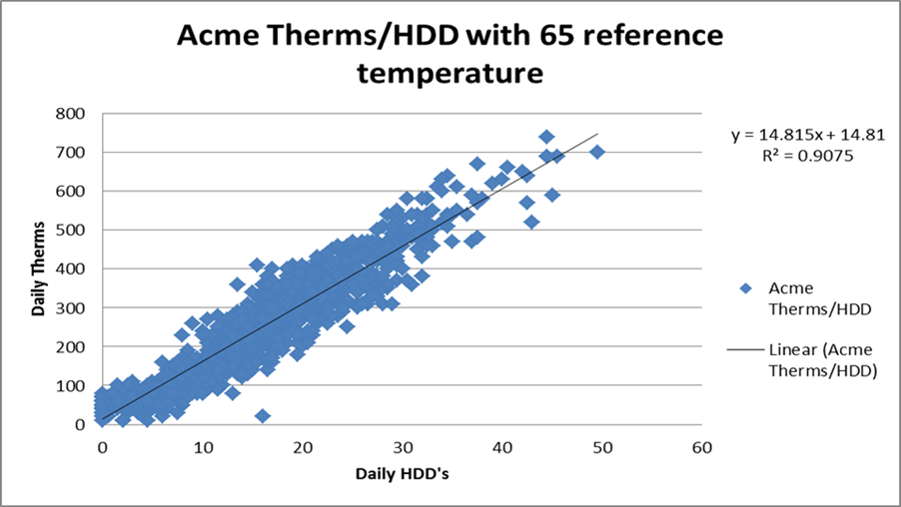

**Graph 3-2: Acme Therm/HDD with 60°F Reference Temperature**

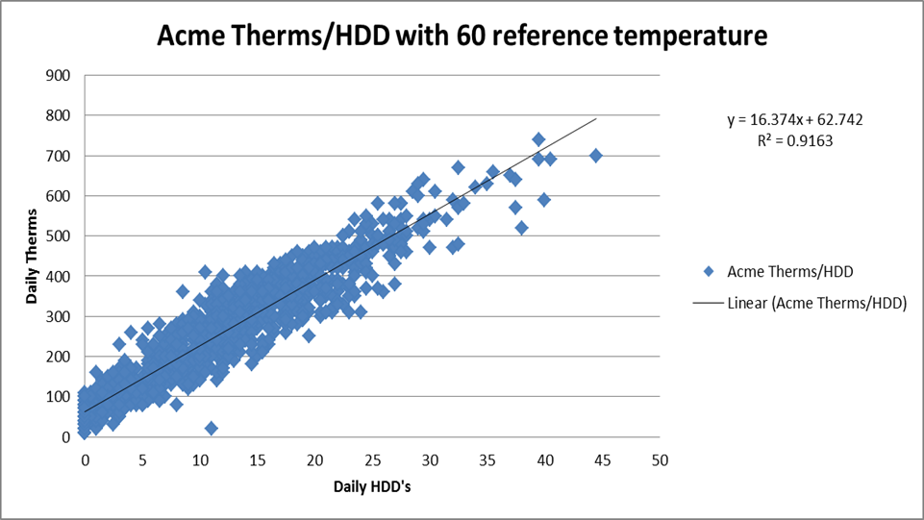

**Peak Day**

In order to ensure satisfaction of core customer demand on the coldest days, Cascade develops three peak day usage forecasts in conjunction with annual base load forecasts. Peak day forecasts enable Cascade to make prudent distribution system and peak capacity planning decisions to fulfill its responsibility to provide heating under all but *force majeure* conditions, particularly as most space-heating customers will have no alternative heating source during the coldest days in the event gas does not flow.

The three scenarios that are analyzed in the forecast model:

* Average peak HDDs;
* System-wide max peak HDDs; and
* Max citygate peak HDDs.

Average peak HDDs in a given year are calculated based on the average of the coldest day for each of the last 30 years. Initially, the coldest system-weighted peak day is found for each year for the last 30 years. The actual HDD from each of those 30 peak days is averaged resulting in an average peak HDD for each weather location.

System-wide max peak HDDs are determined by first selecting the system-wide single coldest day recorded in the past 30 years. To determine the system-wide single coldest day, HDDs from all seven weather stations are considered, giving appropriate weight to the weather stations. The weights are determined by the increase in demand each causes with an increase in 1 HDD. Cascade has found December 21, 1990 to be the highest system weighted HDD, at 56 HDDs, for this period.

The max citygate peak HDDs is determined by finding the coldest HDD for each weather station in the 30-year history and combining those to happen in one day. The max citygate peak day is a hypothetical scenario where the coldest HDD for each weather station happened on one day.

Peak day demand is then derived by applying the HDDs from one of the three peak day scenarios to the monthly linear regression equation for each citygate.

For SENDOUT®, Cascade uses the system-wide max peak HDDs method. Cascade applies the HDDs seen on December 21, 1990, to each of the regressions in the forecast model. For example, all citygates associated with the Bellingham weather station use the HDD for Bellingham on December 21, 1990, and similarly for all the other weather stations and citygates. This provides a highest demand scenario for peak demand load based on 30 years of weather history for each citygate.

These methods rest on the assumption that core market load shape does not significantly change throughout the forecast horizon. Cascade believes that the peak day forecast conservatively overestimates peak day usage as the base forecast does not explicitly include future conservation measures implemented by customers that would act to increase energy efficiency and reduce therm day usage.

Cascade will continue to investigate how the peak day standard affects those core demand load areas which are short of capacity. This investigation will include (but not be limited to) analysis of how other regional utilities look at peak day, discussions with the various weather services, and continued dialogue with Commission Staff and other interested parties.

**Growth**

Customer count forecasts are designed to reflect both demographic trends and economic conditions both in the short and long term. Cascade uses population and employment growth data derived from Woods & Poole. Woods & Poole growth forecasts are provided at the county level and are directly assigned to a citygates previous year’s customer count. It should be noted that Woods & Poole forecasts are adjusted whereas the internal intelligence about a demand area indicates a significant difference from Woods & Poole with regard to observed economic trends.

Customer count and therm forecasts are augmented by revisions to the base data and output to create a portfolio of potential scenarios. Low and high growth scenarios are created by applying Woods & Poole’s forecasts to accurately predict Cascade’s service territory’s strongest and weakest performance over the next 20 years (Appendix B, Demand Forecast). These scenarios, along with the original best-estimate expected scenario, encapsulate a range of most-likely possibilities given known data. The most recent Woods & Poole data indicates an average growth of 1.25% between 2017 and 2036 for Cascade’s service territory. The projected customer growth can be viewed in Appendix B, Demand Forecast. Based on historical experience and given expected weather, Cascade expects system load will likely remain within a range bounded by the low and high growth scenarios.

Among other reasons, the Company believes that growth in the following regions will be a major factor in forecasted system-wide deficiency:

* Bend, Oregon – The city of Bend recently approved an urban growth plan that is projected to allow for the development of 2,380 acres of land. City planners project this will add more than 17,000 homes, and 21,000 jobs. No specific timeline for the completion of this expansion is provided in their May 2016 project update.[1]
* Walla Walla, Washington – The city of Walla Walla is heavily focused on promoting small business growth, tourism, and its reputation as a leading wine producer in a competitive eastern Washington wine market. Cascade currently projects growth of approximately 30% in this area over the 20-year planning horizon.[2]
* Tri-Cities, Washington – Richland, Kennewick, and Pasco have been a hotbed for growth in recent years. As of the most recent census numbers, population grew by 10% in the past four years. Furthermore, Pasco is currently in the top ten cities for population growth in Washington State. Cascade currently projects growth of over 35% in this area over the 20-year planning horizon.[3]

**Methodology**

Cascade uses an ordinary least squares methodology with the goal of predicting demand based on weather and forecasted customers. Demand for each citygate and rate schedule takes on the formula:

Cascade developed the Use per Customer (UPC) coefficient by gathering historical pipeline demand data by month. The pipeline demand data includes core and non-core usage. The non-core data is backed out using Cascade’s non-core Aligne system which leaves monthly core usage data. The monthly data is then allocated to a rate schedule for each citygate by using Cascade’s Customer Care and Billing System (CC&B). This data is then divided by customers to come up with a UPC number for each month for each rate schedule at each citygate. An ordinary least squares regression is then run using the UPC and HDD actuals to derive results.

**Sensitivity Analysis**

Cascade stress tests the system in SENDOUT® by using alternative forecasting methodologies. These alternative forecasting methodologies refer to changing factors that influence demand. Alternative models include high and low customer growth, high and low weather patterns, or a combination thereof. The combination between alternative growth and weather is high growth/cold weather, and low growth/warm weather because these test the extremes as they complement each other when it comes to influencing demand. Table 3-2 identifies the list of scenarios. Figure 3-1 charts the sensitivity analysis over the planning horizon.

**Table 3-2: Growth Scenarios**



**Figure 3-1: Sensitivity Analysis Demand Forecast (Volumes in Therms)**

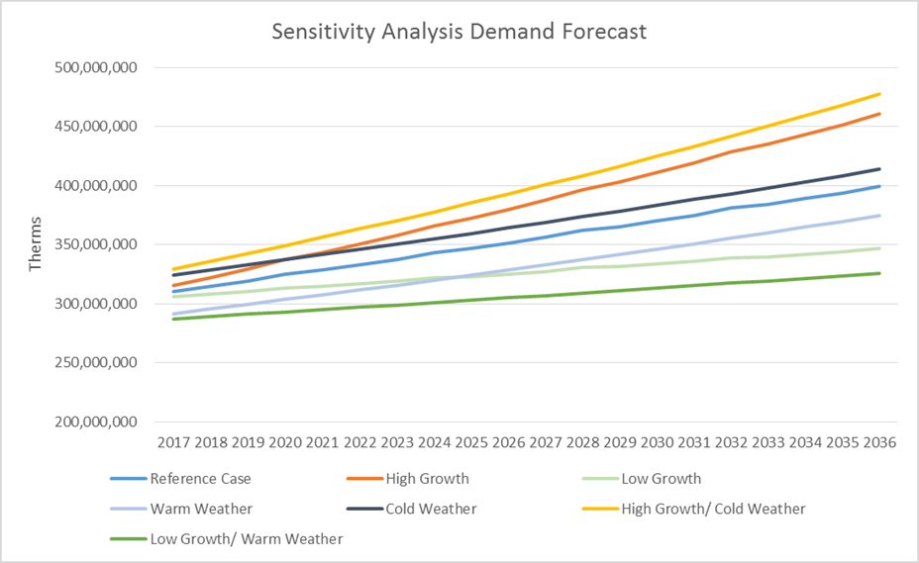

The reference case is the case Cascade expects to happen in regard to weather, growth, and use per customer. The expected scenario is the same as the reference case with a single system-wide max peak day event. Expected weather is the average weather over the past 30 years. For high/low HDDs Cascade used the average temperature of the six coldest/warmest years to create a high and low weather scenario. Six years is a sufficient timeframe to capture a realistic high/low scenario. Cascade applies the growth rates gathered from Woods & Poole as mentioned on pages 3-7 and 3-8 for the expected growth case. Cascade uses the expected regression results as explained on pages 3-8 and 3-9 at each citygate for all cases. High and low growth scenarios, discussed more on page 3-14, explain that Cascade uses percentage errors from previous Woods & Poole forecasts to create the scenarios.

**Forecast Results**

Load growth across Cascade’s system through 2036 is expected to fluctuate between 1.16% and 1.31% annually after smoothing the leap year anomaly. Load growth is split between residential, commercial, and industrial customers. Residential and commercial customer classes are expected to grow at a rate above 1% annually while industrial expects a growth rate of around 0.5%. Table 3-3 shows the percentage of core growth by class over the planning horizon.

**Table 3-3: Expected Load Growth by Class**

|  |  |  |  |  |
| --- | --- | --- | --- | --- |
|  | **Residential** | **Commercial** | **Industrial** | **System** |
| **2017 - 2021** | **1.25%** | **1.69%** | **0.75%** | **1.31%** |
| **2022 - 2026** | **1.24%** | **1.56%** | **0.46%** | **1.28%** |
| **2027 - 2031** | **1.21%** | **1.48%** | **0.33%** | **1.24%** |
| **2032 - 2036** | **1.13%** | **1.39%** | **0.26%** | **1.16%** |
| **2017 - 2036** | **1.21%** | **1.53%** | **0.45%** | **1.25%** |

In absolute numbers, system load under normal weather conditions is expected to exceed over 397 million therms in 2036. A majority of core load today is residential. Cascade projects the ratio between residential, commercial, and industrial to increase in favor of commercial customers. The increase in favor of commercial customers is referring to the fact that commercial customers are expected to grow from being 37.3% of the total core load to 38.7% of the total core load by 2036.Figure 3-2 displays the relative percentage relationship of expected loads by class.

**Figure 3-2: Expected Load Growth by Class**

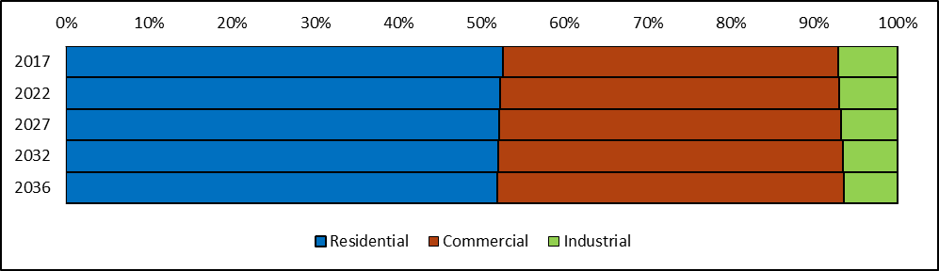

Cascade expects residential and commercial core customers to increase load by around 40-42 million therms each over the 20-year planning horizon. Industrial customers are expected to increase load by approximately 4 million therms over the same time period. Cascade expects load to increase by about 89 million therms. Table 3-4 displays the expected core load volumes by class.

**Table 3-4: Expected Load Growth by Class (Volumes in Therms)**

|  |  |  |  |
| --- | --- | --- | --- |
|  | **Residential** | **Commercial** | **Industrial** |
| **2017** | 162,191,299 | 124,556,975 | 21,888,875 |
| **2022** | 173,002,864 | 135,106,639 | 23,006,406 |
| **2027** | 184,425,511 | 145,676,974 | 23,892,422 |
| **2032** | 197,089,261 | 157,102,305 | 24,702,016 |
| **2036** | 206,484,956 | 165,833,234 | 25,233,289 |
| **2017 - 2036** | 27.31% | 33.14% | 15.28% |

Load growth is primarily a result of increased customer counts. The number of commercial and industrial customers is expected to increase slightly faster than therm usage. Table 3-5 displays the expected customer counts by class.

**Table 3-5: Expected Customer Counts by Class**

|  |  |  |  |
| --- | --- | --- | --- |
|  | **Residential** | **Commercial** | **Industrial** |
| **2017** | 244,177 | 36,339 | 598 |
| **2022** | 259,872 | 39,483 | 620 |
| **2027** | 276,412 | 42,640 | 634 |
| **2032** | 293,424 | 45,863 | 644 |
| **2036** | 306,867 | 48,472 | 651 |
| **2017 - 2036** | 25.67% | 33.39% | 8.83% |

**Geography**

Load across Cascade’s two-state service territory is expected to increase 26% over the planning horizon, with the Oregon portion outpacing Washington at 36% versus 26%. Table 3-6 shows the expected core load volumes by state.

**Table 3-6: Expected Load by State (Volumes in Therms)**

|  |  |  |  |
| --- | --- | --- | --- |
|  | **Washington** | **Oregon** | **System** |
| **2017** | 232,414,950 | 76,222,198 | 308,637,148 |
| **2022** | 248,096,580 | 83,019,329 | 331,115,909 |
| **2027** | 263,898,367 | 90,096,540 | 353,994,907 |
| **2032** | 281,006,139 | 97,887,443 | 378,893,582 |
| **2036** | 293,590,373 | 103,961,106 | 397,551,479 |

Within Washington, the western part of the state as well as Walla Walla is expected to see a large increase in growth. Yakima is expected to experience minimal growth. The 2017 load on 56 HDDs is expected to be 3.5 million therms, rising to 4.5 million by 2036. Peak day load will increase at 1.33% annually, while annual load increases by 1.25%. Table 3-7 shows the percentage growth of load by each of Cascade’s weather locations. Table 3-8 shows the percentage growth of load by each pipeline zone over the planning horizon. Lastly, Table 3-9 displays a range of core peak day growth over the planning horizon along with a sampling of peak day therms.

**Table 3-7: Washington 20-Year Load Growth by Weather Location**

|  |  |
| --- | --- |
|  |  |
| Bellingham | 28.5% |
| Bremerton | 24.2% |
| Walla Walla | 30.5% |
| Yakima  Washington | 18.1%  26.1% |

**Table 3-8: System 20-Year Load Growth by Pipeline Zone**

|  |  |
| --- | --- |
|  |  |
| Zone 10 | 15.9% |
| Zone 11 | 14.8% |
| Zone 20 | 32.8% |
| Zone 24  Zone 26  Zone 30-S  Zone 30-W  Zone GTN  Zone ME-OR  Zone ME-WA | 4.1%  23.2%  22.2%  27.0%  44.4%  14.0%  12.1% |

**Table 3-9: Expected Peak Day Growth (Volumes in Therms)**

|  |  |  |  |
| --- | --- | --- | --- |
| Period | Peak Growth | Year | Peak Day Therms |
| 2017 - 2021 | 1.43% | 2021 | 3,776,574 |
| 2022 - 2026 | 1.36% | 2026 | 4,041,751 |
| 2027 - 2031 | 1.30% | 2031 | 4,313,247 |
| 2032 - 2036 | 1.22% | 2036 | 4,584,628 |

**High and Low Scenarios**

High and low scenarios were created by examining the percentage errors of previous Woods & Poole forecasts. The percentage errors show the average percentage difference between a Woods & Poole forecast and actual results. The previous forecasts averaged a percentage error of 0.5% or less of the actual forecast. Since Cascade is expecting about a 1.25% growth, a reasonable high and low scenario band is 0.65% above or below that growth level. Table 3-10 displays the expected total system load growth across various scenarios.

**Table 3-10: Expected Total System Load Growth (By Percentage) Across Scenarios**

|  |  |  |  |
| --- | --- | --- | --- |
|  | Low | Mid | High |
| 2017 - 2021 | 0.65% | 1.31% | 1.97% |
| 2022 - 2026 | 0.64% | 1.28% | 1.94% |
| 2027 - 2031 | 0.61% | 1.24% | 1.89% |
| 2032 - 2036 | 0.57% | 1.16% | 1.78% |
| 2017 - 2036 | 0.62% | 1.25% | 1.90% |

Load growth under poor economic conditions is expected to be around 0.6% annually over the forecast period, while load growth under good economic conditions is expected to be around 1.9% annually. The cumulative effect of high growth over 20 years could result in additional load of 61 million therms, while low growth could result in a load with 52 million therms less than predicted in the medium growth scenario. Table 3-11 shows the expected total system load across these scenarios.

**Table 3-11: Expected Total System Load Growth Across Scenarios (Volumes in Therms)**

|  |  |  |  |
| --- | --- | --- | --- |
|  | Low | Mid | High |
| 2017 | 303,968,666 | 308,637,148 | 313,346,208 |
| 2021 | 312,685,907 | 326,602,114 | 341,104,474 |
| 2026 | 323,326,756 | 349,373,660 | 377,602,786 |
| 2031 | 333,769,148 | 372,643,579 | 416,609,463 |
| 2036 | 345,227,222 | 397,551,479 | 458,654,121 |
| Deviation | (52,324,257) |  | 61,102,642 |

**Alternative Forecasting Methodologies**

Cascade has made a slight change to the forecast methodology this year by using customers in the coefficient for the demand forecast formula. Cascade plans to continue to look at alternative forecast methodologies and purchased SAS Analytics, a statistical analysis software, and plans to examine non-linear forecasting methodologies.

The Company is responsive to several regulatory principles in forecasting. These include:

* A desire for precision and a high degree of accuracy.
* A universal understanding that forecasts should mirror future realities but may have unanticipated swings in either direction.
* A disconnect between planning and operational functions, in that natural gas purchasing and dispatch will be based on immediate needs which, in actuality, are guaranteed to vary from the plan (per the previous bullet).
* An increased cost of improved precision sometimes has decreasing customer benefits.
* Regulators expect continual improvement because new tools are available and they expect to see what the Washington Commission calls “adaptive management” for all of its jurisdictional energy companies.
* Major differences in accounting treatment between the states regarding “test years” must be considered since they are for ratemaking purposes (that is, for general rate case filings) and not necessarily for planning. At this time, Oregon uses “future test year” accounting while Washington employs an “historic test year”.
* The “fuzziness” of historic data that includes effects of energy efficiency, retail price (from annual PGA—purchased gas adjustment—changes and other rate changes), sometimes abnormal weather, new technology, and then-unique economic conditions (e.g., recession, interest rates, etc.) Cascade uses actual historic data. The term “fuzziness” is used in the context of basing forecasts on past-period data that includes many variables, any one of which may have increased or decreased in the intervening time between historical occurrence and forecasted periods. This causes difficulty for utilities to isolate primary factors for greater precision of long-term calculations.
* Unknown and uncertain future changes such as the assumptions for CO2 required for carbon policy and other environmental externalities.
* A need to demonstrate support for assumptions such as growth in customers, use per customer and changes from previous forecasts, type of use (i.e., heating, manufacturing, etc.), to name a few.

This illustrates the complexity of forecasting and highlights areas of stakeholder attention. Best efforts, at the appropriate cost, distill these factors into a generally-accepted forecast with recognition of inherent uncertainties.

**Uncertainties**

This forecast represents Cascade’s best estimate about future events. At this time there are several important factors that make predicting future demand particularly difficult – economic recovery, carbon legislation, building code changes, direct use campaigns, conservation, and long-term weather patterns. The range of scenarios presented here encompasses the full range of possibilities through econometric analysis. These forecasts were created after running through a matrix of different functional forms and economic indicators. The chosen indicators were selected because of their consistency in returning statistically valid results. While they may be the best results mathematically, they are not the sole and only determinants of demand. As a result, while Cascade believes that the numbers presented here are accurate, and that the scenarios presented represent the full range of possibilities, there are and always will be uncertainties in forecasting future periods.

1. *See* City of Bend Urban Growth Boundary Project Update, issued May 2016
2. *See* http://www.wallawallatrends.ewu.edu/
3. *See* http://www.tri-cityherald.com/news/local/article32225670.html