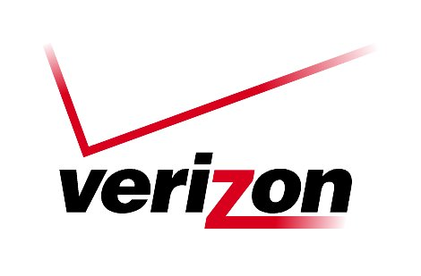 **Verizon Northwest Inc.**

**1800 – 41st Street, WA0105RA**

**P. O. Box 1003**

**Everett, WA 98206-1003**

**Fax: 425-261-5262**

July 1, 2010

Advice No. 3300

Washington Utilities and Transportation Commission

1300 S. Evergreen Park Drive, S. W.

Olympia, Washington 98504-7250

To whom it may concern:

Verizon Northwest Inc. submits Advice No. 3300, a tariff filing in the General and Local Exchange Tariff, WN U-xx, Sec. 2 Rules and Regulations. The purpose of this filing is to 1) increase the residential Service Performance Guarantee credit from $25.00 to $35.00 for qualifying customers, 2) offer alternate service if the Company fails to deliver basic service on time, 3) offer a $5.00 flat rate credit to residential customers for out of service conditions greater than two days and 4) establish a $75.00 credit available to any Washington Telephone Assistance Program (WTAP) -qualified customer that fails to receive the appropriate discount, credit, or waiver of the deposit within the first bill cycle after application, provided the application is received 10 calendar days prior to the end of the bill cycle for an existing customer.

No cost documentation is submitted with this filing, which does not affect existing rates. The effective date for this tariff filing is July 1, 2010.

Pursuant to WAC 480-80-103(4) and WAC 480-80-104(8), I certify that I am authorized to make this filing on behalf of the company. If you have questions regarding this filing, please contact Lin Fogg at (425) 261-6380.

Very truly yours,



Richard E. Potter

Director

Public Affairs, Policy & Communications

Enclosures

W.U.T.C.

July 1, 2010

Advice No. 3300

Attachment A

General and Local Exchange Tariff, WN U-XX

Section 2

3rd Revised Sheet 26

3rd Revised Sheet 27

2nd Revised Sheet 37.5

**VERIZON NORTHWEST INC.**

**EVERETT, WASHINGTON**

**N O T I C E**

Verizon Northwest Inc. submits Advice No. 3300, a tariff filing in the Facilities for Intrastate Access Tariff, WN U-16. The purpose of this filing is to 1) increase the residential Service Performance Guarantee credit from $25.00 to $35.00 for qualifying customers, 2) offer alternate service if the Company fails to deliver basic service on time, 3) offer a $5.00 flat rate credit to residential customers for out of service conditions greater than two days and 4) establish a $75.00 credit available to any Washington Telephone Assistance Program (WTAP) -qualified customer that fails to receive the appropriate discount, credit, or waiver of the deposit within the first bill cycle after application, provided the application is received 10 calendar days prior to the end of the bill cycle for an existing customer.

No cost documentation is submitted with this filing, which does not affect existing rates. The effective date for this tariff filing is July 1, 2010.

A copy of this tariff is available for public inspection at the following Verizon Plus store locations:

1402 SE Everett Mall Way 18700 33rd Ave. West, Suite D

Everett Lynnwood

Everett Verizon Plus Alderwood Verizon Plus

Posted at __________________________

__________________________

by __________________________

Post in above store location.