*Annual Energy and Emissions Intensity Metrics Report  
Pursuant to WAC 480-109-300*

*June 1, 2016*

**Table of Contents**

**Section 1 – Executive Summary**

**Section 2 – Metrics**

**Section 3 – Trends & Analysis**

**Section 4 – Appendices**

**Attachment A – Raw Data and Charts**

**Section 1: Executive Summary**

Per the requirements of WAC 480-109-300, Puget Sound Energy (“PSE”) submits the following report outlining its energy and emissions intensity metrics for the previous 10 years (“reporting period”). This report includes the following metrics for all PSE generating resources serving Washington State customers:

* Average megawatt hours (aMWh) per residential customer
* Average megawatt hours (aMWh) per commercial customer
* Megawatt hours (MWh) per capita
* Annual carbon dioxide (CO2)emissions measured in short tons
* Ratio of Annual CO2 emissions to CO2 emissions in 1990

PSE and the other utilities purchase a percentage of their energy to serve native load from the spot market. The generation sources from purchases made on the spot market are unknown. Therefore, this report also includes a subset of metrics for spot market purchases based on average emission rate factors provided by the Washington State Department of Commerce (“Commerce”). Those metrics include:

* Annual CO2 emissions (short tons) from unknown generation sources
* Annual megawatt hours (MWh) delivered to retail customers from unknown generation sources
* Percentage of load served by unknown generation sources

In addition to the raw data included in Attachment A to this report, the tables and sections below provide trend analysis, narrative descriptions and graphics to help contextualize PSE’s data and trends for the reporting period. Table 1 below summarizes PSE’s greenhouse gas (GHG) emissions intensity and energy metrics for calendar year 2015. Summaries of the previous nine years in the reporting period are included in Attachment A to this report. Section 2 below provides a 10-year “lookback” analysis of the reporting period (to operating year 2006) of the metrics mentioned above, and benchmarks those metrics to a 1990 emissions baseline. Section 3 provides a discussion of the trends observed in the metrics and the broader regional market. Section 4 includes appendices that provide more detail on methodologies used in this report.

**Table 1- 2015 Report – Summary of Energy and Emissions Intensity Metrics**

|  |  |  |  |  |  |  |  |
| --- | --- | --- | --- | --- | --- | --- | --- |
|  | | | | | |  |  |
|  |  | |  |  |  |  |  |
|  | Utility : | | Puget Sound Energy | |  |  |  |
| Reporting for year : | | | 2015 | **MWh per Capita** |  |  |  |
| Population Served : | | | **2,418,979** | **8.48** |  |  |  |
|  |  | |  |  |  |  |  |
|  | *Energy Intensity Metrics* | | | |  |  |  |
|  |  |  | |  |  | Customer | **MWh per** |
|  |  |  | | MWh at Meter | MWh Proportion | Count | **Customer** |
| Residential Customers | | | | 10,164,709 | 49.6% | 970,830 | **10.5** |
| Commercial Customers | | | | 9,087,102 | 44.3% | 129,347 | **70.3** |
| Industrial Customers | | | | 1,257,958 | 6.1% |  |  |
|  | Total Load Served | | | 20,509,769 |  |  |  |
|  |  |  | |  |  |  |  |
|  | *Emissions Intensity Metrics* | | | |  |  |  |
|  |  |  | |  | Percent of | **Short** |  |
|  |  |  | | Busbar MWh | Total Load | **Tons CO2** |  |
| Known Resources Serving WA | | | | 18,582,396 | 84.3% | 10,414,028 |  |
| Unknown Resources Serving WA | | | | **3,448,452** | **15.7%** | **1,200,541** | **% of 1990 CO2** |
|  |  |  | | 2015 | Tons CO2 | **11,614,569** | **167.2%** |
|  |  |  | |  |  |  |  |
|  |  |  | |  |  | 1990 Short Tons CO2 | 6,946,064 |

Summarized in Table 1 above and narrative form below are PSE’s 2015 energy and intensity metrics.

|  |  |
| --- | --- |
| 10.5 | Average MWh per residential customer |
| 70.3 | Average MWh per commercial customer |
| 8.48 | MWh per capita |
| 11,614,569 | Annual CO2 emissions (short tons) |
| 167.2% | Ratio of Annual CO2 emissions to CO2 emissions in 1990 |
| 1,200,541 | Annual CO2 emissions (short tons) from unknown generation sources |
| 3,448,452 | Annual MWh delivered to retail customers from unknown generation sources |
| 15.7% | Percentage of load served by unknown generation sources |

**Section 2: Prior 10-year annual metrics for all generating resources serving Washington customers**

Figure 1 provides a comparison of annual PSE CO2 emissions measured in short tons from known generation sources for the previous 10 years. Figure 1 also includes a 1990 emissions baseline and a 10 year trend showing PSE’s population served. Further discussion on PSE’s methodology to calculate population is provided in Appendix 1.

**Figure 1**

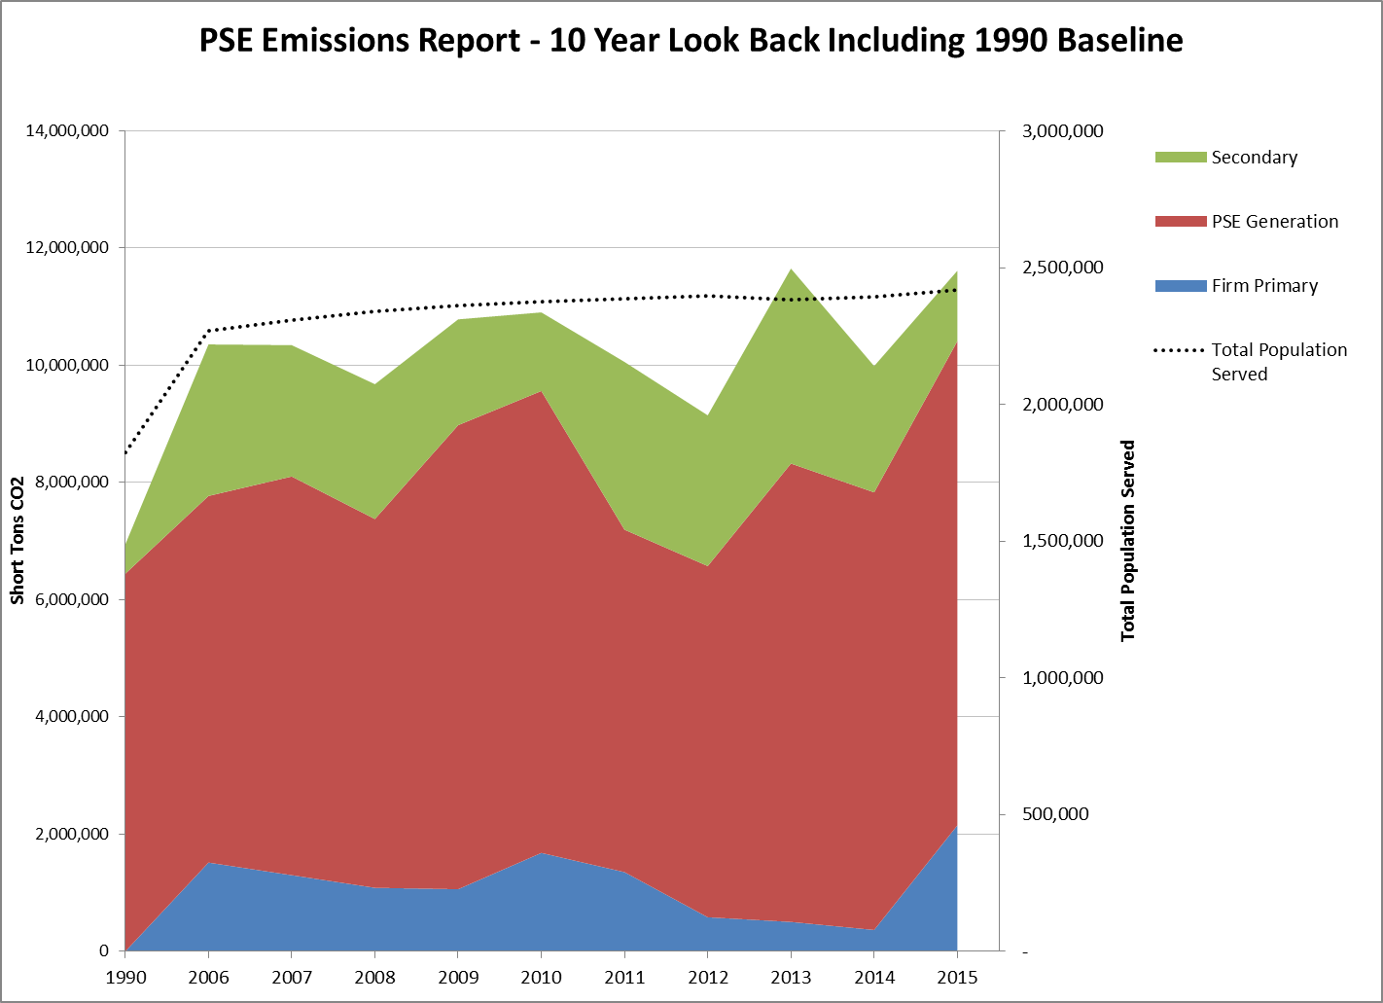

Figure 2 provides a comparison of the average MWh per residential customer, average MWh per commercial customer, and MWh per capita delivered in each of the years during the reporting period in PSE’s service territory.

**Figure 2**

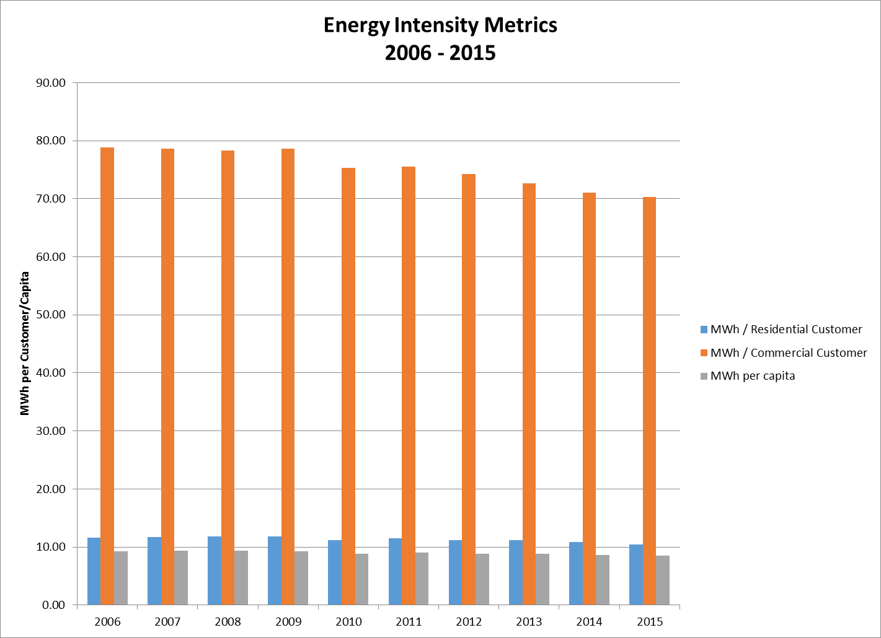

Figure 3 provides a comparison of the ratios of PSE’s annual CO2 emissions from known sources for the reporting period compared to CO2 emission in 1990

**Figure 3**

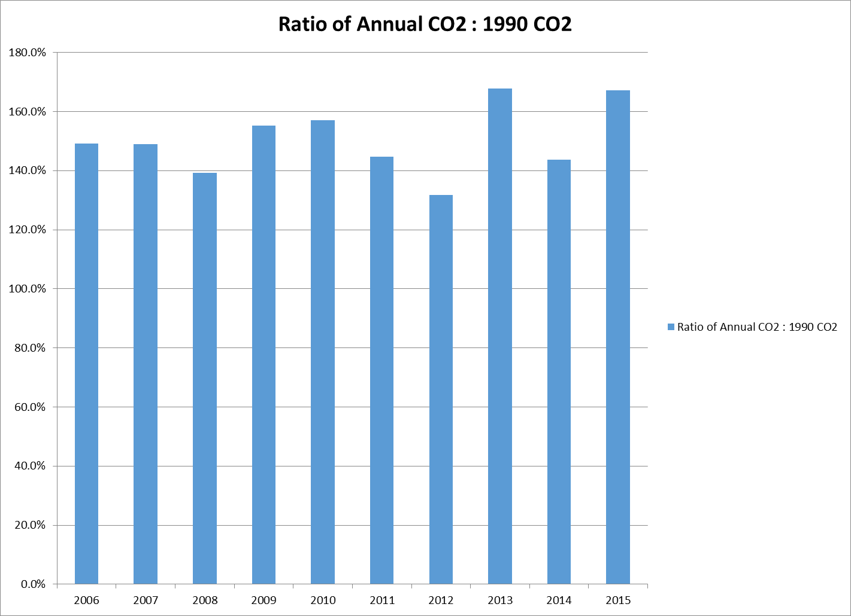

Figure 4 provides a 10-year comparison of generation delivered to PSE from unknown sources and the attributed emissions. Those metrics include annual CO2 emissions (short tons), annual MWh delivered to retail customers, and the percentage of load served. As discussed in the executive summary, the generation sources and attributed emissions for spot market purchases are unknown, and therefore Commerce provided emissions factors for each of the previous 10 years in the reporting period. PSE is unclear of the methodology used by Commerce to calculate those emissions factors. Nonetheless, they are included in PSE’s analysis in Attachment A and Figure 4 below. For comparison purposes only, PSE has included in Appendix 2 a similar analysis to Figure 4 but calculates emissions factors using publically available source data from the Northwest Power Pool eGrid tool and the Fuel Mix Disclosure reports from Commerce. PSE’s analysis in Appendix 2 compares the impacts of using the different emissions factors from both sources.

**Figure 4**

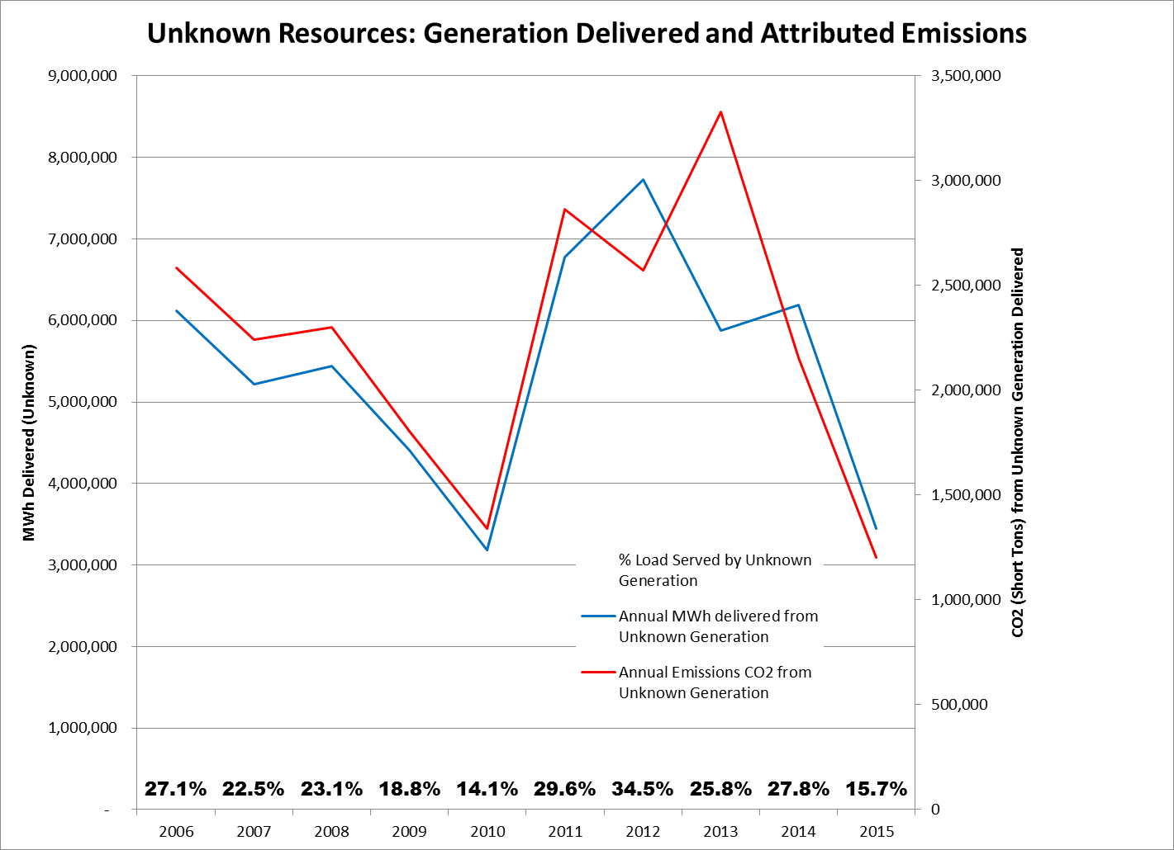

**Section 3: Trend analysis, narrative, findings and graphics**

This section addresses the requirement in WAC 480-109-300(4) to include narrative text describing trends and an analysis of the likely causes of changes, or lack of changes, in the metrics.

*PSE’s Emissions Follow Northwest Fluctuations*

In the Northwest, electric power emissions fluctuate significantly each year, and are inversely correlated to water supply. High water supply leads to increased hydroelectric generation which, all other factors held constant, reduces the need to operate coal and natural gas units. This results in lower overall emissions. This point is illustrated below in Figure 5, where total CO2 emissions (from power generation in the Northwest) are plotted against water supply as a percent of average (right hand axis). Note that during high water years CO2 emissions decline.

Hydroelectric generation is not the only driver of Northwest emissions. Looking at Figure 5, 2001 emissions are slightly lower than 2008 emissions even though 2001 was a lower water year. This rise in emissions was in part due to increased demand for Northwest electricity, both inside and outside of the region. In 2008 the Northwest produced over 25% more electricity than in 2001. Although much of the increased demand was met by hydroelectricity, some of the extra power was produced with natural gas, which increased total emissions. (*Note - Figure 5 does not include calendar years 2014 and 2015 because regional emissions data were not available as of this filing*)

**Figure 5.**

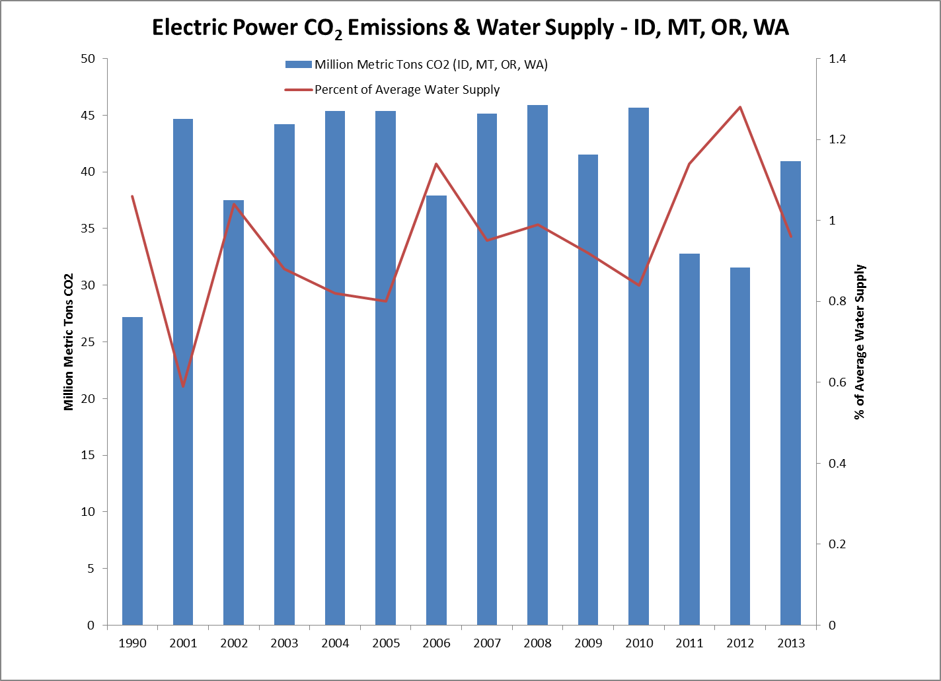

PSE emissions follow these same trends. From 2006 to 2013 PSE’s emissions match the northwest trend lines shown in Figure 5. This is illustrated in PSE’s emissions and generation summaries illustrated below in Figures 6, 7, 8, 9 and 10. PSE compared 2006 to 2013 to regional data because as noted above, regional emissions data for 2014 and 2015 were not available as of the filing deadline of this report.

**Figure 6.**

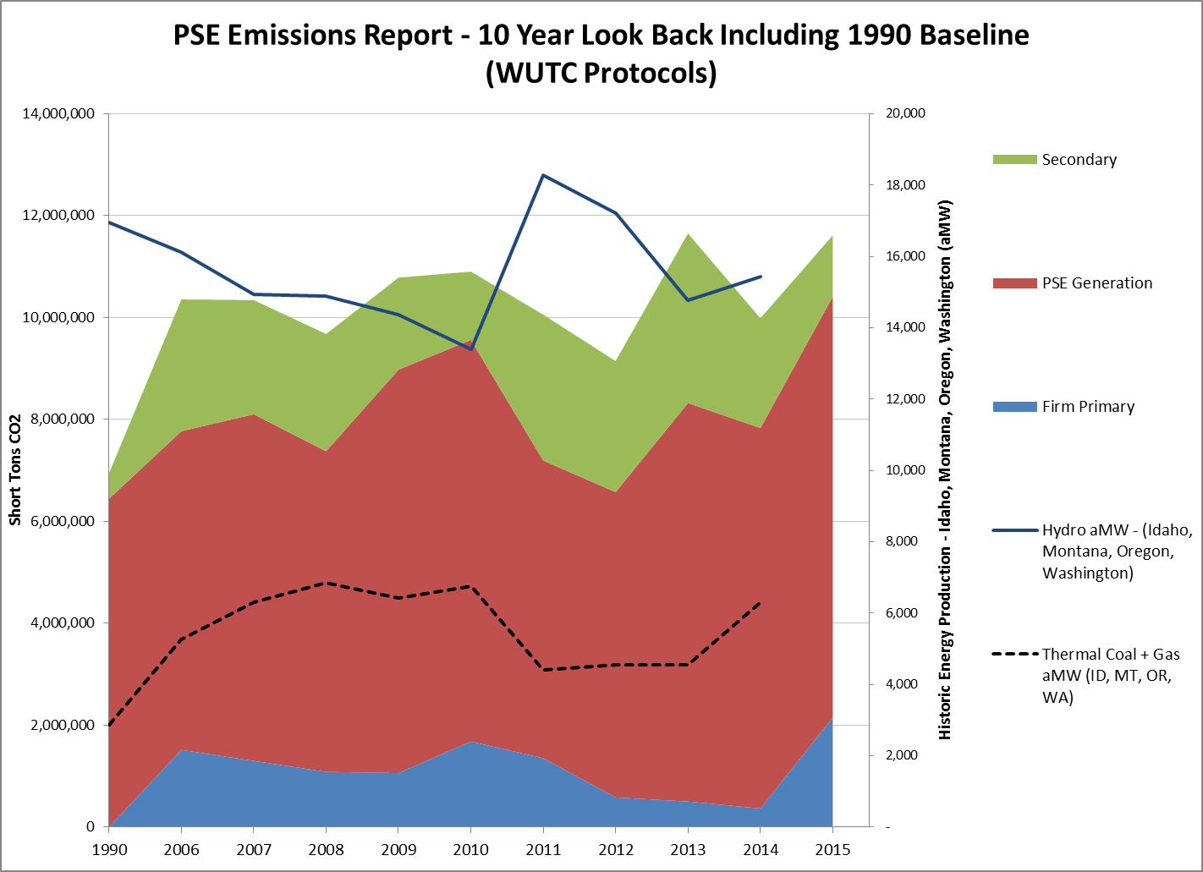

**Figure 7.**

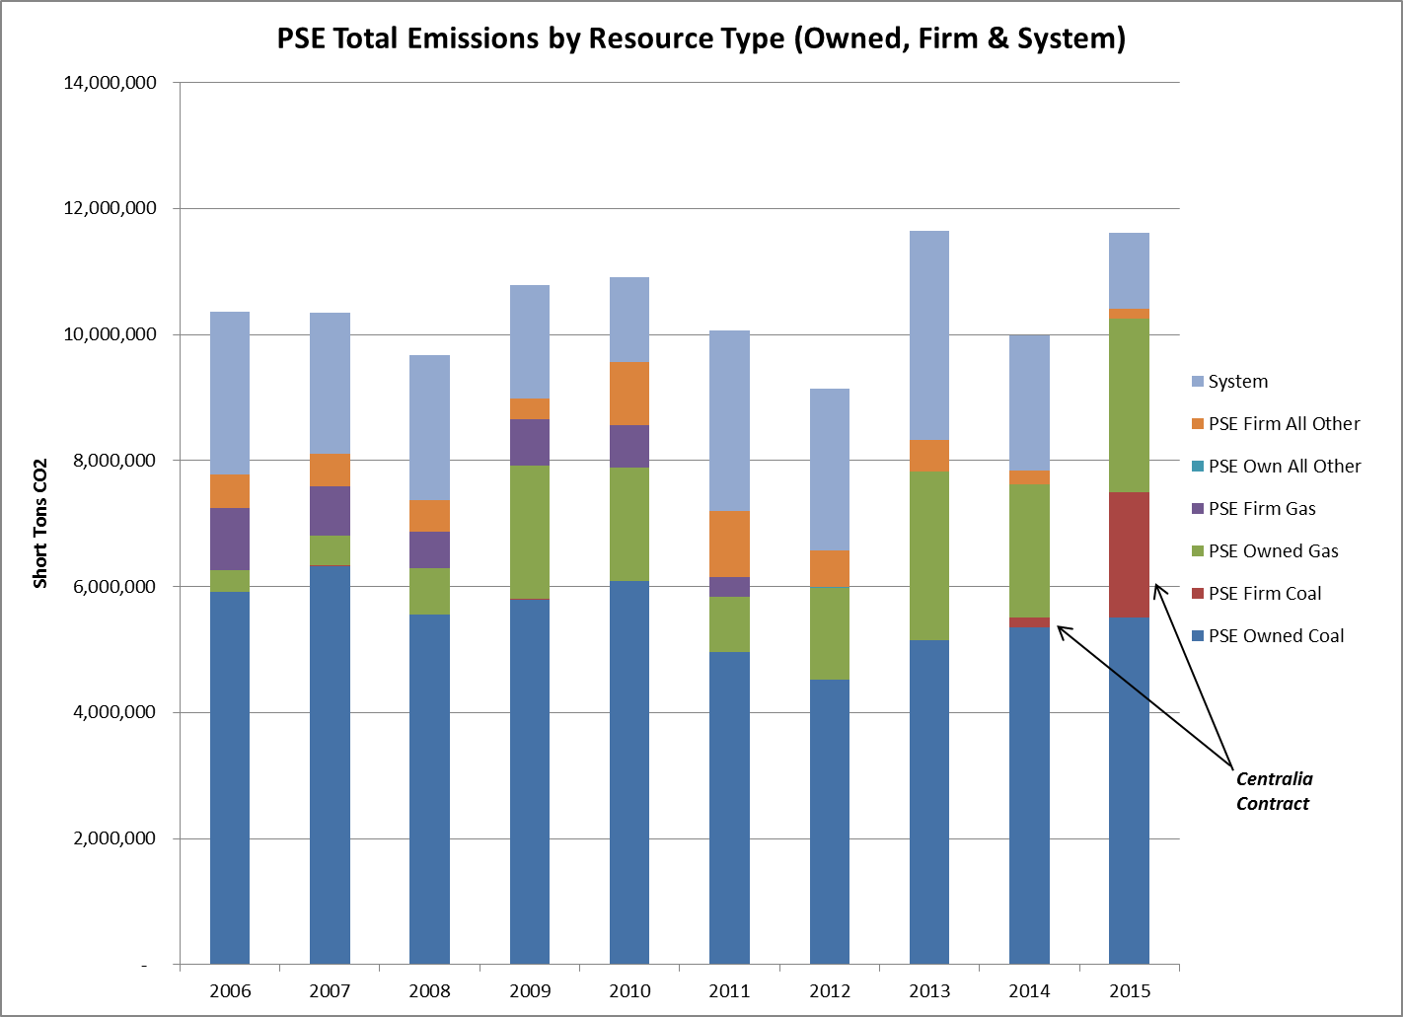

**Figure 8.**

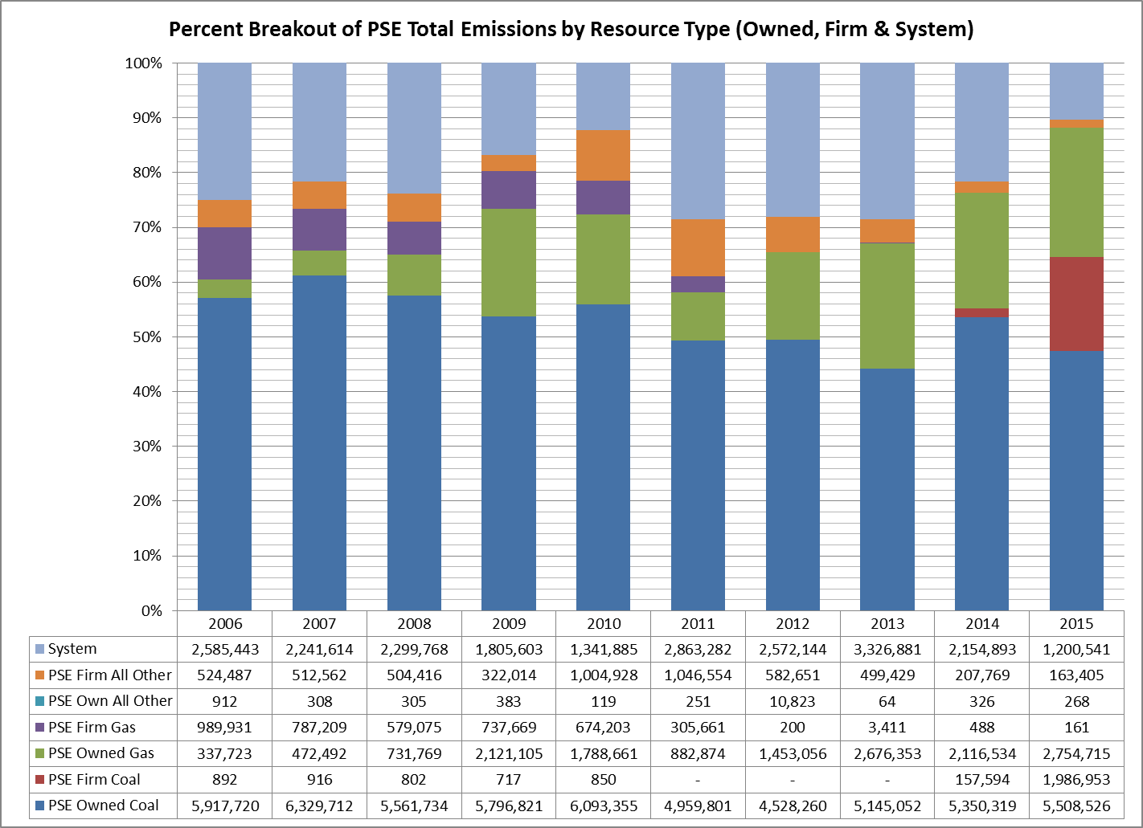

**Figure 9.**

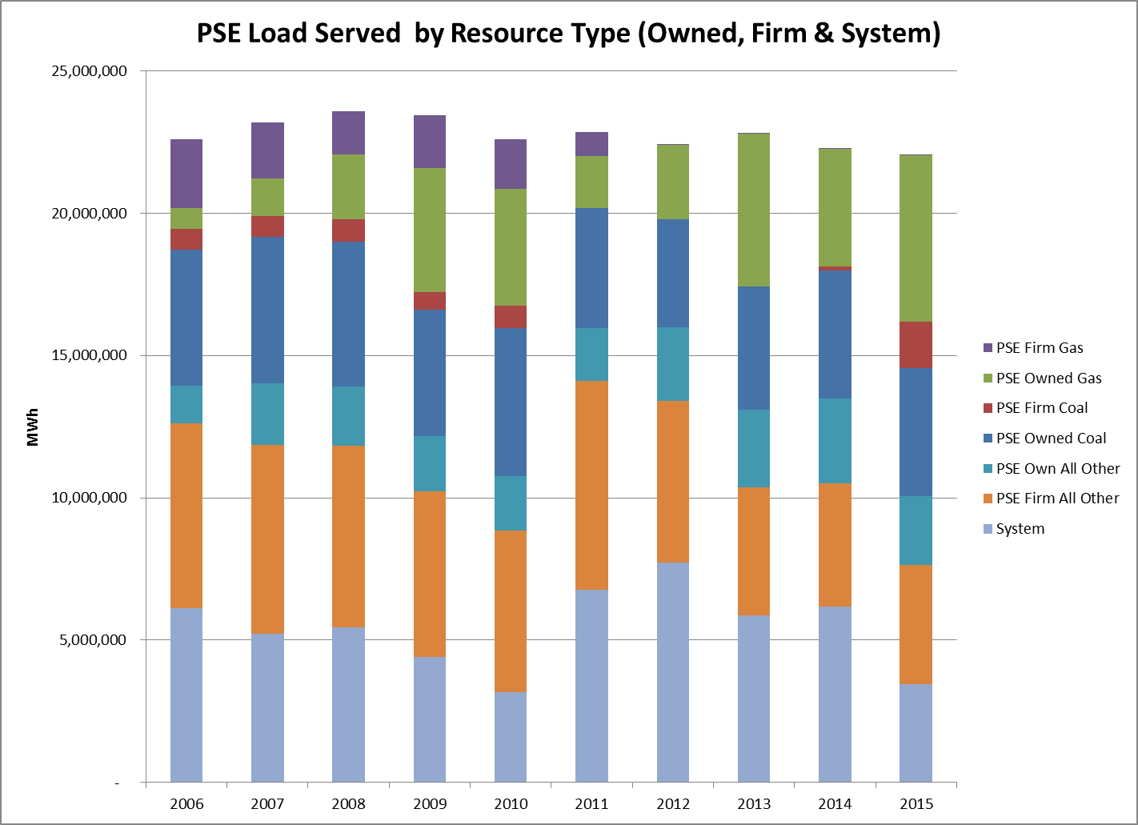

**Figure 10.**

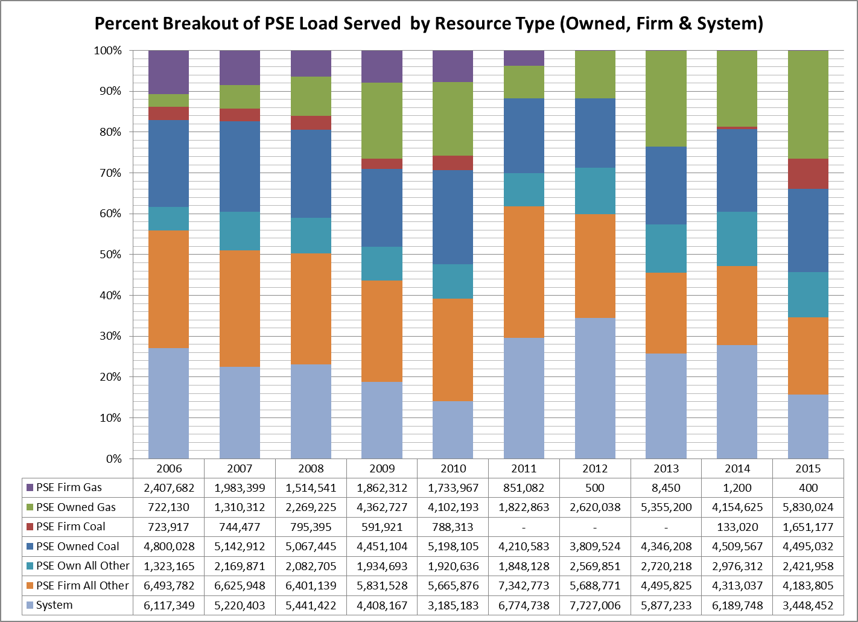

*PSE Thermal Fleet*

Between 2006 and 2015, 60% of the thermal electricity PSE generated came from the Colstrip station, which has a high GHG emission intensity compared to natural gas. Of the CO2 emissions from thermal electricity generated by PSE during that time (Colstrip plus the entire owned and firm gas fleet), 74% of emissions were from coal-combustion. This factors heavily in the total emissions attributed to owned and firm purchases shown in Figures 6 and 7 above.

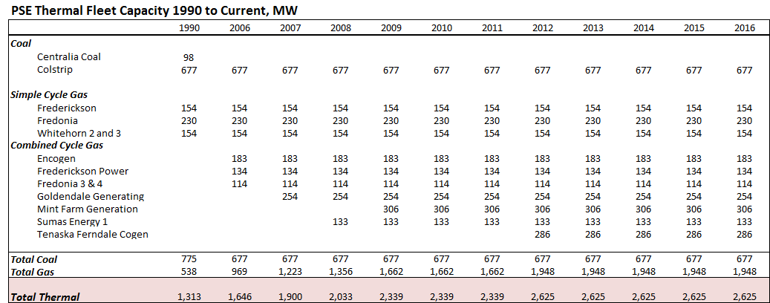

*Emission Rate Correlation*

PSE used regional average emission factors (based on Northwest Power Pool data) to estimate emissions from secondary purchases of electricity. It is difficult to track the source and type of electricity purchased on a non-firm contract from different utilities and non-utilities via the grid. For instance, electricity purchased by a utility from an energy trader could have been purchased by an energy trader from a hydroelectric facility near the utility's operational territory, or from a utility generating electricity using coal outside the utility's operational territory. The emissions associated with the generation are not clearly known because they could be significantly different for each source. Therefore, the emissions associated with non-firm contract purchased electricity were calculated using regional average emission factors that generally reflect the suite of generation sources that produced the purchased electricity. However, similar to the total emission and regional hydropower supply corollary, the average emissions rates in the Northwest Power Pool and the Western Electricity Coordinating Council (“WECC”) are also strongly influenced by hydropower supply. In years of high hydropower supply, emission rate averages are slightly “diluted” by the large number of non-emitting MWh that factor into the rate equation. Conversely, in years of low hydro, thermal resources are dispatched more frequently WECC-wide, adding CO2 pounds to the numerator of the rate equation, resulting in a higher rate average. For example, note in the table below that 2005, 2009, 2010 and 2013 were lower than average hydro supply years which resulted in higher than average regional emission rate averages.

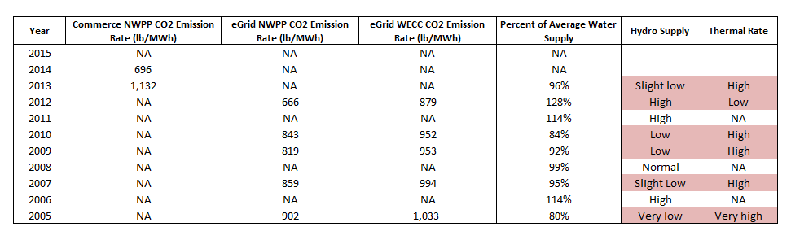

*Population Data*

PSE tracks customers served by class of service but does not track the number of *people* (population) served. Therefore, population data in this report is estimated based upon methodology agreed to by PSE, UTC Staff, and the other utilities. Total service area population for this report was estimated by multiplying the total residential customers in PSE’s service area by the average household size (AHS) of occupied homes, using data from the most recent five-year estimates (2010-2014) from the U.S. Census Bureau’s American Community Survey (ACS). PSE’s population data methodology is described in greater detail in Appendix 1.

*Spot Market Purchases*

Included in this report is energy that PSE has purchased from the spot market associated with the corresponding generation year where the actual generating unit is unknown. As stipulated in this rule, PSE uses a net system mix emissions rate for these spot market purchases where the energy source is unknown ([WAC 480-109-300(3](http://app.leg.wa.gov/WAC/default.aspx?cite=480-109-300))). The net system mix emissions rates for PSE and the other utilities during the reporting period has been calculated and provided by Commerce. However, in this first report only, Commerce noted it is not able to provide the net system mix emission rate for 2015 due to technical difficulties with their new system for tracking and compiling data.   To fill this gap for 2015, Commerce staff will calculate and provide each utility a 10-year weighted average net system mix emissions rate for the period 2005 through 2014 as a proxy for the 2015 net system mix emissions rate.  In future reports, Commerce has indicted it will be able to provide the utilities with the net system mix emission rates for the full 10-year reporting period. In addition, PSE was unclear on the methodology used by Commerce to calculate emissions factors from unknown resources. Therefore, PSE provides an analysis in Appendix 2 comparing emissions from unknown resources using the emissions factors provided by Commerce versus emissions factors developed using available data and methodologies from the Northwest Power Pool eGrid tool and Commerce Fuel Mix Disclosure reports.

**Section 4: Appendices**

*Appendix 1: Estimation of PSE Service Territory Population*

This appendix documents how PSE estimated the population within its service territory to meet the reporting requirement of WAC 480-109-300(2)(c): Megawatt-hours per capita. The estimated population for each reporting year is the product of PSE residential customer count for the year multiplied by the weighted average of household size of the counties that PSE provides electric service. The methodology is consistent with the preferred Per Capita Methodology described in the UTC Staff’s final report[1] and the Commission’s Final Order[2] on the estimation of population in an electric utility service territory. As prescribed in the Commission’s Final Order paragraph 17, “To produce the reports required by WAC 480-109-300(2)(c), the utilities should use the methodology agreed upon by stakeholders and described in the final report and this order.” [3]

PSE’s customer information system is the ultimate source of the annual residential customer count data which represents the number of households within PSE service territory. These customer count data are as reported in PSE’s FERC[4] financial reporting Form No. 1: Annual Report of Major Electric Utilities, Licensees and Others. Not all residents in a multi-family or mixed-use commercial and residential building are included in PSE’s residential customer count as this time. PSE does not have reliable data to make a separate adjustment to account for the persons residing in master-metered residential buildings.

The average household size used in PSE’s WAC 480-109-300: Energy and emissions intensity metrics is 2.49. This is the overall average number of persons per household for PSE’s service territory weighted by the population size for each of the counties for 2010-2014. The source of the five-year average of county-level data is the United States Census Bureau’s *American Communities Survey*, which can be accessed using the Bureau’s web-based application QuickFacts at <http://www.census.gov/quickfacts/table/PST045215/00>.

The following table details the data and the calculation of the 2.49 persons average household size that used in the determination of PSE service territory population for WAC 480‑109‑300(2)(c): Megawatt-hours per capita.



*Appendix 2: Comparison of Emissions from Unknown Sources using different methodologies*

As discussed above, generation sources and attributed emissions for spot market purchases are unknown, and therefore the WA Department of Commerce provided emissions factors for each of the previous 10 years. PSE is unclear of the methodology used by the WA Department of Commerce to calculate those emissions factors. Nonetheless, they are included in PSE’s analysis in Attachment A and Figure 4 above. For comparison purposes only, PSE conducted a similar analysis to Figure 4 above but calculates the emissions factors using publically available source data from the Northwest Power Pool eGrid tool and Fuel Mix Disclosure reports from the WA Department of Commerce. PSE’s analysis below compares the impacts of using the different emissions factors from both sources.

**Attachment A**

1. UE-131732 Proposed EE Metrics Workgroup Results – Final Report, August 7, 2015, (Report at2-3).
2. UE-131732, Final Order, General Order R-581: Order Adopting Rule Permanently, September, 10, 2015, (Order at 6 §17).
3. UE-131732, Final Order, General Order R-581: Order Adopting Rule Permanently, September, 10, 2015, (Order at 6 §17).
4. Federal Energy Regulatory Commission