DEMAND FORECASTS

Contents

**5-2. OVERVIEW**

**5-7. METHODOLOGIES**

* System-level Methodology
* County-level Methodology
* Eastside Area Methodology

**5-12. KEY ASSUMPTIONS**

* Economic Growth
* County-level Outlook
* Eastside Area Outlook
* Energy Prices
* Other Assumptions

**5-22. ELECTRIC DEMAND FORECAST**

* System-level Highlights
* County-level Electric Forecasts
* Eastside Area Electric Forecasts

**5-32. GAS DEMAND FORECAST**

The system-level demand forecast that PSE develops for the IRP is an estimate of energy sales, customer counts, and peak demand over a 20-year period. These estimates are designed for use in long-term resource planning. The 20-year horizon helps us anticipate needs so we can plan to efficiently meet the needs of our customers.

OVERVIEW

At the system level, growth rates have slowed since the 2013 IRP forecast. Recovery from the latest recession has been slower than expected, and as a result, both the nation and the region are experiencing slower population growth, slower GDP growth and slower employment growth than forecast in the 2013 IRP. Within PSE’s service territory, however, demand growth is uneven. Most of the economic growth is concentrated in King County. Other counties are growing, but slowly; except for King County, none has reached its pre-recession growth levels in terms of population or employment.

The 2015 IRP Electric Base Demand Forecast for energy and peak loads is lower than those forecast in the 2013 IRP.

The 2015 IRP Gas Base Demand Forecast for energy and peak loads is slightly higher early in the forecast period compared to the 2013 IRP, but has similar levels for the second half of the forecast horizon. The near-term higher loads are due to lower natural gas prices causing increased gas consumption by customers.

King County, which accounts for half or more of the system’s electric and gas sales demand today, is growing rapidly, particularly in an area referred to as the “Eastside Area.” This geographic region is located east of Lake Washington and includes Bellevue (including Bellevue’s central business district), Mercer Island, Newcastle and portions of Kirkland, Redmond, Renton and Issaquah. Employment in the Eastside Area is expected to grow about 1.8 percent annually in the next 20 years, according to a forecast prepared by the Puget Sound Regional Council (PSRC). This is over twice the growth rate expected for the system as a whole in an area that already accounts for the largest portion of system load.

Figures 5-1 to 5-4 show the wide variation in county shares of PSE’s total population, employment, customers and sales for the electric and gas service territories.

For this IRP, PSE developed both system-level forecasts and county-level forecasts. The system level forecasts are designed for use in long-term resource planning and long-term financial planning. The county-level forecasts provide insight into which parts of the system will be most challenged, and these forecasts are used internally at PSE for local transmission and distribution system planning. The system-level and county-level forecast methodologies and assumptions are explained in the following pages.

**Treatment of Demand-side Resources in IRP Demand Forecasts.** One of the major tasks of the IRP analysis is to identify the most cost-effective amount of conservation to include in the resource plan. To accomplish this, it is necessary to start with demand forecasts that do not already include forward projections of conservation savings. Therefore, the IRP Electric and Gas Demand Forecasts include only DSR measures implemented ***before*** the study period begins in 2016. These charts and tables are labeled “before DSR.”

In the IRP analysis, DSR is ultimately accounted for as a reduction in demand. To illustrate this effect, this chapter includes several examples that apply the full amount of DSR identified as cost-effective in the 2013 IRP to the 2015 IRP Demand Forecasts. These charts and tables are labeled “after applying 2013 IRP DSR.”

Figure 5-1: PSE Electric Service Territory

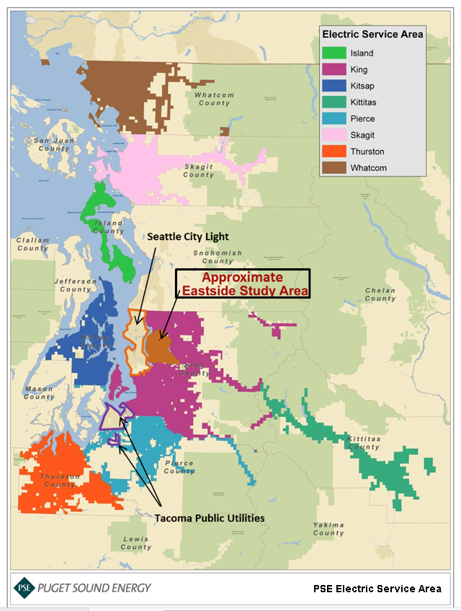

Total Population: 2,630,808

Total Employment: 1,105,778

Total Customers: 1,086,967

Total MWh: 20,966,059

*Figure 5-2: Electric Service Area, Counties and Eastside Area, Percent of PSE Total, 2013 data*

|  |  |  |  |  |
| --- | --- | --- | --- | --- |
| **County** | **Population** | **Employment** | **Customers** | **Sales** |
| King | 48% | 58% | 49% | 52% |
| Thurston | 10% | 9% | 11% | 11% |
| Pierce | 15% | 10% | 10% | 9% |
| Kitsap | 10% | 8% | 11% | 9% |
| Whatcom | 8% | 8% | 9% | 9% |
| Skagit | 5% | 4% | 5% | 7% |
| Island | 3% | 1% | 3% | 2% |
| Kittitas | 2% | 1% | 1% | 1% |
| Eastside Area | 9% | 19% | 10% | 14% |

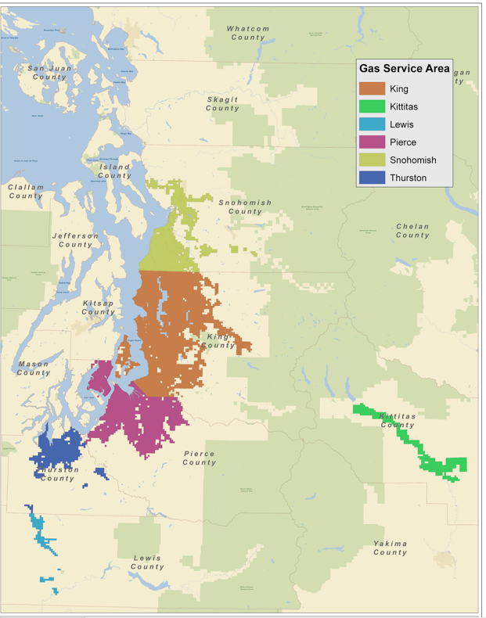Figure 5-3: PSE Gas Service Territory

Total Population: 3,852,855

Total Employment: 1,929,644

Total Customers: 779,778

Total Sales: 115,649 Mdth

Figure 5-4: Gas Service Territory: County Share as a Percent of PSE total, 2013 data

|  |  |  |  |  |
| --- | --- | --- | --- | --- |
| **County** | **Population** | **Employment** | **Customers** | **Sales** |
| King | 52% | 65% | 57% | 57% |
| Pierce | 21% | 15% | 19% | 22% |
| Snohomish | 19% | 14% | 17% | 15% |
| Thurston | 7% | 5% | 6% | 5% |
| Lewis | 1% | 1% | 1% | 1% |
| Kittitas | 1% | 1% | <1% | <1% |

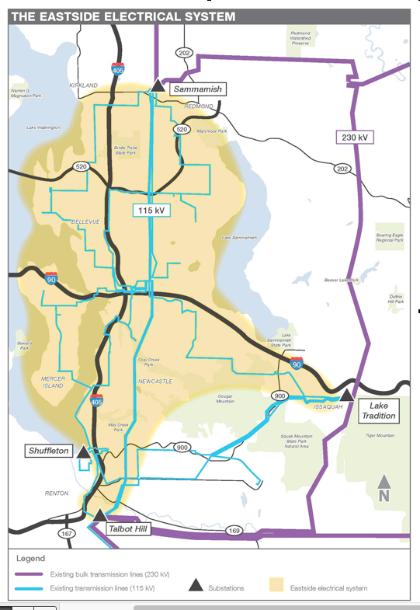Figure 5-5: Eastside Area Electric System

METHODOLOGIES

The methodology used to develop the system-level forecast is described first, followed by the methodology used for county-level forecasts. Finally, the methodology for developing the Eastside Area forecast is described.

System-level Methodology

PSE’s regional economic and demographic model uses both national and regional data to produce a forecast of total employment, types of employment, unemployment, personal income, population, households, consumer price index (CPI) and building permits for both the PSE electric and gas service territories. The regional economic and demographic data are built up from county-level or MSA (metropolitan statistical area)-level information from various sources. The load-forecasting process is illustrated in Figure 5-6, and the input data sources are listed in Figure 5-7.

Figure 5-6: PSE Load Forecasting Process

Figure 5-7: Sources for U.S. and Regional Economic and Demographic Data

|  |  |
| --- | --- |
| **DATA USED IN ECONOMIC AND DEMOGRAPHIC MODEL** |  |
| **County-level Data** | **Source** |
| Labor force, employment,  unemployment rate | US Bureau of Labor Statistics (BLS) www.bls.gov |
| Total non-farm employment,  and breakdowns by type of employment | WA State Employment Security Department, using data from Quarterly Census of Employment and Wages fortress.wa.gov/home |
| Personal income | US Bureau of Economic Analysis (BEA) www.bea.gov |
| Wages and salaries |
| Population |
| Households, single- and multi-family | US Census censtats.census.gov |
| Household size, single- and multi-family |
| Housing permits, single- and multi-family | Building Industry Association of Washington (BIAW) www.biaw.com |
| Aerospace Employment | Puget Sound Economic Forecaster www.economicforecaster.com |
| **US-level Data** | **Source** |
| GDP | Moody's Analytics www.economy.com |
| Industrial Production Index |
| Employment |
| Unemployment rate |
| Personal income |
| Wages and salary disbursements |
| Consumer Price Index (CPI) |
| Housing starts |
| Population |
| Conventional mortgage rate |
| T-bill rate, 3 months |

A wide variety of electricity and natural gas uses are assumed as inputs.

* For residential customers, typical energy uses include space heating, water heating, lighting, cooking, refrigeration, dish washing, laundry washing, televisions, computers and various other plug loads.
* Commercial and industrial customers use energy for production processes; space heating, ventilation and air conditioning (HVAC); lighting; computers; and other office equipment.

To forecast energy sales and customer counts, customers are divided into classes and service levels that use energy for similar purposes and at comparable retail rates. The different classes are modeled separately using variables specific to their usage patterns.

***Transport Customers***

“Transport” in the natural

gas industry has historically referred to customers that acquire their own natural

gas from third-party suppliers and rely on the gas utility for distribution service. It does

not refer to natural gas fuel

for vehicles.

* Electric customer classes include residential, commercial, industrial, streetlights, resale and transport or customers under schedule 449 purchasing their power from other suppliers.
* Gas customer classes include firm (residential, commercial, industrial, commercial large volume and industrial large volume), interruptible (commercial and industrial), and transport (commercial firm, commercial interruptible, industrial firm and industrial interruptible).

Regression equations are used to forecast the number of customers by class as well as the use per customer (UPC) by class. These are multiplied together to arrive at the billed sales forecast. The main drivers of these equations include population or households, housing permits, unemployment rates, retail rates, personal income, weather, total employment and manufacturing employment. Weather inputs are based on temperature readings from Sea-Tac Airport.

For detailed technical descriptions of the econometric methodologies used to forecast billed energy sales and customer counts, peak loads for electricity and natural gas, hourly distribution of electric loads and forecast uncertainty, see Appendix E, Demand Forecasting Models.

**System-level High and Low Scenarios.** Once the base demand forecast scenario is set, PSE develops high and low growth scenarios by performing 250 stochastic simulations for PSE’s economic and demographic model. These simulations use the standard errors for key regional variables such as population, employment and income. The economic assumptions for the low and high scenarios represent the 5th and 95th percentile of the simulations, respectively. More detailed discussion of the stochastic simulations is presented in Appendix E, Demand Forecasting Models.

County-level Methodology

The same regional economic and demographic inputs are used for the electric county-level load forecast models as the system-level model; these are disaggregated into the different counties to ensure consistency with the system-level inputs.

As in the system-level approach, the customer count forecast for each class within each county is modeled as an econometric equation. However, the use per customer equation for each class is scaled to the county level using actual weather-normalized use per customer by county.

Electric peak loads by county were forecast using an approach similar to the system-level approach, given system coincident actual peaks at the county level using substation data. The individual county forecasts were then subject to adding up restrictions so the sum of the county forecasts equals the system-level forecast.

PSE did not produce a peak gas forecast at the county level because of the dearth of actual gas peak day data by county.

Eastside Area Methodology

Because data required for PSE’s economic and demographic models is not available on a sub-county level, different data sources were used for the Eastside Area. This information was broken out by census tract and/or collected directly from PSE’s billing system and substations that serve the area. Sources included the following:

* Historical data and employment forecasts from the PSRC, by census tract,
* Historical population data from the Washington State Office of Financial Management (WA OFM) and population growth forecasts from PSRC, also by census tract,
* Actual customer counts and billed sales by customer class collected from PSE’s billing system, and
* System coincident peaks collected from the substations serving this area.

KEY ASSUMPTIONS

To develop PSE’s demand forecasts, assumptions must be made about economic growth, energy prices, weather and loss factors, including certain system-specific conditions. These and other assumptions are described below.

Economic Growth

Economic activity has a significant effect on energy demand. Overall, recovery from the effects of the latest recession has been slower than expected. As a result, both the nation and the region are experiencing slower population growth, slower GDP growth and slower employment growth than forecast when the 2013 IRP was prepared. In PSE’s service territory, economic growth is uneven. King County, and in particular the Eastside Area, is growing much faster than the rest of the electric service territory. Both building permits and employment growth in that area far exceed other parts of the service territory.

**National Economic Outlook.** Because the Puget Sound region is a major commercial and manufacturing center with strong links to the national economy, PSE’s system-level forecast begins with assumptions about what is happening in the broader U.S. economy. We rely on Moody’s Analytics U.S. Macroeconomic Forecast, a long-term forecast of the U.S. economy, for both economic and population growth rates. The June 2014 forecast was used for this IRP.

Moody’s forecast calls for:

* U.S. GDP growth to reach nearly 4 percent in 2015, a year slower than the Moody’s forecast used in the 2013 IRP.
* Average population growth of 0.78 percent per year for 2014-2033, down from 0.92 percent forecast in the 2013 IRP (2014-2033).

Slower population growth is attributed to lower birth rates and lower international migration.

Economic growth could slow further if the Federal Reserve becomes aggressive in its interest rate setting; if Europe’s economic problems continue to persist, especially combined with the Russia-Ukraine conflict; and if China’s economy experiences a slowdown amid increasing tensions with its neighbors. However, many believe that the U.S. economy will be able to withstand these threats and continue to recover from the recent recession.

**Regional Economic Outlook.** PSE prepares regional economic and demographic forecasts using econometric models whose primary input is a macroeconomic forecast of the United States plus historical economic data for the counties in PSE’s service area.

**Electric Base Demand Scenario Outlook.** The following assumptions are modeled in the 2015 IRP Base Electric Demand Forecast scenario.

* Employment is expected to grow at an average annual rate (aarg) of 0.7 percent between 2016 and 2035, compared to the forecasted annual growth rate in the 2013 IRP of 1.4 percent.
* Manufacturing employment is expected to decline annually by 0.4 percent on average between 2016 and 2035, continuing a long trend, due to capital investments that create increases in productivity.
* Local employers are expected to create about 297,000 jobs between 2016 and 2035 as compared to more than 596,000 jobs in the 2013 IRP (2012 to 2033).
* An inflow of more than 775,000 new residents between 2016 and 2035 will increase PSE’s electric service territory population to almost 4.8 million by 2035. This is lower than the 2013 IRP forecast of a little over 1 million new residents between 2012 and 2033.

As explained above, the slightly slower long-term growth in employment is attributed to the slower than expected recovery from the effects of the latest recession and lower population growth expected by the U.S. Census Bureau.

In the region, long-term growth is driven by a diverse group of employers that includes Microsoft, Amazon, Costco, REI, Boeing and Starbucks among others. Boeing’s strong historical employment growth is not necessarily expected to continue, due to outsourcing and an increase in the number of planes assembled in other states.

**Electric High and Low Scenario Outlooks.** For the Low Electric Demand Forecast scenario, population grows by 0.8 percent annually from 2016 to 2035. Employment grows 0.1 percent annually from 2016 to 2035.

For the High Electric Demand Forecast scenario, population grows by 1.1 percent annually from 2016 to 2035, and employment grows by 1.3 percent per year during that period.

The Base, High and Low population and employment forecasts for PSE’s electric service area are compared in Figures 5-8 and 5-9.

Figure 5-8: Population Growth, Electric Service Area

|  |  |  |  |  |  |  |
| --- | --- | --- | --- | --- | --- | --- |
| **Population Growth, Electric Service Area (1,000s)** | | | | | | |
| **Scenario** | **2016** | **2020** | **2025** | **2030** | **2035** | **AARG**  **2016-2035** |
| 2015 IRP  Base Demand Forecast | 3,998 | 4,176 | 4,393 | 4,587 | 4,774 | 0.9% |
| 2015 IRP  High Demand Forecast | 4,027 | 4,232 | 4,476 | 4,692 | 4,926 | 1.1% |
| 2015 IRP  Low Demand Forecast | 3,970 | 4,119 | 4,308 | 4,477 | 4,645 | 0.8% |

Figure 5-9: Employment Growth, Electric Service Area

|  |  |  |  |  |  |  |
| --- | --- | --- | --- | --- | --- | --- |
| **Employment Growth, Electric Service Area (1,000s)** | | | | | | |
| **Scenario** | **2016** | **2020** | **2025** | **2030** | **2035** | **AARG**  **2016-2035** |
| 2015 IRP  Base Demand Forecast | 2,021 | 2,093 | 2,163 | 2,233 | 2,318 | 0.7% |
| 2015 IRP  High Demand Forecast | 2,111 | 2,260 | 2,403 | 2,529 | 2,703 | 1.3% |
| 2015 IRP  Low Demand Forecast | 1,934 | 1,934 | 1,942 | 1,967 | 1,968 | 0.1% |

**Gas Scenario Outlooks: Base, High and Low.** In the Base Gas Demand Forecast scenario, population grows by 1.2 percent annually from 4.1 million people in 2016 to almost 5.2 million people by 2035. Employment is expected to grow by 1.4 percent annually from 2016 to 2035.

For the Low Gas Demand Forecast scenario, population grows by 1.0 percent annually from 2016 to 2035. Employment grows 0.7 percent annually from 2016 to 2035.

For the High Gas Demand Forecast scenario, population grows by 1.3 percent annually from 2016 to 2035, and employment grows by 2.0 percent per year during that period.

The Base, High and Low population and employment forecasts for PSE’s gas sales service area are compared in Figures 5-10 and 5-11.

Figure 5-10: Population Growth, Gas Service Area

|  |  |  |  |  |  |  |
| --- | --- | --- | --- | --- | --- | --- |
| **Population Growth, Gas Service Area (1,000s)** | | | | | | |
| **Scenario** | **2016** | **2020** | **2025** | **2030** | **2035** | **AARG 2016-2035** |
| 2015 IRP  Base Demand Forecast | 4,146 | 4,364 | 4,640 | 4,900 | 5,161 | 1.2% |
| 2015 IRP  High Demand Forecast | 4,173 | 4,428 | 4,734 | 5,026 | 5,346 | 1.3% |
| 2015 IRP  Low Demand Forecast | 4,117 | 4,300 | 4,543 | 4,772 | 4,999 | 1.0% |

Figure 5-11: Employment Growth, Gas Service Area

|  |  |  |  |  |  |  |
| --- | --- | --- | --- | --- | --- | --- |
| **Employment GROWTH, Gas Service Area (1,000s)** | | | | | | |
| **Scenario** | **2016** | **2020** | **2025** | **2030** | **2035** | **AARG**  **2016-2035** |
| 2015 IRP  Base Demand Forecast | 2,107 | 2,241 | 2,393 | 2,548 | 2,724 | 1.4% |
| 2015 IRP  High Demand Forecast | 2,201 | 2,417 | 2,645 | 2,874 | 3,209 | 2.0% |
| 2015 IRP  Low Demand Forecast | 2,011 | 2,067 | 2,150 | 2,249 | 2,306 | 0.7% |

County-level Outlook

The charts below show the wide variation in economic activity among the counties in PSE’s electric and gas sales service territories. Most of the economic growth is concentrated in King County, as can be seen by the growth in the number of building permits filed in the last five years and by the county’s strong job growth. Other counties are growing, but more slowly; except for King County, none has reached its pre-recession growth levels. County-level forecasts extend only to 2031.

Eastside Area Outlook

In PSE’s service territory, growth is strongest in the Eastside Area, especially in the central business district of Bellevue. Using census tract data, PSRC created 10-, 20-, and 30-year forecasts of population and employment for the area. According to this forecast, employment in the Eastside Area is expected to grow by about 1.7 percent annually in the next 20 years, with slightly higher growth before 2020 due to the recovery from the recession. This is over twice the growth rate expected for the system as a whole. Population is forecast to grow by 0.9 percent annually in the next 20 years, again with a slightly faster growth before 2020 due to the recovery from the most recent recession.

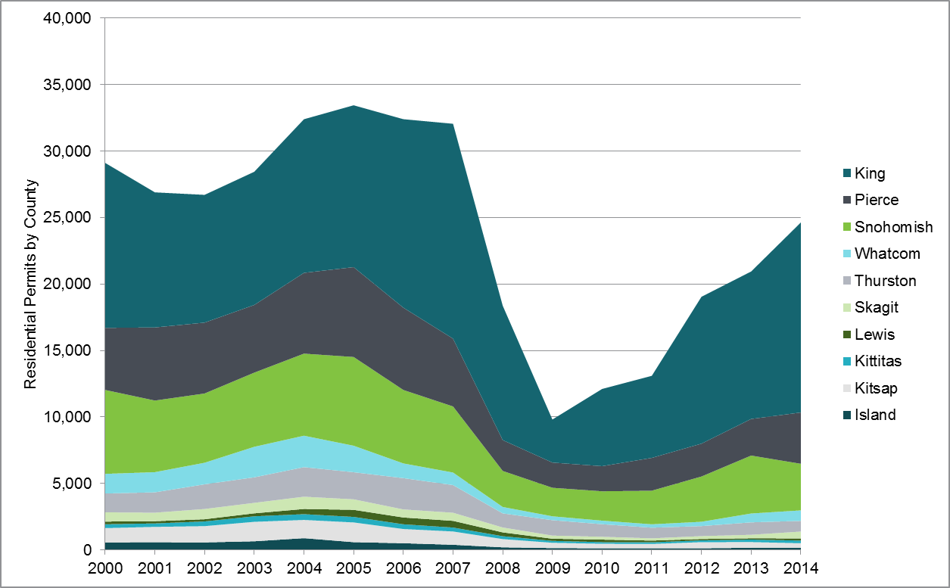Figure 5-12: Residential Building Permits by County, 2000-2014

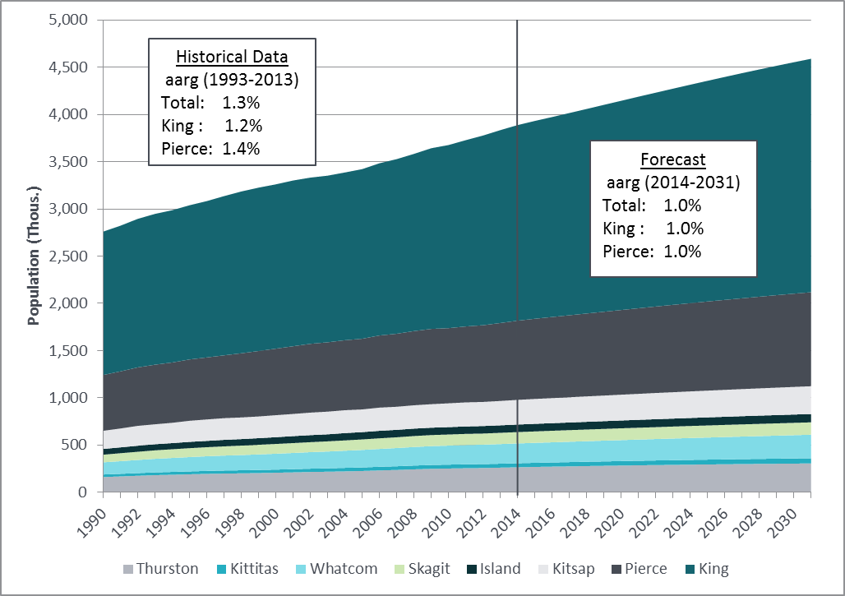Figure 5-13: Population by County, Electric Service Territory Counties, 1990-2031

Figure 5-14: Employment by County, Electric Service Territory Counties, 1990-2031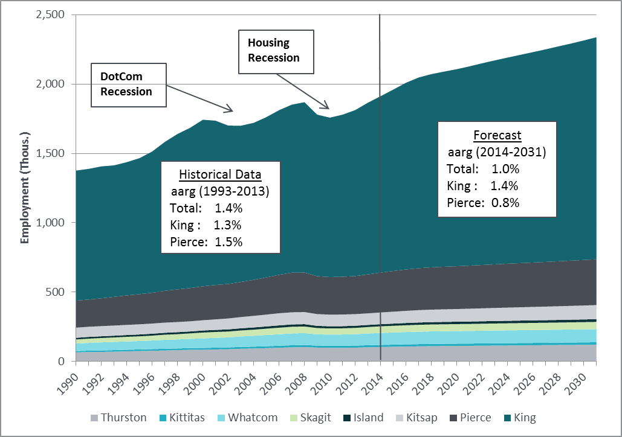

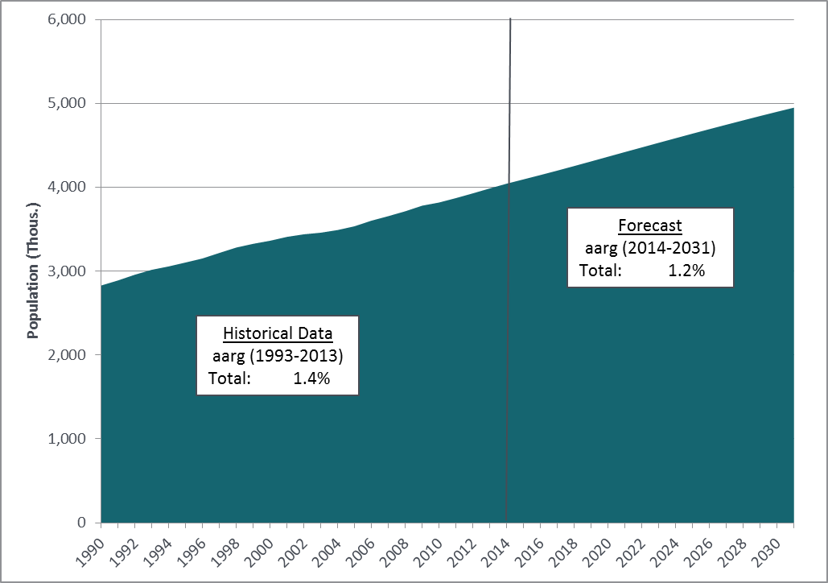Figure 5-15: Population, Gas Service Territory Counties, 1990-2031

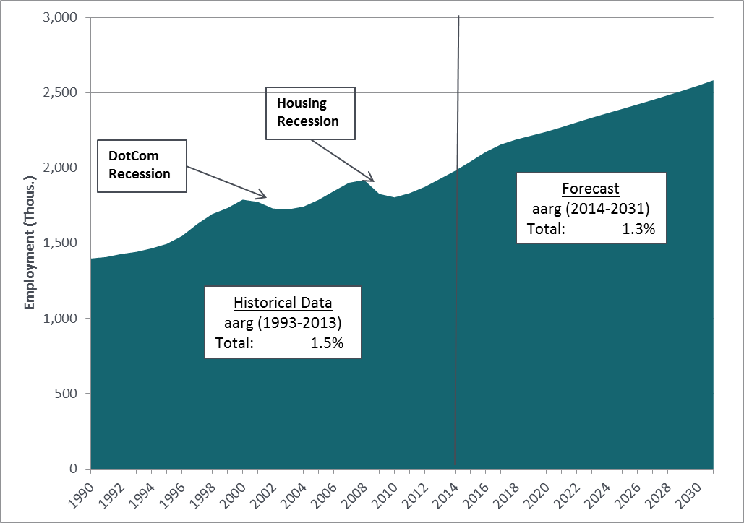Figure 5-16: Employment, Gas Service Territory Counties, 1990-2031

Energy Prices

Retail energy prices – what customers pay for energy – are included as explanatory variables in the demand forecast models, because in the long run, they affect the customer’s choice of the efficiency level of newly acquired appliances, their frequency and level of use and the type of energy source used to power them. The energy price forecasts draw on information obtained from internal and external sources.

**Electric Retail Prices.** PSE projects that between 2016 and 2033, nominal retail electric rates will grow at an average annual rate of between 1.1 and 1.3 percent, depending on the customer class. Assuming an inflation rate of 2.5 percent per year, this means real electric retail rates are expected to decline by 1.2 to 1.4 percent. This is much lower than the 3.1 percent rate increase modeled in the 2013 IRP.

In the near term, the retail price forecast assumes rate increases resulting from PSE’s general and power-cost-only rate cases. Long-term retail rates were derived from PSE’s internal financial model, which showed lower power cost levels compared to the 2013 IRP, hence the lower growth rate assumed here.

**Gas Retail Prices.** PSE expects nominal retail gas rates to rise between 2.9 percent and 3.4 percent per year, depending on the class, between 2016 and 2033. This is slightly more than the long-term inflation rate. However, gas price levels are lower in this forecast compared to the forecast in the 2013 IRP for all classes except the transport classes.

Two components make up gas retail rates: the cost of gas and the cost of distribution, known as the distribution margin. The near-term forecast of gas rates includes PSE’s purchased gas adjustment and general rate case considerations. Forecast gas costs reflect Kiodex gas prices for the 2015 to 2019 period as of July 24, 2014 and inflation projections beyond. The distribution margin is based on PSE’s projection for the near term and inflation projections for the longer term.

Other Assumptions

**Weather.** The billed sales forecast is based on normal weather, defined as the average monthly weather recorded at NOAA’s Sea-Tac Airport station over the 30 years ending in 2013. While the climate may change during the 20-year planning horizon, reliable forecasts for these changes are not yet available. Future IRPs will incorporate new climate information as it becomes available.

**Loss Factors.** The electric loss factor remains at 6.9 percent, and the gas loss factor remains at 0.8 percent.

**Block Load Additions from Major Accounts.** Beyond typical economic change, the demand forecast also takes into account known major load additions and deletions, using information from PSE’s system planners. These adjustments add 128 MW to demand over the next 7 years for the system as a whole. The majority of these additions come from King County.

King County is expected to add:

* 77 MW of load additions between 2014 and 2017
* 45 MW between 2018 and 2020

The Eastside Area is expected to add:

* 42 MW of load additions from 2014 to 2017
* 39 MW from 2018 to 2020

Block load additions are ramped into the forecast and then ramped out of the forecast, as the native load growth accounts for these additions. This avoids double counting block load additions.

The electric forecast also includes the following load additions and deletions.

* Approximately 9 MWs for horticultural lighting, mostly located in Thurston, Whatcom and Skagit counties
* Jefferson County has been deleted; it left PSE’s electric service territory in April 2013.

The gas forecast includes the following block load additions.

* 6.4 Mdth per day is added for 2 large transport customers.
* The City of Buckley joined PSE’s gas service territory in July 2014. (The city added 1,189 residential customers and 187 commercial customers in 2012; residential customers are expected to grow at an annual rate of 1.5 percent, and commercial customers are expected to grow at an annual rate of 0.5 percent.)

**Compressed Natural Gas Vehicles.** Compressed natural gas (CNG) vehicles were added to the 2015 IRP Gas Base Demand Forecast. CNG vehicles include marine vessels, buses, light-duty vehicles, medium-duty vehicles and heavy-duty vehicles. In 2015, this adds 50.9 Mdth to the forecast. This load is expected to grow at an average annual rate of 5.9 percent, based on the Annual Energy Outlook 2014 published by the U.S. Department of Energy.

**Distributed Generation/Electric Vehicles.** Distributed generation, including customer-level generation via solar panels, was not included in the load forecast; this energy production is captured in the IRP scenario modeling process. Analysis of electric vehicle loads in the 2011 IRP indicated that their impact on demand was insignificant, so electric vehicles are also not included in this demand forecast.

**Interruptible Loads.** PSE has 165 electric interruptible customers; 5 of these are commercial and industrial customers and 160 are schools. The school contracts limit the time of day when energy can be curtailed. The other customers represent 7 MW of coincident peak load. Since this 7 MW is so small compared to PSE’s peak load, it was included in the firm load forecast; however, it has been accounted for in PSE’s resource adequacy model. For a number of gas customers, all or part of their volume is interruptible volume. The curtailment of interruptible gas volumes was included when forecasting peak gas loads.

ELECTRIC DEMAND FORECAST

Highlights of the system-level base, high and low demand forecasts PSE developed for the electric service area are presented below. County-level winter peak forecasts follow, plus a forecast for the Eastside Area, the most rapidly growing part of the service territory.

Demand-side resources (DSR), primarily energy efficiency measures, are treated differently at the system-level than they are at the county and sub-county level. At the system level, only DSR measures implemented through December 2015 are included, since the system-level demand forecast itself helps to determine the most cost-effective amount of conservation to include in the portfolio. County forecasts do not perform the same function, so those forecasts apply the full amount of DSR projected in the 2013 IRP, plus an additional 5 percent from 2016 to 2035 to account for the 2013 general rate case Global Settlement. The 2013 Global Settlement that approved decoupling mechanisms requires PSE to acquire an additional 5 percent of energy efficiency over and above the biennial target set for the company to comply with RCW 19.285.

System-level Highlights

**Electric Load Growth.** In the 2015 IRP Base Demand Forecast, total load is expected to grow at a rate of 1.8 percent annually from 2016 to 2025 and 1.5 percent annually from 2025 to 2035, for an average annual growth rate of 1.7 percent over the 20-year study period. Total load is expected to grow from 2,629 aMW in 2016 to 3,598 aMW in 2035. The rate is faster in the early years due to the continued economic recovery.

Residential and commercial loads are driving this growth; they represent 47 percent and 41 percent of load in 2016, respectively. On the residential side, use per customer is relatively flat, so growth in this category is being driven by the increase in the number of customers. On the commercial side, both use per customer and rising customer counts are driving growth.

The 2015 IRP High Demand Forecast projects an average annual growth rate of 2.2 percent; the Low Demand Forecast projects 1.1 percent.

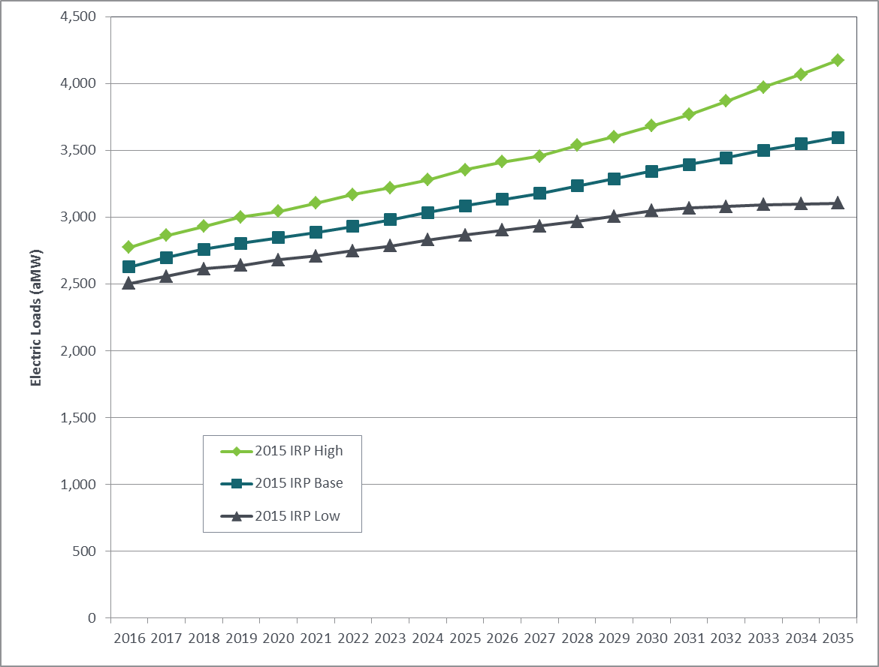Figure 5-17: Electric Demand Forecast before DSR

Base, High and Low Scenarios (aMW)

Figure 5-18: Electric Demand Forecast before DSR (Table)

Base, High and Low Scenarios

|  |  |  |  |  |  |  |
| --- | --- | --- | --- | --- | --- | --- |
| **ELECTRIC DEMAND FORECAST SCENARIOS (aMW)** | | | | | | |
| **Scenario** | **2016** | **2020** | **2025** | **2030** | **2035** | **AARG**  **2016-2035** |
| **2015 IRP**  **Base Demand Forecast** | 2,629 | 2,850 | 3,088 | 3,345 | 3,598 | 1.7% |
| **2015 IRP**  **High Demand Forecast** | 2,776 | 3,044 | 3,357 | 3,685 | 4,176 | 2.2% |
| **2015 IRP**  **Low Demand Forecast** | 2,505 | 2,682 | 2,869 | 3,050 | 3,108 | 1.1% |

**Electric Peak Demand.** The normal electric peak hour load is modeled using 23 degrees Fahrenheit. The 2015 IRP Base Demand Forecast shows an average annual peak load growth of 1.6 percent and an increase in peak load from 4,929 MW to 6,649 MW between 2016 and 2035. Demand grows faster in the first part of the forecast period due to the continued economic recovery (at 1.7 percent from 2016 to 2025 compared to 1.5 percent thereafter).

The 2015 IRP Electric Base Demand Forecast is lower than the 2013 IRP Base Demand Forecast due primarily to the lower population forecast which led to a lower customer forecast.

The 2015 IRP High Demand Forecast shows an average annual peak load growth of 2.0 percent, and the Low Demand Forecast shows a 1.2 percent annual growth rate.

Figure 5-19: Electric Peak Demand Forecast before DSR   
Base, High and Low Scenarios, Hourly Annual Peak (23 Degrees, MW)

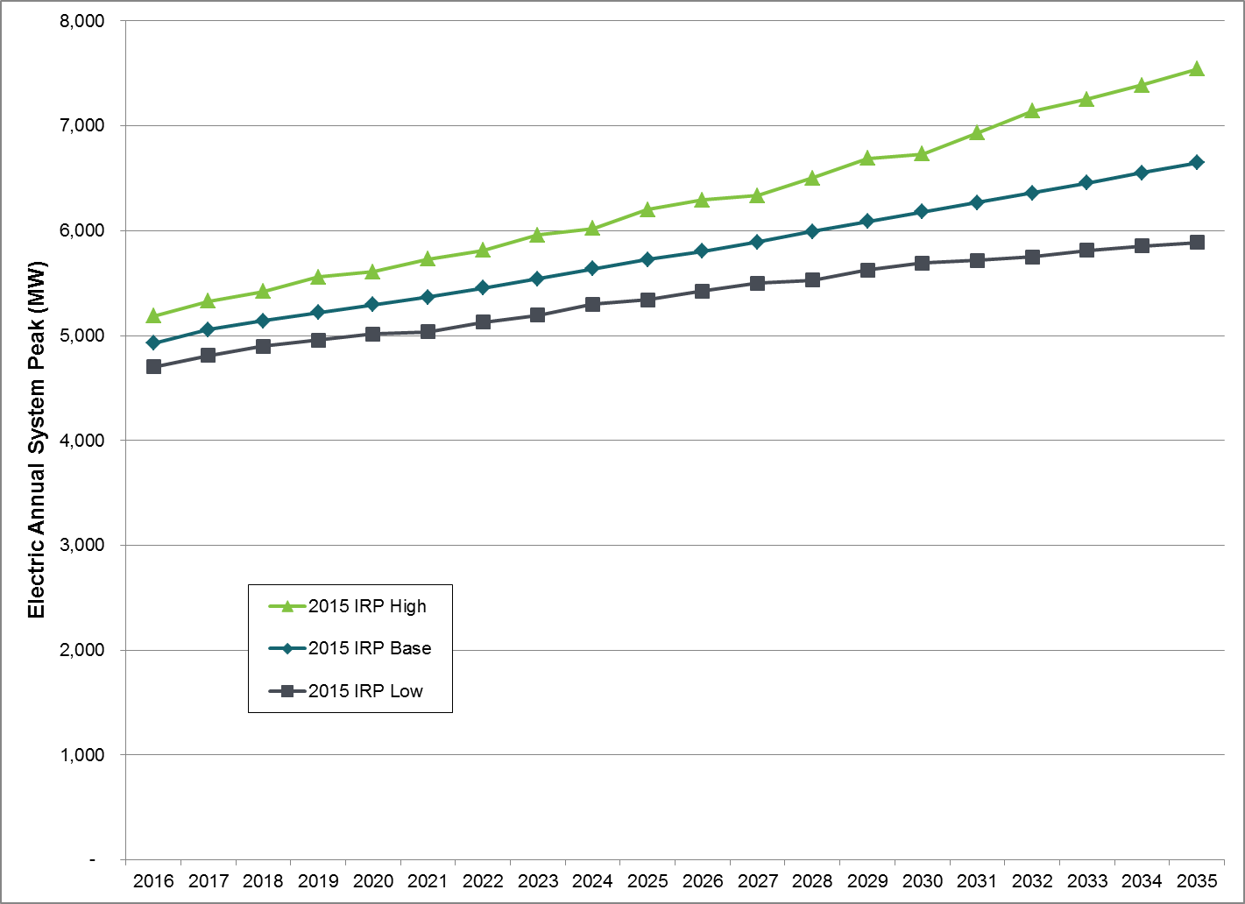

Figure 5-20: Electric Peak Demand Forecast before DSR (Table)  
Base, High and Low Scenarios, Hourly Annual Peak (23 Degrees, MW)

|  |  |  |  |  |  |  |
| --- | --- | --- | --- | --- | --- | --- |
| **ELECTRIC PEAK DEMAND FORECAST SCENARIOS (MW)** | | | | | | |
| **Scenario** | 2016 | 2020 | 2025 | 2030 | 2035 | AARG (2016-2035) |
| **2015 IRP Base Demand Forecast** | 4,929 | 5,294 | 5,726 | 6,180 | 6,649 | 1.6% |
| **2015 IRP**  **High Demand Forecast** | 5,187 | 5,608 | 6,200 | 6,734 | 7,544 | 2.0% |
| **2015 IRP**  **Low Demand Forecast** | 4,701 | 5,013 | 5,340 | 5,693 | 5,887 | 1.2% |

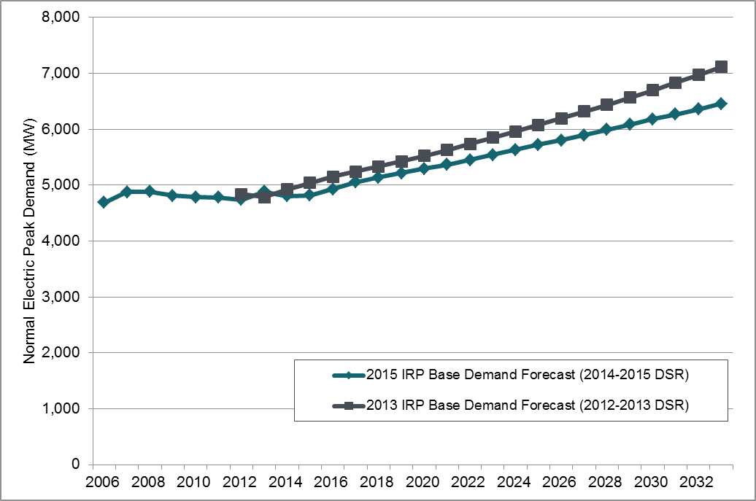Figure 5-21: Electric Peak Demand Forecast before DSR   
2015 IRP Base Scenario versus 2013 IRP Base Scenario   
Hourly Annual Peak (23 Degrees, MW)

**System-level Impacts of Conservation.** The system-level demand forecasts shown above apply only the energy efficiency measures targeted for 2014 and 2015, because those forecasts serve as the starting point for identifying the most cost-effective amount of demand-side resources for the portfolio from 2016 to the end of the forecast.

However, we also examine the effects of conservation on the system load and peak forecasts over the 20-year planning horizon. This forecast is used internally at PSE for financial planning and for transmission and distribution system planning. We apply the demand-side resources from the 2013 IRP to the Base scenario load and peak forecasts for 2016 to 2035. To account for the 2013 general rate case Global Settlement, an additional 5 percent of conservation was also applied for that period. The result is illustrated in Figures 5-21 and 5-22, below.

**DSR Impact on Load:** When 2013 IRP DSR is applied to the load forecast:

* Total system demand is 2,606 aMW in 2016 increasing to 3,022 aMW in 2035.
* Average annual growth is 0.2 percent from 2016 to 2025 and 1.3 percent from 2025 to 2035. Load grows more slowly in the first half of the forecast because that is when the majority of the demand-side measures are expected to be implemented.

**DSR Impact on Peak:** When the 2013 IRP DSR is applied to the peak forecast:

* The system peak is 4,844 MW in 2016 increasing to 5,719 MW in 2035.
* Average annual growth is 0.4 percent per year from 2016 to 2025 and 1.3 percent from 2025 to 2035. Again, peak load grows more slowly in the first 10 years when DSR is more heavily concentrated.

The 2015 IRP DSR is higher than the 2013 IRP DSR. Therefore we would expect the Electric Base Demand Forecast with 2015 IRP DSR to be lower than what is shown in Figure 5-22 and Figure 5-23.

Figure 5-22: 2015 IRP Electric Base Demand Forecast (aMW),

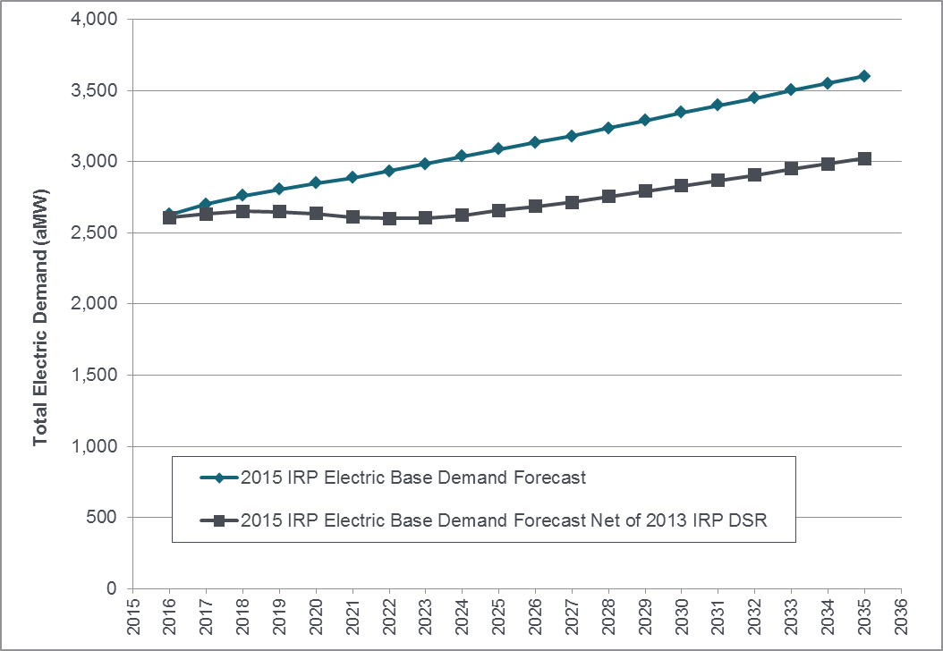before DSR and after applying 2013 IRP DSR

Figure 5-23: Electric Peak Base Demand Forecast (MW),

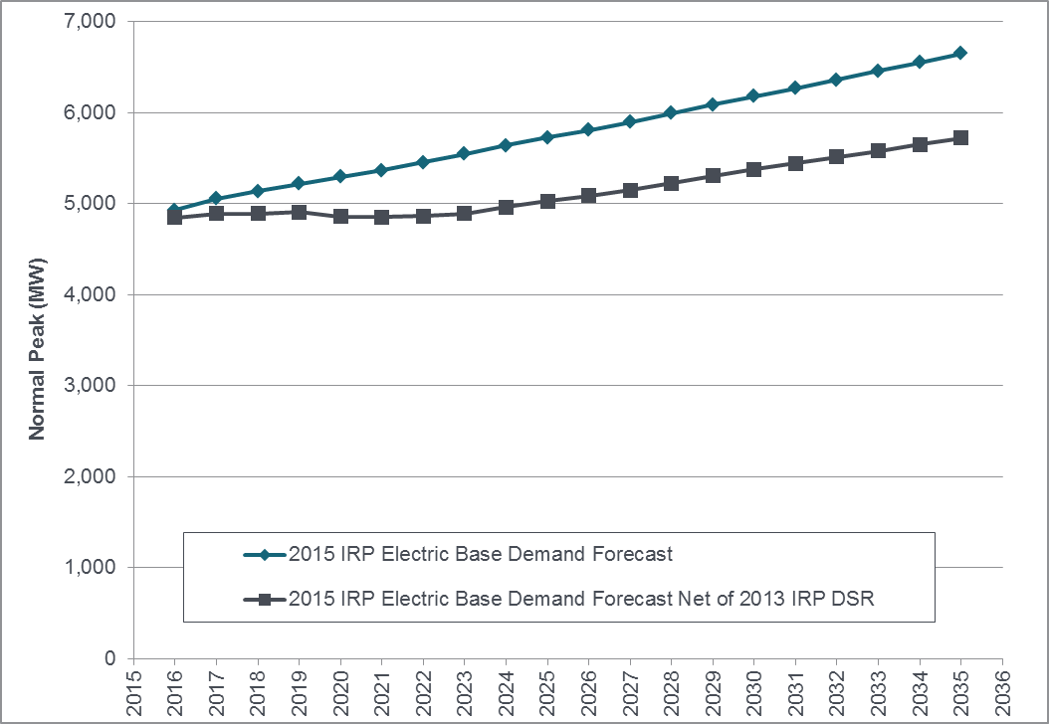before DSR and after applying 2013 IRP DSR

**Electric Customer Counts.** System-level customer counts are expected to grow by 1.5 percent per year on average, from 1.1 million customers in 2016 to 1.5 million customers in 2035. This growth rate is slightly lower than the 2013 IRP Base Demand Forecast growth rate of 1.7 percent, due to the lowered population forecast. Also, continuing weakness in the housing market recovery in recent years led to a lower starting point in the 2016 customer forecast for this IRP compared to the 2013 IRP forecast.

Residential customers are driving the customer count increase; they represent 88 percent of the PSE’s electric customers in 2016. The next largest group, commercial customers, is expected to grow at an annual rate of 1.4 percent from 2016 to 2035. Industrial customer counts are expected to decline, following a historical trend. These trends are expected to continue as the economy in PSE’s service territory grows more commercial and less industrial.

Figure 5-24: December Electric Customer Counts by Class, 2015 IRP Base Demand Forecast

|  |  |  |  |  |  |  |
| --- | --- | --- | --- | --- | --- | --- |
| **December ELECTRIC Customer Counts by Class, Base Demand Forecast** | | | | | | |
| **Class** | **2016** | **2020** | **2025** | **2030** | **2035** | **AARG**  **2016-2035** |
| Total | 1,132,928 | 1,205,903 | 1,307,161 | 1,409,007 | 1,507,494 | 1.5% |
| Residential | 996,090 | 1,060,975 | 1,152,211 | 1,243,344 | 1,330,000 | 1.5% |
| Commercial | 126,580 | 134,116 | 143,527 | 153,569 | 164,560 | 1.4% |
| Industrial | 3,387 | 3,304 | 3,201 | 3,101 | 3,004 | -0.6% |
| Other | 6,871 | 7,508 | 8,222 | 8,993 | 9,929 | 2.0% |

Figure 5-25: Electric Demand by Class, 2015 IRP Base Demand Forecast before DSR

|  |  |  |  |  |  |  |
| --- | --- | --- | --- | --- | --- | --- |
| **Electric Load by class, Base Demand Forecast (aMW)** | | | | | | |
| **Class** | **2016** | **2020** | **2025** | **2030** | **2035** | **AARG  2016-2035** |
| Total | 2,629 | 2,850 | 3,088 | 3,345 | 3,598 | 1.7% |
| Residential | 1,224 | 1,319 | 1,439 | 1,559 | 1,664 | 1.6% |
| Commercial | 1,071 | 1,190 | 1,297 | 1,420 | 1,556 | 2.0% |
| Industrial | 142 | 133 | 128 | 123 | 118 | -1.0% |
| Other | 11 | 11 | 11 | 12 | 12 | 0.4% |
| Losses | 181 | 197 | 213 | 231 | 248 | 1.7% |

**Electric Use per Customer.** Residential use per customer is expected to be flat in the future, absent the impacts of demand-side resources. Multifamily housing growth and the increasing use of natural gas for space and water heating will tend to reduce electric use per customer, but this should be balanced by growth in plug loads and declining or flat real electric rates. As the economy recovers from the recession, commercial use per customer is expected to rise slowly due to higher employment levels and lower vacancy rates in the near term.

Figure 5-26: Electric Use per Customer 2015 IRP Base Demand Forecast before DSR

|  |  |  |  |  |  |  |
| --- | --- | --- | --- | --- | --- | --- |
| **ELECTRIC Use Per Customer, Base Demand Forecast (MWh)** | | | | | | |
| **Type** | **2016** | **2020** | **2025** | **2030** | **2035** | **AARG  2016-2035** |
| Residential | 10.9 | 11.0 | 11.0 | 11.1 | 11.0 | 0.07% |
| Commercial | 74.7 | 78.3 | 79.6 | 81.4 | 83.3 | 0.57% |
| Industrial | 367 | 352 | 349 | 347 | 343 | -0.34% |

County-level Electric Forecasts

All of the county-level and sub-county-level forecasts shown below include the impacts of the 2013 IRP demand-side resources. County-level forecasts extend only to 2031.

King County is the most rapidly growing part of PSE’s service territory. In 2014, it accounted for about 50 percent of PSE’s normal electric peak load. Between 2016 and 2031, it is expected to add 176,000 customers and experience an average customer growth rate of 1.9 percent per year. It is also expected to account for 64 percent of PSE’s future electric peak load growth, with the addition of 386 MW between 2016 and 2031.

Average annual customer growth rates for the other counties are as follows:

* Thurston County: 1.4 percent
* Pierce County: 1.3 percent
* Whatcom, Skagit, Island and Kitsap Counties range from 0.8 to 1.2 percent per year on average.
* The county with the fewest PSE customers, Kittitas, is expected to grow from 13,800 to 22,300 customers between 2016 and 2031.

In terms of peak load growth:

* Thurston, Pierce and Whatcom Counties are expected to grow between 0.6 and 0.7 percent annually between 2016 and 2031.
* Kitsap and Island Counties are expected to grow 0.4 percent and 0.3 percent annually, respectively.
* Kittitas County is expected to grow at 2.6 percent but will only account for 5 percent of the peak load growth from 2016 to 2031.

Figure 5-27: Electric Peak Forecasts by County (MW), after applying 2013 IRP DSR

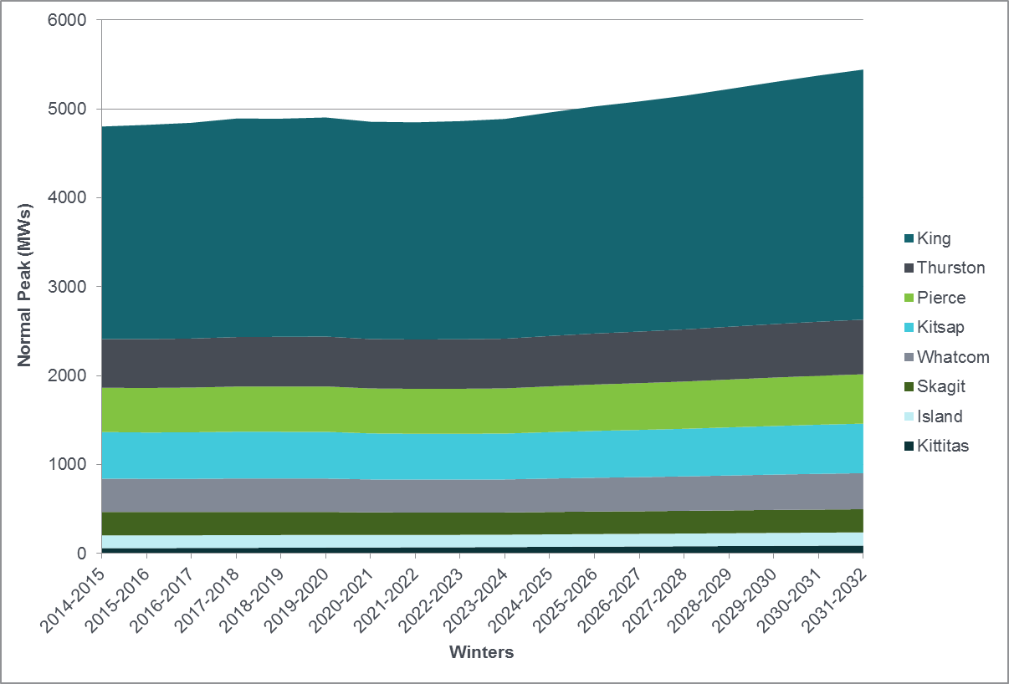

Eastside Area Electric Forecast

PSE updated its Eastside Area peak demand forecast using recent information and external

input forecasts to better understand the diversity of loads in the PSE electric service territory as well as to better understand when the Energize Eastside project is needed. Figure 5-28 illustrates the forecast normal peak load growth in the Eastside Area before DSR and after DSR, along with an extreme peak load forecast after DSR. Figure 5-29 shows the growth rate before DSR is

3.1 percent – nearly twice the 1.6 percent growth rate of the system-level forecast before DSR, shown in Figure 5-20.

Figure 5-28: Eastside Area, Electric Winter Peak Forecasts (MW)

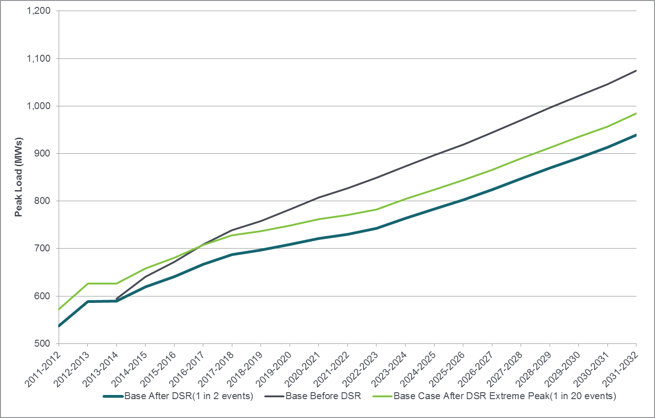

Figure 5-29: Eastside Area, Electric Normal Winter Peak Growth Forecast (Table)

|  |  |  |  |  |
| --- | --- | --- | --- | --- |
|  | **2014-2024** | | **2014-2031** | |
| **SCENARIOS** | **Average Annual Rate of Growth** | **Demand Change** | **Average Annual Rate of Growth** | **Demand Change** |
| Base After DSR | 2.4% | 164 | 2.5% | 320 |
| Base (no DSR) | 3.4% | 256 | 3.1% | 435 |
| Base (extreme peak) | 2.3% | 166 | 2.4% | 327 |

GAS DEMAND FORECAST

Highlights of the system-level base, high and low demand forecasts developed for PSE’s gas sales service are presented below. The gas demand forecasts include only demand-side resources implemented through December 2015, since the demand forecast itself helps to determine the most cost-effective level of DSR to include in the portfolio.

**Gas Load Growth.** The 2015 IRP Gas Base Demand Forecast is a forecast of both firm and interruptible loads, because this is the volume of natural gas that PSE is responsible for securing and delivering to customers. For distribution planning, however, transport loads must be included in total load; transport customers purchase their own natural gas, but contract with PSE for delivery.

In the 2015 IRP Base Demand Forecast, load is projected to grow 1.7 percent per year on average from 2016 to 2035; this would increase load from around 99,000 Mdth in 2016 to 137,000 Mdth in 2035. This rate of load growth is slightly lower than the 2013 IRP Base Demand Forecast, which had an annual growth rate of 1.8 percent (2014 to 2033).

The 2015 IRP High Gas Demand Forecast projects an average annual growth of 2.1 percent; the Low Demand Forecast projects a growth rate of 1.4 percent per year.

Figure 5-30: Gas Demand Forecast before DSR

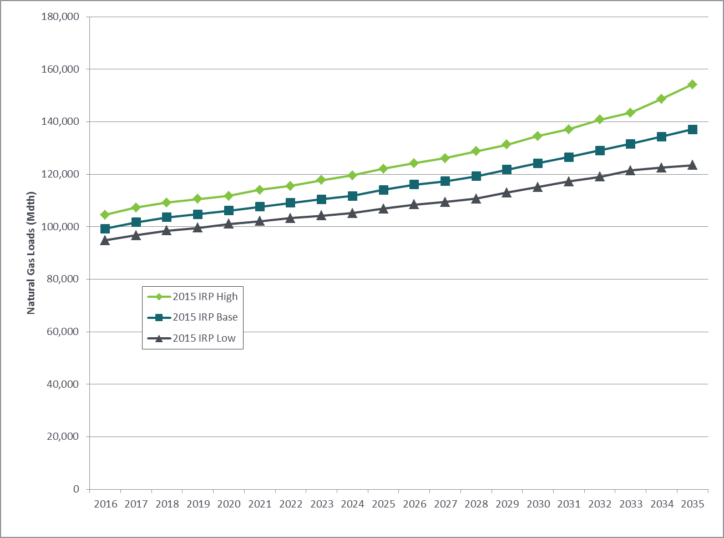Base, High and Low Scenarios, without Transport Load (Mdth)

Figure 5-31: Gas Demand Forecast before DSR (Table)   
Base, High and Low Scenarios without Transport Load (Mdth)

|  |  |  |  |  |  |  |
| --- | --- | --- | --- | --- | --- | --- |
| **GAS LOAD FORECAST SCENARIOS (Mdth), WITHOUT TRANSPORT** | | | | | | |
| **Scenario** | **2016** | **2020** | **2025** | **2030** | **2035** | **AARG  2016-2035** |
| 2015 IRP Base Demand Forecast | 99,232 | 106,171 | 114,010 | 124,200 | 137,126 | 1.7% |
| 2015 IRP High Demand Forecast | 104,603 | 111,745 | 122,075 | 134,536 | 154,183 | 2.1% |
| 2015 IRP Low Demand Forecast | 94,803 | 101,057 | 106,884 | 115,163 | 123,459 | 1.4% |

**Gas Peak Demand.** The gas design peak day is modeled at 13 degrees Fahrenheit average temperature for the day, and the curtailment of interruptible gas volumes was included when forecasting peak gas loads.

For peak gas demand, the 2015 IRP Base Demand Forecast projects an average increase of 1.8 percent per year for the next 20 years; peak demand would rise from 1,008 Mdth in 2016 to 1,427 Mdth in 2035. The High Demand Forecast projects a 2.1 percent annual growth rate, and the Low Demand Forecast projects 1.6 percent. The 2015 IRP Base Demand growth rate is slightly lower than the 2013 IRP Base Demand growth rate of 2.0 percent (2014 to 2033), mainly due to the lower customer forecast; however, it starts out higher than the previous forecast because lower retail gas rates have caused an increase in use per customer at the beginning of the study period. Over time, the two forecasts come back together because of the slower customer growth in the 2015 IRP Base Demand Forecast.

Gas peak day growth rates are slightly higher than the rates for load growth because the classes that contribute most to peak demand (the weather-sensitive residential and commercial sectors) are growing faster than the classes that don’t contribute to peak demand. Rising baseloads are also contributing to peak demand because gas is increasingly being used for purposes other than heating (such as cooking, clothes drying and fireplaces). This effect is slightly offset by higher appliance and home efficiencies.

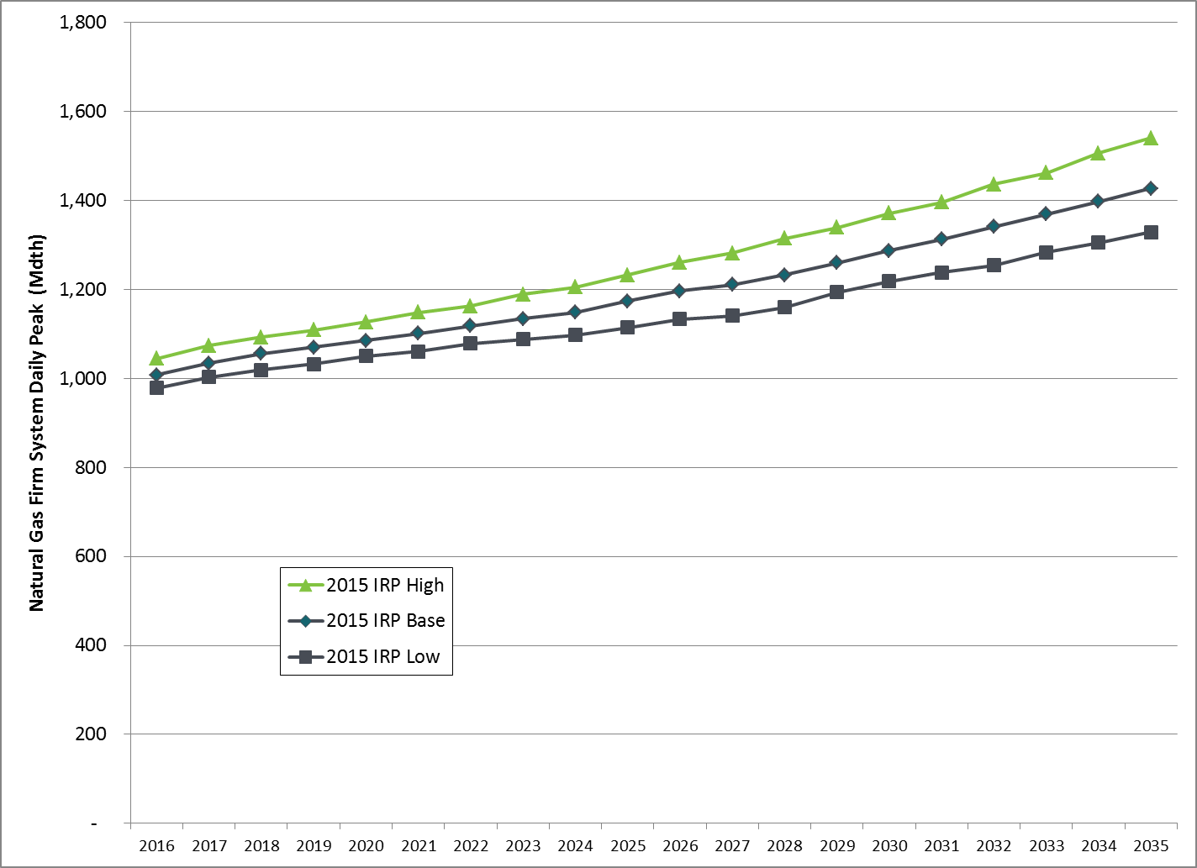Figure 5-32: Gas Peak Day Demand Forecast before DSR   
Base, High and Low Scenarios (13 Degrees, Mdth)

Figure 5-33: Gas Peak Day Demand Forecast before DSR (Table)  
Base, High and Low Scenarios (13 Degrees, Mdth)

|  |  |  |  |  |  |  |
| --- | --- | --- | --- | --- | --- | --- |
| **Firm Gas Peak Day Forecast Scenarios (Mdth)** | | | | | | |
| **Scenario** | **2016** | **2020** | **2025** | **2030** | **2035** | **AARG  2016-2035** |
| 2015 IRP  Base Demand Forecast | 1,008 | 1,085 | 1,173 | 1,287 | 1,427 | 1.8% |
| 2015 IRP  High Demand Forecast | 1,044 | 1,126 | 1,232 | 1,371 | 1,541 | 2.1% |
| 2015 IRP  Low Demand Forecast | 978 | 1,050 | 1,114 | 1,218 | 1,329 | 1.6% |

Figure 5-34: Firm Gas Peak Day Forecast before DSR  
2015 IRP Base Scenario versus 2013 IRP Base Scenario  
Daily Annual Peak (13 Degrees, Mdth)

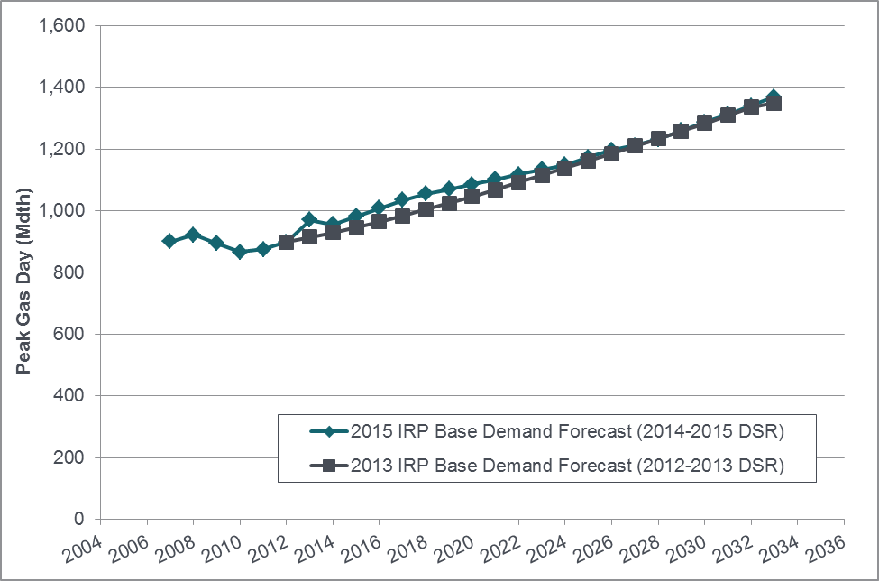



**System-level Impacts of Conservation.** As explained at the beginning of the chapter, the gas demand forecasts include only demand-side resources implemented through December 2015, since the demand forecast itself helps to determine the most cost-effective level of DSR to include in the portfolio. To examine the effects of conservation on the system load and peak forecasts, the full amount of DSR from the 2013 IRP is applied to the total system load and peak forecast for 2016 to 2035. This forecast is used internally at PSE for financial and system planning decisions.

When 2013 IRP DSR is applied:

* Total system load grows at an average annual rate of 0.9 percent from 2016 to 2025 and 1.5 percent from 2025 to 2035; volume (including transport classes) rises from 122,000 Mdth in 2016 to 154,000 Mdth in 2035. Load grows more slowly in the first half of the forecast because that’s when the majority of the demand-side measures are expected to be implemented.
* The design system peak is expected grow at an average annual rate of 1.5 percent from 2016 to 2025 and 2.0 percent from 2025 to 2035. Again, peak load grows more slowly in the first half of the forecast because that is when the majority of the demand-side measures are expected to be implemented.

The 2015 IRP DSR has a lower energy contribution but a higher peak contribution compared to the 2013 IRP DSR. So, if the Gas Base Demand Forecast (which represents annual energy need) were to be updated with the 2015 IRP DSR, we would expect the result to be higher than what is shown in Figure 5-35; and if the Gas Peak Day Base Demand Forecast were to be updated with 2015 IRP DSR, we would expect a result lower than what is shown in Figure 5-36.

Figure 5-35: 2015 IRP Gas Base Demand Forecast,

Before DSR and after applying 2013 IRP DSR

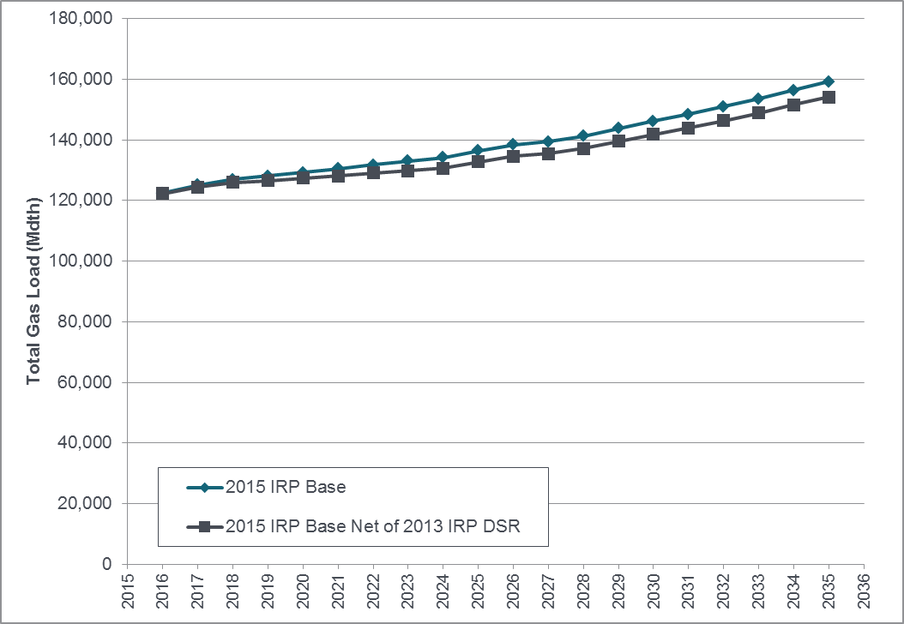



Figure 5-36: 2015 IRP Gas Peak Day Base Demand Forecast,

Before DSR and after applying 2013 IRP DSR

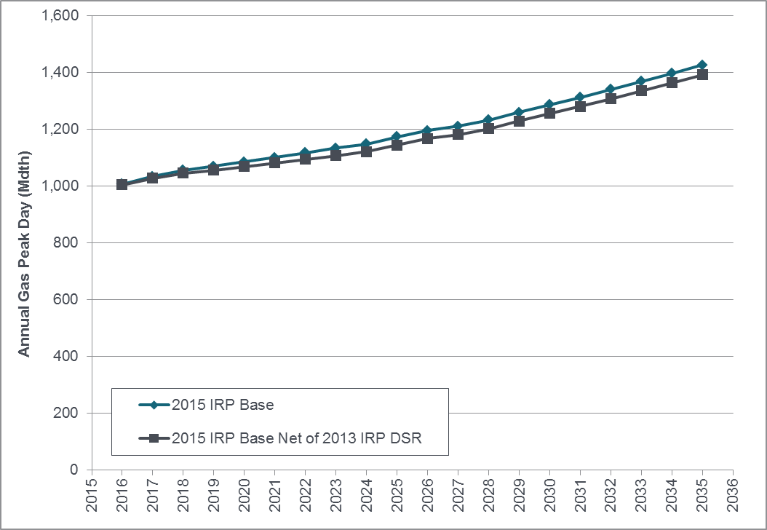



**Gas Customer Counts.** The Base Demand Forecast projects natural gas customer counts will increase at a rate of 1.9 percent per year on average between 2016 and 2035, reaching almost 1.2 million customers by the end of the forecast period for the system as a whole. A lower population forecast has resulted in a lower growth rate than the system growth rate of 2.3 percent projected in the 2013 IRP (2014 to 2033).

Residential customer counts drive the growth in total customers, since this class makes up 93 percent of PSE’s gas sales customers. The next largest group, commercial customers, is expected to grow at an annual rate of 1.6 percent from 2016 to 2035. Industrial and interruptible customer classes are expected to continue to shrink, consistent with historical trends.

Figure 5-37: December Gas Customer Counts by Class,   
from 2015 IRP Base Demand Forecast

|  |  |  |  |  |  |  |
| --- | --- | --- | --- | --- | --- | --- |
| **DECEMBER GAS CUSTOMER COUNTS  BY CLASS FROM 2015 IRP BASE DEMAND FORECAST** | | | | | | |
| **Customer Type** | **2016** | **2020** | **2025** | **2030** | **2035** | **AARG 2016-2035** |
| Residential | 763,406 | 819,348 | 893,618 | 988,150 | 1,095,795 | 1.9% |
| Commercial | 57,232 | 61,173 | 66,237 | 71,676 | 77,672 | 1.6% |
| Industrial | 2,306 | 2,189 | 2,050 | 1,920 | 1,798 | -1.3% |
| Total Firm | 822,944 | 882,711 | 961,906 | 1,061,746 | 1,175,266 | 1.9% |
| Interruptible | 283 | 248 | 217 | 193 | 175 | -2.5% |
| Total Firm & Interruptible | 823,227 | 882,959 | 962,123 | 1,061,939 | 1,175,441 | 1.9% |
| Transport | 208 | 208 | 208 | 208 | 208 | 0.0% |
| System Total | 823,435 | 883,167 | 962,331 | 1,062,147 | 1,175,649 | 1.9% |

**Gas Use per Customer.** Residential use per customer is relatively flat, showing a

-0.1 percent average annual growth for the forecast period. Commercial use per customer is expected to rise 0.4 percent annually over the forecast horizon. Industrial use per customer has been declining in recent years, but lower gas prices increase use somewhat, keeping industrial usage essentially flat.

Figure 5-38: Gas Use per Customer, 2015 IRP Gas Base Demand Forecast before DSR

|  |  |  |  |  |  |  |
| --- | --- | --- | --- | --- | --- | --- |
| **Use Per Customer (Therms) from 2015 IRP Gas Base Demand Forecast** | | | | | | |
| **Customer** | **2016** | **2020** | **2025** | **2030** | **2035** | **AARG 2016-2035** |
| Residential | 827 | 826 | 814 | 808 | 812 | -0.1% |
| Commercial | 4,920 | 5,021 | 5,110 | 5,211 | 5,346 | 0.4% |
| Industrial | 11,696 | 11,870 | 11,946 | 11,909 | 11,781 | 0.0% |

**Gas Load by Class.** Total system load, including transport load, is expected to increase at a rate of 1.4 percent annually between 2016 and 2035. Residential loads, which represent

51 percent of load in 2016, are expected to increase by 1.8% annually during the forecast period. Commercial loads, which represent 23 percent of 2016 load, are expected to increase 2.0 percent annually.

Population growth and electric-to-gas conversions are driving residential load growth. Commercial load growth is driven by increases in both customer counts and use per customer. Some sectors, among them industrial, interruptible and transport, are expected to decline slightly, continuing a more than decade-long trend of slowing manufacturing employment.

Figure 5-39: Gas Loads by Class (Mdth), 2015 IRP Gas Base Demand Forecast before DSR

|  |  |  |  |  |  |  |
| --- | --- | --- | --- | --- | --- | --- |
| **LOAD (Mdth) BY CLASS FROM 2015 IRP Gas BASE DEMAND FORECAST** | | | | | | |
| **Class** | **2016** | **2020** | **2025** | **2030** | **2035** | **AARG 2016-2035** |
| Residential | 62,694 | 67,192 | 72,215 | 79,167 | 88,098 | 1.8% |
| Commercial | 28,317 | 30,871 | 33,958 | 37,414 | 41,510 | 2.0% |
| Industrial | 2,729 | 2,631 | 2,480 | 2,317 | 2,148 | -1.3% |
| Total Firm | 93,741 | 100,694 | 108,653 | 118,897 | 131,756 | 1.8% |
| Interruptible | 4,698 | 4,627 | 4,445 | 4,309 | 4,272 | -0.5% |
| Total Firm and Interruptible | 98,439 | 105,322 | 113,098 | 123,206 | 136,029 | 1.7% |
| Transport | 23,064 | 22,842 | 22,219 | 21,772 | 21,835 | -0.3% |
| System total before losses | 121,503 | 128,164 | 135,316 | 144,979 | 157,863 | 1.4% |
| Losses | 980 | 1,034 | 1,091 | 1,169 | 1,273 | 1.4% |
| System Total | 122,483 | 129,198 | 136,408 | 146,148 | 159,137 | 1.4% |