<https://www.wsj.com/articles/some-shipping-lines-may-not-survive-downturn-hapag-lloyd-chief-says-11588612964?mod=djemlogistics_h>

Some Shipping Lines May Not Survive Downturn, Hapag-Lloyd Chief Says

Chief of Germany’s Hapag-Lloyd expects an uncertain recovery late this year and lots of pain until then

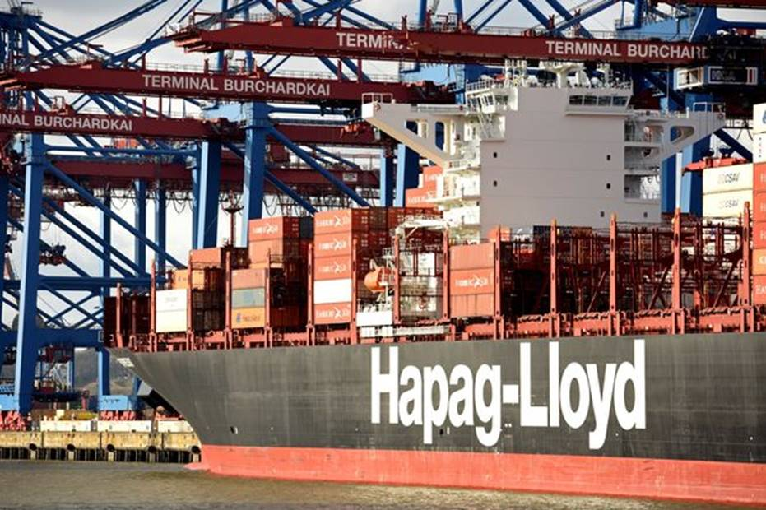

A Hapag Lloyd AG container ship is loaded at a shipping terminal in Hamburg, Germany, in 2017. Some container shipping companies may collapse if the global trade downturn stemming from coronavirus lockdowns extends to the end of the year or beyond, Hapag-Lloyd CEO Rolf Habben Jansen said.

bimmer/Reuters

By

Costas Paris

Some container shipping companies may collapse if the global trade downturn stemming from coronavirus lockdowns extends to the end of the year or beyond, the head of Germany’s biggest shipping company said.

“The shape of the recovery is very uncertain,” [Hapag-Lloyd](https://quotes.wsj.com/XE/XETR/HLAG) AG Chief Executive Rolf Habben Jansen, said in an interview. “We are cutting costs as much as we can to counter the missing volume and to have sufficient liquidity.”

The shipping lines that handle the biggest share of the world’s international trade in retail and manufactured goods have canceled up to a quarter of their sailings since late February amid extensive lockdowns and collapsing demand in the U.S. and Europe.

“In the last four weeks, volumes are under a lot of pressure,” Mr. Jansen said. “This will continue for the coming weeks, and hopefully from the third quarter there will be a slow but steady recovery. But it’s very difficult to predict at this point on whether it will come in July or in September.”

The world’s top 10 liner companies, which collectively handle more than three-quarters of the world’s oceangoing container trade, are looking at steep losses from the falling business, Mr. Jansen said.

“We are looking at a difficult second and third quarter. If a recovery starts in the third quarter, all the top 10 liners will be standing at the end of the year. If it’s going to take longer, then it may become more difficult for some” to survive, he said.

Germany’s Hapag-Lloyd, the world’s fifth-largest container line by capacity, according to industry data group Alphaliner, has canceled about 15% of its scheduled sailings on major ocean trade routes, including Asia-Europe and trans-Pacific operations.

The cancellations are adding to the turbulence in supply chains. Containers filled with goods have piled up at some ports and delivery of many shipments has slowed as carriers have curtailed operations to cut costs. Exporters in some Western countries are reporting shortages of containers as inbound trade has stalled, leaving them without boxes to repack and ship out.

“When you take out capacity, you take out entire services. If you are a customer, it creates difficulties,” Mr. Jansen said.

He said shipping lines have had to cope with sudden country closures that left cargo stranded on ships for extended periods and outbound cargoes sitting at warehouses and terminals.

“All of a sudden, India shut down. The cargo flows, particularly exports, came to a standstill. From one week to another, your volume goes down by more than half and there is a significant impact,” Mr. Jansen said.

He said about 20% of booked containers aren’t showing up at cargo terminals, making it difficult for carriers to plan, and the share of no-shows could grow to 35% to 40% in coming months. He expects companies to start stockpiling more goods to give themselves a buffer against the uncertainty in supply chains.

“Importers will henceforth take in a bit more inventory,” Mr. Jansen said. “Right now, most is just-in-time cargo and any disruption causes serious trouble.”

Some carriers are trying to preserve cash by taking longer trips around Africa instead of crossing the Suez Canal, saving on canal toll costs that can reach around $500,000 for a single big ship. With fuel prices sliding under the crash in oil prices, the cost of the longer sailing makes sense, Mr. Jansen said.

The Suez Canal Authority has introduced discounts ranging from 6% to 75%, depending on the route, to lure back customers.

Hapag-Lloyd has thousands of land-based employees working from home and has frozen management salaries and returned leased ships to charterers. It is not looking at layoffs for now.

But the carrier is pushing back an order of six megaships that move more than 20,000 containers each, to add to the six it already operates. Those megaships are the big losers with volumes crashing since many are sailing half full, giving up the benefits operators gain from the ships’ economies of scale.