**DOCKETS UE-120436 AND UG-120437 *(consolidated)* PAGE 9**

**ORDER 01**

**EXHIBIT B (EXPERT AGREEMENT)**

AGREEMENT CONCERNING CONFIDENTIAL INFORMATION IN DOCKETS UE-120436 AND UG-120437

BEFORE THE

WASHINGTON UTILITIES AND TRANSPORTATION COMMISSION

I, Ralph C. Cavanagh , as expert witness in this proceeding for NW Energy Coalition (a party to this proceeding) hereby agree to comply with and be bound by the Protective Order entered by the Washington Utilities and Transportation Commission in Dockets

UE-120436 and UG-120437 and acknowledge that I have reviewed the Protective

Order and fully understand its terms and conditions.

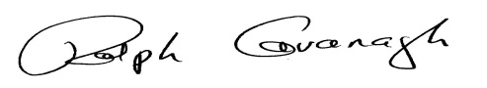

06/06/2012

Signature Date

Natural Resources Defense Council

Employer

111 Sutter Street, 20th Floor

San Francisco, California 94305 Energy Program Co-Director

Address Position and Responsibilities

* * *

The following portion is to be completed by the responding party and filed with the Commission within 10 days of receipt; failure to do so will constitute a waiver and the above-named person will be deemed an expert having access to Confidential Information under the terms and conditions of the protective order.

No objection.

Objection. The responding party objects to the above-named expert having access to Confidential Information. The objecting party shall file a motion setting forth the basis for objection and asking exclusion of the expert from access to

Confidential Information.

_ Signature Date