February 13, 2015

VIA U.S. MAIL AND EMAIL

Steven King – Executive Director/Secretary

Washington Utilities and Transportation Commission

1300 S. Evergreen Park Drive S.W.

P.O. Box 47250

Olympia, WA 98504-7250

**RE: PREFILED TESTIMONY FOR TR-140382 and TR-14083**

Dear Director King:

Enclosed please find an original and three copies of the following document for each above-referenced docket/matter number:

* PREFILED TESTIMONY OF JOHNSON MENINICK

The documents, including this cover letter, have also been submitted electronically, and copies have been sent to all interested parties via electronic mail and U.S. Mail, and to the presiding administrative law judge via electronic mail.

Sincerely yours,

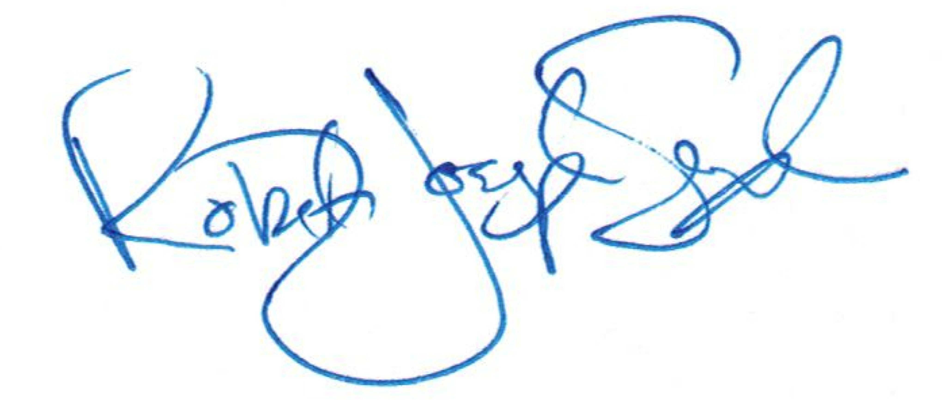

R. Joseph Sexton

Attorney at Law

[joe@galandabroadman.com](mailto:joe@galandabroadman.com)

Enclosures: Original Prefiled Testimony w/ Copies

cc: Yakama Nation Office of Legal Counsel