GAS ANALYSIS

Contents

**O-2. ANALYTICAL MODEL**

* Sendout
* Resource Alternatives Assumptions
* Scenarios and Sensitivities Analyzed

**O-7. ANALYSIS RESULTS**

**O-22. PORTFOLIO DELIVERED   
 GAS COSTS**

This appendix presents details of the methods and model employed in PSE’s gas sales resource analysis, and the data produced by that analysis.

**ANALYTICAL MODEL**

To model gas resources and alternatives for both long-term planning and gas resource acquisition activities, PSE uses a gas portfolio model (GPM). The GPM used in this IRP is SENDOUT® from ABB, a widely used software tool that helps identify the long-term least-cost combination of resources to meet stated loads. Other regional utilities that provide natural gas services, such as Avista, Cascade Natural Gas, and FortisBC, use the SENDOUT model. SENDOUT Version 14.2.0 was used for this analysis.

SENDOUT

SENDOUT is an integrated tool set for gas resource analysis thatmodels the gas supply network and the portfolio of supply, storage, transportation and demand-side resources (DSR) to meet demand requirements.

SENDOUTcan operate in two modes: For a defined planning period, it can determine the optimal set of resources to minimize costs; or, for a defined portfolio, it can determine the least-cost dispatch to meet demand requirements for that portfolio. SENDOUTsolves both problems using a linear program (LP) todetermine how a portfolio of resources (energy efficiency, supply, storage and transport), including associated costs and contractual or physical constraints, should be added and dispatched to meet demand in a least-cost fashion. The linear programconsiders thousands of variables and evaluates tens of thousands of possible solutions in order to generate a solution. A standard planning-period dispatch considers the capacity level of all resources as given, and therefore performs a variable-cost dispatch. A resource-mix dispatch can look at a range of potential capacity and size resources, including their fixed and variable costs.

**Demand-side Resources (Energy Efficiency).** SENDOUTprovides a comprehensive set of inputs to model a variety of energy efficiency programs. Costs can be modeled at an overall program level or broken down into a variety of detailed accounts. The impact of efficiency programs on load can be modeled at the same detail level as demand. SENDOUThas the ability to determine the most cost-effective size of energy efficiency programs on an integrated basis with supply-side alternatives in a long-run resource mix analysis.

**Gas Supply.** SENDOUT allows a system to be supplied by either long-term gas contracts or short-term spot market purchases. Specific physical and contractual constraints can be modeled on a daily, monthly, seasonal or annual basis, such as maximum flow levels and minimum flow percentages. SENDOUTuses standard gas contract costs; the rates may be changed on a monthly or daily basis.

**Storage.** SENDOUT allows storage sources (either leased or company-owned) to serve the system. Storage input data include the minimum or maximum inventory levels, minimum or maximum injection and withdrawal rates, injection and withdrawal fuel loss, to and from interconnects, and the period of activity (i.e., when the gas is available for injection or withdrawal). There is also the option to define and name volume-dependent injection and withdrawal percentage tables (ratchets), which can be applied to one or more storage sources.

**Transportation.** SENDOUTprovides the means to model transportation segments to define flows, costs and fuel loss. Flow values include minimum and maximum daily quantities available for sale to gas markets or for release. Cost values include standard fixed and variable transportation rates, as well as a per-unit cost generated for released capacity. Seasonal transportation contracts can also be modeled.

**Demand.** SENDOUT allows the user to define multiple demand areas and it can compute a demand forecast by class based on weather. The demand input is segregated into two components: 1) base load, which is not weather dependent, and 2) heat load, which is weather dependent. Both factors are further computed as a function of customer counts. The heat load factor is estimated by dividing the remaining non-base portion of the load by historical monthly average heating degree days (HDD) and monthly forecasted customer counts to derive energy per HDD per customer.  The demand is input into SENDOUT on a monthly basis and includes the customer forecast, the baseload factors and the heat load factors computed over the entire 20-year demand forecast period.

As discussed, the gas system load is dependent on the weather pattern. The 2015 IRP used the most recent 30 years of data ending in 2014 to estimate the historical normal HDDs for each month. This monthly average HDD was then used to find an actual month that most closely matches this average. (Using an actual month produces a better distribution of daily temperatures for the representative month than simply using daily average temperatures.) In this way, months were selected to match the monthly average HDDs and a 12-month weather year was constructed for use in the IRP study. Finally, the gas analysis uses a design day peak standard of 52 HDD.[1] This design peak day demand value is manually inserted into the historical peak month, which is December for this 2015 IRP.Resource Alternatives Assumptions

Figure O-1 summarizes resource costs and modeling assumptions for the pipeline alternatives considered in the IRP, and Figure O-2 summarizes resource costs and modeling assumptions for storage alternatives.

Figure O-1: Prospective Pipeline Alternatives Available

|  |  |  |  |  |  |  |  |  |
| --- | --- | --- | --- | --- | --- | --- | --- | --- |
| **Alt**  **No.** | **Alternative** | **From/To** | **Years Available beginning October** | **Maximum Capacity Available in Sendout (MDth per Day)** | **Capacity Demand  ($ per Dth per Day)** | **Variable Commodity ($ per Dth per Day)** | **Fuel Use  (%)** | **Comments** |
|  |  |  |  |  |  |  |  |  |
| 1A | Short Term NWP TF-1 | Sumas to PSE | 2016 - 2018 | 100 | 0.56 | 0.03 | 1.9 | Potential available in marketplace from third parties from 2016-2018. |
| 1 | Westcoast + NWP Expansions | Station 2 to PSE | 2018, 2022, 2026 and 2030 | 400 in 2018, 2022, 2026;  500 in 2030 | 0.52 + 0.56 | 0.01 + 0.03 | 1.6 + 1.9 | Westcoast expansion coupled with NWP. Expansion expected to be available 2018 at the earliest. |
| 2 | FortisBC / Westcoast (KORP) + NWP Expansions | Kingsgate to PSE via Sumas | 2018, 2022, 2026 and 2030 | 50 in 2018, 2022;  100 in 2026, 2030 | 0.42 + 0.56 | 0.01 + 0.03 | 1.0 + 1.4 | Prospective projects & estimated project cost - expected to be available 2018 at the earliest.  (Requires NGTL and Foothills pipelines.) |
| 3 | NGTL (Nova) Pipeline | AECO to Alberta / BC border | 2018, 2022, 2026 and 2030 | 100 in 2018, 2022; 200 in 2026, 2030 | 0.16 | 0 | 0 | Prospective projects & estimated project cost - expected to be available 2018 at the earliest. |
| 3 | Foothills Pipeline | Alberta / BC Border to Kingsgate | 2018, 2022, 2026 and 2030 | 100 in 2018, 2022; 200 in 2026, 2030 | 0.097 | 0 | 1.0 | Uncontracted capacity is available.  (Requires NGTL.) |
| 3 | GTN Pipeline | Kingsgate to Stanfield | 2018, 2022, 2026 and 2030 | 100 | 0.177 | 0.044 | 1.4 | Uncontracted capacity is available.  (Requires NGTL and Foothills pipelines.) |
| 3 & 4 | Cross Cascades | Stanfield to PSE | 2018, 2022, 2026 and 2030 | 150 | 0.80 | 0.005 | 2.0 | Prospective project & estimated project cost - expected available 2018 at the earliest. (Requires GTN Backhaul or NGTL/Foothills/GTN.) |
| 4 | Ruby Pipeline | Opal to Malin | 2018,2022,2026 and 2030 | 100 | 0.15 | 0 | 2.0 | Published tariff is $1.14 but discounted rates are expected to be available for several years. |
| 4 | GTN "Backhaul" | Malin to Stanfield | 2018,2022,2026 and 2030 | 100 | 0.21 | 0.005 | 0 | Uncontracted capacity is available. |
| 6 | Mist | Mist Storage to PSE | 2018,2022,2026 and 2030 | 50 | 0.56 | .03 | 1.9 | Expansion on NWP for delivery of gas from Mist Storage |

Figure O-2: Prospective Storage Alternatives Available

|  |  |  |  |  |  |  |  |  |
| --- | --- | --- | --- | --- | --- | --- | --- | --- |
| **Alt No.** | **Alternative** | **Location** | **Years Storage Capacity Estimated to be Available** | **Storage Capacity (MDth)** | **Maximum Withdrawal Capacity (MDth per day)** | **Days of Full Withdrawal (days)** | **Max. Injection Capacity (MDth per day)** | **Comments** |
|  |  |  |  |  |  |  |  |  |
| 5 | PSE LNG Project  (PSE portion) (1) | PSE System | winter 2018-19 | 538 | 66 | 8.2 | 2 | Prospective confidential project, estimated size and costs |
| 5 | LNG Peak Gas Supply | PSE System | winter 2020-21 | - | 19 | - | - | Only available with PSE LNG Project |
| 6 | Mist Expansion (1) | Portland, OR | winter 2018-19 | 1000 | 50 | 20 | 22.5 | PSE to lease storage capacity from NW Natural after an expansion of the Mist storage facility |
| 7 | Swarr | PSE System | Winter 2016-2017 | 90 | 30 | 3 | - | Existing plant requiring upgrades |

*NOTE*

*1 Prospective confidential project, estimated size and costs.*

Scenarios and Sensitivities Analyzed

Ten scenarios were analyzed for the gas sales portfolio using the SENDOUT model. The assumptions used to create those scenarios are described in detail in Chapter 4, Key Analytical Assumptions, and summarized briefly below in Figure O-3.

*Figure O-3: 2015 IRP Scenarios*

|  |  |  |  |  |
| --- | --- | --- | --- | --- |
|  | **Scenario Name** | **Gas Price** | **CO2 Price** | **Demand** |
| 1 | Low Scenario | Low | None | Low |
| 2 | Base Scenario | Mid | Mid | Mid |
| 3 | High Scenario | High | High | High |
| 4 | Base + Low Gas Price | Low | Mid | Mid |
| 5 | Base + High Gas Price | High | Mid | Mid |
| 6 | Base + Very High Gas Price | Very High | Mid | Mid |
| 7 | Base + No CO2 | Mid | None | Mid |
| 8 | Base + High CO2 | Mid | High | Mid |
| 9 | Base + Low Demand | Mid | Mid | Low |
| 10 | Base + High Demand | Mid | Mid | High |

Two sensitivity analyses were also run through the SENDOUT model to isolate the effect a single resource has on the portfolio:

**Alternate Discount Rate.** This sensitivity tests the cost-effective amount of DSR in the Base Scenario using an alternate discount rate to model the value of demand-side resources over time. It compares the use of PSE’s assigned weighted average cost of capital of 7.77 percent with an alternate discount rate of 4.93 percent.

**Pipeline Timing.** This sensitivity tests whether smoothing out pipeline capacity expansion changes the lowest cost portfolio in the Base Scenario. Instead of being restricted to every four years, pipeline additions are allowed annually.

**ANALYSIS RESULTS**

The optimal portfolios of supply- and demand-side resources for each of the scenarios and sensitivities were identified using SENDOUT. The cumulative resources added in each of the gas sales scenarios for the winter periods 2018-19, 2022-23, 2026-27, 2030-31 and 2032-33 are shown in Figures O-4 through O-8. Graphs of the resource additions for each of the scenarios are shown in Figures O-9 thru O-18. Resource additions for the each of the two sensitivities are shown in Figures O-19 and O-20.

Figure O-4: Gas Sales Scenario Cumulative Resource Additions for 2018-19 (MDth/day)

Figure O-5: Gas Sales Scenario Cumulative Resource Additions for 2022-23 (MDth/day)

Figure O-6: Gas Sales Scenario Cumulative Resource Additions for 2026-27 (MDth/day)

Figure O-7: Gas Sales Scenario Cumulative Resource Additions for 2030-31 (MDth/day)

Figure O-8: Gas Sales Scenario Cumulative Resource Additions for 2034-35 (MDth/day)

Figure O-9: Base Scenario Optimal Portfolio – Gas Sales

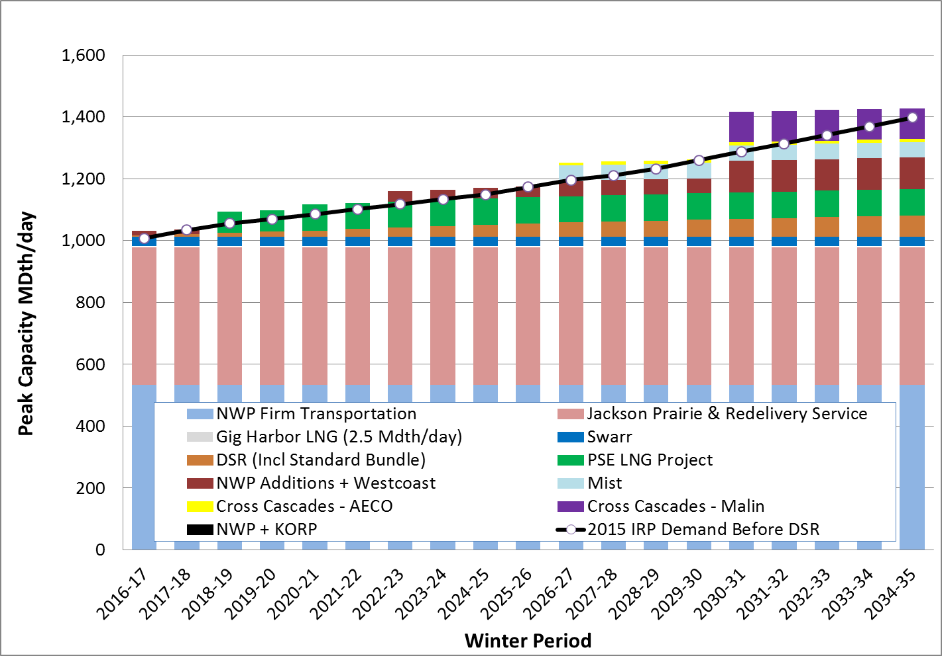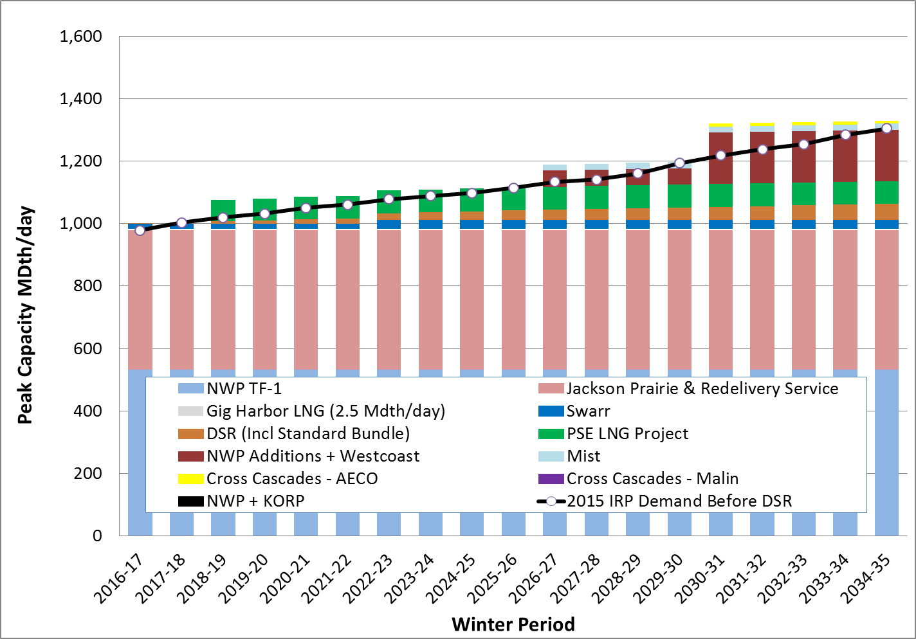Figure O-10: Low Scenario Optimal Portfolio – Gas Sales

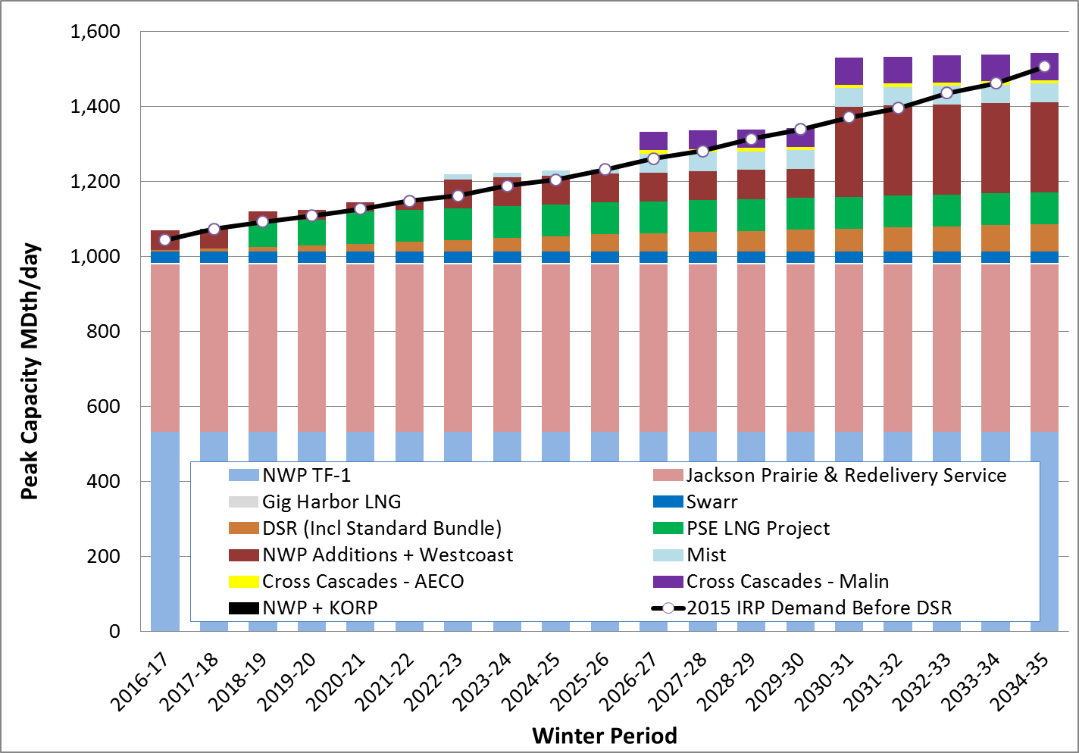Figure O-11: High Scenario Optimal Portfolio – Gas Sales

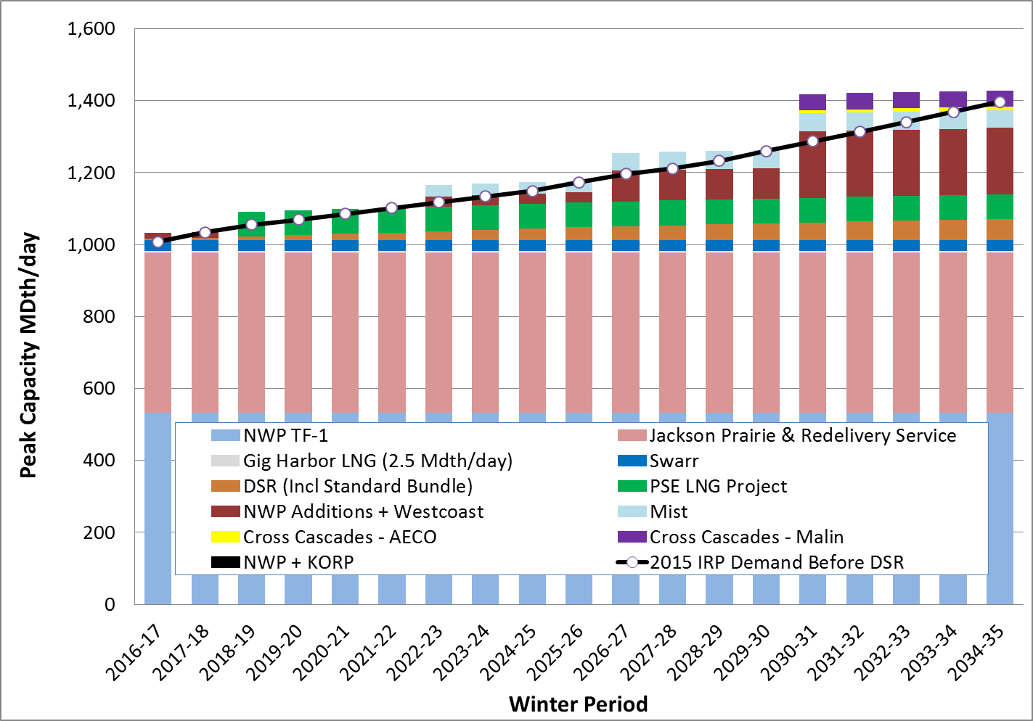Figure O-12: Base + Low Gas Price Optimal Portfolio – Gas Sales

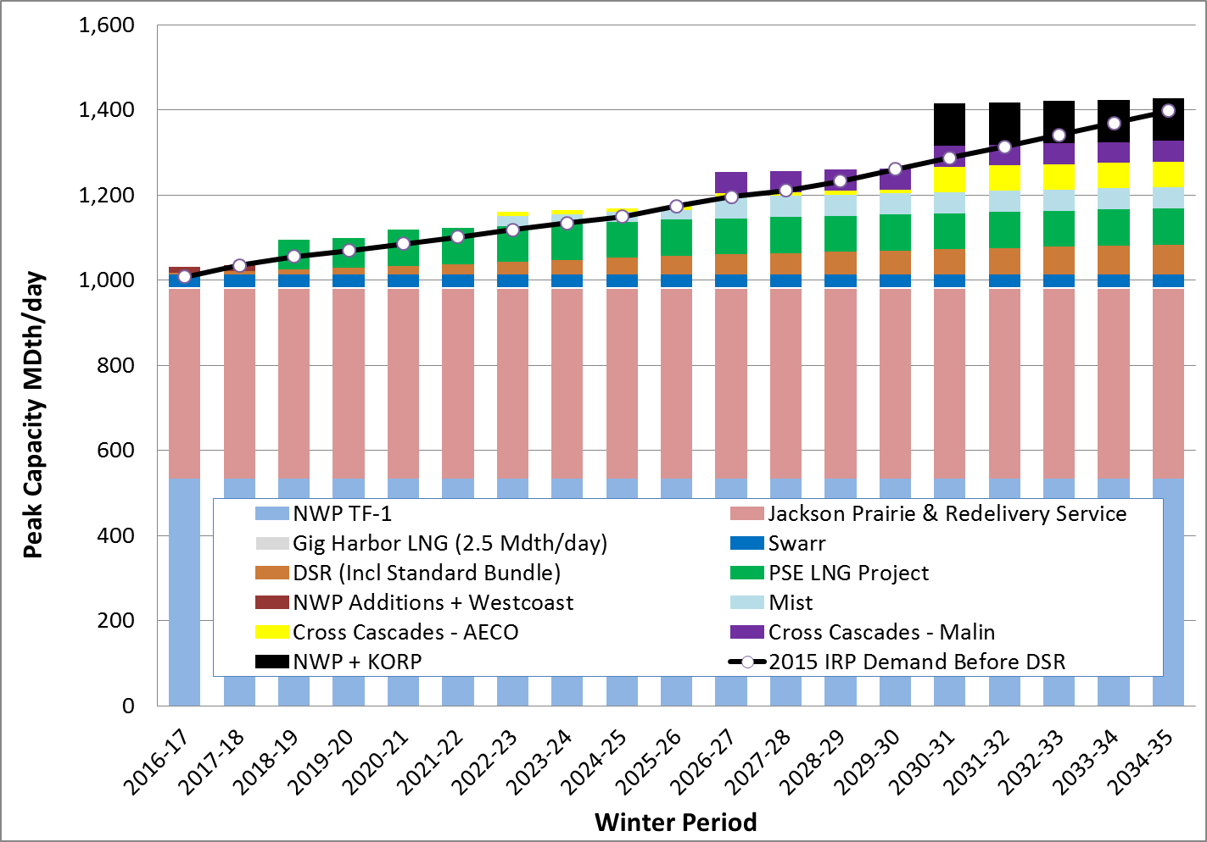Figure O-13: Base + High Gas Price Scenario Optimal Portfolio – Gas Sales

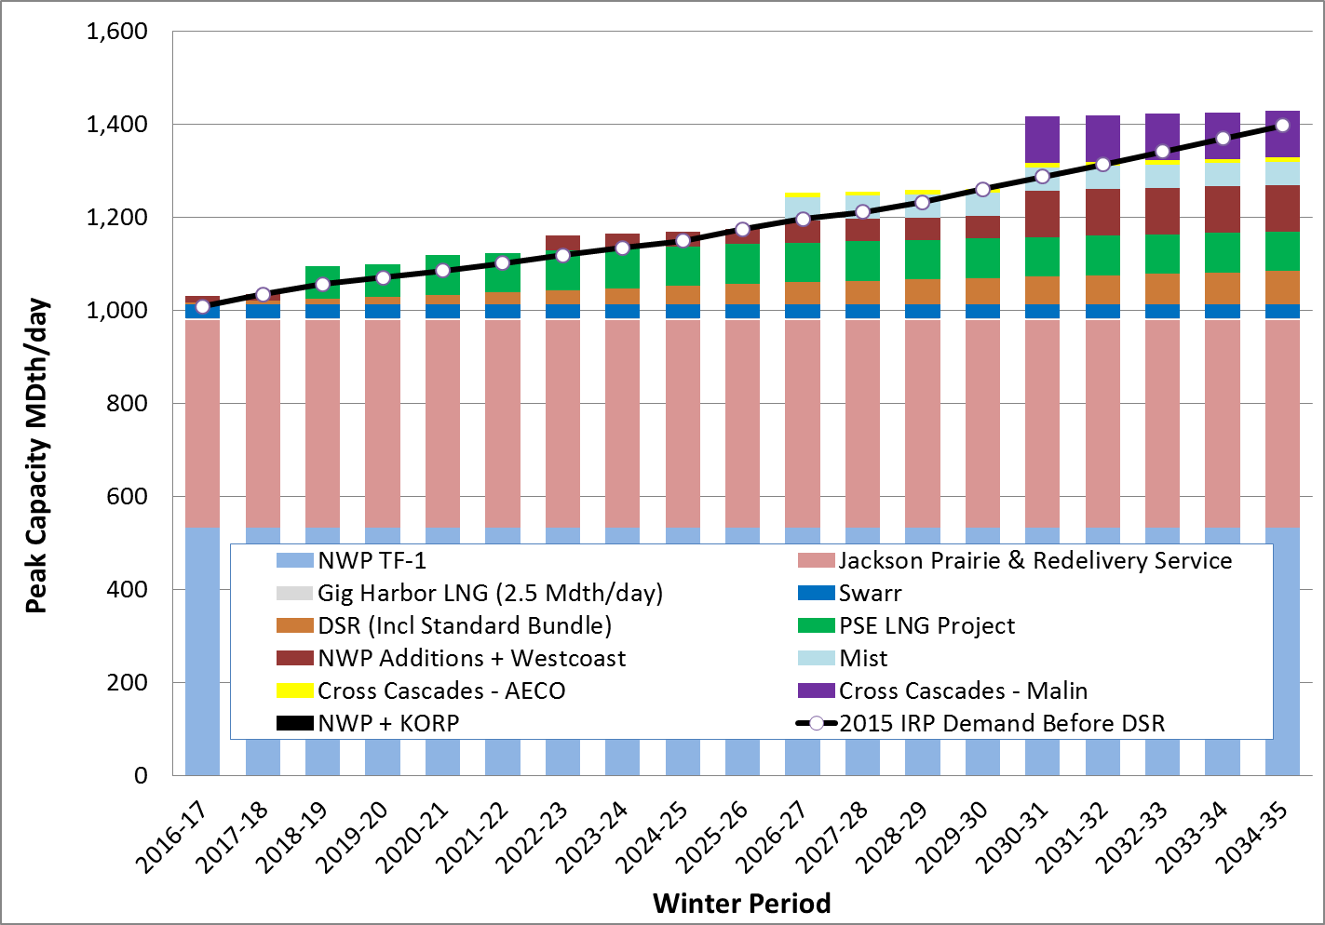Figure O-14: Base + Very High Gas Price Optimal Portfolio – Gas Sales

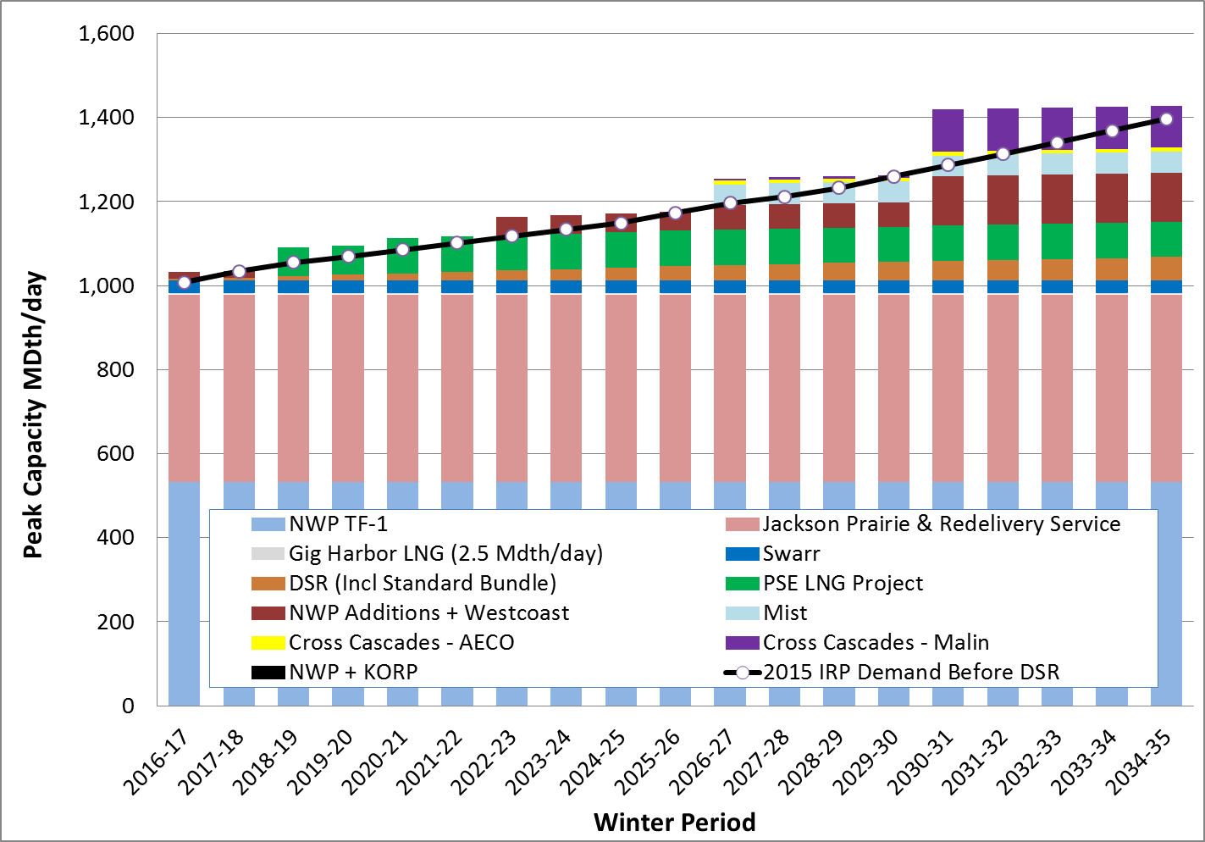Figure O-15: Base + No CO2 Optimal Portfolio – Gas Sales

Figure O-16: Base + High CO2 Optimal Portfolio – Gas Sales

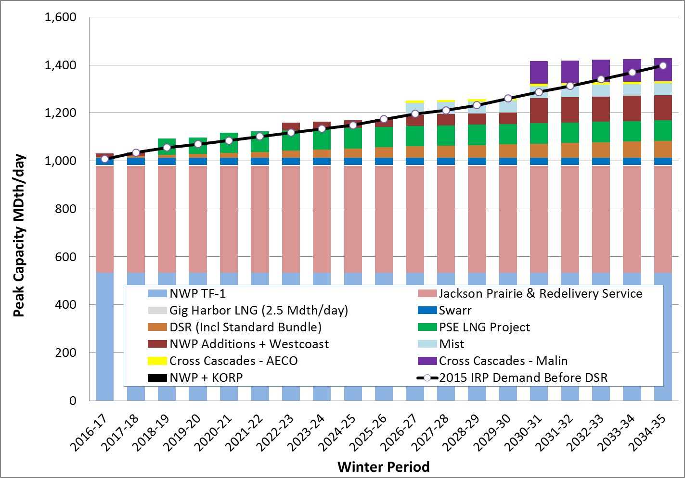

Figure O-17: Base + Low Demand Optimal Portfolio – Gas Sales

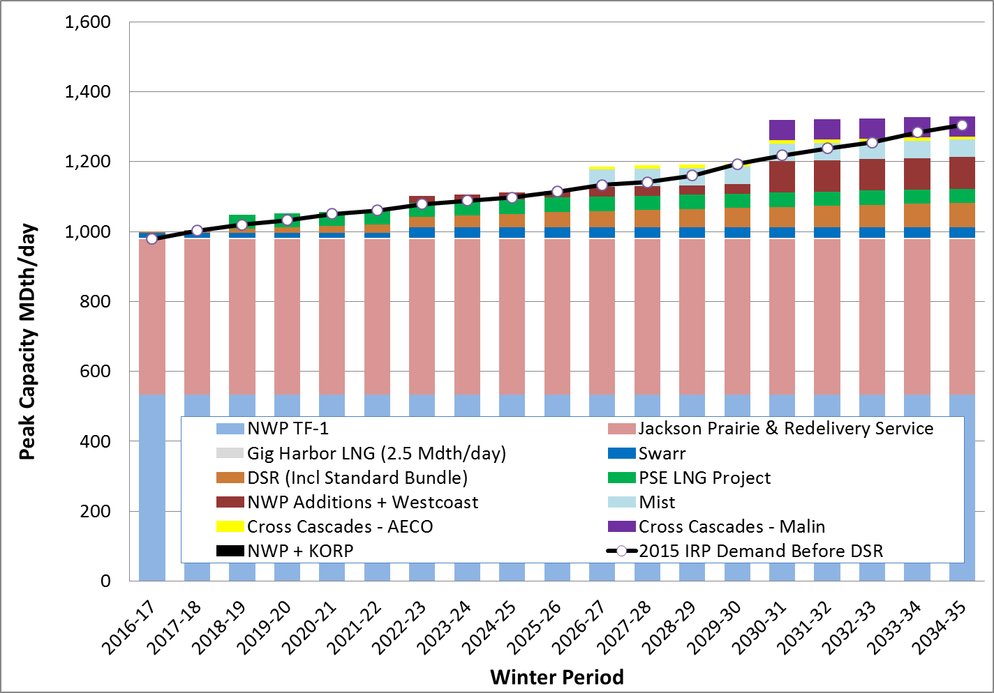

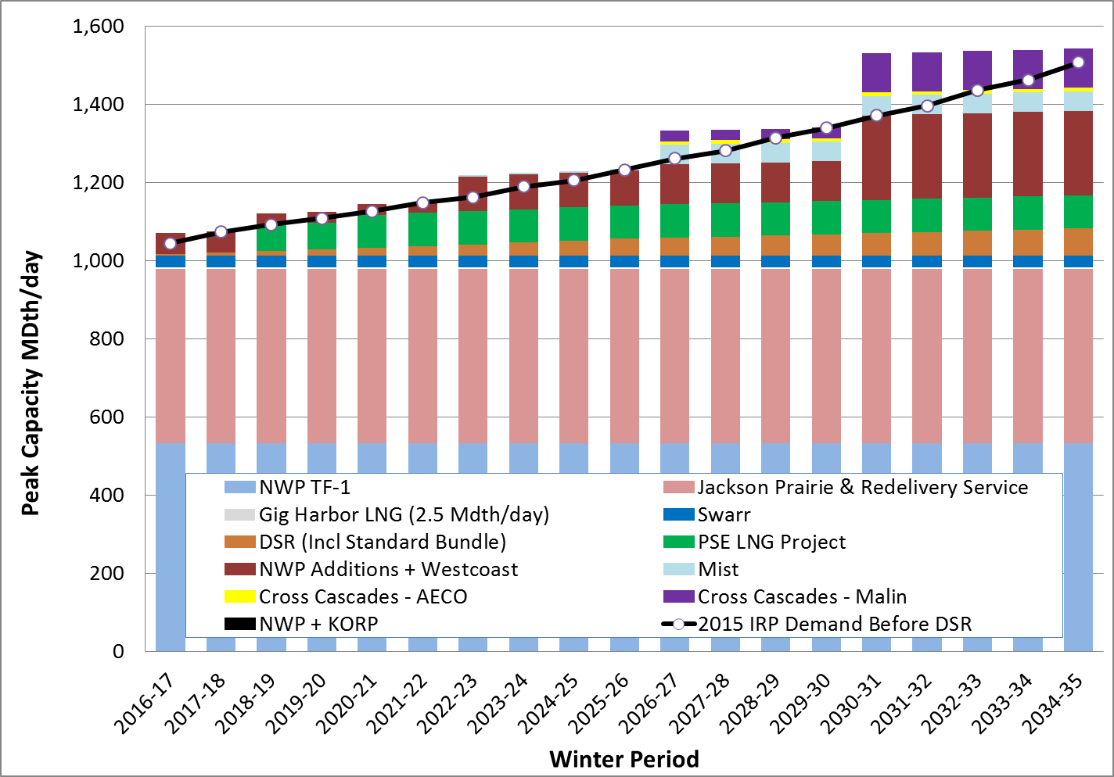Figure O-18: Base + High Demand Optimal Portfolio – Gas Sales

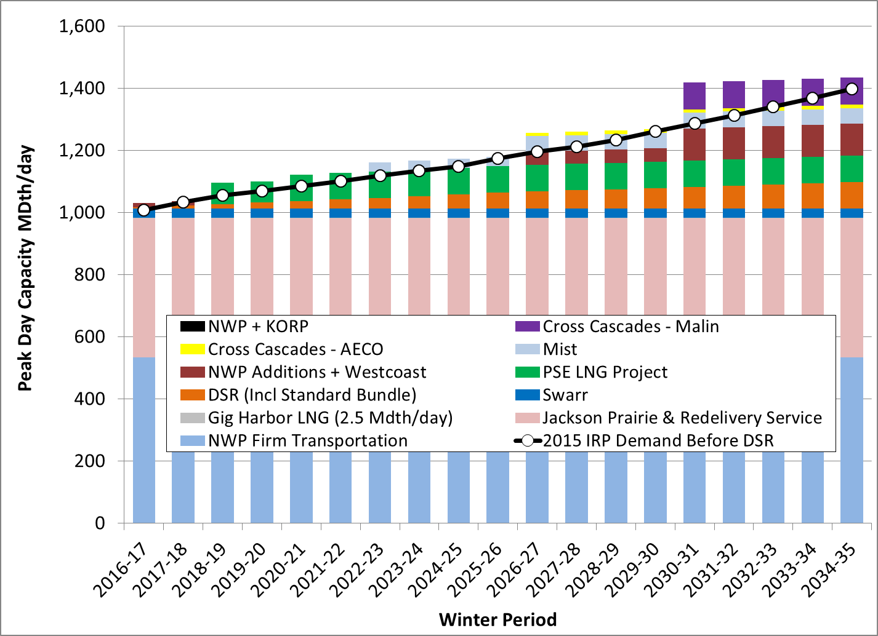Figure O-19: Alternate Discount Rate Sensitivity

Gas Sales Cumulative Resource Additions (MDth/day)

Figure O-20: Pipeline Timing Sensitivity

Gas Sales Cumulative Resource Additions (MDth/day)

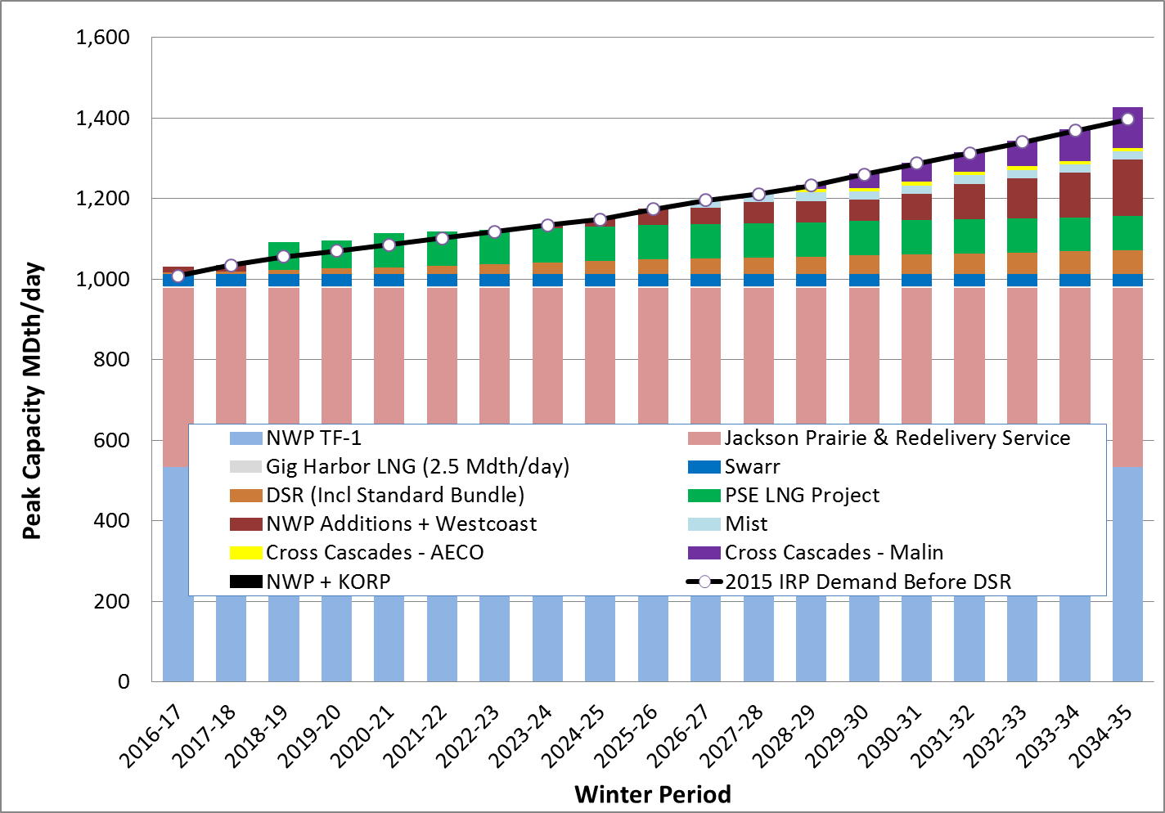

**PortfoliO DELIVERED Gas Costs**

The average delivered portfolio cost for the gas sales scenarios are shown graphically in Chapter 7. They are presented below in tabular form in Figure O-21. Note however, these costs represent the cost of gas delivered to PSE’s system; they do not include distribution system costs.

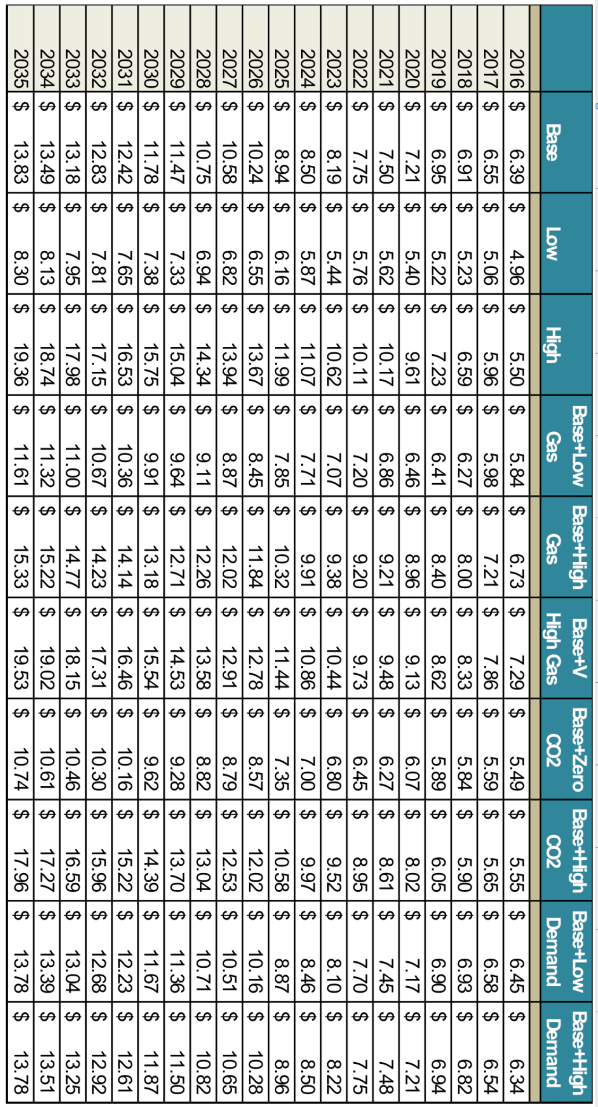Figure O-21: Portfolio Delivered Gas Costs - ($/Dth)

1. / The design day peak standard of 52 Heating Degree Days was established in PSE’s 2005 IRP, Appendix I, Gas Planning Standard.