**FlexCharging, Inc.**

**Comments on Docket UE-180877: Puget Sound Energy’s EV charging pilot projects**

November 18, 2018

FlexCharging is generally supportive of PSE’s EV pilot projects. They have a wide range of programs that should cover many bases, and the programs intend to smartly test human charging behavior in the absence of time-of-use rates.  However, FlexCharging has some deep concerns as well.  We all want to see the residential EV pilot programs be as effective, informative & relevant as possible.  Additionally, the public charging program has some issues around cost, equipment type and location that need to be thought through. Demand charges for DC fast chargers should be eliminated.

# Residential EV Charging Program Comments

**Keeping the Residential EV Charging Program Relevant**

Our biggest concern is that they may be not collecting a wide enough amount of data in the best way possible.  My fear is they’ll come back in a few years with data on a commercially uninteresting subset of the EV population, and the UTC will be disappointed.  The residential charging program’s ability to successfully test human behavior depends on getting the right vehicle owners to join, and that requires getting a suitably high-power charging station and/or the right monitoring solution.  PSE should:

1. Increase their reliance on vehicle telematics as a proportion of the fleet they monitor.
2. Evaluate their smart chargers to ensure they are not reducing charging capacity for residential pilot participants, or they won’t get uptake from the right customers.
   1. If they re-poll the market, they may find that certain vehicle telematics are cheaper than buying & installing the higher-power EVSE that they would otherwise need.

For their residential EV charging program, they’re looking at focusing on smart EVSE.  That’s an adequate approach for cars that require an EVSE installed in a garage, and that is almost all models on the market today.  However, it may not be the best or only approach.

Tesla owners typically have a NEMA 14-50 outlet in their garage, and no dedicated EV charging station.  Many Tesla vehicles can charge at 9.6 kW, and some at 19.2 kW (using a high-amperage L2 charger). If PSE is offering residential chargers with a lower power (like 6.6 kW), I don’t think they will get the right uptake among Tesla drivers. Supporting this higher charging power drives up the cost of the EVSE, but is necessary if PSE is going to rely on smart charging stations to implement the program. I suggest that a vehicle telematics based solution might be cheaper than paying for and installing higher power EVSE.

We should place an immense emphasis on Tesla vehicles for two reasons:

1. Tesla EV’s are seeing a huge amount of growth in PSE’s service territory, due to the Model 3.
   1. Tesla is delivering often ~50 vehicles per day in Bellevue & Redmond, in the heart of PSE’s service territory.
   2. FlexCharging estimates is Tesla’s are 30% of the BEV’s in PSE’s service territory. Here is state-wide BEV data from WA DoT:

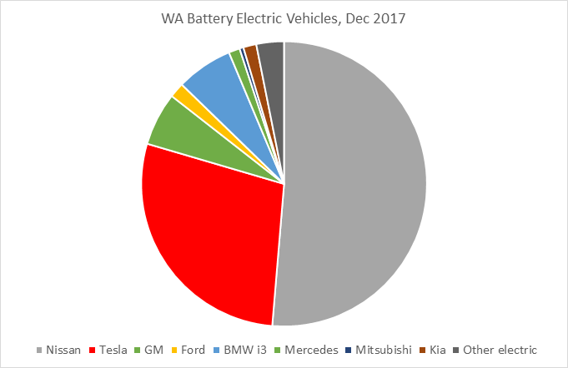

But if you look at an annualized growth in number of cars per manufacturer, which ones are growing the most?

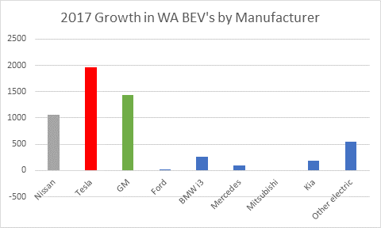

This is ***before*** the Model 3 made a substantial impact.  Here is Tesla’s exponential growth curve, with noticeable acceleration in Q3 of this year.[1]



Anecdotally, I estimate 4% of all cars at Microsoft are Teslas, and this is growing every month.

1. We need to analyze long-range BEV’s coupled with a DC fast charging network, so we are looking at what the industry will be producing over the next several years.  What Tesla is doing now, the rest of the auto industry will be doing a few years later.
   1. Matt Stevens (CEO of FleetCarma) observed that long-range BEV’s are a different class of vehicle than many of the shorter-range EV’s on the roads today.  Old data indicated 90% of charging happened at home.  In a recent study done for SRP, FleetCarma observed 32% of charging for long-range BEV’s was done away from home.  “EV data from 2014 has expired.”[2]
   2. Shorter-range EV’s are good for commuting, but often are barely capable of inter-city travel.  If PSE’s residential program attracts primarily Nissan Leaf drivers and a smattering of other short-range EV’s or hybrids, the study won’t provide enough insight into what’s really going on with the cars we care about by the end of the pilot project.
   3. We observed long range EV drivers often don’t charge up their vehicle every night, even though they trivially could.

Vehicle telematics can build a much more accurate picture of EV charging behavior, since it can capture charging at home, work, in various public places, and inter-city travel, in addition to other factors like how far & fast a car drove.  All of those other charging locations indirectly impact how much charging will happen at home, and FleetCarma’s data shows this is substantial.  A viable DC fast charging network changes behavior, as does having a car capable of driving long distances with recharging times on par with a fast food stop.

**Will Incentives Create a Third Peak?**

The Residential EV pilot’s goal of testing human behavior is good. Specifically, the pilot presents a new problem, and hopefully will be able to answer it. A predictable response to being told to charge at a certain time of night is that everyone will charge at exactly that time of night. The Salt River Project noticed that at their off-peak charging time, many EV’s start charging simultaneously. The utility has finite ramp capacity, and as the number of EV’s grow over time, this could present a large problem. PSE should be able to report on this whenever reporting results from the pilot.

**New Treatment Group: Smart Phone App-based Load Shifting Solution**

In addition to testing human behavior in response to incentives, PSE should consider adding another experimental group to their residential charging program.  For load management, this is a great place to use software to shift charging to off-peak hours.  PSE could test this by using a load shifting technology, giving drivers a way to override it, and measure how frequently drivers let the utility shift load.  This can’t be done via a “smart meter” effectively, because you need to respect the driver’s preferences as well as provide an override switch.  This can be done through a vehicle telematics solution.  Additionally, a system could smooth out the ramp rate when vehicles start charging. FlexCharging has been operating this exact type of system for a year on a growing fleet of Teslas.

It may prove cheaper to incentivize drivers to use a mobile app-based solution than to install smart chargers, or to pay large financial incentives to drivers in the hopes that drivers rearrange their lives around their utility’s needs.  Since the default option would be load shifting at home, compliance would be the default, and may be substantially higher than other incentives that require human interaction.  All this complexity can be hidden from drivers though software.  And if a solution like this works, over the long run a utility can get a higher value from a solution like this, since car charging could be shifted not just to say 10 PM, but to almost any time of the night, subject to the vehicle’s time needed to charge & driver constraints.

**Selecting Multiple Monitoring Technologies**

PSE intends to include vehicle telematics and/or EPRI’s Open Vehicle Grid Integration Platform for a small number of vehicles as part of their residential program.  This is good, but they should use telematics for a larger portion of their fleet.  Also at this stage, it makes sense to invest in multiple approaches for a pilot project.  The truth is the current solutions are less than perfect on one of these axes:

1. Completeness
2. Rich detail about vehicle & driver behavior
3. Respecting drivers’ needs
4. Cost

Every solution has different strengths & weaknesses, and some solutions address a commercially interesting subset of vehicles.

EPRI and FlexCharging are exploring ways to collaborate to make OVGIP more commercially relevant by leveraging FlexCharging’s ability to collect data from Tesla vehicles.  EPRI & FlexCharging are also in initial conversations about a large scale EV data collection pilot project.  Perhaps PSE’s residential charging pilot could align with this program.

There aren’t many other options in this space currently. I discussed Android Auto’s capabilities with one of their engineering managers.  Google has no solution;  they are focused on entertainment and their own workplace charging.

When PSE looks at vehicle telematics choices for their residential program, I believe PSE should re-evaluate the vehicle telematics market.  New companies may have incorporated that didn’t exist when PSE gathered pricing information several years ago.  The quality of PSE’s residential EV program will be vastly improved by working with any vehicle telematics partner.  And the larger the share devoted to telematics, the better.

**Avoided Costs of Distribution, Transmission, and Generation System Upgrades**

PSE has displayed some numbers showing the avoided costs from their EV charging program, but some of these were hard to square up with similar numbers from the previous IRP. I realize there is a chunkiness to system upgrades, and I think this explains the difference. However, the IRP is also capable of ascribing a per kW-yr value to conservation activities. Load shifting seems like it should also be measurable on a per kW-yr basis. Specifically, even if a cost isn’t avoided in a ~3 year window for the pilot, if the number of EV’s was scaled up, we should be able to get a meaningful estimate for what the value of EV conservation measures should be.

While the pilot projects are not intended to be least cost and shouldn’t be held to a strict cost test for whether to build or not build, it would be helpful if PSE’s reports at the end provided some insight into both actual avoided costs, and projected avoided costs for a large number of EV’s in a large area like a city, or perhaps even on a neighborhood distribution grid feeder.

Perhaps the pilot project and the Integrated Resource Plan need to do some information sharing here, and perhaps those numbers are best included in the IRP. But it would be helpful to see what assumptions are produced by the pilot project.

# Public Charging Program Feedback

It’s interesting to see PSE’s take on *where* to invest in public charging. Our state has two needs: some type of charging solution for apartment dwellers in dense urban cores, and a state-wide DC fast charging network for inter-city driving. We could benefit from something like Portland’s “Electric Avenue” built in downtown Bellevue or Redmond. At the same time, we need DC fast chargers in towns like Cle Elum to enable travel across the Cascades and act as a bridge to Leavenworth, Wenatchee & Chelan. I’m glad PSE may be exploring both angles.

I cannot predict whether charging for commuter cars within a city or whether allowing inter-state electric transportation will provide a larger transformation. My guess was on the second, but that assumed most of the vehicles would be long-range BEV’s in the first place with adequate home charging. It looks like that may be the case based on the cars coming out in the next few years, however experimenting with some urban charging solution is still a good idea.

I think focusing on a few DC fast charging locations first is a great start. If PSE were to start designing a complete DC fast charging network instead of building just a few pilot locations, I suggest they take some hints from Tesla’s existing Supercharger locations in Washington (red = existing, grey = planned).

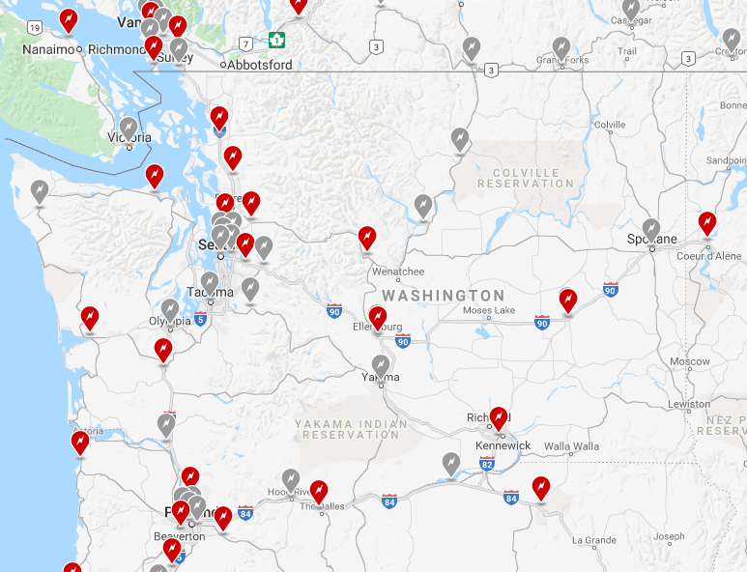

In the future, this program could be augmented with high-amperage L2 charging stations (capable of charging at 19.2 kW) at hotels, small-town central business districts, wineries and other destinations throughout the state. For comparison, Tesla does have a Destination Charging program, with high-amperage L2 chargers in all of these locations:[3]

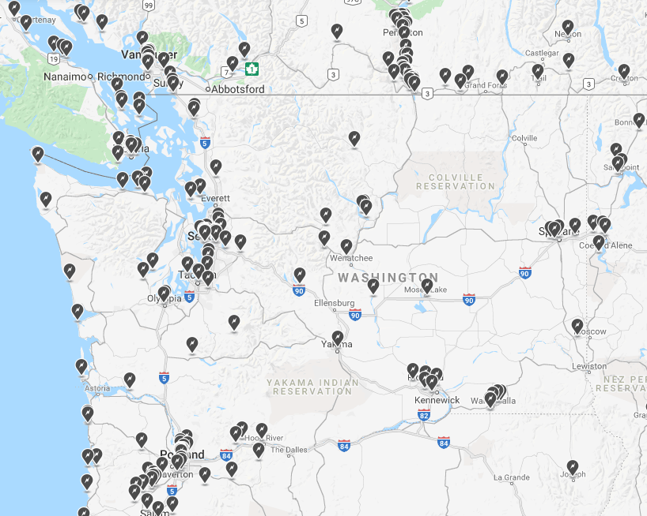

The DC fast charging network must exist, but the destination charging program can augment that network and should be expandable at substantially smaller capex. This is primarily to make sure drivers don’t get stuck somewhere, and is a temporary band-aid until installing fast chargers becomes economical & commonplace.

**High Charging Station Fees are Barriers to EV Market Transformation**

I understand PSE is proposing to charge market rates, but the market rates are exorbitant.  Let me tell you about my shock at seeing a Blink station, then suggest a fix.

On my way to the EV Roadmap Conference, I stopped at the new Vancouver, WA Tesla Supercharger.  I got 72 kWh, and that was free (Tesla rolled the Supercharging cost into the initial purchase price of my car).

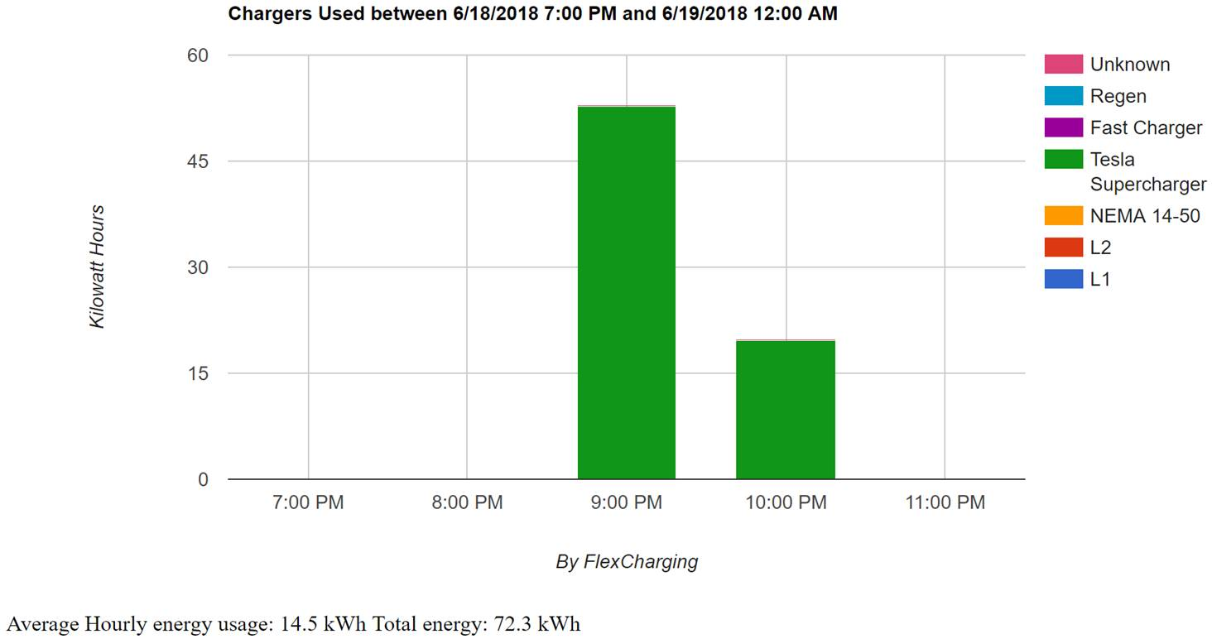

But in the same parking lot there was a giant Blink CHAdeMO charging station.  They charged 60 cents/kWh!  That same energy would have cost me $43, and it would have taken me over 90 minutes for that charge!  That’s crazy.  A gasoline car with 25 mpg and $3 gas would do the trip for about $24 with ~10 minutes of gas station time.  Potential EV buyers may seriously consider buying a gasoline car if they hear of prices like that.

I appreciate PSE wants to set their prices for charging based on market rates, but with today’s low utilization rates, two opposing ideas are simultaneously true:

1. Pricing is too low to make EV charging stations economically viable.
2. The current pricing is too high to encourage switching from gasoline cars, becoming a barrier for market transformation.

As a comparison point, Tesla’s Superchargers are now not free to new drivers, and they are charging $0.25/kWh at WA Superchargers. In 30 minutes, that will provide up to 50 kWh for the 100 kWh battery vehicles, at a cost of $12.50. PSE is proposing $7.50 per 30 minutes, at a cost of $0.30/kWh. Given the power difference between a Supercharger (120 kW) and a 50 kW DC fast charger, PSE’s option will take twice as long to charge up, at a higher price. The price isn’t completely out line, but the charging power is a big step down. I suggest the price at PSE’s DC fast chargers should be lower to reflect the longer time needed to charge at these 50 kW fast chargers.

As an EV driver, I’d prefer rates that were proportional to energy costs instead of time spent parked. If I charge at a non-high amperage L2 charging station, I’ll get 6.6 kW max, at an energy cost of around 66 cents for an hour of charging. If charging for an hour costs me $2.50, it seems like I’m paying 4x for the electricity cost. Of course there is a cost for the station, installation, maintenance, etc. But at this point, we need to further market transformation, which means the cost of driving a mile on electricity should be below the cost of driving per mile on gasoline. If gasoline is $2.80/gallon and you drive a car getting 25 miles/gallon, that implies a cost of 11.2 cents/mile in energy costs. For an EV with 300 Wh/mile efficiency and charging at home at 10 cents/kWh, that’s a cost of 3.33 cents/mile. But at PSE’s proposed rate of $2.50 for 6.6 kWh, then I’m paying 37.8 cents/kWh, or 11.34 cents/mile. This is actually higher than the cost of driving a gasoline car. I suggest this rate should be lower.

**Solution: No Demand Charges for Fast Chargers**

We should fund market transformation by building the infrastructure then further educating people about buying EV’s, even if it means taking a short-term loss, especially on the corridor charging.

I suggest getting rid of all demand charges for corridor charging stations, state-wide.  This should affect both private charging networks as well as public charging networks. That should bring the prices down for both the private networks and utility-constructed charging stations. This is how we further the Legislature’s goals of market transformation.

This change could perhaps pay for itself as well. Lowering the corridor charging cost means we’re likely to get a faster pace of EV adoption. Every EV that charges at off-peak hours lowers everyone else’s rates, by increasing the revenue received by the utility without raising peak capacity needs. By increasing utilization of existing assets, EV’s provide a benefit for all ratepayers. That same benefit could be used to eliminate the demand charge costs. With faster EV adoption, this could be a growing, self-reinforcing source of avoided costs. Counterintuitively, building DC fast chargers may well pay for themselves, from a ratepayer point of view over many years. To ensure utilities don’t use this structural advantage to preclude competition from privately-owned charging networks, demand charges should be eliminated for all fast chargers.

**Charging Station Types**

If PSE is going to go forward with installing L2 charging stations, please ensure they are high amperage L2 chargers capable of delivering the highest power output for the L2 standard (19.2 kW). While some vehicles like the Leaf can’t charge that fast, others can, and we don’t want to penalize PSE’s charging network with under-powered charging stations for corridor charging or public charging in general.

It’s worth noting that new Tesla vehicles come with a 72 amp, 240 volt charger built in as standard. That means they can all charge at ~17.3 kW, providing around ~50-65 miles of range in one hour with a high amperage L2 connector. Time is valuable for everyone, even if they’re on vacation or just charging up in a downtown location somewhere. Other new vehicles will also be capable of charging high speeds.

To be clear, high amperage L2 is ***not adequate*** for corridor charging, but it’s a good fallback option in case you don’t have a CHAdeMO adapter.  To illustrate this, here is the power output and SoC for my Tesla using a high amperage L2 charger in Wenatchee, going from 36% to 99% in just under four hours.

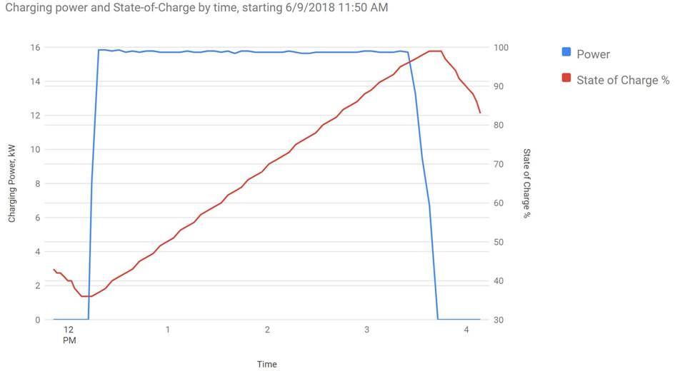

You’ll note the power doesn’t tail off below ~16 kW until the car is about at 96% SoC.  Augmenting a DC fast charging network with other HA L2 chargers is enough to facilitate day trips that end in a specific destination.

PSE should consider ways to make EV charging easy to understand to everyone, such as Chargeway’s innovative color & numbering scheme for identifying types of adapters and speed. This simple system makes EV charging understandable to normal humans without engineering degrees.

**Cold Weather Corridor Charging**

If anyone is building the first parts of a charging network, we must carefully think about temperature effects. Winter temperatures seriously affect battery range, perhaps by up to 30%.  Combined with mountain passes, and it becomes difficult to plan the amount of energy needed to successfully drive from one corridor charger to the next.

A friend of mine drove from Grant’s Pass Oregon up to Mt. Shasta through lots of snow and sub-zero temperatures.  He left Grant’s Pass with 50% more range than the mileage he needed to travel.  The elevation does matter – a Model S loses or gains about 7 miles per 1000 feet elevation change, but this was primarily about the snow and the cold.  His Model S ran out of power 7 miles before the Mt. Shasta Supercharger, with kids in the back.  He never thought that he’d need around 155% of the distance to his destination.

With this in mind, towns along highways in the Cascades like Cle Elum, Greenwater, Leavenworth, and Packwood seem like obvious candidates for charging locations in a future, complete charging network for the state.  You really don’t want to get stuck on a mountain pass in the winter.  In the immediate future, PSE should of course look at some locations around Snoqualmie Pass and Stevens Pass.

**Site Selection**

PSE wisely chose to leave the individual site selection out of the proposal for public charging. Site selection is way more fun, and deserves some degree of public input. Every EV driver will have some strong opinions on this, and that will be influenced by what type of car they drive (a short-range vs. long-range BEV, and whether they have access to a DC fast charger network), & where they go on all electric.

I did want to share my thoughts on site selection, primarily to educate our EV Stakeholders of one driver’s experiences & thought process.

My experience is with a 260 mile range car capable of charging at 19.2 kW (240 V, 80 A), in addition to using Tesla’s private Supercharger network.  I’ve driven to Yosemite National Park three times, Coeur d’Alene three times, and Lake Chelan three times.  I do not own a CHAdeMO adapter for my car.  There are five locations state-wide where I’ve felt inconvenienced by the lack of a DC fast charging option.  Only the first two are in PSE service territory, but these are illustrative:

1. Auburn / Puyallup.  Very helpful for a trip to Mt. Rainier.  The right spot in Auburn could help people going to either Mt. Rainier via Longmire or Crystal Mountain.
2. Cle Elum / Roslyn.  Getting to Leavenworth, Wenatchee, or Chelan from I-90 over Blewitt Pass is harder than it should be.
   1. Yes, there’s a Tesla Supercharger in Ellensburg, but that’s 30 minutes out of the way.
   2. Tesla has now opened a Supercharger in Leavenworth, but there needs to be a DC Fast Charging station for everyone else too somewhere between Cle Elum & Leavenworth.
   3. Cle Elum is the best spot for true corridor charging that doesn’t already have something.
3. Longview.  I was staying at an off-the-beaten path property 20 miles out of town and drove to Cannon Beach, Oregon.  It was a busy day there, and the two charging stations in Cannon Beach were in use.  I got back to the house outside Longview, but was almost completely out of power.  I had to charge off of L1 for an entire day to get back to a civilized Supercharger.  Longview does have one L2 charger in downtown, but the location was less than ideal for my vacation party.
   1. Tesla is building a Supercharger in Longview too, but again, we need something for everyone else.
   2. For PSE service territory, Bellingham and Monroe might be comparable destinations.
4. Chelan – they have two high amperage L2 chargers in town.  Nice, but they could use more, and more power would be helpful.  Chelan could benefit from a large bank of L2 chargers at a hotel or in the business district somewhere.  However, there’s also 30 wineries spread out throughout the area.  A fast charger EV gas station model might work best here.
5. Packwood, a small town on the far side of Mt. Rainier with their own festivals, etc.  Hard to get to, period.  But this much more difficult if you’re in an EV, because mountains make it very hard to predict your range.
   1. There are places around Mt. Rainier where you’ll use 8 miles of range in 1 mile of distance, or you can travel almost 13 miles using 1 mile of range.
   2. A comparable location closer to PSE service territory might be Marblemont, something on Whidbey Island, or a town by Mt. Baker.

A Greenwater fast charger could be a great thought experiment, if not a good actual location.  That would support corridor charging on the way to Mt. Rainier or going to Yakima on 410.  It would also clearly illustrate all the challenges of fast charging in a barely developed location.

# Parting Thoughts

It’s important to remember why all our efforts matter. We are not arguing over graphs, nor turning the crank on some legislation, nor are we promoting EV’s to save utilities from a solar-powered death spiral. I’m not comparing PSE’s pilots with Tesla’s existing network idly, but to help us all aspire to a little more. Our vision calls us to a higher, broader purpose.

As part of a worldwide push for sustainability, we need to redesign our economy to eliminate carbon emissions. In Washington we must transform our transportation sector dramatically, both to curb climate change and save ourselves from the eventual arrival of Peak Oil. We must enable citizens to both get to work and also enjoy our natural world. Electric transportation enables a sustainable future, if we build high-power charging stations in the right locations and consume the cleanest energy. In our state, we can literally drive on rain, snow, wind and sunlight. In another decade, we can open up the doors for freight hauling & farming to be electrified. Let’s get there together, and build the infrastructure to bring all of society with us. Thank you to PSE, UTC staff, and all participants in the EV Stakeholders process.

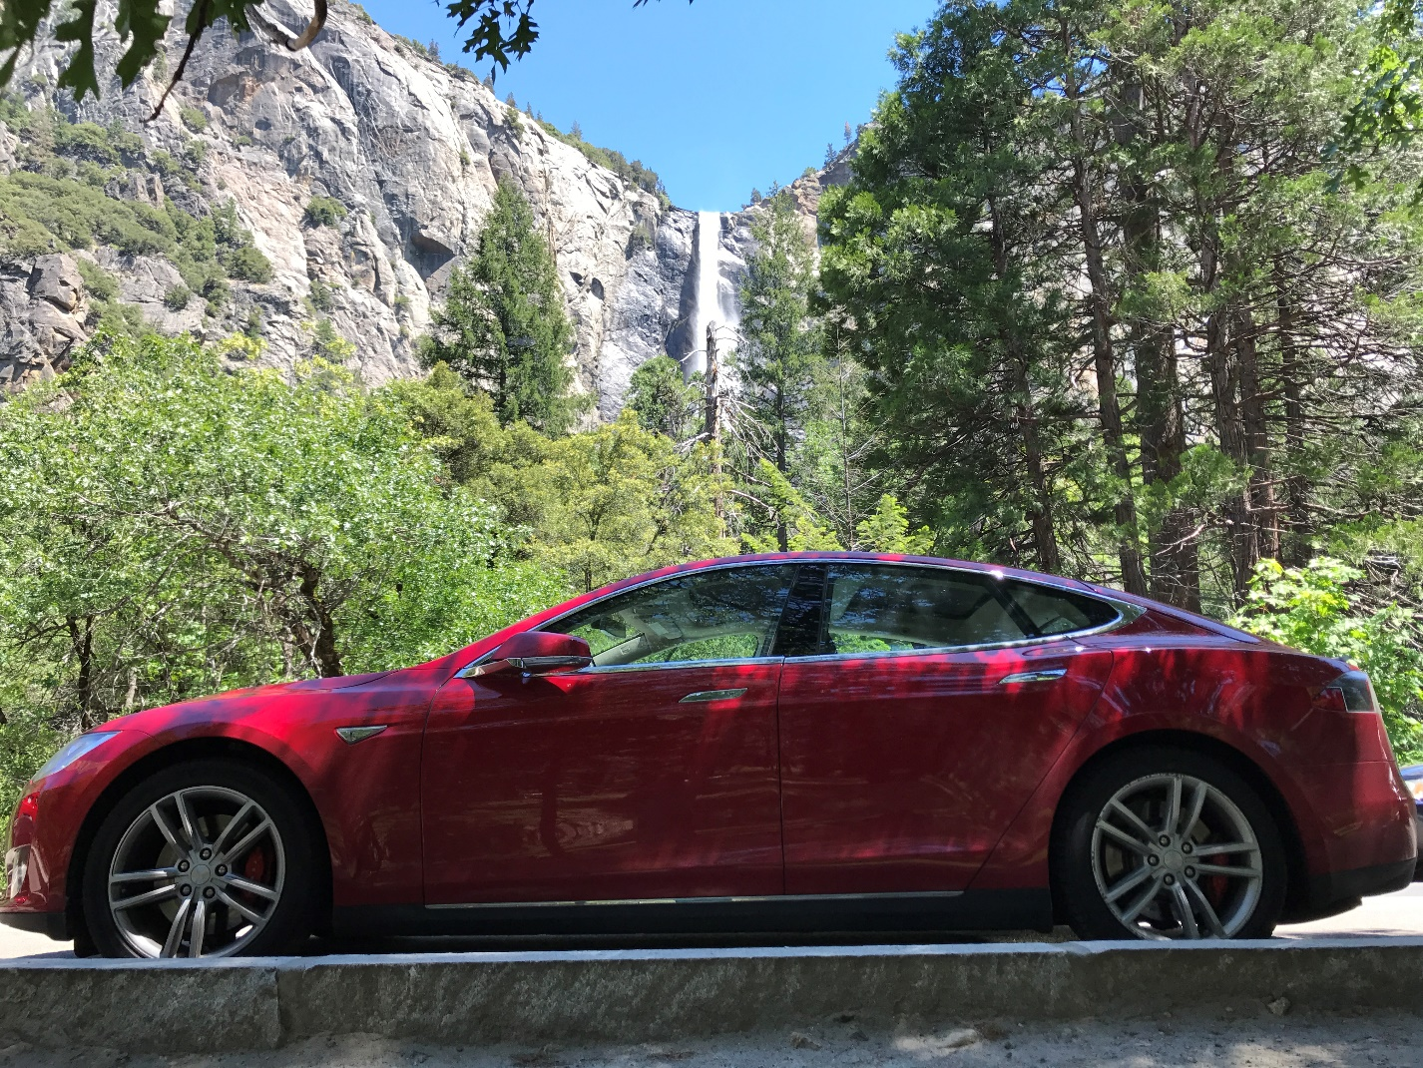

*Bridal Veil Falls, Yosemite Valley, Brian’s Tesla Model S*

Brian Grunkemeyer

Founder, FlexCharging

1. Tesla Q3 2018 Update Letter for shareholders, from <http://ir.tesla.com>
2. Matt Stevens, “Understanding EV Drivers’ Data Analytics”, Electrification 2018
3. Tesla’s Supercharger & Destination Charger maps: <https://www.tesla.com/findus?v=2&search=North%20America&bounds=50.65366857253567%2C-113.504638671875%2C44.056833720033055%2C-127.413330078125&filters=destination%20charger&zoom=7>