*www.pse.com*

PSE2_TAG_DARK

*Puget Sound Energy*

### *P.O. Box 97034*

### *Bellevue, WA 98009-9734*

# October 14, 2016

Mr. Steven V. King

Executive Director and Secretary

Washington Utilities and Transportation Commission

P.O. Box 47250

Olympia, Washington 98504-7250

**RE: Washington Utilities and Transportation Commission v. Puget Sound Energy, Docket No. UE-161123**

**Agreement of Puget Sound Energy to Suspension of Schedule 451**

Dear Mr. King:

On October 7, 2016, Puget Sound Energy (“PSE”) filed proposed Schedule 451 to the WN U-60, Tariff G for electric service in Docket UE-161123. Staff for the Commission has subsequently inquired whether PSE would agree to the immediate suspension of the filing in Docket UE-161123. PSE hereby notifies the Commission that PSE agrees to waive the suspension hearing and requests that the Commission issue an order suspending Schedule 451 for investigation.

Please contact Jason Kuzma at (425) 635-1416 for additional information about this filing. If you have any other questions please contact me at (425) 456-2110.

Sincerely,

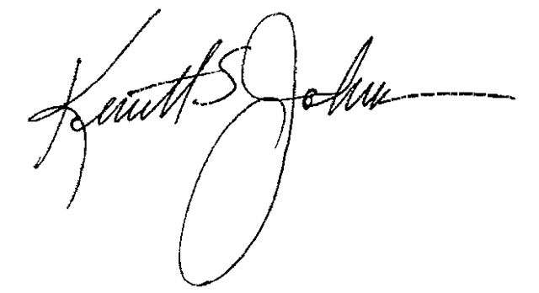

Ken Johnson

Director, State Regulatory Affairs

Enclosures

cc: Lisa Gafken, Public Counsel

Sheree Carson, Perkins Coie