

**STATE OF WASHINGTON**

WASHINGTON UTILITIES AND TRANSPORTATION COMMISSION

***1300 S. Evergreen Park Dr. S.W., P.O. Box 47250 ● Olympia, Washington 98504-7250***

***(360) 664-1160 ● TTY (360) 586-8203***

March 20, 2013

Steven V. King, Acting Executive Director and Secretary

Washington Utilities and Transportation Commission

1300 S. Evergreen Park Dr. SW

P. O. Box 47250

Olympia, Washington 98504-7250

RE: *Washington Utilities and Transportation Commission v. SwiftySwift, LLC d/b/a Spokane Party Bus*

Commission Staff’s Response to Application for Mitigation of Penalties

Docket TE-130214

Dear Mr. King:

On March 5, 2013, the Washington Utilities and Transportation Commission issued a $75 Penalty Assessment in Docket TE-130214 against SwiftySwift, LLC d/b/a Spokane Party Bus (Spokane Party Bus) for three violation of WAC 480-30-071, which requires Charter and Excursion companies to file annual safety reports with the Commission by December 31 each year; and WAC 480-30-076, which requires such companies to pay regulatory fees annually on that date. [1]

On March 13, 2013, Spokane Party Bus responded to the commission, requesting mitigation of the penalty. In its Mitigation Request, Spokane Party Bus does not dispute that the violations occurred. The company states, “I knowledge [sic] that the regulatory report and fee’s [sic] were an oversight by myself. I received a notice on January 10 [sic] 2013 that they had not been filed and that penalties would start January 7th [sic] 2013, three days prior to me receiving the notice. There was no email correspondence or mailing giving any warning of the late charges before January 7th  [sic] 2013. I do not feel this is a fair practice to mail a late fee assessment the day after the penalties have started being charged…” Spokane Party Bus states it made immediate contact with the commission of its error and resolved it. It questions the commission’s ability to assess such a penalty. Spokane Party Bus also states that illegal carriers are operating without regulation and taking away its business, despite contacting the appropriate authorities with information about the illegal activity. It requests consideration of the penalty because of its compliance over the past three year while in business.[2]

It is the company’s responsibility to ensure that the regulatory fee is paid and the annual report is filed by the December 31 deadline. On November 15, 2012, the commission mailed 2012 Annual Safety Report forms and 2013 regulatory fee packets to Charter and Excursion companies registered in Washington state. A letter from the commission’s Assistant Director for Transportation Safety, David Pratt, instructed these companies to file annual reports and pay regulatory fees by December 31, 2012. The letter stated failure to file the annual report by December 31 would result in a penalty and possible cancellation of the company’s permit to operate in Washington. Those companies wishing to request an extension to file the annual report were asked to do so prior to December 31, providing a reason for the requested extension. No extension was requested.[3]

On January 7, 2013, the commission issued a notice to companies that had not yet filed their annual report and paid regulatory fees, informing these companies that they were subject to enforcement action, including the assessment of penalties beginning to accrue on that date. Companies that filed their annual reports and paid regulatory fees after January 7, 2013, but on or before January 18, 2013, are subject to penalties that the commission uses its discretion to mitigate to $25 per day if the company had not made these filings late in prior years. Companies that were late in prior years are subject to an additional $25 per day for each year in which they were late up to a total of $100 per day. For first time late-filers who filed their report after January 18, the commission will mitigate the penalties to 50 percent of the maximum permissible amount. No further mitigation will be granted unless the company provides new information that is unrelated to these factors. Mitigation will not be granted on the basis that a company was unaware a report must be filed.[4]

Spokane Party Bus filed its 2012 annual safety report and paid its 2013 regulatory fee on January 10, 2013. That date is three business days past the January 7, 2013, notice date when penalties began to accrue, resulting in a potential penalty assessment of $300 ($100 per day times three days). SwiftySwift, LLC, is a first time late-filer and, therefore, received a mitigated penalty of $25 per day for three days or $75. The commission could have begun assessing penalties of $100 per business day, beginning January 2, which would have made the company responsible for a penalty of $700.

Staff does not support mitigating the $75 penalty assessment. The penalty was already administratively mitigated by 75 percent, from $300 to $75 and Spokane Party Bus provided no new information related to the factors above. Staff recommends denying the mitigation request.

If you have questions regarding this recommendation, please contact Mathew Perkinson, Compliance Investigator, at (360) 664-1105, or at mperkinson@utc.wa.gov.

Sincerely,

Sharon Wallace, Assistant Director

Consumer Protection and Communications

**Attachment A**

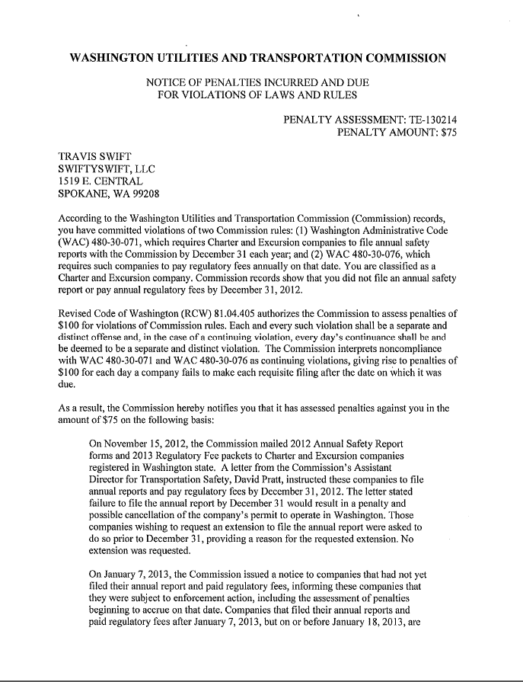

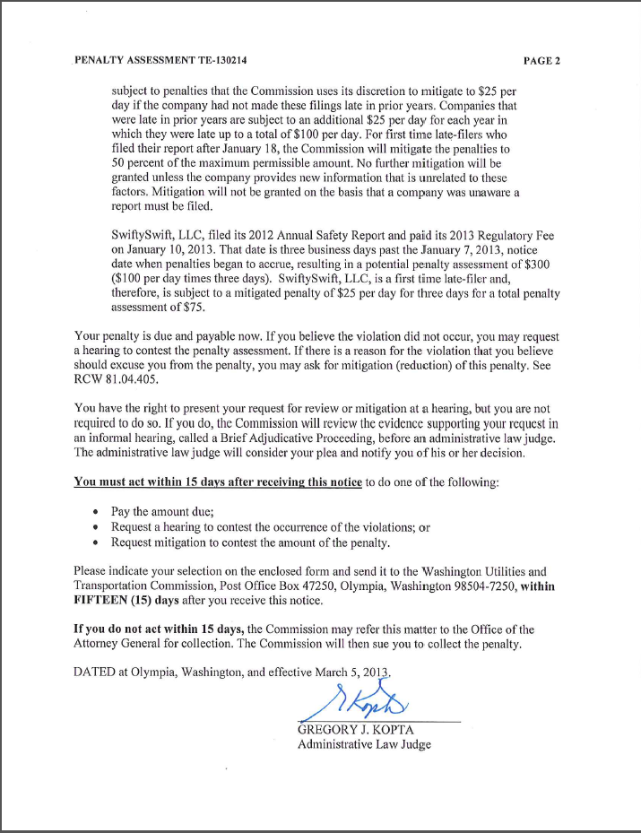

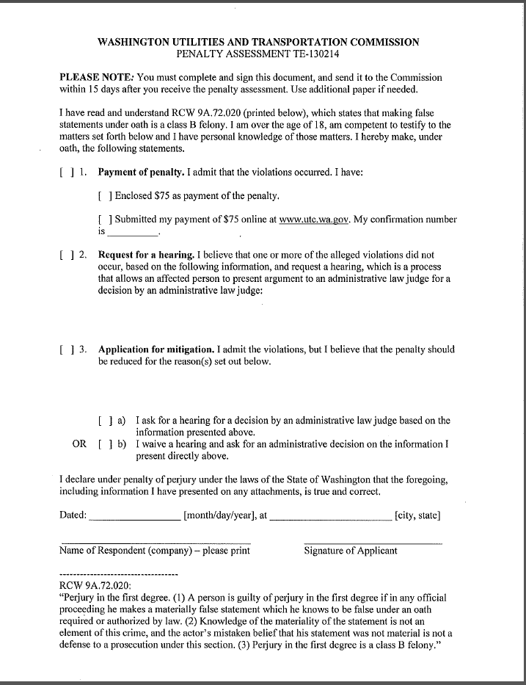

**Attachment B**

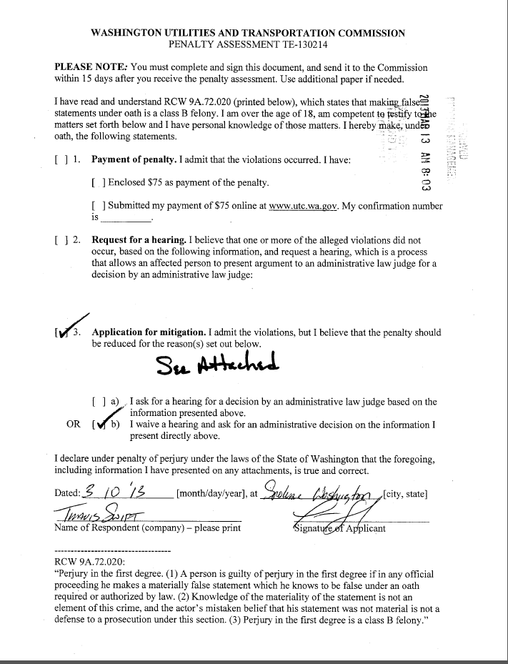

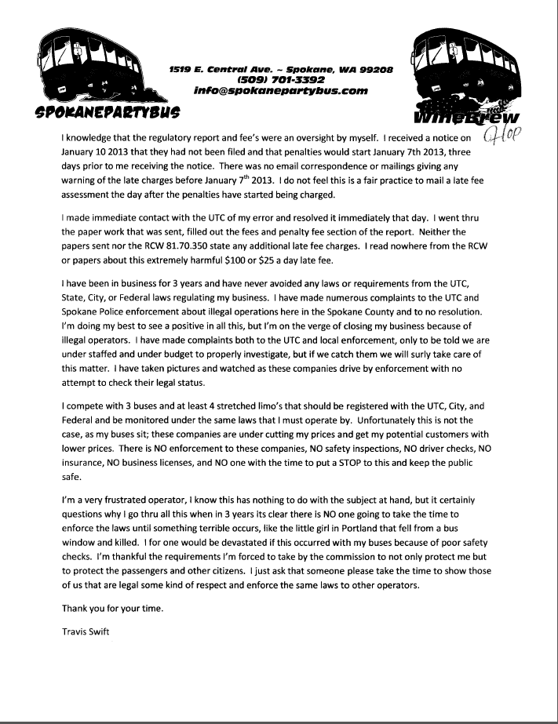

**Attachment C**

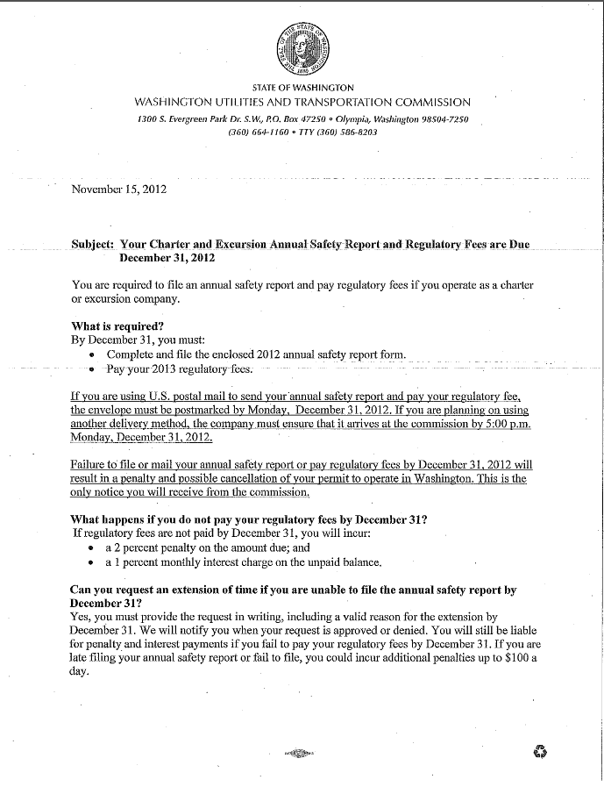

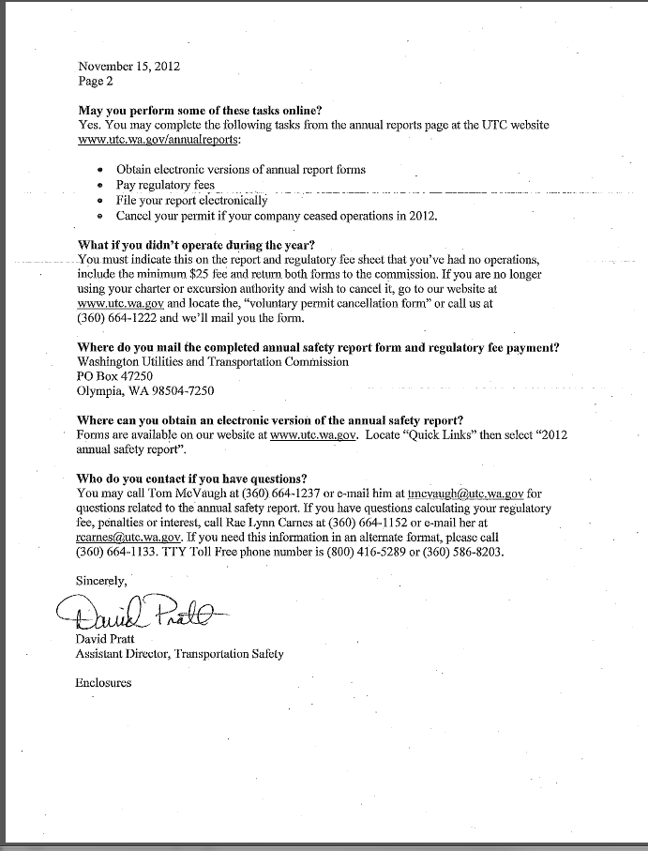

**Attachment D**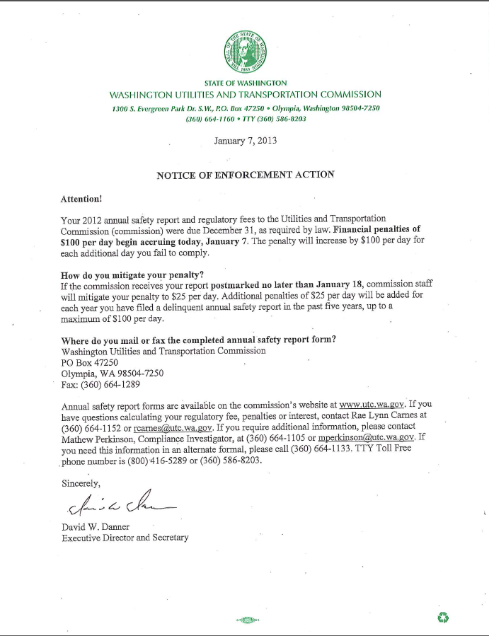

1. See Attachment A for a copy of the penalty assessment sent to Spokane Party Bus.
2. See Attachment B for a copy of the letter submitted by the company on March 13, 2013.
3. See Attachment C for a copy of the letter sent to all regulated companies on November 15, 2012.
4. See Attachment D for a copy of the Enforcement letter sent to all delinquent companies on January 7, 2013.