May 22, 2014

***Via* Electronic Mail**

Steven V. King, Executive Director and Secretary

Washington Utilities and Transportation Commission

P.O. Box 47250

1300 S. Evergreen Park Drive S.W.

Olympia, Washington 98504-7250

Re: Docket U-140632: Comments of Puget Sound Energy, Inc. on Utility Low-Income Bill-Assistance Programs

Dear Mr. King:

Puget Sound Energy, Inc. (“PSE” or the “Company”) submits the following comments in response to the request in the Washington Utilities and Transportation Commission’s (Commission) Notice of Opportunity to Submit Written Comments (Notice) issued in Docket U-140632.

**1. A brief description of the company’s low-income assistance program.**

Puget Sound Energy's low-income bill-assistance program, the Home Energy Lifeline Program (“HELP”), provides bill-payment assistance to eligible PSE customers whose household is considered as a “very low-income household” per RCW 43.63A.510[[1]](#footnote-1). The majority of the HELP funding is collected from all PSE customers via rates that are set by the Company’s Low Income Program (electric and natural gas Schedules 129). Also, if the Company does not meet any of the service quality index (“SQI”) benchmarks set forth in its Service Quality program and the total annual penalty dollars are less than the equivalent of $12 per customer, the SQI penalty will then be allocated to the appropriate PSE HELP funding based upon the energy service affected by the missed SQI.

Puget Sound Energy’s HELP was first implemented in accordance with Exhibit G to Settlement Stipulation Agreement approved by the Commission in consolidated Dockets UE‑011570 and UG‑011571 Twelfth Supplemental Order dated June 20, 2002. The HELP settlement terms allow eligible very low-income customers to receive bill-payment assistance and they do not limit how the benefits are applied to any amounts owed by these customers to PSE. HELP benefits are supplemental to the Federal Low Income Home Energy Assistance Program (“LIHEAP”), which are available year-round to eligible households. For the 2012 program year, October 2012 through September 2013, eligible households may receive up to $1,000 per year per customer in HELP credit to offset their PSE electricity or natural gas bills.

In summary:

* Tariff-based (Schedule 129) funding for qualifying PSE “very low-income household” customers. Program costs are collected from all rate schedules.
* Year-round program – Program year is Oct. 1st through Sept. 30th.
* Administered by 11 Community Action Agencies throughout PSE territory.
* $20.2 million is the annual revenue cap; $16.9 million available for client benefits. 75% allocated for Electric customers and 25% allocated for Natural Gas customers.
* 21% administrative cap for the Agencies.
* The benefit is applied as a one-time payment per year on the customer’s energy bill.
* Current benefit range is from $50 to $1,000 per customer, per program year
* Income eligibility is 50% of the median income of a county. The ceiling ranges from 125% to 150% of poverty level.
* PSE and agencies promote the program.

Please also see Attachment 1, Low Income Program Outcome Report filed in UE-011570 & UG-011571.

**2. A description of how the company measures the success of its low-income assistance program.**

Please see Attachment 1, Low Income Program Outcome Report filed in UE-011570 & UG-011571.

Success is also measured by: (1) A baseline of full expenditure of the funding; and (2) Ensuring that annual evaluations of the agencies are performed, and their internal audits submitted to PSE.

**3. The total number of residential customers in the company’s service territory, an estimate of the total number of low-income customers in the company’s service territory, and the number of customers participating in the company’s low-income assistance program for each of the last five program years.**

|  |  |  |  |  |  |
| --- | --- | --- | --- | --- | --- |
| Year Note1 | 2008 | 2009 | 2010 | 2011 | 2012 |
| Estimated Number of Households Note 2 | 1,241,230 | 1,254,035 | 1,263,015 | 1,270,855 | 1,279,326 |
| Estimated Number of Low-Income Households Note 3 | 29,483 | 43,517 | 45,724 | 47,248 | 40,289 |
| PSE HELP Households Note 4 | 13,887 | 25,792 | 20,773 | 25,193 | 21,324 |

Note 1: Based upon calendar year data as not all the comparable information is readily available at the PSE HELP program year basis due to change in PSE's customer information system and service territory in April 2013.

Note 2: PSE residential customer with either electric or natural gas account or with both electric and natural gas accounts is counted as one household.

Note 3: PSE residential customer received a pledge or pledges during the year either for an electric or natural gas bill or for both electric and natural gas bills from PSE HELP and/or any other low-income assistance agencies affiliated with PSE.

Note 4: PSE residential customer received a PSE HELP assistance or PSE HELP assistances during the year either for an electric or natural gas bill or for both electric and natural gas bills.

**4. The number of customers who receive low-income assistance two or more years in a row, and the distribution of the number of years that assistance was received by those customers in each of the last five program years.**

|  |  |
| --- | --- |
| Number of “Bill-Assistances” Received Note 1 | Number of Households Note 2 |
| **2** | 9,602 |
| **3** | 7,593 |
| **4** | 5,497 |
| **5** | 3,154 |
| Number of Households that received PSE HELP Bill-Assistance two or more years during 10/2008 – 9/2013 Program Years: | 25,846 |

Note 1: PSE HELP assistances for either electric or natural gas account or with both electric and natural gas accounts.

Note 2: PSE residential customer received PSE HELP assistances for either electric or natural gas account or with both electric and natural gas accounts during a year is counted as one household.

**5. The number and proportion of low-income assistance customers who also receive low-income weatherization, and the total number of customers who received low-income weatherization in each of the last five program years.**

The table below presents data on PSE’s LIW program for the past five years.

|  |  |  |  |  |  |
| --- | --- | --- | --- | --- | --- |
| Year Note 1 | **2008** | **2009** | **2010** | **2011** | **2012** |
| Number of LIW Projects Completed | 395 | 574 | 785 | 738 | 461 |
| Number of Housing Units Associated with Projects Note 2 | 718 | 1,520 | 2,261 | 2,861 | 1,457 |
| Number of Customers Note 3 | 394 | 547 | 641 | 600 | 405 |

Note 1: Based upon calendar year that the low-income weatherization project was completed.

Note 2: A weatherization project for a low-income multiple-family building would include more than one unit in the building when the project is conjunction with the building owner.

Note 3: Some weatherization projects were initiated by the same customer.

PSE has not yet identified any specific PSE residential customer who received both PSE HELP bill-assistance and PSE Low-Income Weatherization (“LIW”).  While income eligibility is tied to the customer, the ultimate focus is on weatherization.  The focus of bill-assistance is on bill payments. Even though both programs are designed to serve similar customer segments, trying to compare these two different programs is difficult at the current time for some of the following reasons:

1. The Multi-family component of the LIW program does not collect customer specific information, but tracks installation of energy efficiency measures at the unit and building level.  Therefore, PSE does not have data regarding participation of tenants in bill-assistance.
2. Since LIW is an Energy Efficiency program, structures may not qualify for weatherization even though a customer qualified for bill-assistance.  This is because the structures are already weatherized or built to current codes; or the structures are so degraded and in need of extensive repairs that they cannot be weatherized.
3. Participation in Energy Assistance is not a prerequisite for participating in the PSE LIW program or any State and Federal Weatherization Assistance Program.  Therefore the LIW program does not track customer participation in bill-assistance.
4. PSE does not house data regarding participation in State and Federal Weatherization Assistance programs.  Therefore, it is possible and expected that many bill-assistance customers have received weatherization with non-PSE funds.

**6. A spreadsheet or distribution curve of the monthly energy usage of low-income assistance recipients.**

The following charts, by electric and natural gas, show the distribution curve of the average monthly energy usage of PSE HELP customers for calendar years 2008-2012. These charts are intended to demonstrate the average monthly natural gas and electric usages of low-income customers. The data is based upon the customers who received either electric and/or natural gas PSE HELP assistance/s during a year and had at least 360 days of billing history at a location. PSE HELP customers who moved in/moved out at a location during a year are not included in this analysis due to the gap in monthly usage and the location change. Both natural gas and electric usage of a PSE HELP customer are included in the analysis, i.e., an electric PSE HELP bill-assistance recipient's natural gas usage is also reflected in the average natural gas monthly distribution curve.

**7. Disconnection ratios for the past three years comparing total customer population with low-income assistance recipients. Please indicate the percentage of disconnected low-income assistance recipients whose service was restored because of low-income programs.**

The following table shows the ratio of disconnections due to non-payment, move-in/move out, and any other reason as a percentage of all PSE customers and HELP customers.

|  |  |  |  |  |
| --- | --- | --- | --- | --- |
| Period | 10/2009 – 9/2010 | 10/2010 – 9/2011 | 10/2011 – 9/2012 | 10/2012 – 9/20131 |
| Disconnection Ratio –  All PSE Customers | 3% | 3% | 3% | 1% |
| Disconnection Ratio –  PSE HELP Customers | 17% | 19% | 17% | 6% |

Note 1: Disconnection percentage lower for 2013 due to customer information system conversion.

PSE does not track the percentage of disconnected low-income bill-assistance recipients whose service was restored because of low-income programs.

PSE appreciates the opportunity to provide these responses to the questions identified above in the Notice of Opportunity to File Written Comments. Please contact Mr. Eric Englert at (425) 456-2312, Kathie Barnard (425) 462-3716, or myself at (425) 456-2110 for additional information about this filing.

Sincerely,

*/s/ Katherine J. Barnard* for

Ken Johnson

Director, State Regulatory Affairs

**ATTACHMENT 1**

**Puget Sound Energy**

**Annual Report on Program Outcome of PSE's Low Income Program, HELP**

**For 2012 Program Year**

**October 2012 through September 2013**

**Filed May 22, 2014**

**PSE2_TAG_DARK**

Table of Contents

[Introduction and Background 2](#_Toc386617969)

[Description of HELP Bill-Payment Assistance 4](#_Toc386617970)

[HELP Bill-Payment Assistance by Fuel Type and Program Year 4](#_Toc386617971)

[Monthly Pattern of Distribution of HELP Bill-Payment Assistance 7](#_Toc386617972)

[Demographics of Customer Households 10](#_Toc386617973)

[HELP Bill-Payment Assistance by County Area 10](#_Toc386617974)

[HELP Bill-Payment Assistance and Annual Bill by County Area 11](#_Toc386617975)

[HELP Bill-Payment Assistance by Residential Housing Structure 14](#_Toc386617976)

[HELP Bill-Payment Assistance Impacts 15](#_Toc386617977)

[Administration of Program 17](#_Toc386617978)

[Marketing of PSE Home Energy Lifeline Program 18](#_Toc386617979)

## Introduction and Background

Puget Sound Energy's (“PSE’s” or the “Company’s”) low income bill assistance program, the Home Energy Lifeline Program (“HELP”), provides bill-payment assistance to eligible PSE customers whose household is considered as a “very low-income household” per RCW 43.63A.510[[2]](#footnote-2). The majority of the HELP funding is collected from all PSE customers via rates that are set by the Company’s Low Income Program (electric and natural gas Schedules 129). Also, if the Company does not meet any of the service quality index (“SQI”) benchmarks set forth in its Service Quality program and the total annual penalty dollars are less than the equivalent of $12 per customer, the SQI penalty will then be allocated to the appropriate PSE HELP funding based upon the energy service affected by the missed SQI.

HELP benefits are supplemental to the Federal Low Income Home Energy Assistance Program (“LIHEAP”), which are available year-round to eligible households. For the 2012 program year, October 2012 through September 2013, eligible households may receive up to $1,000 per year per customer in HELP credit to offset their PSE electricity or natural gas bills, which is the same maximum as the 2009, 2010, and 2011 program years.

Puget Sound Energy’s HELP was first implemented in accordance with Exhibit G to Settlement Stipulation Agreement approved by the Commission in consolidated Dockets UE‑011570 and UG‑011571 Twelfth Supplemental Order dated June 20, 2002, which was amended by the Partial Settlement Agreement approved by the Commission on January 5, 2007, in Dockets UE‑060266 and UG‑060267. The HELP settlement terms allow eligible very low-income customers to receive bill-payment assistance and they do not limit how the benefits are applied to any amounts owed (past, present, and future) by these customers to PSE.

On October 8, 2008, the Commission approved three HELP changes in its Order 12 of the consolidated Dockets UE‑072300 and UG‑072301 (2007 Order 12). Appendix D to the 2007 Order 12 set forth details of these three changes which became effective for program years starting 2008. These changes are:

1. HELP funding is distributed to electric and natural gas customers at the fixed ratio of 75% and 25%, respectively.
2. The total annual HELP funding is increased from $10.25 million to $15 million.
3. Any HELP funds not distributed to customers in any single program year will be carried over to the next program year as supplemental HELP funding.

In Docket U‑072375, merger of PSE and Puget Holdings LLC, these changes are further affirmed as Commitments 22, 23, and 42 of the Multi-Party Settlement Stipulation approved by the Commission on December 30, 2008, in Order 8 of Docket U‑072375, Approving and Adopting Settlement Stipulation; Authorizing Transaction Subject to Conditions.

Additional funding has been available to very low-income customers to mitigate the effect of PSE electric and natural gas rate changes since 2008. This supplemental HELP funding adjustment was described in PSE’s Initial Brief in the Company’s 2009 General Rate Case under the consolidated Dockets UE-090704 and UG-090705, as follows:

The company proposed to increase the annual level of low-income electric and natural gas bill assistance funding by the corresponding percent increase to the residential class that are approved by this Commission. The amount of this percentage increase would be added to the low income tariff in the next program year.

This funding adjustment had been incorporated into PSE’s annual electric and natural gas Schedules 129 HELP funding requirement true-up for the periods of October 1, 2010, through September 30, 2012.

On May 7, 2012, per Order 8 of the consolidated Dockets UE-111048 and UG-111049, the base funding for the low-income bill assistance program was increased to $20.2 million, based on 0.665 percent of PSE’s 2010 operating revenues. Prior funding level reflected about 0.51 percent of PSE’s 2010 operating revenues. The base HELP funding is distributed to electric and natural gas customers at the fixed ratio of 75% and 25%, respectively, as set forth in 2007 Order 12.

For the 2012 program year of October 1, 2012, through September 30, 2013, in addition to the $20.2 million base funds, the available HELP funding was increased, per 2007 Order 12, by the supplemental funding of the carried-over HELP funds of $423,109 from the 2011 program year.

## Description of HELP Bill-Payment Assistance

### HELP Bill-Payment Assistance by Fuel Type and Program Year

The following table shows the number of PSE residential very low-income customers who received bill-payment assistance from PSE’s HELP during the 2012 program year, the 12-month period of October 1, 2012, through September 30, 2013.

Electric customers 23,835

Natural gas customers 9,369

The number of eligible very low-income households that received bill-payment assistance is lower than the sum of the two numbers above since some households are both PSE natural gas and electric customers. The total number of very low-income households that received bill-payment assistance is 29,630, i.e., there are 3,574 HELP households that received both PSE electric and natural services in the 2012 program year. Of the electric customers who received bill-payment assistance, 15% were also natural gas customers. Of the natural gas customers who received bill-payment assistance, 38% were also electric customers. The chart below is a comparison of the number of customers who received bill-payment assistance since 2008 by fuel type and by program year. The increase in the numbers of electric and natural gas customers is due to more HELP funding.

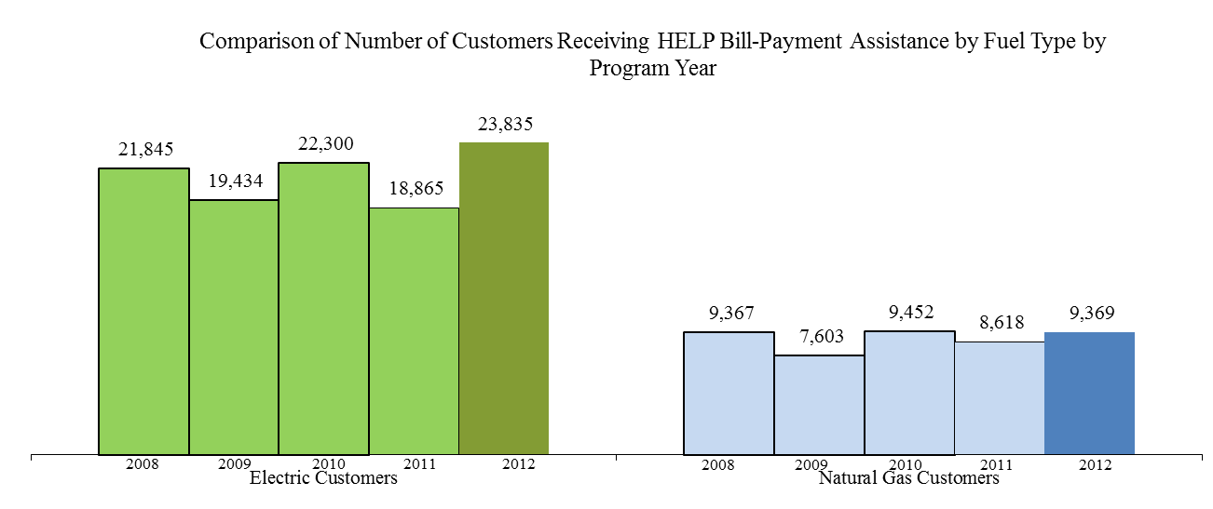

The number of eligible very low-income customers received HELP bill-payment assistance as percentage of the number of residential customers by electric and natural gas is 2.5% (23,835 out of 961,173) and 1.3% (9,369 out of 708,889), respectively.

The chart below shows the distribution of the number of years a customer received HELP bill-payment assistance during the 2008-2012 program years. About half (49%) of the HELP customers received only one bill-payment assistance during those years; while 4% of customers received HELP assistance every year during that 5-year period.

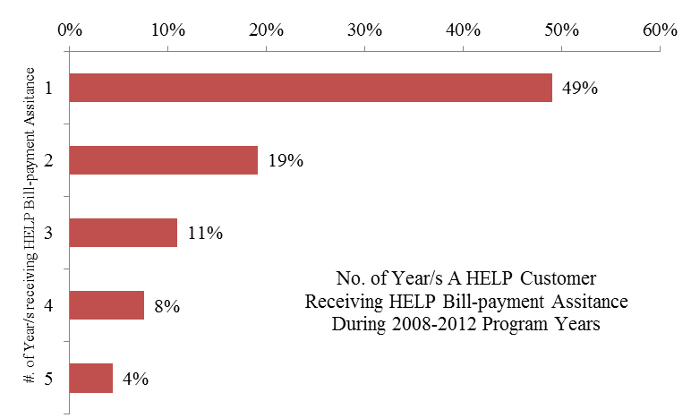

The total dollar amount of HELP bill-payment assistance during the 2012 program year was:

Electric $ 11,409,903

Natural Gas $ 3,336,126

Total $14,746,028

The charts below show the relative amount of payment assistance credited to eligible very low-income electric and natural gas residential customers by program year. The total distributed bill payment assistance includes both the base and overflow prior HELP funding net of PSE program costs and agency administration fees.

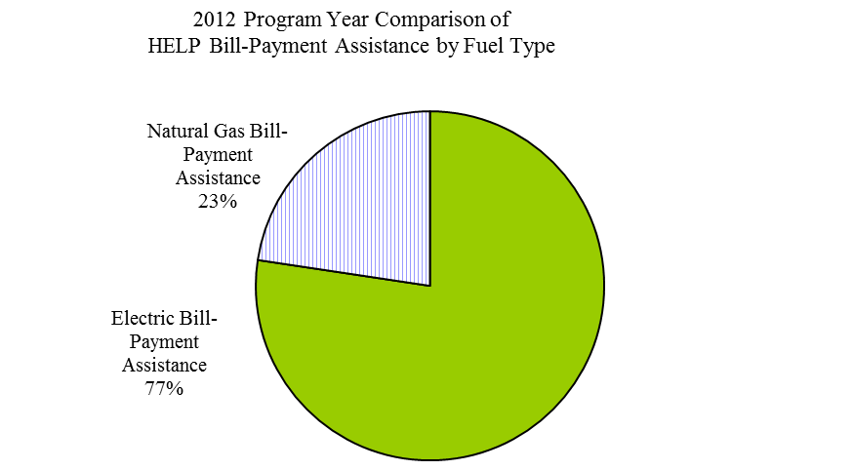

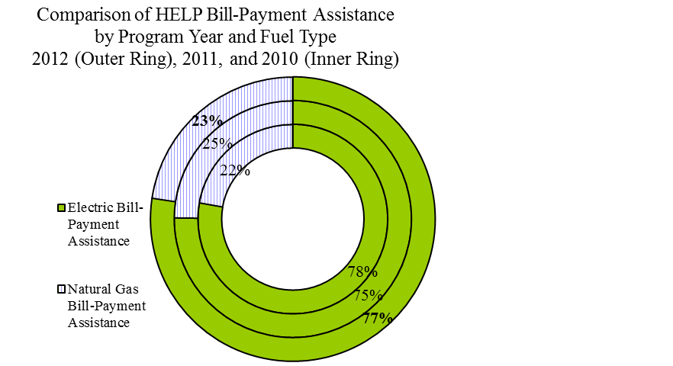

With the overflow funding of from the 2011 HELP year, the actual percentages of HELP bill-payment assistance credited to each fuel are 77% electric and 23% natural gas for the 2012 program year. The base 2012 program year HELP funding of $20.2 million was allocated as 75% for electric and 25% for natural gas as prescribed in the Appendix D to the 2007 Order 12 while the overflow funding went back to the fuel type that the bill-payment assistance was originally distributed to.

The table below shows a comparison, by fuel type, of the percentages of bill-payment assistance distributed with the percentages of total residential customers and total residential revenues. Electric residential customers were allocated relatively more HELP payment assistance than that of natural gas residential customers based upon the proportion of total residential revenue and total residential customer count percentages.

|  |  |  |  |
| --- | --- | --- | --- |
|  | % of Actual Total Distributed HELP Bill-Payment Assistance | % of Residential Customers | % of Residential Revenues |
| Electric | 77% | 57% | 62% |
| Natural Gas | 23% | 43% | 38% |

### Monthly Pattern of Distribution of HELP Bill-Payment Assistance

The following two charts show the monthly pattern of distribution of HELP bill-payment assistance to eligible very low-income PSE customers during the 2012 program year by fuel type. The first chart is a side-by-side bar chart with both the electric and natural gas payment assistance.

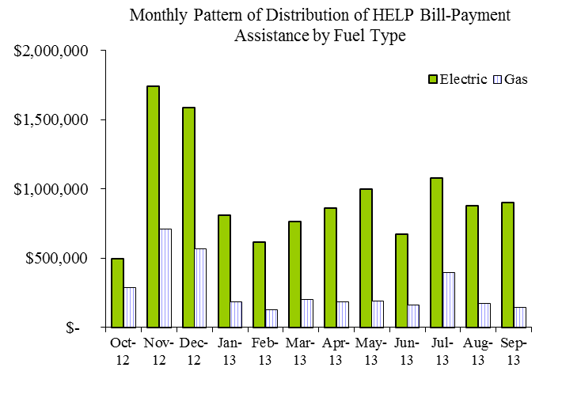

The second chart is a stacked bar chart with both the electric and natural gas payment assistance by month.

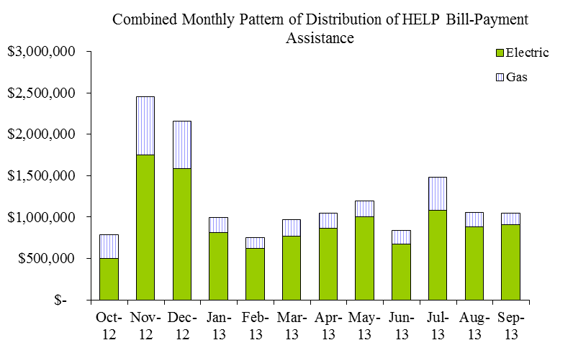

The chart below shows the combined electric and natural gas distributed HELP bill-payment assistance on a monthly basis for the 2012 program year (depicted by the heavy line) and the previous two program years (in light lines). More than 40% of the annual amount of HELP bill-payment assistance was distributed to the eligible very-low income customers in the first four months of the HELP year, October through January, before and during the peak of winter heating season.

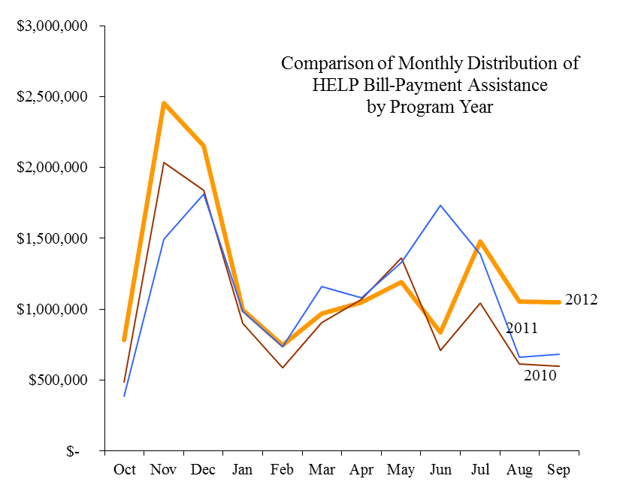

The chart below shows a comparison of the cumulative amount of distributed HELP bill-payment assistance on a monthly basis for the 2012 program year (shown in heavy line) and the previous five program years (in light lines). More HELP payment assistance was distributed to eligible very low-income customers during the 2012 program year compared with the last four program years due to the additional funding increase as discussed in the ***Introduction and Background*** section.

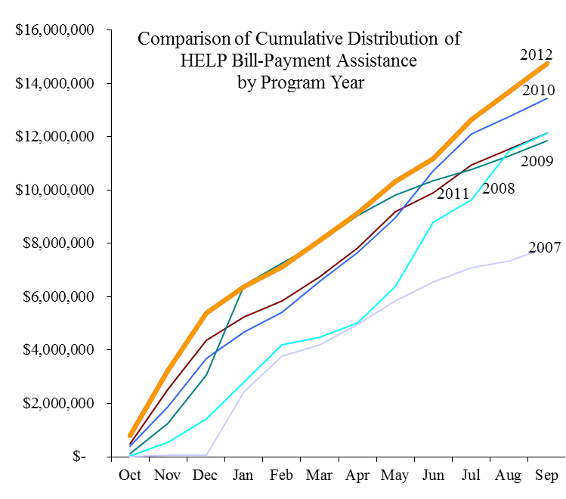

Demographics of Customer Households

### HELP Bill-Payment Assistance by County Area

The average level of HELP bill-payment assistance to each eligible very low-income household is $511 for this program year. It is a $10 increase from the $501 per household of the 2011 program year.

The chart below shows the average HELP bill-payment assistance per household for the various county areas in PSE’s service territory. The overall average HELP bill-payment assistance per PSE energy account that received HELP bill assistance is $456 due to the fact that 3,574 households have both PSE electric and natural gas services.

The Jefferson County results shown in the chart pertain only to the period of October 1, 2012, through March 31, 2013, while the county was still being served by PSE’s distribution system. Jefferson County Public Utility District No. 1 assumed ownership of PSE’s electric system infrastructure within the county on April 1, 2013. The residual amount of the HELP funding that had been allocated to that county but had not been given to a specific customer was distributed to other agencies associated with PSE’s HELP.

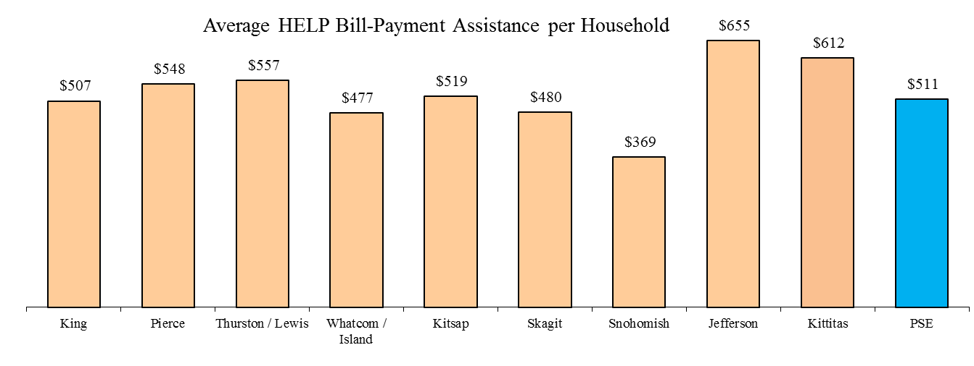

### HELP Bill-Payment Assistance and Annual Bill by County Area

For the purpose of comparison among all the county areas, the average residential and the HELP customer annual bill information presented in the following charts and the customer count information used in the calculation is based upon 12 months ending March 31, 2013, so that the numbers for each of the counties would be comparable, including the data for Jefferson County.

The chart below shows a comparison by county area of the average annual bill per HELP account and per PSE residential account, thus comparing the average bill of a HELP customer to the average bill a general residential customer. For the 2012 program year, the customers who received HELP bill-payment assistance had, on average, annual bills that were about the same as that of average PSE residential customers. Most of the county areas show similar relationship.

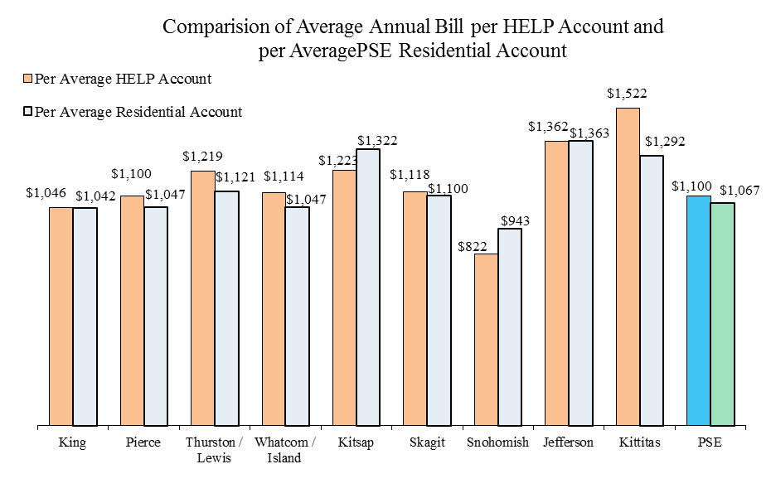

The chart below compares the ratio of average HELP bill-payment assistance per HELP account to the average annual bill per HELP account for the 2012 program year by county area. It generally demonstrates, on average, how much of an electric or natural gas HELP customer’s energy bill was mitigated by HELP bill-payment assistance. The overall average ratio is 41%, i.e. the HELP bill-payment assistance alone could pay for 41% of a HELP customer’s annual energy bills. Among the current PSE service areas, Snohomish County has the highest ratio of 45% and Thurston/Lewis Counties has the lowest ratio of 38%. 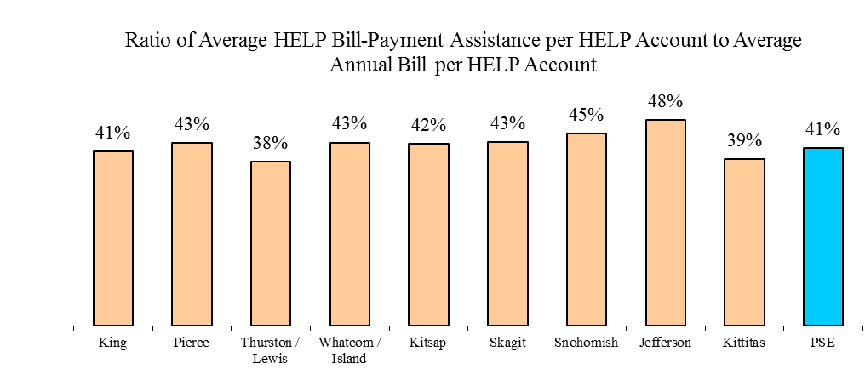

The following charts show the number of eligible very low-income customers receiving HELP bill-payment assistance as percentage of the number of residential customers in a county area. The overall percentages for electric and natural gas are 2.5% and 1.3%, respectively.

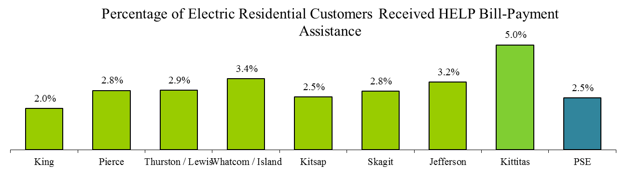

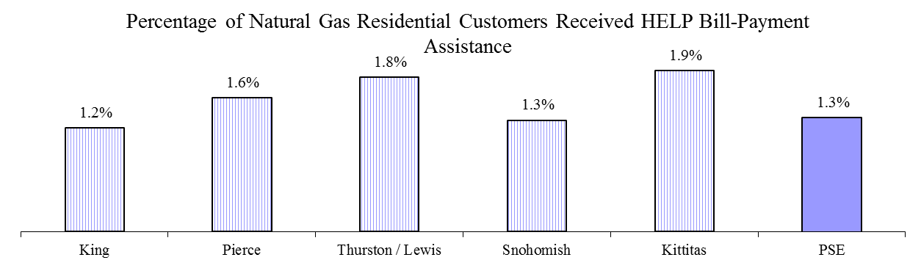The chart below shows the percentage distribution of PSE residential customers, including both electric and natural gas, by county area along with the percentage of PSE HELP customers in that area. Snohomish County, where PSE provides only natural gas service, and King County, received proportionally significantly less HELP bill-payment assistance than the rest of the county areas. King County has 52.2% of the PSE’s residential customers but in comparison only 42.3% of the PSE HELP customers are in King County. 7.2% of PSE residential customers are in Snohomish County but only 4.7% of the PSE HELP customers are in the county. The other county areas--especially Whatcom/Island, Thurston/Lewis, Jefferson, and Kittitas Counties--have higher percentages of PSE HELP customers than that of PSE residential customers in the areas.

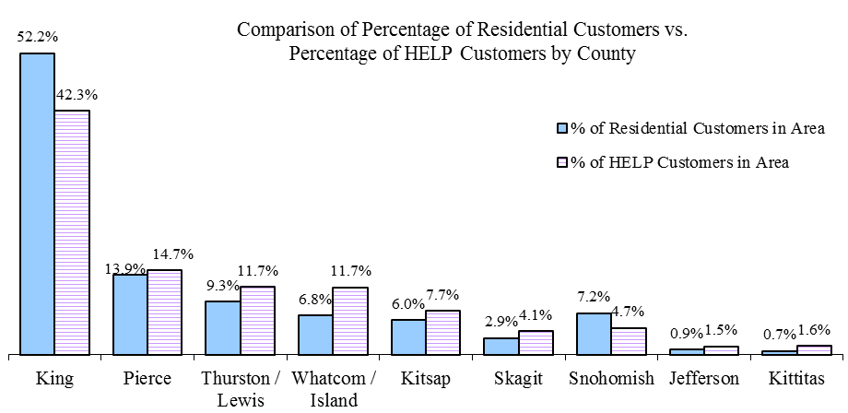

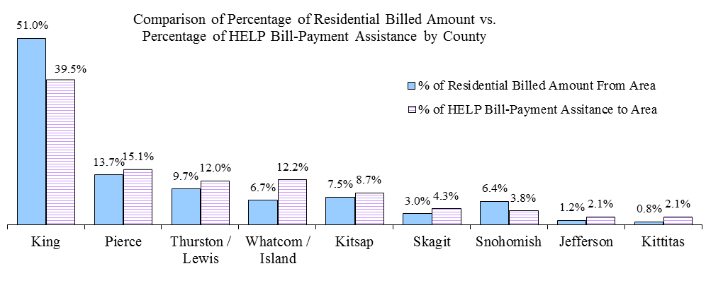The chart below shows the percentage by county area of PSE total residential electric and natural gas billed amount in a county area compared to the percentage of PSE HELP bill-payment assistance distributed to that area. Similar to the customer count comparison above, Snohomishand King Counties received less HELP bill-payment assistance than the rest of the county areas in terms of the residential billed amount. 6.4% of PSE residential billed amount came from Snohomish County but only 3.8% of the PSE HELP bill-payment assistance went to the area. The results for King County were 51.0% and 39.5%, respectively. Whatcom/Island, Jefferson, Thurston/Lewis, and Kittitas Counties received higher percentages of PSE HELP bill-payment assistance than that of PSE residential billed amount from these areas.

### HELP Bill-Payment Assistance by Residential Housing Structure

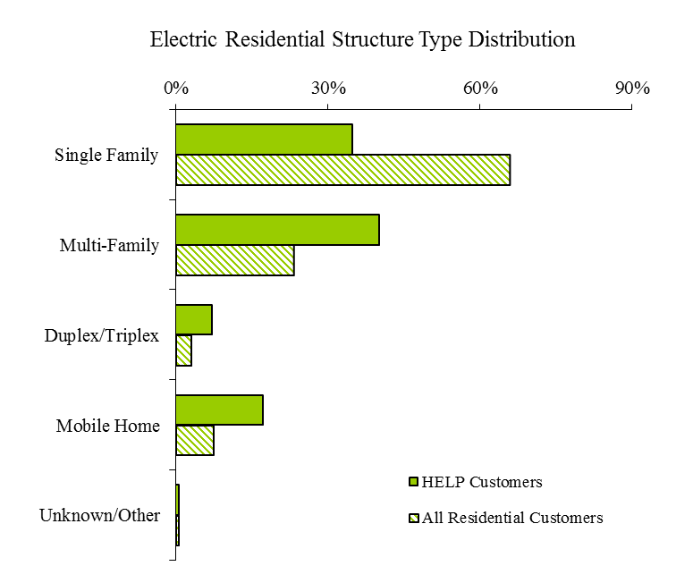The two charts below show comparisons by fuel type and residential housing structure type between PSE residential customers and the eligible very low-income customers receiving HELP bill-payment assistance during the 2012 program year. Electric HELP customers were more likely to live in a multi-family structure whereas natural gas HELP customers were mostly living in a single-family structure.

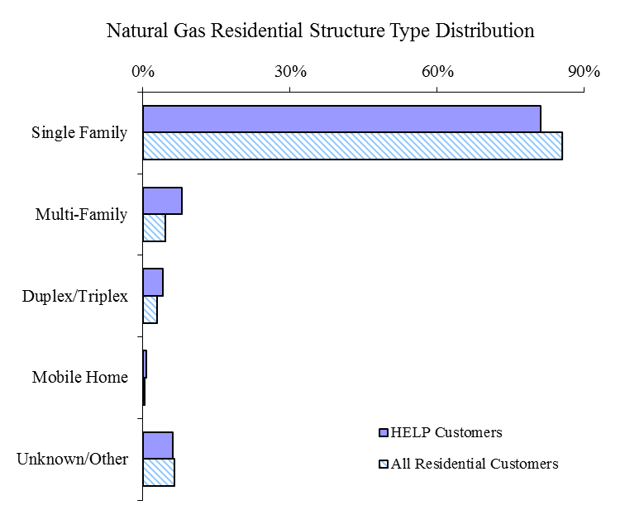

### HELP Bill-Payment Assistance Impacts

The HELP bill-payment assistance impacts are presented in two six‑month periods due to the implementation of PSE’s new Customer Information System (“CIS”) on April 1, 2013, and the timing difference among the initial award of HELP bill-payment assistance, the subsequent applications of the HELP bill-payment assistance to customer account, and the disconnection date.

The first period consists of October 2012 through March 2013 of the 2012 program year for the HELP transactions and *all* disconnections‑ move-in/move-out, non-payment/credit, or any other disconnection reasons‑tracked in PSE’s legacy CIS. The second period extends from April 2013 through September 2013 for the new HELP bill-payment assistances that originated in the new CIS and the *non-payment/ credit* disconnection activities that occurred in the new CIS rather than all the disconnection activities.

*October 1, 2012, through March 31, 2013*

The two charts below show the relationship between the HELP bill-payment assistance distributed during October 2012 through March 2013 of the 2012 program year and the disconnection events due to move-in/move-out, non-payment/credit, or any other disconnection reasons occurred during the same six‑month period. These two charts only show what happened to customers during the six‑month period and do not indicate which event occurred first, namely the receipt of HELP assistance or the disconnection. The first chart highlights the percentage of customers who received HELP payment assistance with disconnection for any reason by fuel. Overall, 6% of PSE HELP customers experienced any type of service disconnection. The second chart highlights the percentage of all disconnected customers who received HELP payment assistance during the 2012 program year. Overall, 11% of the disconnected customers received HELP bill-payment assistance.



*April 1, 2013, through September 30, 2013*

The two charts below show the relationship between the very‑low income customers who became eligible HELP customers during April 2013 through September 2013 and the non-payment/credit disconnections that occurred during the same period. These two charts only show what happened to these customers during the six month period and do not indicate which event occurred first, namely the receipt of HELP assistance or the non-payment/credit disconnection. The first chart highlights the percentage of customers who became eligible HELP customers and were also disconnected due to non-payment/credit by fuel during the six‑month period. Overall, 3% of these newly eligible PSE HELP customers experienced non-payment/credit disconnection. The second chart highlights the percentage of non-payment/credit disconnected customers who became eligible HELP customers during the six‑month period. The combined percentage for both electric and natural gas non-payment/credit disconnected customers is 5%.



## Administration of Program

At the beginning of the 2012 program year, there were twelve qualifying low-income agencies administering HELP and distributing bill-payment assistance to customers for PSE. In addition to the funding for bill-payment assistance to eligible low-income customers, these agencies also received allotment of funds from PSE for administrative fees to run HELP and related services such as customer education, eligibility evaluation, bill-assistance amount determination and distribution, and other support services.

Starting from April 1, 2013, there were eleven HELP agencies instead. Jefferson County Public Utility District No. 1 assumed ownership of PSE’s electric system infrastructure within the county on that date therefore the agency in the county stopped the distribution of PSE HELP bill-payment assistance going forward. The residual amount of the HELP funding and the agency administration fees that had been allocated to that agency but had not been used, was distributed to PSE’s other HELP agencies.

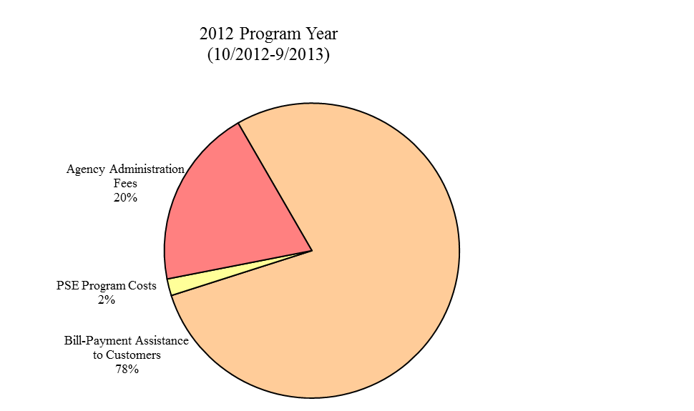The charts below illustrate the allocation of the HELP administration costs and bill-payment assistance to customers by program year. For this program year, the overall agency administration fees comprised about 20% of the total funding of the HELP, a 1% increase from the last program year of 19%. PSE’s own administrative program costs were 2%, a 1% decrease from that of the previous program year.

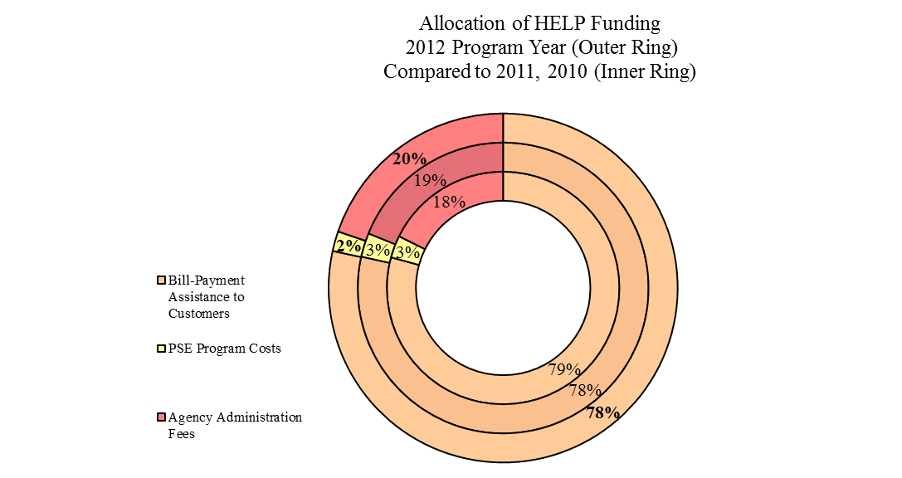

## Marketing of PSE Home Energy Lifeline Program

The following are some highlights regarding the marketing of the HELP during the 2012 program year, October 2012 through September 2013:

* January-February 2013 EnergyWise customer newsletter articles, "Let Us Help you” and "You can help those in need," sent in PSE bill statements, linked to online PSE bill statements, and posted on PSE.com throughout year.
* January 2013, February 2013, and April 2013, all billing envelopes included messaging about payment options and payment assistance programs.
* September 2013 “The Voice of myPSE” customer newsletter, "Get help paying your winter heating bill,” sent in PSE bill statements, linked to online PSE bill statements, and posted on PSE.com throughout year.
* November 2012-March 2013, all credit notice letters sent out to customers included the "Energy Assistance for PSE Customers" insert that provides information about the Winter Moratorium, LIHEAP, PSE HELP, Warm Home Fund, Weatherization and Energy Assistance Centers.
* Multilingual HELP brochures ([English](http://pse.com/accountsandservices/YourBill/Documents/3436_HELP.pdf), [Spanish,](http://pse.com/accountsandservices/YourBill/Documents/3437_SPA.pdf) [Russian](http://pse.com/accountsandservices/YourBill/Documents/3439_RUS.pdf), [Korean](http://pse.com/accountsandservices/YourBill/Documents/3440_KOR.pdf) and [Vietnamese](http://pse.com/accountsandservices/YourBill/Documents/3438_VIET.pdf)) with information about income eligibility and assistance centers were available at low income agencies, in PSE customer service offices, and posted on PSE.com. Brochures were updated in October of 2012 and posted online in October 2012.
* Frequently Asked Questions brochure was provided to all the twelve qualifying low income agencies and PSE customer service representatives. The brochure helps answer questions about payment of the PSE HELP grants and impacts on subsequent bills.
* Year-round HELP promotion posted on PSE.com at “[Accounts and Services](http://pse.com/accountsandservices/YourBill/Pages/default.aspx)” site.
* The multilingual recorded telephone line (1-866-223-5425) about the HELP and options for local agency contact information (English, Spanish, Russian, Korean and Vietnamese) was accessible 24/7.

1. RCW 43.63A.510, Affordable housing — Inventory of state-owned land:

   (1) (b) "Very low-income household" means a single person, family, or unrelated persons living together whose income is at or below fifty percent of the median income, adjusted for household size, for the county where the affordable housing is located. [↑](#footnote-ref-1)
2. RCW 43.63A.510, Affordable housing — Inventory of state-owned land:

   (1) (b) "Very low-income household" means a single person, family, or unrelated persons living together whose income is at or below fifty percent of the median income, adjusted for household size, for the county where the affordable housing is located. [↑](#footnote-ref-2)