|  |  |
| --- | --- |
| **Avista Corp.**  1411 East Mission P.O. Box 3727  Spokane, Washington 99220-0500  Telephone 509-489-0500  Toll Free 800-727-9170 |  |

November 1, 2016

***Via Electronic Mail***

Steven V. King

Executive Director and Secretary

Washington Utilities & Transportation Commission

1300 S. Evergreen Park Drive S. W.

P.O. Box 47250

Olympia, Washington 98504-7250

Re: Docket No. UE-160082 – Avista Utilities Quarterly Report on Electric Vehicle Supply Equipment Pilot Program

Dear Mr. King,

On April 28, 2016 the Commission issued Order 01 in Docket UE-160882 approving Avista Corporation’s, dba Avista Utilities (Avista or Company) tariff Schedule 77 for its Electric Vehicle Supply Equipment (EVSE) Pilot Program. Within the Order the Commission required Avista to submit quarterly reports on the status of the program beginning on August 1, 2016 and ending on August 1, 2018. The quarterly reports must include the following:

1. For DC Fast Charging stations, Avista shall report the locations and utilization of stations, review and revise the DC fast charging rate, and assess the amount of overall fixed and variable costs recovered through user payments and report its findings to the Commission quarterly, beginning August 1, 2016.
2. For all other services offered under the Electric Vehicle Supply Equipment Pilot Program, Avista shall report participation levels, expenditures, and revenues for each service offered for the duration of the program. We expect the Company to collect and report additional data necessary to provide enough information to evaluate accurately the program’s success by August 1, 2018.

As described in Order 01 the effective date of tariff Schedule 77 was May 2, 2016. The term of the program began with the first residential EVSE installation on July 20, 2016. The following are updates on each element of the program.

**DC Fast Charging Stations**

The first DC Fast Charging station is currently under construction in Rosalia, Washington. It is expected to be complete and operational by November 21, 2016. Sites for additional stations have been identified and are in various phases of approval and design in Pullman, Spokane, Liberty Lake, and the West Plains interchange just west of Spokane. The Liberty Lake and Pullman sites will most likely begin construction by early 2017, followed by the Spokane site later in the spring or early summer. The West Plains site is part of a proposed new Park & Ride by the Spokane Transit Authority (STA), a major project with construction anticipated in late 2017 or early 2018.

Two additional sites will be determined as the Company gathers more information and obtains lessons learned from the first set of installations. The Company continues to consult with Washington State’s Department of Transportation on each DCFC site, ensuring alignment with statewide plans to build out EV infrastructure.

Total construction and installation costs are currently estimated at $133,700 for the Rosalia site, itemized as follows:

$ 28,000 DC Fast Charger EVSE

$ 4,700 AC Level 2 EVSE

$ 5,000 Engineering & Design

$ 3,000 Project Management

$ 65,000 Construction Labor & Materials

$ 28,000 Utility Service Labor & Materials

$133,700 Total

Final expenditures will be reported as each DCFC site is completed. Once operational, data on the utilization of stations, assessment of revenues received through user payments, and evaluation of the approved rate of $0.30/minute will also be reported.

**Level 2 Charging Stations – Home/Workplace/Public**

Overall, customer participation levels and feedback continue to be very positive. As of   
October 31, 2016, the number of applications and installations for the various EVSE categories are as follows:

|  |  |  |  |  |  |
| --- | --- | --- | --- | --- | --- |
|  | **2-Year Goal of Port Installations** | **Applicants** | | **Installations** | |
|  | **Applicants** | **Approved** | **Additional Scheduled** | **# Ports Installed** |
| **Residential SFH[1]** | 120 | 82 | 73 | 18 | 28 |
| **Workplace\Fleet\MUD[2]** | 100 | 71 | 42 | 2 | 11 |
| **Public** | 45 | 39 | 24 | 0 | 0 |
| **DCFC** | 7 | 5* | 1** | 1 | 0 |

*Sites identified

**Sites where site agreement has been signed to move ahead with construction.

Some technical challenges with reliable communications between residential EVSE, the owner’s Wi-Fi systems, and the integrated network necessitated a period of troubleshooting and software updates by the equipment vendor. This caused delays for new residential installations until these challenges were resolved. Some concerns remain as to the viability of reliable Wi-Fi communications in commercial installations, which we expect to determine as the pilot unfolds. Using Wi-Fi or hard-wired Ethernet enabled communications is desirable as it avoids recurring cellular fees, which can add up to significant costs over time. However, reliable communications and data are of utmost importance to achieve learning objectives, enable EVSE user fees where desired by the site host, and maintain a positive, trouble-free customer experience.

The following chart shows the status of residential applications and installations a graphic format by category, including: Battery Electric Vehicle Commuter, Battery Electric Vehicle Non-Commuter, Plug-In Hybrid Electric Vehicle Commuter, and Plug-In Hybrid Electric Vehicle Non-Commuter.



New residential applications have slowed considerably, indicating that stronger efforts may be needed in the future to obtain the desired target of 120 residential installations. This will most likely involve renewed attempts to identify potential customers and partner with auto dealerships. Some residential customers withdrew their participation due to high installation costs, such as when higher capacity service panels were required. Residential cost breakdowns have been close to expectations, and follow-up surveys have indicated high customer satisfaction, as shown by the charts below.



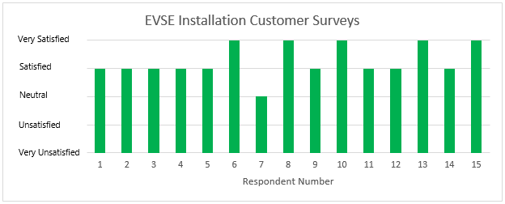

The following chart shows the status of commercial applications and installations by category[3]:



More complicated siting details, legal agreements, approval hierarchies, and equipment procurements all lead to longer lead times for commercial EVSE installations. A number of the pending installations represented in the chart above are nearing the point of construction, and the Company expects several completed installations by the time of the next report. Strong education and outreach efforts continue, partnering with businesses and local governments to create a pipeline of approved installations that achieves the pilot’s targets before the two-year deadline.

A much higher percentage of withdrawn applications have been experienced for commercial applications, compared to residential. This is due to high costs associated with pavement cutting and replacement, concrete work, and other factors involved in many commercial sites, such as in parking lots unavoidably distant from the nearest power source. As the Company has made site visits and contractor quotations have been provided in the smaller towns throughout Eastern Washington, even modest costs borne by the site host have resulted in application withdrawals. This is a significant concern as one desired outcome of the pilot is to establish a basic network of public EVSE across eastern Washington to help support longer distance EV driving in the region. As a way to overcome this barrier, the Company is exploring the feasibility of utilizing local contractors to complete premises wiring and construction, which may help reduce costs such as equipment transport and per diem expenses. Additionally, if this trend continues, it may be worth revisiting the amount of the premises wiring reimbursements, as discussed during the Open Meetings where the Company’s tariff filing was reviewed.

The number of public applications “on hold” are due to proposed locations judged to be of lesser value to the public in terms of proximity to desirable amenities and attractions, which would likely result in lower relative utilization. These applications will be reconsidered after sufficient time is given to promote the program and receive and evaluate additional applications from a variety of business organizations and local governments.

The first installation of a residential EVSE occurred on July 20, 2016 and the total number of port installations installed has increased to 32 at the time of this report. The Company has limited data available regarding charging behavior and baseline charging profiles at this time. Preliminary data from our network provider is summarized below. The table below shows the total charge sessions, kWh consumed, estimated lbs of C02 saved, and gallons of gasoline saved to date:

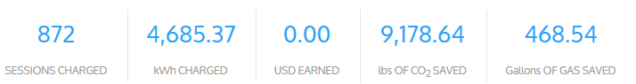

The charts below show the daily average number of charge sessions and kWh consumed for the limited number or chargers installed to date. In the future more data will be available regarding the average charging sessions and kWh consumed per installation.

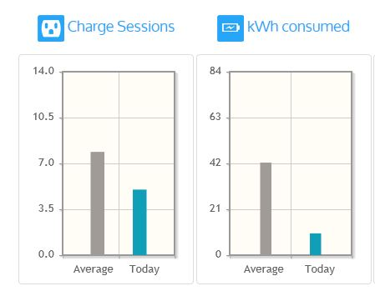

Expenditures through October 24, 2016 totaled $349,303. A summary of the expenditures is as follows, with a more detailed breakdown provided in Attachment A of this report:

$ 122,556 EVSE Hardware & Installation (AC Level 2)

$ 14,048 EVSE Hardware & Installation (DCFC)

$ 8,090 Premises Wiring Reimbursements

$ 182,298 Network Software & Data Management

$ 22,311 Other Project Expenses

$ 349,303 Total

The Company does not yet have sufficient information regarding revenues for each service offered. As the pilot progresses, this information will become available and reported.

Please direct any questions regarding this report to Rendall Farley at 509-495-2823, [rendall.farley@avistacorp.com](mailto:rendall.farley@avistacorp.com), or myself at 509-495-2782, [shawn.bonfield@avistacorp.com](mailto:shawn.bonfield@avistacorp.com).

Sincerely,

Shawn Bonfield

Sr. Regulatory Policy Analyst

Avista Utilities

[shawn.bonfield@avistacorp.com](mailto:shawn.bonfield@avistacorp.com)

509-495-2782

**Attachment A**

**Avista EVSE Pilot Program Expenditures through October 24, 2016**

|  |  |  |  |
| --- | --- | --- | --- |
| **Expenditure Category/Type** | **Capital** | **O&M** | **Total** |
| **DC Fast Charging Stations** |  |  |  |
| Hardware | $ - | $ - | $ - |
| Design and Installation | $ 14,048 | $ - | $ - |
| **Total** | $ 14,048 | $ - | $ 14,048 |
|  |  |  |  |
| **Residential Level 2 EVSE** |  |  |  |
| Hardware | $ 38,010 | $ - | $ 38,010 |
| Design and Installation | $ 26,105 | $ - | $ 26,105 |
| Premises Wiring Reimbursements | $ - | $ 6,905 | $ 6,905 |
| **Total** | $ 64,115 | $ 6,905 | $ 71,020 |
|  |  |  |  |
| **Workplace Level 2 EVSE** |  |  |  |
| Hardware | $ 26,912 | $ - | $ 26,912 |
| Design and Installation | $ 17,811 | $ - | $ 17,811 |
| Premises Wiring Reimbursements | $ - | $ 1,186 | $ 1,186 |
| **Total** | $ 44,723 | $ 1,186 | $ 45,909 |
|  |  |  |  |
| **Public Level 2 EVSE** |  |  |  |
| Hardware | $ 13,718 | $ - | $ 13,718 |
| Design and Installation | $ - | $ - | $ - |
| Premises Wiring Reimbursements | $ - | $ - | $ - |
| **Total** | $ 13,718 | $ - | $ 13,718 |
|  |  |  |  |
| **Other Project Expenses** |  |  |  |
| Network Software and Data Management | $ 182,298 | $ - | $ 182,298 |
| Maintenance & Administration | $ - | $ - | $ - |
| Communication Materials | $ - | $ 14,811 | $ 14,811 |
| Project Management | $ - | $ 7,500 | $ 7,500 |
| Auto Dealer Referral Incentive | $ - | $ - | $ - |
| **Total** | $ 182,298 | $ 22,311 | $ 204,609 |
|  |  |  |  |
| **Grand Total** | $ 318,901 | $ 30,402 | $ 349,303 |

1. Single Family Home
2. Multifamily Unit Dwelling
3. Completed – EVSE has been installed. Scheduled – EVSE is scheduled to be installed. Pending – customer application is pending full approval. Withdrawn – customer has withdrawn application from program. On Hold – customer application is on hold due to location of requested EVSE.