Exhibit No.___(SAH-1T)

BEFORE THE WASHINGTON UTILITIES AND TRANSPORTATION COMMISSION

DOCKET NO. UG-14____

DIRECT TESTIMONY OF

STEPHEN A. HARPER

REPRESENTING AVISTA CORPORATION

**I. INTRODUCTION**

**Q. Please state your name, business address, and present position with Avista Corp.**

A. My name is Stephen Harper and I am employed as Director of Gas Supply for Avista Utilities (Avista or Company). My business address is at 1411 East Mission Avenue, Spokane, Washington.

**Q. Would you please describe your education and business experience?**

A. Yes. I graduated from the University of Washington with a Bachelor of Science Degree in Mathematics. I joined the Company in 2008 as the Senior Manager of Natural Gas Acquisition. In 2012, I was appointed the Director of Gas Supply. Prior to joining Avista, I was a Principle with Evergreen Energy Company, LLC, a Spokane-based commodity hedge fund, from 2006 to 2008. From 1999 to 2006, I was employed as Manager of Asset Optimization with Avista Energy. From 1991 to 1999, I was Manager of Gas Supply with Puget Sound Energy (formally Washington Natural Gas Company). From 1990 to 1991, I was employed by Williams Energy Company as a Regional Marketing Representative in their Western Region. From 1981 to 1990, I held several positions with Washington Natural Gas.

**Q. Mr. Harper, what is the purpose of your testimony in this proceeding?**

A. The purpose of my testimony is to describe Avista’s natural gas procurement planning process and provide an update on the Company’s 2012 Natural Gas Integrated Resource Plan.

**Q. Are you sponsoring exhibits in this proceeding?**

A. Yes. I am sponsoring Exhibit No.___(SAH-2) which is a copy of the Company’s 2012 Natural Gas Integrated Resource Plan.

**Q. Is the Company proposing any changes to the cost of natural gas for its retail natural gas customers in this case?**

A. No, Avista is not proposing changes in this filing related to the cost of natural gas. Changes in the cost of natural gas included in customers’ rates are addressed in the Company’s annual PGA filing. The Company expects to make its annual PGA filing on or before September 15, 2014.

**II. PROCUREMENT PLANNING**

**Q. Please describe Avista’s natural gas portfolio as it relates to the procurement of natural gas for its local distribution company (“LDC”) customers?**

A. Avista purchases natural gas for its distribution customers in wholesale markets at multiple supply basins in the western United States and western Canada. Purchased natural gas can be transported through six connected pipelines on which Avista holds firm contractual transportation rights. These contracts provide access to both US and Canadian-sourced supply. The US-sourced gas represents 20% of the contractual rights and provides transportation from the Rocky Mountains. The remaining 80% provides access to Alberta and British Columbia supply basins. This diverse portfolio of natural gas resources allows the Company to make natural gas procurement decisions based on the reliability and economics that provide the most benefit to our customers. As natural gas prices in the Pacific Northwest can be affected by global energy markets, as well as supply and demand factors in other regions of the United States and Canada, future prices and delivery constraints may cause the source mix to vary.

Illustration No. 1 below is map showing our service territory, natural gas trading hubs, interstate pipelines, and natural gas storage facilities:

**Illustration No. 1**

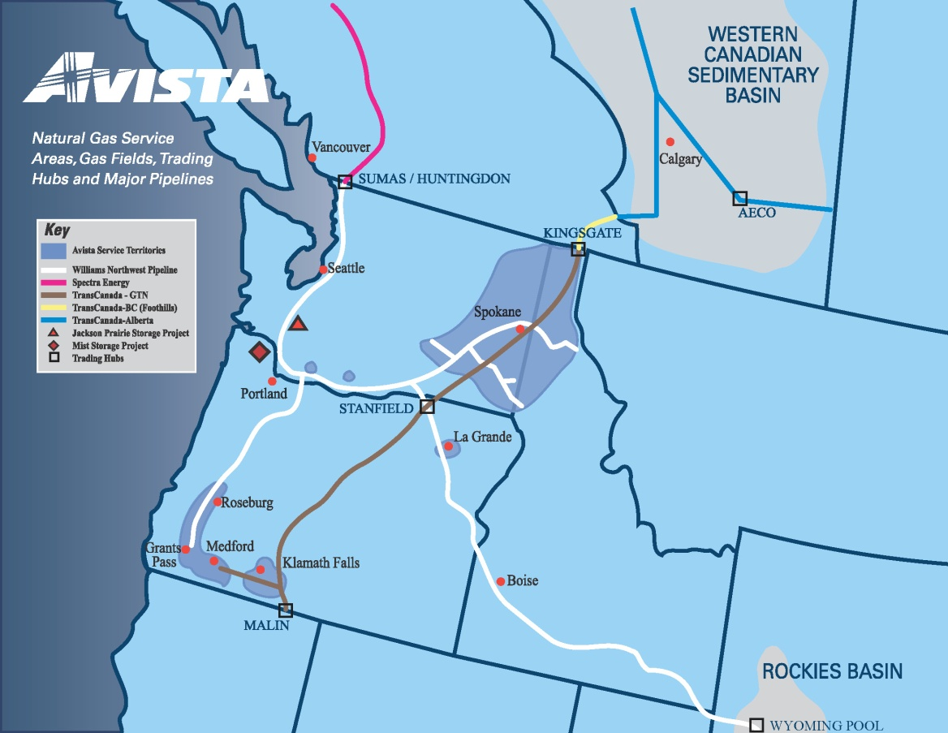

Future natural gas prices cannot be accurately predicted; however, market conditions, information, analysis, and experience shape our overall procurement approach. The Company’s goal is to provide reliable supply at competitive prices, with a level of price certainty, in a volatile commodity market. To that end, the Company utilizes a Procurement Plan which includes hedging (on both a short-term and long-term basis), storage utilization, and index purchases. This approach is diversified by transaction time, term, counterparty, volume and supply basin. The Procurement Plan is disciplined, yet flexible, and layers in fixed-price purchases over time and term to provide a level of price certainty to customers. A copy of the Company’s Natural Gas Procurement Plan is included as an exhibit to Avista’s Energy Resources Risk Policy (see Confidential Exhibit No.___(SJK-4C))

The Procurement Plan provides a process that fixes future gas prices for a pre-designated portion of the portfolio through the use of hedge windows. The hedge windows are “open” for a predetermined time period and have upper and lower pricing levels which are determined by the market at the time the window becomes effective. In a rising market, this reduces exposure to extreme price spikes. In a declining market, it can facilitate locking in lower prices. These windows can be executed, or “closed” if certain pricing levels are met, or upon time expiration if no pricing events occur. The Company always maintains some level of discretion and may choose not to execute within a window or to change some aspect of a window given market and fundamental conditions.

In addition, a portion of the portfolio that is separate from the defined hedge windows is designated as discretionary. This opportunistic portion of the portfolio allows the Company to hedge additional, predetermined volumes in gas years beyond the prompt year at potentially favorable pricing levels. In the event those pricing levels are not reached, the unexecuted volumes designated as discretionary hedges will then become a part of the prompt year hedging program.

Gas Supply continuously monitors the results of the Procurement Plan, evolving market conditions, variation in demand profiles, new supply opportunities, and regulatory conditions. Although various windows and targets are established in the initial design phase of the portfolio, the plan provides flexibility to exercise judgment to revise and/or adjust the Procurement Plan in response to changing conditions. Material changes to the Procurement Plan are communicated to Avista’s Senior Management, through the Risk Management Committee, and Commission Staff.

**Q. What delivery period does the natural gas Procurement Plan include?**

A. The Procurement Plan includes four complete natural gas operating years (November through October) and whole months remaining from the current month until the next October 31 period (the current natural gas operating year). The four complete upcoming natural gas operating years are designated “Prompt”, “Second”, “Third”, and “Fourth” years.

**Q. Please describe the components of the natural gas Procurement Plan.**

A. Each year a comprehensive review of the previous year’s plan is performed. The review includes analysis of historical and forecasted market trends, fundamental market analysis, demand forecasting, and transportation, storage and other resource considerations. The plan includes the following components:

1. **Previous Year’s Hedges** – longer-term fixed-price purchases executed as a part of a previous year’s Procurement Plan.
2. **Prompt Year Hedges** – the portion of the portfolio addressed through the utilization of hedge windows. In each window, fixed price purchases are made for various prompt year delivery periods. Prior to the execution of each window, market conditions, fundamental market knowledge, and other information are considered to determine if the hedge will be executed and the window closed.
3. **Storage** – utilizing the capacity and deliverability from the Jackson Prairie storage facility, Avista is able to inject natural gas during the summer months and withdraw it to serve customers during the higher demand winter months.
4. **Discretionary Long-term Hedges** – opportunistic purchases based on a set of price levels, or targets, which trigger possible execution. At the time the triggers are reached, evaluation of market conditions, fundamental market knowledge, and other information are considered. These hedges will generally be executed when they can be done at or below the established targets.
5. **Index Purchases** – physical index-based natural gas purchases are procured prior to or throughout the delivery month. These purchases are usually associated with daily pricing. The amount of index purchases planned is the difference between the forecasted demand less the sum of the previous year hedges, prompt year hedges, and storage withdrawals.

**Q. Please describe how the Procurement Plan manages supply to meet the volatility in customers demand, as well as manages the impact to customers from volatility in market prices.**

A. Natural gas demand is volatile and will vary day to day. For example, system-wide *average* daily demand can fluctuate between 27,000 dekatherms (Dth) per day during a summer month and 180,000 Dth/day during a winter month. Further, December’s system-wide daily demand volatility has ranged from a low of 100,000 Dth/day to a high of 300,000 Dth/Day. For 2013, the observed system-wide peak demand was 295,913 Dth/Day. Finally, from Avista’s 2012 IRP, system-wide peak day demand for the 2013-2014 heating season is forecasted to be approximately 320,000 Dth per day.

In order to manage these seasonal, monthly and daily volume swings, Avista shapes the components of the Procurement Plan by month (i.e. more natural gas is hedged for the winter months than for the summer). Illustration No. 2 below includes a chart that shows the demand volatility:

**Illustration No. 2**



Price volatility can also vary widely by season, month and day. Illustration No. 3 below includes a chart depicting the natural gas price volatility over time. Avista cannot predict with accuracy what natural gas prices may be, however, our experience and fundamentally based market intelligence guide our procurement decisions. By layering in fixed price purchases over time, setting upper and lower pricing levels on the hedge windows, opportunistically hedging at favorable pricing levels through the discretionary hedge program, and actively managing storage resources, Avista is able to meet our goal of providing a meaningful measure of price stability and certainty, together with competitive prices, for our customers.

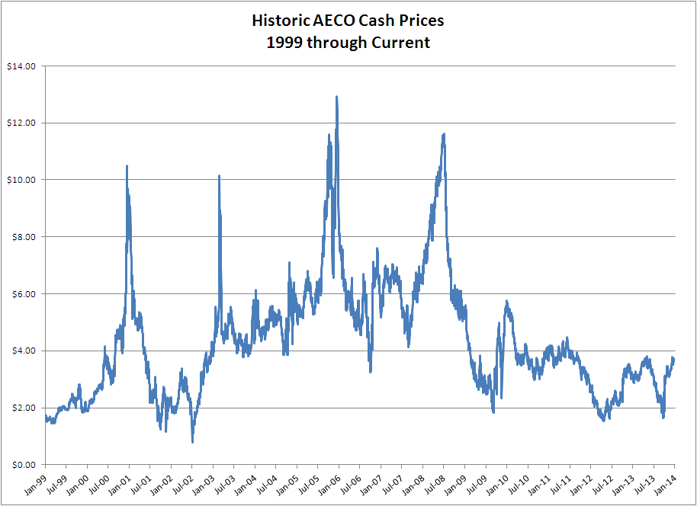**Illustration No. 3**

**III. JACKSON PRAIRIE STORAGE**

**Q. Please describe Avista’s involvement with the Jackson Prairie natural gas storage facility.**

A. Avista is one of the three original developers of the underground storage facility at Jackson Prairie, which is located near Chehalis, Washington. Although there have been corporate changes due to mergers, acquisitions and name changes, Avista, Puget Sound Energy (PSE) and Williams Northwest Pipeline each hold a one-third share (equal, undivided interest) of this underground gas storage facility through a joint ownership agreement. Development of the facility began in the 1960’s and the project first went into service in the early 1970’s. Puget Sound Energy is the operator of the facility.

**Q. What type of storage facility is Jackson Prairie?**

A. Jackson Prairie is an underground aquifer storage facility. Storage and the associated withdrawal and injection capability has been created by a combination of wells, gathering pipelines, compression and dehydration equipment, and the removal and disposal of aquifer water.

**Q. Please describe the present level of storage that Avista owns at Jackson Prairie.**

A. At the present time, Avista Utilities owns a total of 8,528,013 dekatherms (Dth) of capacity. This capacity comes with a withdrawal capability of 398,667 Dth per day (deliverability). Washington/Idaho’s current share of that capacity is 7,704,676 Dth and 346,667 Dth of deliverability. The remaining amount is allocated to our customers in the Oregon jurisdiction.

**Q. What are the benefits of storage to Avista’s customers?**

A. Access to regionally located storage provides several benefits to Avista customers. It enables the Company to capture seasonal price spreads (differentials) between summer and winter, improves reliability of supply, increases operational flexibility, mitigates peak demand price spikes and provides numerous other economic benefits.

**IV. 2012 NATURAL GAS INTEGRATED RESOURCE PLAN**

**Q. Please provide an overview of the Company’s development of its 2012 Natural Gas Integrated Resource Plan.**

A. On August 31, 2012, Avista filed with the Commission its Natural Gas Integrated Resource Plan. The IRP includes forecasts of natural gas demand and any supply-side transportation resources needed for the coming 20 years, which will help Avista continue to reliably provide natural gas to our customers. A copy of the Company’s 2012 Natural Gas Integrated Resource Plan is included as Exhibit No.___(SAH-2).

**Q. What are the summary highlights from the 2012 IRP?**

A. Highlights from the 2012 IRP are as follows:

* The Company forecasted sufficient natural gas resources well into the future with resource needs not occurring until 2028 in Oregon and 2030 in Washington and Idaho;
* The major change from the 2009 IRP was that customer growth had slowed, and it was not anticipated to rebound in the near term, and use per customer had declined;
* The price of natural gas had dropped significantly since our last IRP. Robust North American supplies led by shale gas developments coupled with low demand growth due to the economy had pushed prices down to levels not seen in the last decade; and
* As forecasted demand is relatively flat, the Company will monitor actual demand for signs of increased growth which could accelerate resource requirements.

**Q. Has the Company’s 2012 IRP been acknowledged by the Commission?**

A. Yes, the Company’s IRP was acknowledged by the Commission on February 11, 2013.

**Q. When will the Company file its next IRP?**

A. The Company will file its next IRP on or before August 31, 2014. On August 31, 2013, the Company filed its Natural Gas IRP Work Plan in compliance with WAC 480-90-238. That work plan detailed Avista’s IRP planning process, as well as tentative dates and content for meetings with the Technical Advisory Group, which includes Commission Staff. Technical Advisory Group meetings began January 2014.

**Q. Does this complete your pre-filed direct testimony?**

A. Yes, it does.