BEFORE THE WASHINGTON UTILITIES AND TRANSPORTATION COMMISSION

DOCKET NO. UE-17________

DOCKET NO. UG-17________

DIRECT TESTIMONY OF

JAMES M. KENSOK

REPRESENTING AVISTA CORPORATION

# I. INTRODUCTION

Q. Please state your name, employer and business address.

A. My name is James M. Kensok. I am employed by Avista Corporation as the Vice-President and Chief Information and Security Officer. My business address is 1411 E. Mission Avenue, Spokane, Washington.

Q. Mr. Kensok, please provide information pertaining to your educational background and professional experience?

A. I am a graduate of Eastern Washington University with a Bachelor of Arts Degree in Business Administration, majoring in Management Information Systems and from Washington State University with an Executive MBA. I have experience through direct application and management of Information Services over the course of my 34-year information technology career. I joined Avista in June of 1996. Over the past 20 plus years, I have spent approximately one year in Avista’s Internal Audit Department as an Information Systems Auditor with involvement in performing internal information systems compliance and technology audits. I have been in the Information Services Department for approximately 19 years in a variety of management roles directing and leading information systems, infrastructure technology and security strategy, system delivery and operations, complex communication networks, cyber security, applications development, outsourcing agreements, contract negotiations, technical support, cost management, and data management. I was appointed Vice-President and CIO in January of 2007 and Chief Security Officer in January of 2013.

A table of contents for my testimony is as follows:

Description Page

I. INTRODUCTION 1

II. IS/IT OVERVIEW 2

A. Networks 4

B. Data Management and Analytics 4

C. Mobility 5

D. Security and Business Continuity 6

E. Technology Refresh and Expansion 8

F. Customer Engagement 9

III. IS/IT CAPITAL PROJECTS 9

IV. IS/IT OPERATING AND MAINTENANCE EXPENSES 23

Q. Are you sponsoring any exhibits in this proceeding?

A. Yes. I am sponsoring Exhibit JMK-2, which includes the Information Technology Capital Project Business Cases.

# II. IS/IT OVERVIEW

**Q. What is Avista’s approach to information technology?**

A. Overall, information technology for Avista is generally driven by the need for cyber security systems to protect customer data and critical utility operations, legal and regulatory requirements, cost-effective replacement of information technology assets, management of information technology obsolescence, efficient and cost-effective work processes, and training.

Avista’s approach to making investments in information technology is a multistep process, which consists of identifying, analyzing, assessing and decision-making. Avista identifies foundational technologies that support an evolving digital business model aligned with industry best practices and customer needs (e.g., safe and reliable infrastructure, real-time customer engagement, and cyber security).

**Q. Please provide a brief overview of the foundational areas of Avista’s technology investment.**

A. The core information technology investments are focused in the following six technology areas:

1. **Networks**
2. **Data Management and Analytics**
3. **Mobility**
4. **Security and Business Continuity**
5. **Technology Refresh and Expansion**
6. **Customer Engagement**

Making investments in these six areas in the utility industry is not new — and has been the focus of information technology for decades — but these areas are experiencing significant change as a result of new technologies, increases in volume and velocity of data, the sophistication of cyber-attacks, and consumer behavior.

Based on these changes, Avista is focused on 1) responsive field staff and crews who are able to communicate and transmit information across a reliable network; 2) near real-time integrated data and analytics to improve customer satisfaction and employee productivity; 3) near real-time information exchanges between customers and Avista through varying mobile devices in the field and on the web; 4) strong and skilled defenses against increasingly sophisticated cyber threats to the utility industry; and 5) the tools to help customers manage their energy consumption and pay for the services they use. A brief summary, with examples, is provided below:

## Networks

Networks are the backbone of Avista’s communication infrastructure, continuously transmitting critical data, information, and voice communication across our entire system to support daily operations and responsiveness to our customers.

An example of a critical network technology investment is replacing Avista’s aging microwave equipment and systems with current technology to provide for high speed voice and data communications that receive and transmit data for electric and natural gas operations across all jurisdictions. Avista’s current network technology is past its useful life and is no longer supported by the manufacturer. Many of the communication sites to be replaced not only serve as primary communication paths for critical data, but also as redundant paths during network outages. Maintaining redundant paths allows for business continuity in the event of an outage. Avista’s customer service representatives, field staff workers, and crews all rely on the same networks to communicate with customers regarding service connects, disconnects, outages, etc. Continuous investment in network systems technology has a direct impact on customer satisfaction, as we build our ability to communicate directly with our customers in the field, on the phone, and through the web.

## Data Management and Analytics

Data Management is part of the fabric of our company and informs daily decisions to improve operational efficiencies and respond to customer requests. We use data to determine optimal dispatch of generation resources to meet our customer loads, to determine our future demand for electricity and natural gas, and to ensure that customer needs and preferences are addressed. We use call volume data to adjust customer service representative staffing times to align with customer call volume. We use data to schedule our crews. Through research with other utilities (e.g., CenterPoint Energy) Avista is learning about foundational data and analytics technology platforms and business use cases that support customer-focused programs. As such, Avista is focusing on additional uses of data and analytics to help advance workforce efficiency, as well as to assess existing and new customer programs.

## Mobility

Improved mobile technology is changing what it means to “digitally enable” our utility workforce and our customers. Mobile technology has been one of the fastest-growing technology areas in the past 10 years, mainly as a result of the rapid growth in consumer mobile device technologies and applications, such as tablets, smart phones, and applications (apps). These new devices are key components of future mobile workforce enablement at Avista. For example, the mobile system design tool provides field personnel with powerful functionality to meet customer responsiveness expectations, such as: providing electronic receipt and completion of construction work orders; access to Geographic Information System (GIS) data in the field; capture of as-built configuration and materials; and document asset and compliance data electronically by taking advantage of a variety of data sources, including digital image data, keyed data, bar code scanned data, and Global Positioning System (GPS) location data.

Mobile customer interaction technology enables Avista to deliver information and services to customers using smartphones or tablet computers, and to deliver communications and services via short message service (SMS) or text messaging. New responsive design allows desktop webpages to be viewed in response to the size of the screen or web browser so that Avista can interact with a broader customer base via smaller screen mobile devices.

A mobile-friendly website that is connected to relevant systems of record allows customers to access Avista’s information system for bill presentment and payment, the outage management system for outage reporting, and the meter data management system for customer consumption analytics.

Mobile customer interaction channels help improve customer-facing functions and outbound notifications. Mobile access can reduce call center volumes resulting in reduced hold times and enhanced customer satisfaction. It can also increase adoption of electronic billing and payment transactions resulting in lower processing costs.

## Security and Business Continuity

Security technologies in the electric and natural gas utility industry are critical to the protection of the energy infrastructure and of Avista’s sensitive customer data, employee data, operating data and financial data. Investments are necessary to protect Avista’s utility assets and to prepare for the appropriate response and recovery when there is a security incident, a data breach, or when a disaster event takes place. Avista’s security program focuses on protecting its physical and cyber assets, including protecting against a data breach.

The number of U.S. data breaches tracked in 2016 hit an all-time record high of 1,093 according to a report released by the Identity Theft Resource Center (ITRC) and CyberScout (formerly IDT911). This represents a substantial increase of 40 percent over the near record high of 780 reported in 2015. Avista’s security program is critical to defend against a data breach. Illustration No. 1 is a graph from ITRC showing the steep increase in data breach incidents through 2016 by a variety of sources.

**Illustration No. 1:**

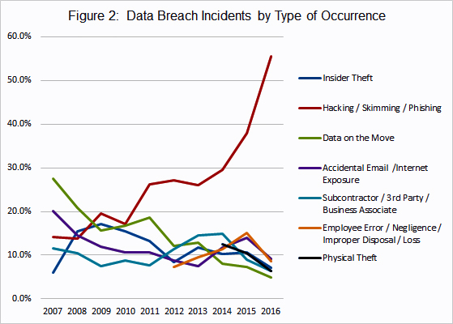

Avista is a member of the AGA/EEI cyber security task force that analyzes and follows best security practices for protecting the utility industry using the National Institute of Standards and Technology (NIST) framework. Avista is an active participant in additional industry security groups, such as Downstream Natural Gas Information Sharing and Analysis Center (DNG-ISAC) that serves natural gas utility (distribution) companies, Electricity Information Sharing and Analysis Center (E-ISAC) that serves electric utilities, EEI Cyber Mutual Assistance that serves electric and natural gas utilities, and the use of Transportation Security Administration’s (TSA) Pipeline Security Guidelines, as well as others.

In addition to being an active participant in protecting U.S. critical infrastructure and following best practices in security, Avista appropriately invests in its business continuity program, following the industry standard NIST framework which focuses on the following: Identify, Protect, Detect, Respond, and Recover. Avista also follows the Federal Emergency Management Administration (FEMA) Incident Command System (ICS) for planning, response and recovery efforts. Continuous investment in security and business continuity programs and technologies is a technology investment priority to maintain a safe and reliable energy infrastructure and to protect sensitive customer data, employee data, operating data and financial data.

## Technology Refresh and Expansion

Through our technology refresh and expansion program, Avista evaluates and plans the direction of its information technology (“IT”) portfolio. A team of IT professionals, managers, and directors guide the technology refresh and expansion program analyzing the benefits and costs of investing in new technology and maintaining existing technology. The team considers whether the current technology environment is stable and secure so that it is in Avista’s and its customers’ best interests to maintain it, and if so, for how long. If not, other options that may better suit the technology needs of Avista and its customers are discussed. The technology refresh and expansion program also evaluates the risks of not making an immediate technology change or pushing a change to a later date. Periodic technology planning sessions are held, which includes Vice Presidents, Directors and Managers from various business units, to review and discuss initiatives and guide project prioritization. Decisions based on the discussions in these technology refresh and expansion planning sessions are documented in more formal business cases that guide future technology investments.

## Customer Engagement

Customer engagement is how we identify and respond to customer expectations. Throughout our industry, customers continue to expect more value for their energy costs and are interested in a variety of offerings that can simplify their interactions with Avista and give them more information about, and control over, their energy use.[1]

Research shows that by 2018 more than 50 percent of our customers will use a tablet or smartphone technology first for all online activities[2]. To meet our customers’ expectations we must stay abreast of the technological changes and be prepared to offer services and choices that align with customers’ everyday use. For example, environmentally conscious consumers may be interested in managing their carbon footprint by electing to pursue alternative energy resources, setting up auto-payments, or receive alerts when reaching preset therm or kilowatt hour thresholds. Only through continuous customer engagement can we truly understand and begin to meet their changing needs and expectations, which are growing beyond just electric and natural gas services.

# III. IS/IT CAPITAL PROJECTS

**Q. Company witness Mr. Morris identifies the six “Investment Drivers” or classifications of Avista’s infrastructure projects and programs. What are the Company’s planned investments in IS/IT, and how do they fit within the six investment drivers?**

A. The six Investment Drivers are summarized as follows:

1. Customer Requested - Respond to customer requests for new service or service enhancements;
2. Customer Service Quality and Reliability - Meet our customers’ expectations for quality and reliability of service;
3. Mandatory and Compliance - Meet regulatory and other mandatory obligations;
4. Performance and Capacity - Address system performance and capacity issues;
5. Asset Condition - Replace infrastructure at the end of its useful life based on asset condition, and
6. Failed Plant and Operations - Replace equipment that is damaged or fails, and support field operations.

The IS/IT capital projects planned to be transferred to plant in service during the period 2017 through 2021 are shown in Table No. 1 below. The projects are grouped together under the relevant investment driver. The table also identifies the specific projects that are included by Company witness Ms. Schuh in the Traditional Pro Forma Study, and the projects that are included in the EOP Rate Base Study and Rate Year Study. An explanation of each of the projects follows the table.

**Table No. 1:**



**Projects in Traditional Pro Forma Study**

**Asset Condition:**

**Technology Refresh to Sustain Business Process – 2017: $21,191,000**

Avista manages an ongoing program to systematically-replace aging and obsolete technology under “refresh cycles” that are timed to optimize hardware/software system changes and industry trends. The business case program generally has over one hundred active projects each year. The scope spans technology solutions for back office, customer facing, energy operating and control systems. An example of the 2017 project scope is as follows: Oracle E-Business Suite, Enterprise Budget Tool Replacement, BizTalk Upgrade, Cognos Upgrade, Metropolitan Area Network Transport Backhaul Refresh, Spokane Field Area Network Refresh, MS Exchange 2013 Upgrade, SCCM Software Package Implementation, Virtual Server Upgrade, and Linux Operation System Upgrade. This technology investment is made at this time based on technology lifecycle planning and risk management. The decision to make this technology investment will lessen the use and maintenance of obsolete or custom technology and optimize integrations with other commercial off-the-shelf (COTS) investments. If we delay or cancel this technology investment, Avista risks various technologies that currently support automated business processes and operational efficiencies, to degrade and fall risk to technology obsolescence and security vulnerabilities due to loss of maintenance, support and patching.

**Performance and Capacity:**

**Technology Expansion to Enable Business Process – 2017: $13,941,000**

This program facilitates technology growth throughout Avista, including technology expansion for the entire workforce, business process automation and increased technology to support efficient business processes. For example; when trucks are added to the fleet, communication equipment needs to be added to the truck; as Avista hosts more customer data, disk storage needs to be expanded, as customers expand their use of the website, additional computing capacity is needed. This investment is made at this time to promote efficiencies through automated business technologies that allow Avista to gather, transmit, and analyze more information and guide sound business decisions. If we delay or cancel this technology investment, Avista risks a longer lag in business automation, which can result in longer wait times, manual business processes, and system-wide inefficiencies.

**Projects in EOP Rate Base Study and Rate Year Study**

**Asset Condition:**

**Microwave Refresh – 2017: $5,322,000; 2018: $2,100,000; 2019: $2,100,000, 2020: $2,247,000**

Avista manages an ongoing program to systematically-replace aging and obsolete technology under “refresh cycles” that are timed to optimize hardware/software system changes. This project will replace aging microwave communications technology with current technology to provide for high speed and more reliable data communications. These communication systems support relay and protection schemes of the electrical transmission system. The decision to make this technology investment at this time will reduce Avista's risk that failure of these critical communication systems will have a significant impact on Avista's transmission capacity and ability to serve our customers electrical needs. If we delay or cancel this microwave refresh technology investment, Avista risks out of date communications technology that could result in a shut-down of critical communications and transmissions systems.

**Project Atlas – 2017: $6,563,000; 2018: $9,734,000; 2019: $807,000; 2020: $12,500,000; 2021: $11,600,000**

Avista Facility Management (AFM) is the legacy custom-coded system that the utility uses to manage the location and current operating state of its critical electric and gas assets (e.g. pipes, poles and wires). Environmental Systems Research Institute (ESRI) GIS serves as the foundational data structure on which AFM applications are built or rely on. AFM is the system of record for spatial electric and gas facility data and provides the connectivity model to support the AFM applications. This program replaces legacy custom-coded systems with COTS technology common in the utility industry. Project examples include the replacement of the Electric and Gas Design tools, which are applications for the design of electric and gas facilities, as well as Electric and Gas Edit tools inherent in the system used for data edits prior to committing final data changes and additions. These tools also include a mobile version for in-the-field updates by field staff, resulting real time changes in the system, as well as meeting customer responsiveness expectations. For the reliability of system records and the efficiency reasons stated above, this technology investment is made at this time. If we delay or cancel this AFM technology investment, Avista risks not having up to date information on our natural gas and electric assets that could result in harm to our customers, crews and business operations.

**Technology Refresh to Sustain Business Process –2018: $16,957,000; 2019: $14,140,000; 2020: $18,000,000; 2021: $23,000,000**

Please see the explanation for the Technology Refresh Project description above, as well as the additional explanation later in my testimony regarding Technology Refresh.

**Customer Service Quality and Reliability:**

**AvistaUtilities.com Redesign – 2017: $9,093,000**

Like many businesses today, Avista is experiencing continued growth in the use of its customer website, Avistautilities.com. The website was originally built in 2006-2007, but because the technology landscape has advanced so quickly, the site does not meet current web best practices for customer usability and security. This project updated and improved the technology, overall web usability, security and customer satisfaction. Not replacing the aging website, would limit its potential for customer engagement opportunities and open it to security risks. The website is part of Avista’s plan to provide customers a more effective channel to meet their expectations for self-service options, including mobile, energy efficiency education, and to drive self-service as a means to lower transaction costs. After the revenue requirement was finalized in this case, it was determined that the transfer to plant amount has increased to approximately $12 million on a system basis. The Company will update this business case throughout the process of this case. If we were to delay or cancel this technology investment, it would pose risks to customer data security on the existing website platform.

**Customer Facing Technology – 2017: $1,830,000; 2018: $2,237,000; 2019: $1,900,000; 2020: $2,000,000; 2021: $2,000,000**

In an effort to keep pace with customer demands and quickly changing technologies, Avista intends to expand on the foundational technologies established during previous business cases, and offer more channels of choice including self-service options that meet customer needs and help reduce overall business cost. A primary example of a project funded under the Customer Facing Technology Program business case is the expansion of our outage mobile app to include payments, SMS messaging around payments and billing, and “pay by text” functionality. Expanding our mobile options can reduce call center volumes, resulting in reduced hold times and enhanced customer satisfaction. It can also increase adoption of electronic billing and payment transactions, which can lead to lower processing costs. Efforts like this are focused on providing tools for our customers that support general consumer preferences for mobile devices. The decision to make this technology investment now is based on industry practice and trends.[3] If we delay or cancel this technology investment, Avista risks longer call center wait times, lower customer satisfaction and generally, less efficient and higher cost operations.

**Mandatory and Compliance:**

**High Voltage Protection for Substations – 2017: $937,000; 2018: $30,000**

Telecommunication facilities, including Phone, Communication Switches, SCADA, and Metering & Monitoring systems, are commonly co-located inside Avista’s high voltage substations. This requires communications technicians to work in close association with our high-voltage electrical equipment. Avista has implemented new high-voltage protection & isolation standards that are designed to lower potential risks to our personnel and equipment. The decision to make this technology investment at this time will ensure implementation of the clearance changes required to meet the new standards and will result in a safer working environment for our crews who work in close proximity to high voltage electrical equipment. If we delay or cancel this high voltage protection upgrade investment, Avista crews will be at a higher risk of injury or death.

**Next Generation Radio Refresh – 2017: $102,000**

This project is refreshing Avista’s 20-year-old Land Mobile Radio system. Avista maintains this private system because no public provider is capable of supporting communications throughout our rural service territory. And, since our systems comprise a portion of our nation’s critical infrastructure, Avista is required to have a communication system that will operate in the event of a disaster. This technology investment is made at this time to fulfill a mandate from the Federal Communications Commission that all licensees in the Industrial/Business Radio Pool migrate to spectrum efficient narrowband technology. If we delay or cancel this technology investment, Avista risks a less efficient and reliable critical infrastructure communication system and potentially significant fines and penalties, and potential loss of our two-way radio license.

**Performance and Capacity:**

**Enterprise Business Continuity Plan - 2017: $665,000; 2018: $486,000; 2019: $450,000; 2020: $450,000; 2021: $450,000**

Avista has developed and maintains an Enterprise Business Continuity Program to support Avista’s emergency response, and to ensure the continuity of its critical business systems under crisis conditions. The framework includes the key areas of technology recovery, alternate facilities, and overall business processes. The effort of developing and continuously improving the program ensures the readiness of systems, procedures, processes, and people required to support our customers and our communities any time we are required to operate under critical emergency conditions. A Business Impact Assessment (BIA) typically drives the need for improvement projects, however some projects are funded based on quality issues with existing infrastructure following an annual exercise or actual event. Projects within this business case may also support regulatory requirements. The decision to make this technology investment now is based on the continued need for reliable emergency and business continuity systems to protect Avista’s critical technology and ensure continued operations. If we delay or cancel this technology investment, Avista risks a potential complete shut-down of operations and communications in the event of an emergency.

**Enterprise Security – 2017: $3,816,000; 2018: $3,639,000; 2019: $1,710,000; 2020: $4,000,000; 2021: $3,600,000**

There are three primary drivers of the increasing costs for Enterprise Security: cyber security, physical security and regulatory standards. Each plays a critical role in supporting our delivery of safe and reliable energy to our customers.

Cyber Security

The security of our electric and natural gas infrastructure is a significant priority at a national and state level, and is of critical importance to Avista. Threats from cyber space, including viruses, phishing, and spyware, continue to test our industry’s capabilities. And while these malicious intentions are often unknown, it is clear the methods are becoming more advanced and the attacks more persistent. In addition to these threats, the vulnerabilities of hardware and software systems continue to increase, especially with industrial control systems such as those supporting the delivery of energy. The decision to make this technology investment now is based on Avista’s need to advance its cyber security program and invest in security controls to prevent, detect, and respond to increasingly frequent and sophisticated cyberattacks.

Physical Security

While considerable attention is focused on cyber security, physical security also remains a concern for our industry. Physical security encompasses the aspects of employee safety and the protective security of our facilities and critical infrastructure. Acts of theft, vandalism, and sabotage of critical infrastructure not only results in property losses, but can also directly impact our ability to serve customers. Securing remote unmanned or unmonitored critical infrastructure is difficult, especially when traditional tools such as perimeter fencing by itself are not adequate. In response to these challenges, Avista is investing in additional physical security equipment, expertise and technology. The decision to make this technology investment now is based on the need to protect our utility assets from theft and vandalism and employees from acts of terror or violence through additional physical security protection measures (i.e., lighting and crash barriers), remote detection and response technology.

Regulatory Obligations

Advancing cyber threats continue to drive change in the regulatory landscape faced by Avista and the utility industry. Early in 2013, President Obama issued the Executive Order “Improving Critical Infrastructure Cyber Security.” The Order directed the National Institute of Standards and Technology (NIST) to work with stakeholders in developing a voluntary framework for reducing cyber risks to critical infrastructure. The framework consists of standards, guidelines, and best practices to promote the protection of critical infrastructure. On May 11, 2017, a new Executive Order “Strengthening the Cybersecurity of Federal Networks and Critical Infrastructure” was issued that builds upon the 2013 Executive Order and addresses cybersecurity requirements in federal networks, in critical infrastructure and for the nation in general. The Federal Energy Regulatory Commission also issued Order 791 on November 22, 2013, approving the North American Electric Reliability Corporation (NERC) Critical Infrastructure Protection (CIP) Standards, Version 5. Both of these activities will increase our security-related operating costs because they require Avista’s security controls and processes to conform to new standards, guidelines, and best practices, and is the basis for the decision to make this technology investment now. For example, Avista is required by NERC to adhere to the new CIP v.5 Standards by 2018. In addition Avista also has requirements under the Payment Card Industry (PCI) standards. These standards continue to change as updates are made to the standards on a 1-2 year cycle. If we delay or cancel Enterprise Security technology investments, Avista risks non-compliance with federal mandates and recommendations, a weaker and less reliable infrastructure (both cyber and physical), and we risk placing electric and gas operations, sensitive customer and employee information and the safety and security of people and critical operations and systems in jeopardy.

**Technology Expansion to Enable Business Process – 2018: $14,350,000; 2019: $12,315,000; 2020: $14,000,000; 2021: $14,000,000;**

Please see the above explanation for the Technology Expansion Project description, as well as the additional explanation later in my testimony regarding Technology Expansion.

**Q. A major portion of Avista’s planned technology investment falls within the Technology Refresh and Technology Expansion Programs. Please further explain Avista’s Technology Refresh Program.**

A. Avista’s Technology Refresh Business Case supports technology replacement across six technology domains: 1) Distributed Systems, 2) Central Systems, 3) Communication Systems, 4) Network Systems, 5) Environmental Systems, and 6) Business Applications. Each technology domain is governed by a Program Steering Committee that guides annual project priority in response to Avista’s overall approach to technology and technology roadmaps, while balancing the risk of reliability and functionality. The Technology Refresh Business Case refreshes existing technology in alignment with roadmaps for application and technology lifecycles.

At a fundamental level, Avista’s Technology Refresh Business Case is necessary to allow Avista to effectively manage its technology portfolio, given that IT assets are foundational in the provision of utility service, and that IT components naturally become outdated or reach technological obsolescence over a period that is much shorter than the life of other utility assets such as a natural gas pipe in the ground. As technology assets reach manufacturer-planned or real obsolescence, vendor support for these assets is reduced, or ceases altogether. As vendor support ends, the risk associated with Avista’s business systems that rely upon these technology products increases and the value provided by these business systems is jeopardized. These factors present a risk to Avista in the form of increased failure rates, inefficient work practice, employee/public safety incidents due to system failures, and reduced customer satisfaction, among other areas of risk.

**Q. Please explain how the Technology Refresh Program refreshes existing technology in alignment with roadmaps for applications and technology lifecycles?**

A. Information technology components have varying useful lives. For example, servers tend to have a shorter lifespans, while the lifespan of network switches tends to be longer. Additionally, software vendors regularly update their products to provide improved functionality, maintain and improve security, and implement bug fixes. It is generally Avista’s practice to replace technology within an acceptable failure tolerance outside of the vendor recommended lifecycles. For example, Avista completed its upgrade to Microsoft Office 2013 in 2015 and 2016. Prior to this upgrade, Avista had been using Microsoft Office 2007. By prudently managing its upgrade cycles and using Microsoft Office 2007 for an extended period, Avista was able to avoid the intermediate upgrade to Microsoft Office 2010.

With that said, approximately 25 percent of Avista’s asset base of more than 10,000 assets recorded in the technology asset management system have exceeded the manufacturer suggested lifecycle. As a result, the demand for technology refresh investment has continued to grow over time (a natural outcome of the growth in the installed base of information technology assets as the modern utility continues to rely more and more on enabling technologies).

Illustration No. 2 shows the level of demand for capital investment within the Technology Refresh Business Case, along with the level of capital investment approved by the Capital Planning Group (“CPG”) (approximately $18 million from 2016 through 2020, and $23 million in 2021, as indicated by the red line). This illustrates the work Avista is doing to limit the amount of capital investment, while remaining attentive to the risk associated with not making timely investments to refresh its technology assets.

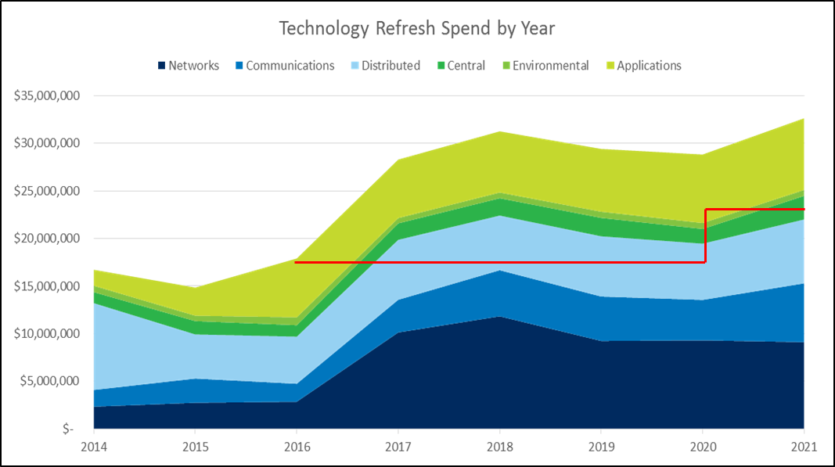**Illustration No. 2:**

Technology Refresh Demand vs Spend by Year

CPG Funded

**Q. Please explain the growth in investment associated with the Technology Expansion Program.**

A. The growth in investment in the Technology Expansion Program in recent years has primarily been driven by applications and networks. This program addresses many types of application investment projects, including projects that increase end user counts of existing COTS applications, functionality enhancements of existing COTS applications, functionality enhancements of custom applications, and investments in new COTS applications. Examples of application investment include: Customer Care and Billing (CC&B) and Work and Asset Management (Maximo) systems, Energy Settlements & Risk Management (Nucleus) system, Geographical Information System (GIS), Oracle Financials & Power Plant System, and other enhancements and license expansion.

Additionally, this program addresses many types of network investment projects, including projects that expand Avista’s network infrastructure (e.g., in offices, substations, plants, meters, and data centers, etc.) Examples of network investment under this program include hardware, software, fiber optic products, and services for inside and outside construction. The network sub-program is experiencing growth within the data center, among other areas. Primary drivers within the data center have been increasing numbers of applications, increasing security controls, and an increasing need for enhanced network management systems. Data center operations support Avista’s business applications and are beneficial to all jurisdictions, and to all customers.

Illustration No. 3 below shows the level of demand for capital investment within the Technology Expansion Business Case, along with the level of capital investment approved by the CPG ($14.6 million in 2016, $14 million from 2017 through 2020, and $19 million in 2021, as indicated by the red line). This illustrates the work Avista is doing to limit the amount of capital investment, while remaining attentive to making timely investments to enable, maintain or enhance our critical technology systems.

**Illustration No. 3:**

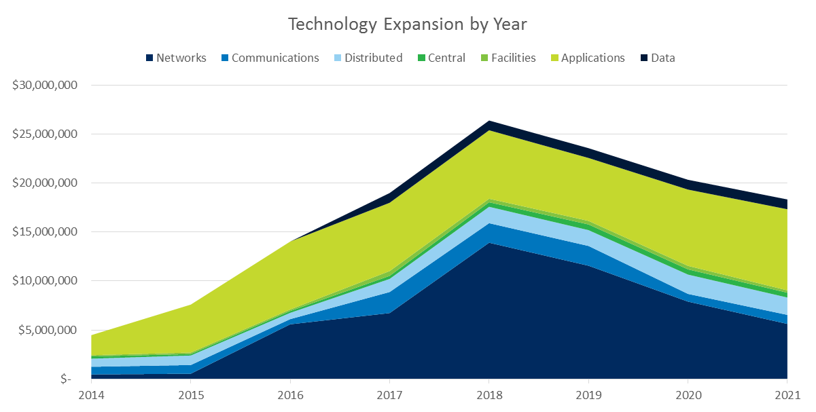

Technology Refresh Demand vs Spend by Year

CPG Funded

**Q. Please provide some examples of the types of Technology Refresh and Technology Expansion projects that were not approved as shown in the illustration Nos. 2 and 3 above (projects above the red line), and the risk associated with not completing or deferring these projects.**

A. Examples of projects that were not approved during the 2016-17 budget cycle include:

* Oracle Database Upgrade Project Delay. This technology investment was delayed due to competition for funding. This delay will result in more manual driven processes, higher inefficiencies, and less digital integration with other programs. Due to the decision to delay this project, we may experience inefficiencies in delivering customer bills, answering customer questions, processing customer payments, and in dispatching crews that may ultimately result in higher costs to customers and lower customer satisfaction with our services.
* Fiber Network Expansion Projects. This technology investment was deferred due to competition for funding. The delay in these projects will result in not being in lock-step with the Transmission Rebuild Schedule, thereby needing to access private property multiple times, taking additional outages on the transmission line where Optical Ground Wire (OPGW) is planned to be installed, and delaying other business initiatives, such as SCADA at every substation, mobility, and security monitoring.
* Asset Management System Mobile Enhancement Project. This technology was deferred due to competition for funding. The delay in this project will result in the continuation of inefficient manual work processes for collecting asset information, conducting audits and inspections, and updating asset data to support other interdependent business processes, such as work order assignments, etc.

1. **How does Avista cut costs during a refresh and/or expansion initiative?**

A. The cost of a refresh is dependent on several factors. During the time spent evaluating, vetting, and negotiating with vendors, we work to identify the best products and service pricing. Avista considers the IT components or systems being refreshed, the new technology replacement, and the costs to integrate with other components and systems. For multiple components, multiple vendors and subject matter expert teams are often needed. However, integrated solutions that offer a single-vendor solution that may help cut costs by integrating a portion, or in some cases, components of a traditional IT application portfolio into a platform (e.g., CC&B and Meter Data Management share a common Oracle platform) are pursued.

**Q. Please explain how Avista prioritizes technology investments.**

A. During each annual planning cycle, the respective technology business case owner surfaces the project demand or roadmap for the upcoming five years to the Technology Planning Group (“TPG”) and Executive Technology Steering Committee (“ETSC”) with a recommended business case priority, including the factors driving the current and expected need and timing for the investment. Avista’s technology initiatives are established by senior executives who are members of the ETSC. The TPG sets priority across the technology investment portfolio, balancing business value and customer benefits, and based on the ETSC’s guidance. Through a mid-year special session, the TPG and ETSC provide an objective review of all technology investment demands and prioritize requests based on mandatory investment drivers and customer benefits. Projects with the highest business value and customer benefit are prioritized, while projects that cannot demonstrate similar merits are returned for reconsideration. An additional filter is applied following this vetting by the TPG and respective business case owners considering resource capacity, risk assessment criteria, and alternatives. Following this exercise, the overall technology investment plan of approved projects is submitted to the CPG for funding consideration across all other Avista business cases, as part of the overall demand for capital. Projects that were not approved for consideration are not included in the list of project demand provided to the CPG.

The CPG establishes limits on annual capital investment through a published five-year plan. The five-year plan requires the TPG and technology business case owners to review and revise their initial investment plan to fit within the new established investment level. Steering committees prioritize technology asset risks, such as lifecycle obsolescence, business impact if failure occurs, vendor specifications to maintain support, and roadmaps of integrated technology strategy, while considering the resource capacity and funding constraints for each year. Technology asset refresh funding is generally assigned priority in this sequence: Safety, Energy Control, Customer Facing, and Back Office.

# 

# IV. IS/IT OPERATING AND MAINTENANCE EXPENSES

**Q. Please summarize the increases in O&M expenses, to arrive at IS/IT O&M expenses included in this case effective May 1, 2018.**

A. In Company witness Ms. Andrews’ Traditional Pro Forma Study, she has pro formed the level of expected information services and technology expenses, which includes both incremental labor costs and non-labor costs, associated with software development, application licenses, maintenance fees, and technical support for a range of information services programs that will be in place during the rate period beginning May 1, 2018. These incremental expenditures are necessary to support Company cyber and general security, emergency operations readiness, electric and natural gas facilities and operations support, and customer services.

Table No. 2 below summarizes the net increase in IS/IT O&M expenses for the rate year on a system basis. A discussion of these increases are provided following Table No. 2.

**Table No. 2:**

Q. Please discuss the specific projects driving the incremental labor and O&M increases?

A. Incremental changes to labor operating expenses are largely driven by capital investments in core business systems necessary to provide safe and reliable electric and natural gas service to our customers as discussed earlier in the IS/IT Overview and IS/IT Capital Additions sections. As shown in Table No. 3 below, there are two specific projects driving the increases which have been pro formed in this case.

Beginning in mid-2017, when Project Atlas goes into service, we will need to hire an Integration Analyst to provide operational support. Project Atlas is used to manage the location and current operating state of its critical electric and natural gas assets (e.g. pipes, poles and wires). Likewise, the Company will hire two System Analysts to manage the operation of Project Phoenix. Project Phoenix upgrades Avista’s existing website to provide a more effective channel to meet customer expectations for self-service options, including mobile, energy efficiency education, and to drive self-service as a means to lower transaction costs. Table No. 3 below summarizes the incremental labor changes for projects Atlas and Phoenix, beginning mid-2017, followed by a 3 percent incremental increase thereafter.[4]

**Table No. 3:**



Q. What are the primary IS/IT non-labor O&M expenses?

A. There are two primary non-labor O&M expenses, which include product maintenance and support provided by our technology vendors, as well as contracted professional services. Product maintenance and support typically includes licensing costs, vendor provided security patches, bug fixes, incremental upgrades, and expert technical support with pre-determined service level agreements. Contracted professional services provide Avista’s IS/IT team with external subject matter expertise to various systems outside of our internal expertise. Illustration No. 4 shows the break out between the two primary non-labor O&M expense increases.

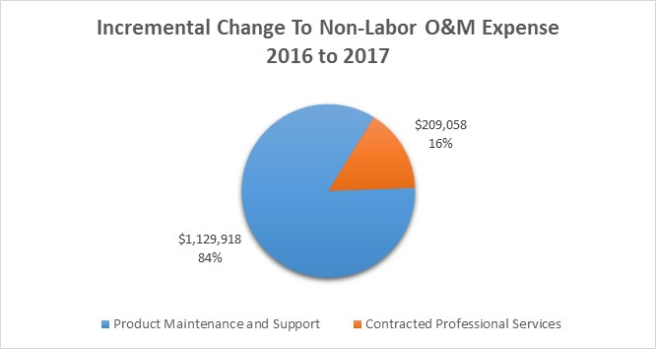**Illustration No. 4:**

**Q. What is driving the increase in these non-labor O&M expense categories?**

A. There are several factors driving the increase in IS/IT non-labor operational expenses. Drivers of non-labor costs include: growth in capital investments in technology that results in an increase to product maintenance and support expenses for each of the systems; vendor changes to their licensing models – for instance, from an on-premises solution to a cloud-based solution or from a perpetual license to a subscription or term license; and demand for highly specialized contracted professional services to implement or maintain technology systems where such skills are outside of Avista’s core expertise.

The non-labor expense planned increases below in Illustration No. 5 demonstrate a 6.7 percent increase between 2016 and 2017, followed by more modest growth the subsequent years (3 percent between 2017 and 2018, and 1.0 percent between 2018 and 2019).

**Illustration No. 5:**

However, of the 2016 to 2017 total non-labor expense increase of ($1.34 million or 6.7 percent), the majority (84.3 percent or $1.13 million) is directly related to product maintenance and support. Table No. 4 below lists major systems with incremental increases to required product maintenance and support.

**Table No. 4:**



**Q. Please discuss a few examples of product maintenance and support and how it affects core systems used by the Company.**

A. Core systems are becoming more and more highly integrated as business transactions transmit across various systems to deliver information. In some cases, issues can arise while business transactions are traveling through these paths and result in system errors, which can cause data transmission delay or overall system unresponsiveness directly affecting those using the tools (e.g. outage management, financial and accounting systems, billing systems, etc.) Quick identification and root cause analyses of these issues is paramount to system recovery and mitigation of future similar causes.

In 2016, Avista invested in an application performance management and IT operations tool that optimizes resource time in identifying issues when they arise to assist in the quick identification of the root cause in application or system performance degradation. Although the introduction of this tool increases non-labor expenses, it provides visibility into each and every business transaction and its path across multiple complex core system integrations, allowing the technology operations team to quickly respond to and recover from unknown issues. Based on the number of business transactions that occur across various core systems, it would be humanly impossible to meet system or transaction recovery time objectives without automation.

**Q. What is the second driver increasing non-labor operational expense costs for Avista’s technology department?**

A. The second driver of the non-labor increases are the contracted professional services. Approximately 15.7 percent or $209,000 of the incremental increase between 2016 and 2017 is for contracted professional services, which is largely to support nearly a dozen business systems, including COTS development, financial systems, geographic information systems, energy settlement systems, billing systems, asset management systems, and the web.

In subsequent years, the incremental changes are less substantial, 3 percent and 1 percent, respectively. However, as in the current year, much of the increase in the non-labor costs is in product maintenance and support, as seen in Illustration No. 6. These slight increases are mainly due to Avista’s efforts in negotiating multi-year, enterprise agreements with technology vendors that result in less significant increases for technology maintenance and support.

**Illustration No. 6:**

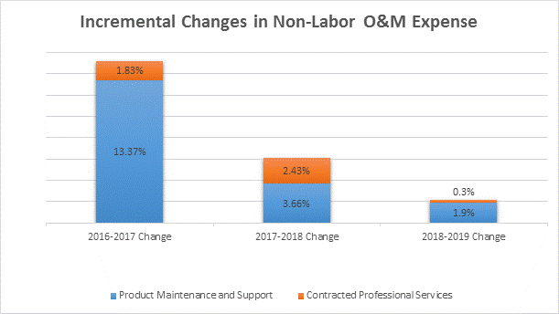

**Q. How has Avista focused on managing its overall IS/IT expenses for the benefit of its customers?**

A. Avista focuses on increasing reliability and optimizing systems for our customers’ needs through the deployment, maintenance and support of technology.

To mitigate operating expense increases, Avista works to automate our systems through technology where reasonable and prudent to do so, and we work to negotiate discounted multi-year contracts with vendors that result in discounted maintenance and support rates. For example, in 2016 we introduced a cloud-based business performance monitoring tool that automates a portion of the labor performed by our IS teams. As a subscription-based license model, the cost of the tool is amortized over three years, resulting in approximately $192,000 per year in additional expense costs. However, this particular increase in product maintenance and support expense resulted in a significant reduction of internal labor costs modeled over the same three year period, allowing us to redeploy our IS operations team labor resources and providing an immediate benefit by reducing the time to determine root cause and rectify system issues when they arise.

A second example where the Company has successfully managed its O&M expenses, was a 2017 telecommunications contract, which had two years remaining on its term. The contract was renegotiated early in the term in order to commit to a longer, five year term which resulted in approximately $215,000 in annual savings over the life of the agreement.

These two examples of cost reductions required no changes to service or quality, no equipment deployments, and were implemented by changing the delivery model in one instance and committing to a longer term in the other. Both are continuous improvement practices to manage costs over time.

**Q. Does this conclude your pre-filed direct testimony?**

A. Yes.

1. KPMG, The race for the customer, Winning in a dynamic marketplace (2016)
2. Gartner, Newsroom. (2014, December 8). *Gartner Says By 2018, More Than 50 Percent of Users Will Use a Tablet or Smartphone First for All Online Activities* [Press release]. Retrieved May 8, 2017, from http://www.gartner.com/newsroom/id/2939217
3. KPMG, The race for the customer, Winning in a dynamic marketplace (2016)
4. After completion of the Company’s revenue requirement it was brought to its attention that the labor increases in mid-2017 as shown in Table No. 3 should have been annualized and included in full in Pro Forma adjustment 3.07. Correction for this would increase expense approximately $33,045, and Pro Forma revenue requirement approximately $35,000. This increase would affect both the electric and natural gas Pro Forma and EOP Rate Base Studies.