[MARKETS](https://www.wsj.com/news/markets?mod=breadcrumb)[HEARD ON THE STREET](https://www.wsj.com/news/heard-on-the-street?mod=breadcrumb)

Utilities Have a High-Wire Act Ahead

Rising fuel prices and interest rates could test utilities’ ability to increase their earning potential without overly burdening customers

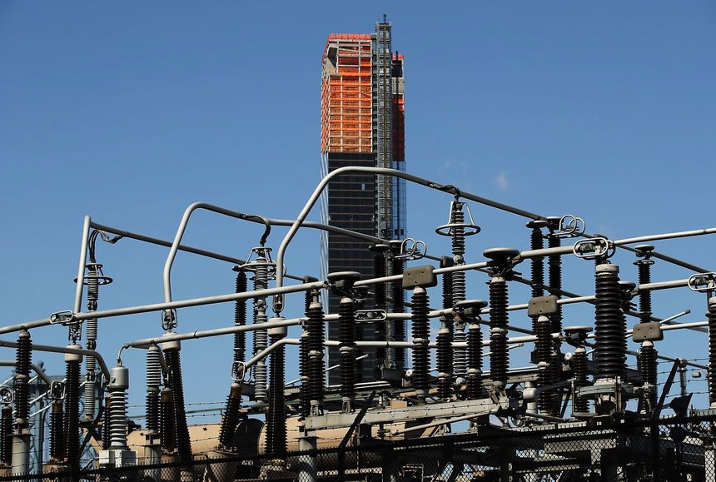

*By* [*Jinjoo Lee*](https://www.wsj.com/news/author/jinjoo-lee)

Follow

Updated Oct. 9, 2022 10:03 am ET

Utilities are meant to serve both the customers who pay the bills and the investors who fund them. For years, [low interest rates](https://www.wsj.com/articles/interest-rates-are-well-below-what-academic-formulas-suggest-fed-report-says-11655483175?mod=article_inline) and cheap natural gas made it easy to please both stakeholders. Today’s environment could break down that win-win formula.

Thus far, [high natural-gas prices](https://www.wsj.com/articles/high-natural-gas-prices-push-european-manufacturers-to-shift-to-the-u-s-11663707594?mod=article_inline) have been a problem for consumers, not utilities, many of which automatically pass on the cost of fuel to customers. But trouble for utilities could start the next time they ask regulators for a bump in the revenue they can collect. In what is known as the rate-case process, a utility has to make the case for a rate increase that depends partly on what it costs to improve and maintain its service (say, a new transmission line) and partly on what it costs to fairly compensate investors.

The higher the burden on consumers, the bigger the risk that regulatory commissions will take a long, hard look at whether a rate increase is warranted. Utility regulators are typically elected or else appointed by elected oﬃcials, so they can be sensitive to ratepayer concerns.

In the last decade or so, rate cases have been a breeze for utilities. Low natural-gas prices meant they could get aggressive capital-spending plans approved without causing big utility bill shocks to customers, according to Lillian Federico, energy research director at S&P Global Commodity Insights. Those lower costs might also have helped utilities persuade regulators to keep approving attractive returns on equity rather than passing on the declining cost of capital to consumers.

A recent working paper by Karl Dunkle Werner and Stephen Jarvis published by the Energy Institute at Haas showed that the inﬂation-adjusted return regulators allow equity investors to earn has been steady over the past 40 years, even while various measures of capital cost— such as the [U.S. Treasury yield](https://www.wsj.com/articles/10-year-treasury-yield-hits-4-11664354445?mod=article_inline)—have been declining. The study found that utilities were quick to ask for increases on their return on equity when market measures of capital cost rose and regulators were quick to respond.

Conversely, when cost of capital measures declined, utilities were slower to adjust those rates. The researchers estimate that consumers might be paying anywhere from $2 billion to

$20 billion a year more than they otherwise would if rates of return fell in line with capital- market trends.

In any other year, that could just be an interesting academic ﬁnding. But in an environment in which both fuel prices and interest rates are rising so quickly, it might give regulators pause. [Given their record, utilities are likely to ask for higher returns on equity given rising interest rates, but getting approval might not be a breeze. Last year, electric and gas utilities tracked](https://www.wsj.com/articles/why-interest-rates-are-rising-everywhereexcept-your-savings-account-11664737431?mod=article_inline) by S&P Global Commodity Insights collectively asked for $15 billion in rate increases, the biggest bump since 2000. So far this year, they have requested $12.4 billion in rate increases.

Of course, utilities might make the case that high natural-gas and [coal prices](https://www.wsj.com/articles/red-hot-coal-prices-threaten-more-increases-in-power-bills-11654167025?mod=article_inline) are just the reason regulators should allow larger capital-spending plans for solar, wind and other grid improvements. Clean-energy incentives in the [Inﬂation Reduction Act](https://www.wsj.com/articles/whats-in-joe-manchin-and-chuck-schumers-reconciliation-deal-on-climate-health-and-tax-policy-11658973323?mod=article_inline) should also support such investments. But short-term [shocks to customer bills](https://www.wsj.com/articles/your-utility-bill-is-going-to-hurt-but-the-market-might-benefit-11663246981?mod=article_inline) could nevertheless make it hard for utilities to convince regulators. “The growth opportunity [for utilities] is even better today, but rising bills could be the thing that derails some of that,” said Jay Rhame, chief executive of Reaves Asset Management, which manages utilities-focused funds.

For now, the [fears of a recession](https://www.wsj.com/articles/recession-fears-save-pharma-from-drug-pricing-concerns-11664124785?mod=article_inline) seem to have overridden those concerns among investors. Utilities in the S&P 500 are down 11% year to date, outperforming the rest of the index by 13 percentage points.

Utilities are indeed more defensive than most other sectors, but no industry is a perfect shelter from disgruntled customers.

Write to Jinjoo Lee at [jinjoo.lee@wsj.com](mailto:jinjoo.lee@wsj.com)